SMART-BIN: AN ESP32-BASED IoT WASTE BIN MONITORING SYSTEM WITH FILL, WEIGHT, AIR-QUALITY AND TAMPER DETECTION
FOR PRIORITY-BASED COLLECTION

WASTE MANAGEMENT AND CLEANLINESS
PROBLEM: Overflowing Garbage Bins and Inefficient Waste Collection Routes

Technological University of the Philippines - Manila
Bachelor of Engineering Technology major in Computer Engineering Technology

Embedded Systems: Final Project
BET-CPET 4A-M, Group 2

Submitted By:
Brian Jay Celeste
Genesis Walter D. Reyes II
Jade C. Gunayan
King Perth G. Pepito
Rodel S. Banogbanog

Submitted To:
Prof. Jonel R. Macalisang

November, 2026
TABLE OF CONTENTS
TITLE PAGE i
TABLE OF CONTENTS ii
LIST OF FIGURES iii
LIST OF TABLES vii
I. INTRODUCTION 1
1.1 Introduction and Problem 1
1.2 Sustainable Development Goal (SDG) Addressed 2
1.3 Review of Related Literature 3
1.4 Objectives 54
1.5 Conceptual Framework 55
1.6 Target Beneficiaries 59
II. PROTOTYPE DESIGN AND DEVELOPMENT 60
2.1 Development Methodology 60
2.2 Prototype Design 64
2.3 Block Diagram 65
2.4 System Flowchart 67
2.5 Schematic Design 73
2.6 Component Materials 76
III. TESTING, RESULTS, AND CONCLUSION 87
3.1 Test Cases 87
3.2 Results and Discussion 92
3.3 Conclusion 104
3.4 Recommendations 105
REFERENCES 107
CURRICULUM VITAE 117
Rodel S. Banogbanog 117
Brian Jay Celeste 118
Jade C. Gunayan 120
King Perth G. Pepito 121
Genesis Walter D. Reyes II 122
APPENDICES 123
Appendix A: Gantt Chart 124
Appendix B: Bill of Materials of the Smart-Bin Prototype 125
Appendix C: User Interface Screens 126
Appendix D: Build Documentation 156

LIST OF FIGURES
Figure 1. Sustainable Development Goal 11: Sustainable Cities and Communities 2
Figure 2. Patents Reviewed by Priority Year and Region 6
Figure 3. Remote Status Units Linked to a Central Unit 7
Figure 4. Compacting Ram and Chambers of the Solar Compactor 8
Figure 5. Path of a Full Message From the Compactor Monitor to the Service Provider 9
Figure 6. Trash Can With a Motor-Driven Lid 10
Figure 7. Container With a Bag Between Capacitive Plates 11
Figure 8. Waste Collection System of Containers, Server and Vehicles 12
Figure 9. Refuse Container With Scale, Display and Lights 13
Figure 10. Sensor Device Mounted Under the Lid Behind a Thermal Barrier 14
Figure 11. Gauge Mounted Under the Lid of a Container 15
Figure 12. Smart Garbage Bin With a Lid-Mounted Sensor Device 16
Figure 13. Pay-by-Weight Food Waste Processor With a Load-Cell Hopper 17
Figure 14. Infrared Beam Across a Container 18
Figure 15. Circuit of the Induction Flip Lid With a Settable Sensing Distance 19
Figure 16. Overall Smart Waste Management System 20
Figure 17. Garbage Cans and the Monitoring Center 21
Figure 18. Waste Measurement System With Weighing Devices and Reports 22
Figure 19. Block Diagram of the Capacity-Detecting Bin 23
Figure 20. Electrical Block Diagram of the Bin Intelligent Controller 24
Figure 21. Automatic Alerting System for a Trash Can 25
Figure 22. Network of Waste Bins, Cloud Server and Vehicles 26
Figure 23. Block Diagram of the Smart Waste Management System 29
Figure 24. Circuit Setup of the LoRa Bin Unit 30
Figure 25. Proposed System Architecture for Hospital Waste Monitoring 32
Figure 26. Proposed Network Architecture for Waste Collection in Bukavu 34
Figure 27. Prototype of the Smart Dustbin 35
Figure 28. Block Diagram of the Arduino-Based Smart Dustbin 37
Figure 29. Data Communication Structure of the Smart Waste Management System 38
Figure 30. Prototype of the SmartTrashBin 39
Figure 31. Data Flow of the Garbage Monitoring System 40
Figure 32. Power Chain of the ESP32-CAM Node 44
Figure 33. SWOT Analysis of Smart-Bin 49
Figure 34. Features Found in the 30 Related Studies 52
Figure 35. Input-Process-Output Model of Smart-Bin 55
Figure 36. System Architecture of Smart-Bin 57
Figure 37. Water-Scrum-Fall Development Life Cycle of Smart-Bin 61
Figure 38. Front View and Side Cross-Section of One Smart-Bin Unit 64
Figure 39. Block Diagram of the Smart-Bin System 65
Figure 40. System Flowchart of the Smart-Bin 67
Figure 41. Operator Flowchart of the Smart-Bin Apps 69
Figure 42. Collector Flowchart of the Smart-Bin Apps 71
Figure 43. Schematic Diagram, Sheet 1: Microcontroller 73
Figure 44. Schematic Diagram, Sheet 2: Actuators and Outputs 74
Figure 45. Schematic Diagram, Sheet 3: Sensors and Inputs 75
Figure 46. ESP32 DevKit V1 (38-Pin, ESP32-WROOM-32D) 76
Figure 47. HC-SR04 Ultrasonic Distance Sensor 77
Figure 48. FC-51 IR Obstacle Avoidance Sensor 78
Figure 49. BME680 Environmental Sensor 79
Figure 50. BMI160 Six-Axis Inertial Measurement Unit 80
Figure 51. HX711 Load Cell Amplifier and 5kg Load Cell 81
Figure 52. SG90 Micro Servo Motor 82
Figure 53. 2.4-in. TFT Touchscreen (ILI9341 With XPT2046 Touch Controller) 83
Figure 54. KY-016 RGB LED Module 84
Figure 55. Passive Buzzer Module (MH-FMD) 85
Figure 56. 18650-Battery Shields for Bin A (4-Cell) and Bin B (2-Cell) 86
Figure 57. The Two Built Smart-Bin Units 88
Figure 58. Inside Bin A: Trash Chamber From Above (a) and Controller and Battery Compartment (b) 89
Figure 59. Lid Test: Hand in Front of the IR Sensor (a) and the Lid Opened (b) 96
Figure 60. Bin 01 With the Original PIR Sensor During the First Test 97
Figure 61. Home Screen of Bin 01, With the IR Sensor Above It 102
Figure C1. Start Page of the Web Dashboard 127
Figure C2. Creating the Operator PIN 128
Figure C3. Overview Tab with Bin Cards and Collection Priority 129
Figure C4. Overview Tab in Grid View 130
Figure C5. Bin Detail Opened from the Grid 131
Figure C6. Charts Tab 132
Figure C7. Settings Tab in Calibration Mode: Fill Range, Alert Limits and Air Sensor 133
Figure C8. Settings Tab in Calibration Mode: Tilt Sensor, Lid, Weight and Touchscreen 134
Figure C9. Bluetooth Setup Panel 135
Figure C10. Cloud Backup Panel for Firebase and ThingSpeak 136
Figure C11. Operator Access Panel 137
Figure C12. Demo Options Panel 138
Figure C13. Sound Test Panel 139
Figure C14. Simulation Tab with One Sensor in Manual 140
Figure C15. Alerts Tab 141
Figure C16. Overview Tab in Dark Theme 142
Figure C17. Start Page and Operator PIN in the Android App 143
Figure C18. Overview Tab with Banners, Collection Priority and Bin Grid 144
Figure C19. Starting and Finishing a Pickup from a Bin Card 145
Figure C20. Needs Attention Sheet and Alert History 146
Figure C21. Charts Tab in the Android App 147
Figure C22. Settings Tab with Calibration Mode Off and On 148
Figure C23. Calibration Settings: Fill Range, Alert Limits and Air Sensor 149
Figure C24. Calibration Settings: Tilt Sensor, Lid, Weight and Touchscreen 150
Figure C25. Simulation Tab in the Android App 151
Figure C26. App Settings 152
Figure C27. Connection Page 153
Figure C28. Bluetooth Setup Page and Bin Settings Sheet 154
Figure C29. Overview in List View, Light and Dark Themes 155
Figure D1. Choosing the Bin Body, October 24, 2026 156
Figure D2. Building the Board and Testing the Parts, October 27, 2026 157
Figure D3. Fitting the Board Into the Bin, October 28, 2026 158
Figure D4. Moving Every Part Into the Bin and Changing the Lid, October 29, 2026 159
Figure D5. Finishing the Build, October 30, 2026 160
LIST OF TABLES
Table 1. Related Patents, by Priority Year 4
Table 2. Related Studies From 2023 to 2026 27
Table 3. Commercial and Student Systems as Described by Their Own Pages 47
Table 4. Technical Basis of the Main Design Choices 48
Table 5. The Four Closest Patents Compared With Smart-Bin 51
Table 6. The Research Gap by Capability 53
Table 7. Reference Instruments Used in the Tests 87
Table 8. Test Cases for Specific Objective 1: Sensor Monitoring and Detection 89
Table 9. Test Cases for Specific Objective 2: Real-Time Monitoring and Alerts 90
Table 10. Test Cases for Specific Objective 3: Bin Control and Collection Prioritization 91
Table 11. Fill Level Readings Against the Ruler (TC1.1) 92
Table 12. Weight Readings Against the Test Masses (TC1.2) 93
Table 13. Temperature and Humidity Against the Thermo-Hygrometer (TC1.3) 93
Table 14. Air Quality Response After the Warm-Up (TC1.4) 94
Table 15. Tamper Detection by Tilt Angle (TC1.5) 94
Table 16. Automatic Lid Response by Hand Distance (TC1.6) 95
Table 17. Time to Show a New Reading (TC2.1) 98
Table 18. ThingSpeak Logging Over 30 Minutes (TC2.2) 98
Table 19. Alert Delivery to the Phone (TC2.3) 99
Table 20. Offline Detection, Role Access and Two-Bin Results (TC2.4 to TC2.6) 100
Table 21. Collection Priority Order for Five of the Ten Combinations (TC3.1) 100
Table 22. Estimated and Actual Time to Reach the 80% Fill Limit (TC3.2) 101
Table 23. Lock, PIN Collection, Simulation and Calibration Results (TC3.3 to TC3.6) 101
Table 24. Summary of Test Results 103

I. INTRODUCTION

1.1 Introduction and Problem
Clean and healthy communities depend on how well their waste is managed. As the amount of waste grows, so does the burden on local governments and commercial waste collectors in the Philippines. The Philippines is estimated to be producing a total of 60.76 thousand tons of garbage every day in 2025, according to the Philippine Statistics Authority (PSA, 2026). Despite its efforts, Metro Manila was projected to produce 9,498 MT/D of garbage in 2020, making it the country's waste capital (World Bank, 2022). This was projected to rise to 10,368 MT per day by 2025 (World Bank, 2022). Better waste management and collection is therefore a priority for the country. Most garbage is collected on a fixed schedule, so some bins overflow before pickup while others are emptied before they are full. The smell, pollution, temperature and tilt of a bin, and any unauthorized access, are also worth monitoring, since they show the condition of the area and how well its waste is handled.
The researchers propose Smart-Bin, an Internet of Things (IoT) bin monitoring system built on the ESP32 microcontroller, to improve garbage collection. Its sensors measure the fill level, weight, temperature, humidity and air quality of the bin. It also reports a bin that is tilted or opened without permission to a web dashboard and a mobile app. A touchscreen on the bin lets staff view and acknowledge collection instructions, use a PIN that controls who can open the bin, and change collection settings. The project builds two table-size prototypes that use ESP32 boards, local Wi-Fi, ThingSpeak, a web dashboard, an Android app and a screen on the bin. Smart-Bin ranks the bins for collection by fill level and by how soon each will be full, so that collection and fuel use can be planned better.

1.2 Sustainable Development Goal (SDG) Addressed
Figure 1
Sustainable Development Goal 11: Sustainable Cities and Communities

Smart-Bin addresses one of the Sustainable Development Goals (SDGs) of the United Nations (Agenda 2030), namely SDG 11: Sustainable Cities and Communities. Smart-Bin is specifically targeting the environmental impact of cities, per capita, with particular attention to air quality and municipal and other waste management (United Nations Department of Economic and Social Affairs [UN DESA], n.d., Target 11.6).
Smart-Bin contributes to this target by sensing the state of the waste in each bin and collecting the readings so that collection decisions are made on time. The dashboard and app of the project notify the operator of each bin's state: fill level, weight, temperature, humidity and the air quality around the bin.
With this data, the fullest bins can be emptied first, before they overflow. The same readings warn of harm to the surroundings, for example when the temperature or air quality (a sign of rot) passes its limit. Ranking the bins this way also means fewer truck trips and less fuel.

1.3 Review of Related Literature
This review covers three kinds of sources. Patents show what has already been claimed, in any year. Studies from 2023 onward show what researchers have built lately, and a handful of commercial products show what is already on sale. The patents were found and read on Google Patents which also provided the legal status listed in Table 1. Every study was checked against its DOI or publisher page, and each reference list entry was checked against its source. Each patent and study has its own entry, a figure from the source where one can be reused, and a comparison with Smart-Bin. Those comparisons are drawn together in the synthesis, the SWOT analysis and the research gap at the end of the section.

Prior Art
Twenty patents were reviewed. They are in effect through 2023 and their owners are in the United States, Europe, China and Korea. They are listed in priority year order in Table 1, and their coverage and differences from Smart-Bin are summarized. Google treats these status labels as assumptions, not legal conclusions, so an Active or Expired status should be confirmed with the patent office before anyone relies on it. Figure 2 puts the twenty into a time line. Most of the activity is recent: five have priority years before 2012 and fifteen in 2012 or later.
Each of the patents is discussed individually below, in the order of the table. The figure for each entry is the first image of the patent as published on Google Patents, and the text below it covers what the patent claims and how it relates to Smart-Bin. The four closest patents are Kurani (2023), Sait et al. (2025), Shahabdeen (2016) and Yan and Chen (2021) and the synthesis at the end of this section compares their features with Smart-Bin side by side.

Table 1
Related Patents, by Priority Year
No. | Patent | Priority year | Status | What it covers | How Smart-Bin differs
1 | US 5,016,197  (Neumann & Allison, 1991) | 1986 | Expired | Remote status units judge how full compactor containers are from hydraulic pressure or weight, and report over a telephone line to a central unit that calls the hauler. | A phone-line system for hydraulic compactors. It has no gas, tilt, lid, display, wireless link or phone app.
2 | US 7,124,680  (Poss et al., 2006) | 2003 | Expired | A public trash compactor powered by a solar panel and a battery, with a removable bin, so it is emptied less often than an ordinary bin. | It compacts rather than senses. It has no weight, air-quality or tilt sensing, touchscreen, PIN mode or priority list.
3 | US 7,145,450  (Brown, 2006) | 2004 | Expired | A processor reads the pressure on a compactor ram, flags the unit as full after a preset time and emails a work order to a service provider. | Fullness is inferred from pressure only. It has no fill level, weight, gas, lid, local display or app.
4 | US 7,781,995  (Yang & Sandor, 2010) | 2005 | Expired | A trash can whose electric drive opens the lid when a sensor detects an object near the lower part of the can. | The trigger is a foot-level sensor. There is no fill, weight, air-quality, tilt, wireless or collection feature.
5 | EP 2 516 974 B1  (Di Giugno et al., 2016) | 2009 | Not in force | A container that holds a bag has capacitive plates that give several fill levels. Its status goes wirelessly to stations that plan the emptying routes. | The sensing is capacitive around a bag. There is no weight, gas, tilt, powered lid, PIN mode or phone app.
6 | WO 2014/079586 A1  (Kekalainen & Engstrom, 2014) | 2012 | Ceased | Containers with sensors report their status over a wireless network to a server, which plans the collection vehicles and can run bidding for the jobs. | It is a fleet-level planning platform with sensors only. There is no weight, tamper detection, powered lid, PIN mode or on-bin display.
7 | US 9,347,821 B1  (Mullaney, 2016) | 2012 | Expired | The refuse container has a scale on it that indicates the weight of refuse in the container and alerts to a maximum weight. | It is capable to sense weight. Fill level, air quality, tamper alarm, IR sensor lid, PIN mode and dashboard are not present.
8 | US 9,927,278 B2  (Kekalainen & Engstrom, 2018) | 2013 | Expired | A sensor device fixed under the container lid, behind a thermal barrier, measures the amount of waste and the conditions inside and sends them to a remote location. | Its novelty is the heat-insulated lid mounting of a cellular sensor module. There is no weight, tamper alarm, powered lid, PIN mode or priority list.
9 | US 9,930,429 B2  (Kekäläinen, 2018) | 2014 | Active | A gauge compares the fill rate with limits set by a server and contacts the server only when a limit is crossed, which saves battery. | It is a battery-saving reporting scheme. No motorized lid, tamper alarm, PIN mode, touchscreen or phone app is described.
10 | US 2016/0176630 A1  (Shahabdeen, 2016) | 2014 | Abandoned | A bin carries a lid-mounted range finder or a weight sensor at the base, with optional hydrogen sulfide, ammonia and methane sensing, and a controller that sends the data wirelessly. | It has no tamper detection, powered lid, lock, on-bin display, PIN mode or priority list. Temperature and humidity are not mentioned.
11 | KR 10-1581944 B1  (Shin, 2016) | 2015 | Active | The hopper of a pay-by-weight food waste processor sits on a load cell and rotates to drop the waste into a crushing tank. | It is a weighing and payment machine. There is no fill sensing, gas sensing, tilt sensing, wireless reporting or priority list.
12 | US 11,054,545 B2  (Devitt & Walsh, 2021) | 2016 | Active | Two low-power ways to detect a full container: an infrared beam across the container, or the resting tilt angle of the lid. | The output is only full or not full. There is no weight, gas, temperature, powered lid, PIN mode or tamper alarm.
13 | EP 3 620 405 A1  (Wang, Chen, et al., 2020) | 2017 | Withdrawn | An induction flip-lid can whose infrared sensing distance the user can set, built into a single microcomputer chip. | It only opens the lid. There is no fill, weight, gas, tilt, display or wireless link.
14 | US 11,702,280 B2  (Kurani, 2023) | 2018 | Active | 12 sensors, including those measuring fill level, weight, air quality, temperature, humidity and pressure, along with an accelerometer, are installed on the bin and communicate with a cloud server, which generates statistics and works out collection routes, also notifying mobile apps. | Focuses on litter, biohazard and pathogen sensing, with a sterilizer. There was no IR-sensor servo lid, no remote lock or no PIN collect mode or latched tamper alarm.
15 | CN 109324552 B  (Yan & Chen, 2021) | 2018 | Active | Each can has weight, infrared height, odor and smoke sensors and a positioning unit. A monitoring center decides which cans to visit and builds the truck route. | It plans city-wide truck routes with GPS. No powered lid, tamper detection, PIN mode, on-bin display or phone alert was found.
16 | US 11,788,877 B2  (Balachandran & Talavera, 2023) | 2018 | Active | Load cells under a platform weigh the waste of two or more bins, and cameras with image analysis identify the contents for waste audit reports. | It is a waste audit and reporting service, not a single bin with fill, tilt, lid and lock control, a PIN collect mode and a collection priority list.
17 | CN 210504152 U  (Yang et al., 2020) | 2019 | Expired | A bin with an infrared induction module, an ultrasonic ranging module and a programming module lets users see how much capacity is left. | It is a stand-alone local device. There is no weight, gas, tilt, lid actuator, wireless link or phone app.
18 | CN 111559590 A  (Wang, Zhang, et al., 2020) | 2020 | Withdrawn | A controller for top or side installation measures the distance to the garbage and uploads it to a supervisory platform, which has an early-warning unit. | It comprises of one laser ToF sensor. No weight, gas, temperature, tilt, lid control or touchscreen collect mode or priority list.
19 | US 12,125,361 B2  (Keller et al., 2024) | 2021 | Active | Two calibration setpoints enable a processor to convert distance readouts to a fill percentage and signal a user device when it exceeds a threshold, which varies depending on the can owner. | It uses a single laser time-of-flight sensor. There is no weight, gas, temperature, tilt, lid control, touchscreen collect mode or priority list.
20 | US 12,450,575 B1  (Sait et al., 2025) | 2023 | Active | Each bin has methane, fill level and temperature/humidity sensors that provide data to neural networks which calculate the time required to reach the methane and fill limits; a scheduler creates routes considering the vehicle emissions. | It revolves around the sensing of methane by air quality. There is no load cell, tilt alarm, IR sensor lid, remote lock or PIN collect mode.
Note. Status is as reported by Google Patents in October 2026. The differences are those found in the patent text read for this review.
Figure 2
Patents Reviewed by Priority Year and Region
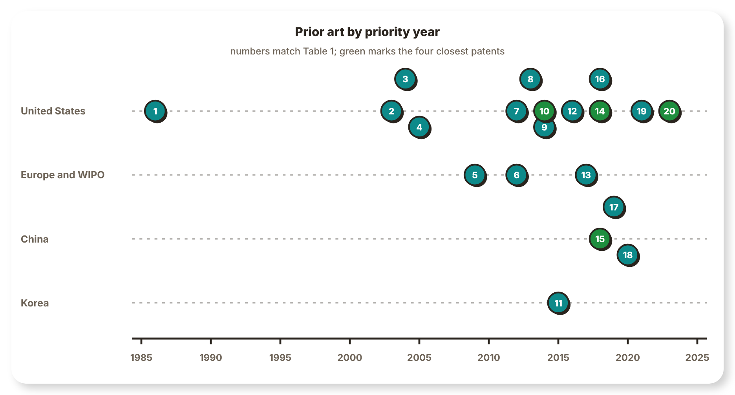
Note. Numbers match Table 1. The four patents in green are the closest to Smart-Bin.
Automated Trash Management System (Neumann & Allison, 1991)
Figure 3
Remote Status Units Linked to a Central Unit
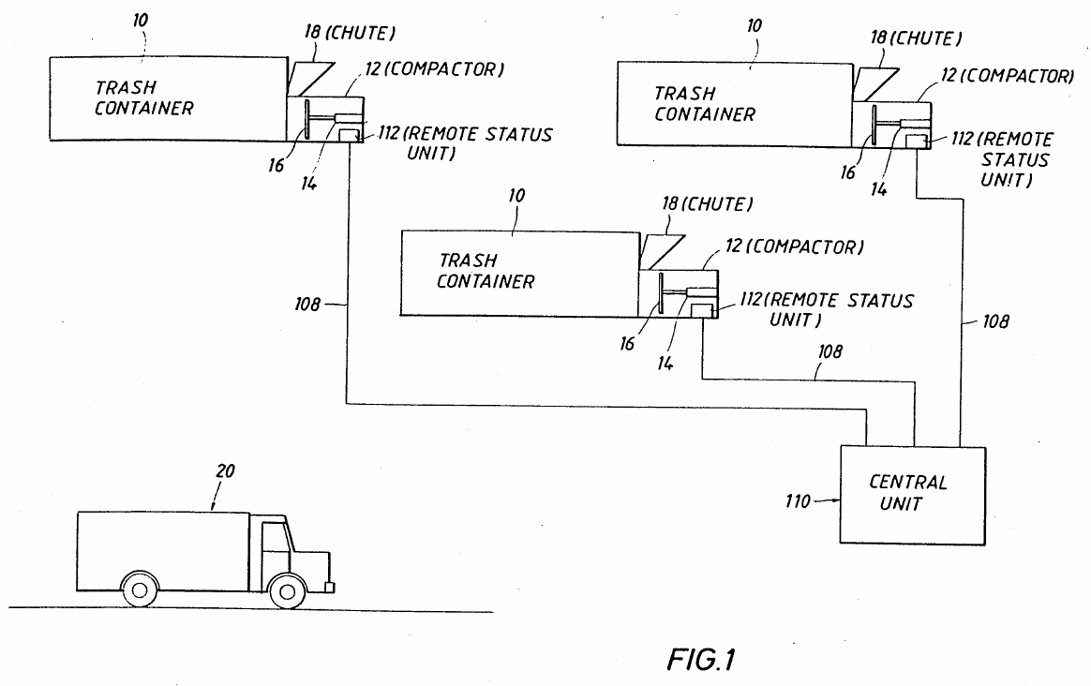
Note. From Automated trash management system (U.S. Patent No. 5,016,197), by R. H. Neumann and C. B. Allison, 1991, U.S. Patent and Trademark Office.

Figure 3 shows the layout of the system that Neumann and Allison (1991) patented for MGM Services. Each remote status unit serves three containers, each with its own compactor, and all units are linked by a communications line, typically a telephone line, to a central unit that keeps a database. The hauler sends a truck only to the containers that report full. For compactors, fullness is inferred from the hydraulic pressure during the packing stroke, from the work done per stroke or from the current drawn by the pump motor, and for any container a measured weight can be compared with a preset full weight.
Calling for a pickup only when a container is full is the idea behind the priority tags of Smart-Bin, and the load cell is a signal that both systems can use. The differences come from the era. The data travel by modem, a person calls the hauler, and no alert or route is generated. The patent describes no gas, temperature or tilt sensing, no lid, no display on the container and no phone app. Smart-Bin also measures the fill directly with an ultrasonic sensor and does not infer it from the work of a compactor.
Solar Powered Compaction Apparatus (Poss et al., 2006)
Figure 4
Compacting Ram and Chambers of the Solar Compactor
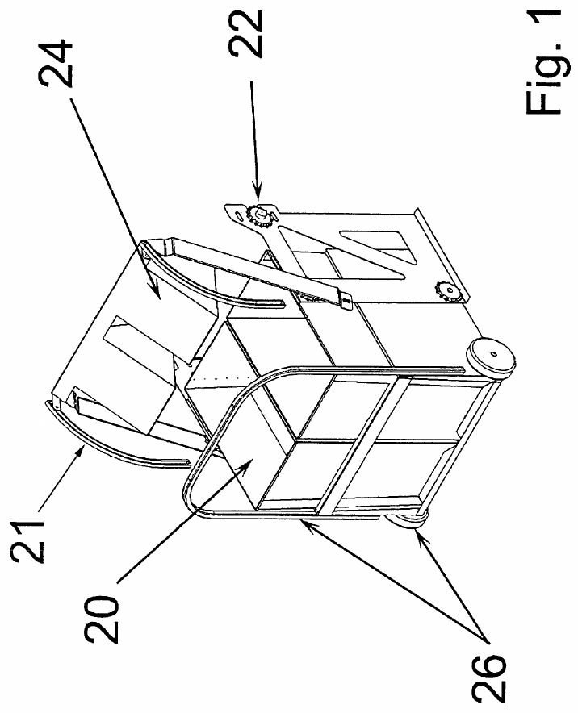
Note. From Solar powered compaction apparatus (U.S. Patent No. 7,124,680), by J. Poss, J. Satwicz, B. Richmond, and M. Taylor, 2006, U.S. Patent and Trademark Office.

Poss et al. (2006) of BigBelly Solar patented a public compactor that a photovoltaic array powers, so that it can stand where there is no mains power but many people pass. Figure 4 shows the compacting ram with its chain drive and guide track and the compaction chambers. A roof panel charges a battery, and a compaction cycle is skipped when the charge is low. Because the trash is compacted, the unit needs emptying less often than a regular bin. Fullness is sensed by a photo-eye, by the ram motor current (the stall time) and by pressure sensors, and a wireless transmitter reports to sanitation staff.
The patent attacks the same public-space problem as Smart-Bin, a bin that overflows and is costly to visit, but it answers with compaction and solar power instead of sensing. Scales are named only as an alternative fullness sensor, and the only display is a set of status lamps. No weight or air sensing, tilt alarm, touchscreen, PIN mode or phone app is described. One remark does bear on the project: the patent says that real-time fill data could feed routing and scheduling software, which is the use that Smart-Bin makes of its fill ranking.
Compactor Service and Monitoring System (Brown, 2006)
Figure 5
Path of a Full Message From the Compactor Monitor to the Service Provider
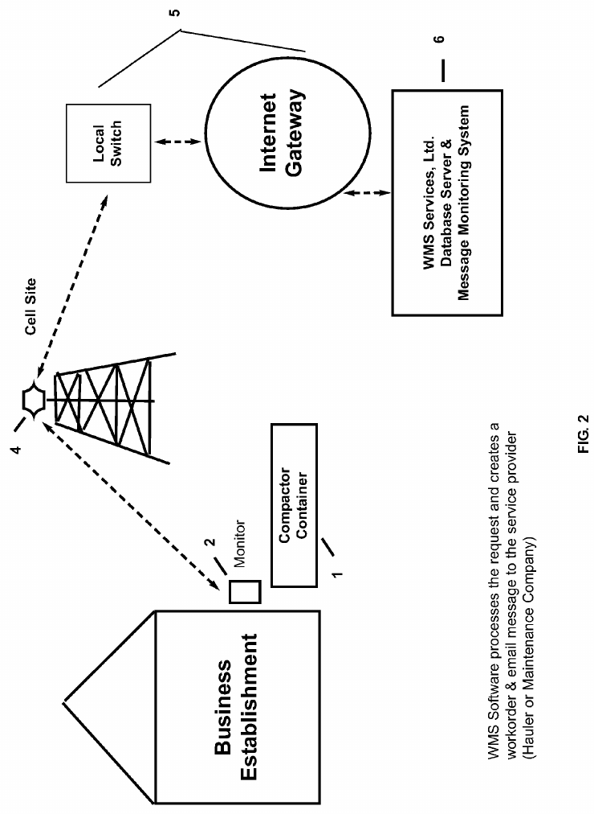
Note. From Compactor service and monitoring system (U.S. Patent No. 7,145,450), by W. J. Brown, 2006, U.S. Patent and Trademark Office.

Brown (2006), an individual inventor, patented a monitor that is added to an existing compactor. A pressure sensor on the hydraulic system of the ram measures the pressure during each cycle, and when the pressure stays at or above a preset value for a preset time the unit is flagged as full. Figure 5, which is Figure 2 of the patent, shows the path of a message. The monitor at the compactor reaches a cell site, an internet gateway and a server that runs the message monitoring software, which creates a work order, emails it to the service provider (a hauler or maintenance company) and supplies a tracking web link.
Like Smart-Bin, the system detects a full container by itself and notifies the people who must empty it. Fullness is inferred from pressure, though, and the patent has no level or weight sensor, since the tonnage is typed in by hand after a pickup. Alerts go out as email work orders, with fax as an option, and not as phone notifications, and the only local indication is a set of LEDs. Overdue work orders are flagged for staff, which is a rough counterpart of the priority tags of Smart-Bin, except that Smart-Bin bases its tags on the measured fill rate.
Trash Can With Power Operated Lid (Yang & Sandor, 2010)
Figure 6
Trash Can With a Motor-Driven Lid
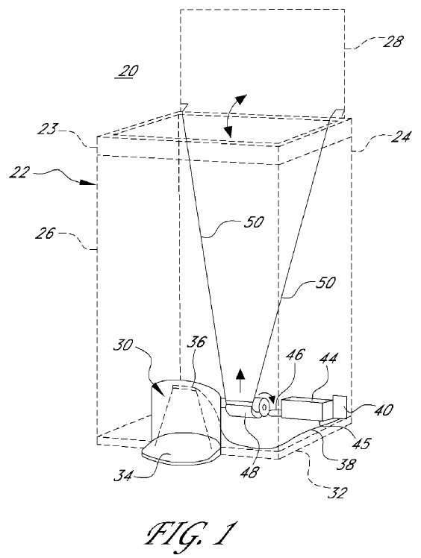
Note. From Trash can with power operated lid (U.S. Patent No. 7,781,995), by F. Yang and J. Sandor, 2010, U.S. Patent and Trademark Office.

Yang and Sandor (2010) patented the power-operated lid of Simplehuman. Figure 6 shows the can with its lid open. There's a recess in front that houses the sensor, two link rods on the back wall connect a motor-operated lifting bar to the lid, and the circuit board, batteries and motor gear all reside in the base. When the sensor detects an object near the bottom of the can, the electric drive opens the lid and the lid remains open for a predetermined period (2 seconds, for example). Claim 1 covers the motor for the door. On each command the controller checks the supply voltage, adjusts motor power to keep the door speed within a range, brakes the motor by briefly reversing it, and stops it with a fault output if it runs too long.
Smart-Bin also opens its lid by motor when a sensor notices a user, so that nobody has to touch the lid, but it uses an IR sensor and a servo and not a foot-level light beam. Everything else in the patent concerns lid mechanics. It has no fill, weight, air-quality, tilt, lock, display or wireless feature, and nothing on the collection side. The patent shows that a hands-free lid is old, so the contribution of Smart-Bin cannot be the lid itself. It lies in the sensing and reporting behind the lid.
Measuring Device and Monitoring System for Containers (Di Giugno et al., 2016)
Figure 7
Container With a Bag Between Capacitive Plates
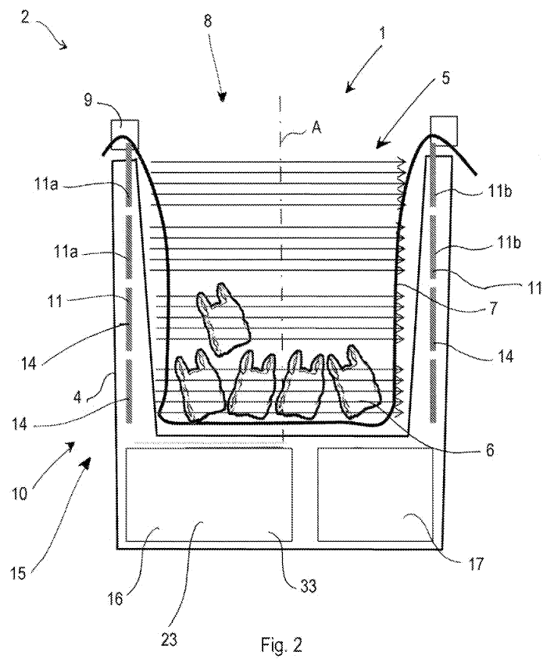
Note. From Measuring device, container means and system for monitoring and managing container means (European Patent No. 2516974), by M. Di Giugno, F. Giovanelli, S. Tiraboschi, and P. Villa, 2016, European Patent Office.

Di Giugno et al. (2016), from Cefriel and the Milanese environmental services company AMSA, describe a container whose casing holds a bag. Figure 7, which is Figure 2 of the patent, shows the container: the casing, the bag that the lid element holds in place and the plates at the sides of the cavity. Claim 1 places capacitive plates on opposite sides of the cavity, spaced along its length, so that the change in electrical capacity caused by the waste gives several progressive fill levels, with the bag lying between the plates. Status goes by GPRS or short-range wireless to an internet server, and stations plan the paths of the vehicles.
What matches Smart-Bin is the chain and not the sensor: measure the fill inside the bin, send it to a back end with a user interface, and use it to plan the collection of full bins. The sensing is different. Capacitive plates around a bag give levels in steps, while Smart-Bin measures distance by ultrasound and converts it to a percentage with two calibrated distances. It has no gas, temperature, tilt or weight sensing, no powered lid or lock, no PIN collect mode and no phone app.
Smart Waste Collection System and Method (Kekalainen & Engstrom, 2014)
Figure 8
Waste Collection System of Containers, Server and Vehicles
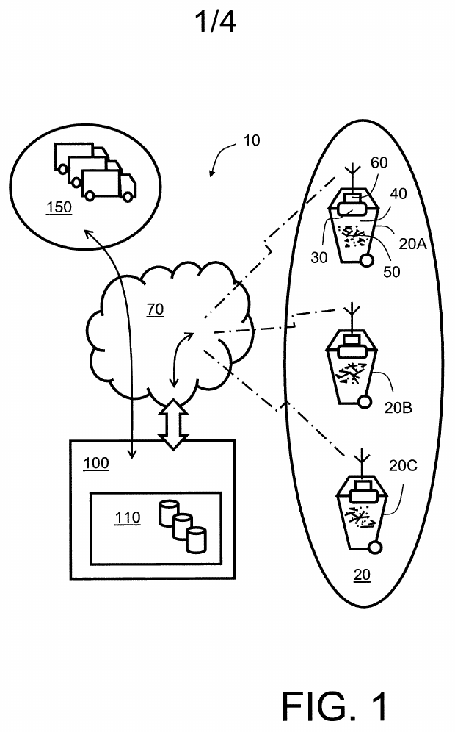
Note. From Smart waste collection system and method (International Patent Application Publication No. WO 2014/079586 A1), by F. Kekalainen and J. Engstrom, 2014, World Intellectual Property Organization.

Figure 8 shows the system in the application that Kekalainen and Engstrom (2014) filed for Enevo. The status is transmitted via a wireless network (GSM/3G) to a central server, which maintains the information in a database and arranges collection for vehicles on the way to collection or recycling facilities. The sensors are located in a rotating lid to measure fill level, gasses (methane, CO2 and CO type) and temperature. Weight is not measured. The server forecasts container fill times and routes them using a Monte Carlo simulation based on GPS data of the vehicles.The application also describes a marketplace in which haulers bid for collection jobs.
This is an early statement of the idea that fill data should decide which bins are collected first, and Smart-Bin carries it out on a much smaller scale with its priority tags. The patent works at fleet level, with bidding, simulated models and vehicle tracking, and the bin is only a sensor. It has no weight sensing, tilt or tamper alarm, powered lid, PIN mode or display on the bin, and humidity and odor are not measured.
Refuse Container With Weight Indicator and Danger Alerting (Mullaney, 2016)
Figure 9
Refuse Container with Scale, Display and Lights
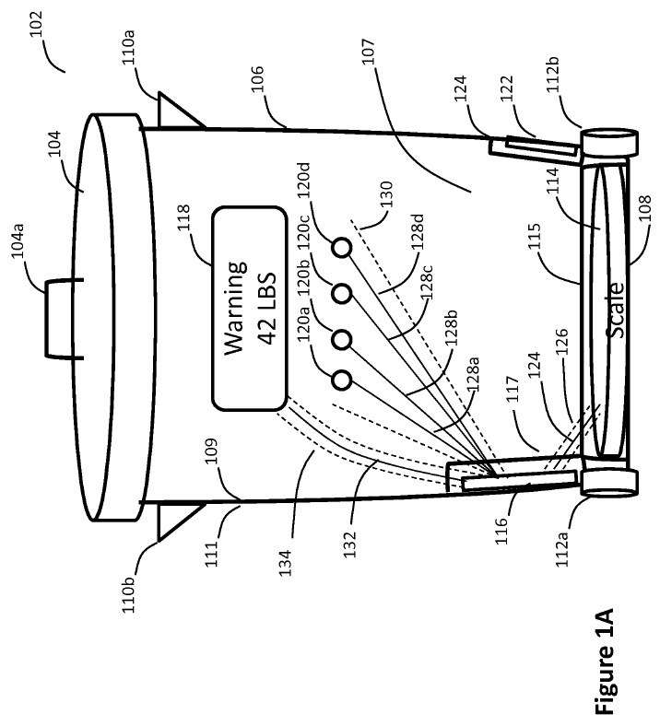
Note. From Refuse container with weight indicator and danger alerting (U.S. Patent No. 9,347,821), by G. Mullaney, 2016, U.S. Patent and Trademark Office.

Mullaney (2016), an individual inventor, patented a refuse container that shows how heavy its contents are. Figure 9, which is Figure 1A of the patent, shows a container with a floor scale, a controller, a display and four lights. The lights track the percentage of the maximum weight, and all of them light, with one flashing, once the limit is exceeded. The maximum weight can be set by location (a city or ZIP code lookup), by the user or by default, and an optional beep is mentioned. Claim 1 adds a memory that stores a history of readings, a controller that sends that history to a service provider, and a lock that locks the lid once the refuse reaches a predetermined weight. An inversion sensor releases the lock for emptying.
The container weighs its contents, shows the weight and warnings on the bin, locks the lid under a condition and can report to a remote party, and Smart-Bin does all four. The lock is the point of difference. It closes at a weight limit to stop overloading, where the lock of Smart-Bin is controlled remotely or by a PIN. The patent does not measure fill level or air quality, has no tamper alarm, IR sensor lid or collection priority list, and uses the mobile app only for configuration.
Sensor Device for Smart Waste Collection Systems (Kekalainen & Engstrom, 2018)
Figure 10
Sensor Device Mounted Under the Lid Behind a Thermal Barrier
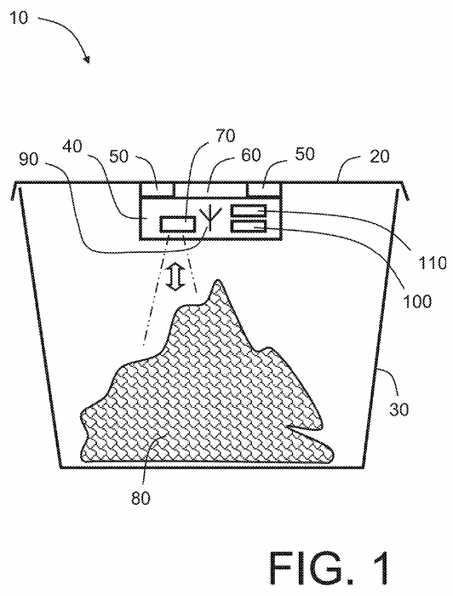
Note. From Sensor device for smart waste collection systems and method (U.S. Patent No. 9,927,278), by F. Kekalainen and J. Engstrom, 2018, U.S. Patent and Trademark Office.

Kekalainen and Engstrom (2018) patented the sensor module itself and not the system around it. Figure 10 shows a container with a pivoting lid and the sensor device under the lid, held off its surface by spacers that leave an air gap. The spacers and a heat-reflecting metal foil layer form a thermal barrier between the lid and the electronics. The module has an ultrasonic sensor for the amount of waste and sensors for temperature, humidity and a hydrocarbon or methane gas that indicates decomposition. The data is sent constantly, periodically or when a threshold is reached via a cellular modem (GSM or 3G), and the fasteners can be designed to avoid unauthorized removing.
This is the nearest match to the sensing side of Smart-Bin. Ultrasonic fill, temperature, humidity and gas are all on the bin, and the data go wirelessly to a remote location. The novelty lies in the insulated lid mounting and not in the sensors. The data support collection scheduling, but the device does not compute routes, and no weight sensor, powered lid, PIN mode or priority list is described. The anti-removal fasteners are a mechanical measure, where Smart-Bin senses the tilt and sounds an alarm.
Monitoring and Communicating the Fill Rate of a Container (Kekäläinen, 2018)
Figure 11
Gauge Mounted Under the Lid of a Container
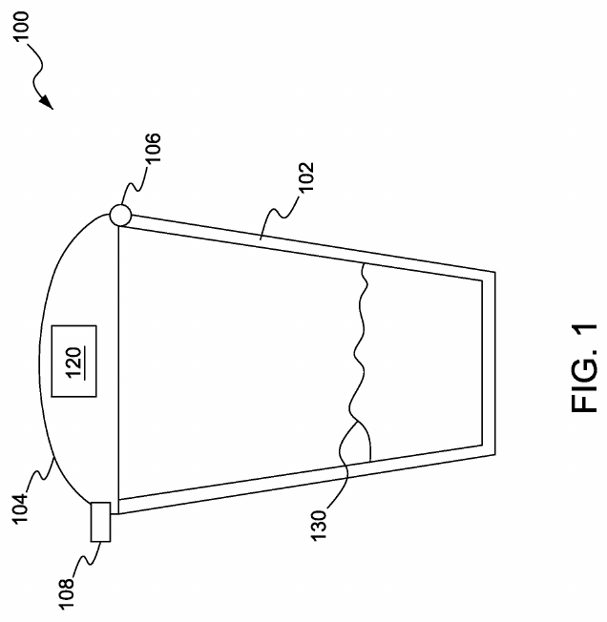
Note. From Method and system for monitoring and communicating fill rate of container (U.S. Patent No. 9,930,429), by F. Kekäläinen, 2018, U.S. Patent and Trademark Office.

Kekäläinen (2018), also for Enevo, is about how often the gauge talks and not about what it measures. Figure 11 shows a garbage container with a hinged lid and the gauge attached under the lid. A server sends the gauge a model of how it should behave, with upper and lower fill-rate limits and a communication schedule. The gauge keeps its microcontroller and transceiver asleep while it senses the fill rate, wakes only when the rate reaches a limit, sends the measurement and receives an updated model. Fewer transmissions mean a longer battery life.
Smart-Bin handles the same issue more simply. It writes to ThingSpeak every 30s while readings change and at least every 5 minutes otherwise, with no server model. In the parts read, the patent describes no motorized lid, tamper alarm, PIN mode, touchscreen or phone app, and its user device is a laptop or desktop.
Smart Garbage Bin (Shahabdeen, 2016)
Figure 12
Smart Garbage Bin with a Lid-Mounted Sensor Device
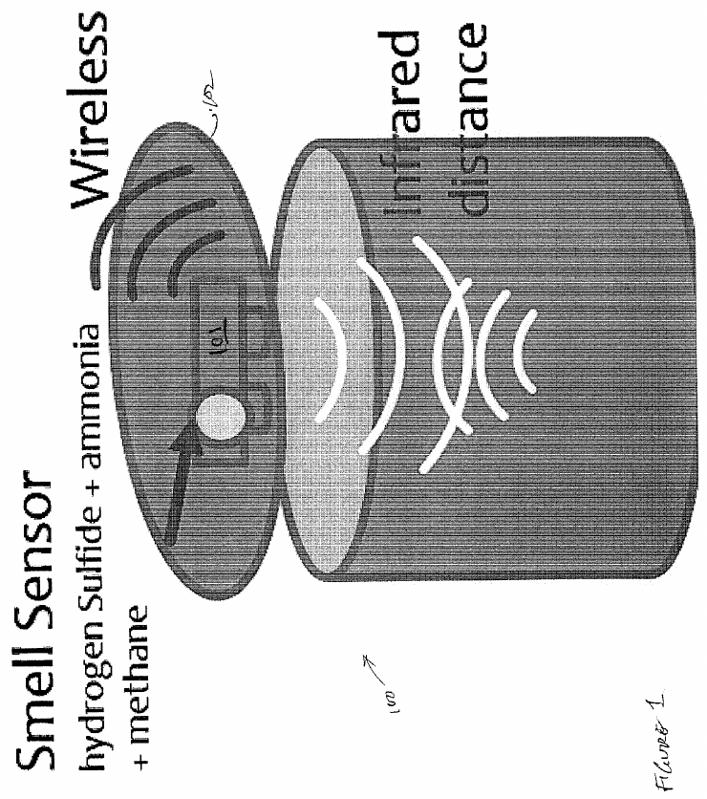
Note. From Smart garbage bin (U.S. Patent Application Publication No. 2016/0176630 A1), by J. A. Shahabdeen, 2016, U.S. Patent and Trademark Office.

Shahabdeen (2016) filed this application for Zan Compute. Figure 12 shows the bin with a battery-powered wireless sensor device on its lid. The sensor is a reflective infrared range finder (a Sharp GP2Y0A41SK0F) aimed at the waste, and the description adds MQ-136, MQ-137 and MQ-4 gas sensors for hydrogen sulfide, ammonia and methane. A weight sensor at the base is the alternative way to measure how much has been deposited. A local controller sends the data wirelessly to a remote controller (MQTT in claim 17), and claim 13 sends an alert when a sensed value passes a threshold. The application says that an ultrasonic sensor was a possible alternative to the infrared range finder but judged it too power-hungry.
It's the closest to Smart-Bin in hardware: the distance to the trash from under the lid, the weight under it, gas sensing, and wireless reporting. It has no tamper detection, powered lid, lock, display, PIN mode or priority list, and it does not mention temperature or humidity. The lid only carries the sensor. Google Patents lists the application as abandoned.
Input Device for a Pay-by-Weight Food Waste Processor (Shin, 2016)
Figure 13
Pay-by-Weight Food Waste Processor with a Load-Cell Hopper
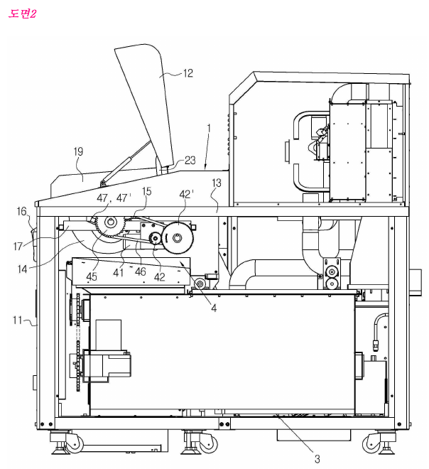
Note. From Inputting device for quantity and weight loss of food garbage container (Korean Patent No. 10-1581944), by H. Shin, 2016, Korean Intellectual Property Office.

Shin (2016), for Concoftech, patented the waste input device of a pay-by-weight food waste processor. Figure 13 is a perspective view of part of the machine, with some parts omitted and separated. The waste is dropped into a hopper which sits on a load cell, the user pays electronically on the display, and the hopper then rotates approximately 170-180 degrees and releases the waste into a crushing and stirring tank. A guide member with rollers lets the hopper turn inside the lid space without snagging, which keeps the machine compact and the loading height convenient. Payment data go to a main server that the drawings do not show.
The load cell, a powered lid and a display for the user are shared with Smart-Bin. The purpose differs. The Korean device crushes the garbage and charges according to its weight, while Smart-Bin weighs to verify the garbage level. There is no fill-level, gas, tilt or tamper sensing, no wireless or cloud reporting in the text read, no collection priority list and no mobile alerts in the patent. Odor comes up only as background, in a mention of earlier deodorant sprayers and sterilizing lamps.
Techniques for Optimally Sensing Full Containers (Devitt & Walsh, 2021)
Figure 14
Infrared Beam Across a Container
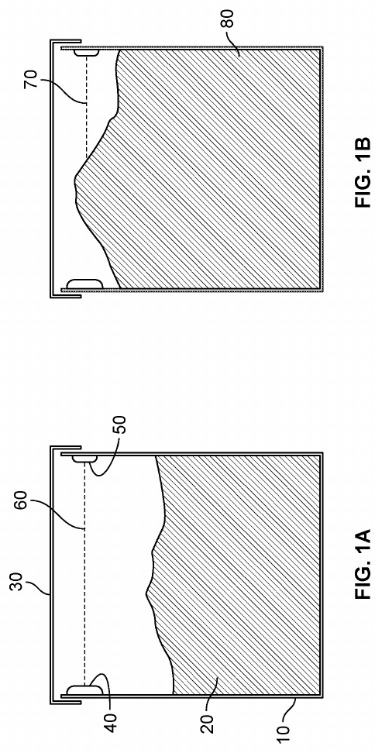
Note. From Techniques for optimally sensing full containers (U.S. Patent No. 11,054,545), by S. Devitt and B. Walsh, 2021, U.S. Patent and Trademark Office.

Devitt and Walsh (2021), for Oneplus Systems, give two ways to detect a full container while keeping the current drawn by battery-powered wireless circuitry very low. Figure 14, which combines Figures 1A and 1B of the patent, shows the first: an infrared emitter and receiver mounted on the side walls, so that the line between them marks the full level. The emitter transmits a wake-up signal and coded pulses, the receiver waits in sleep mode until the wake-up signal is received, and at the end of a specified period of time, if the coded signals are not received, the container is considered full. The second checks the resting angle of the lid in three axes, since a lid propped up by overfull waste rests at a different angle. Fullness data go to a cloud server.
The patent only gives full or not full, where Smart-Bin gives a calibrated percentage and a time to full. The parts read show no weight, gas, temperature, powered lid, PIN mode or tamper alarm. The tilt here is the angle of the lid, used as a sensing element, and it is not a tamper check, so it should not be confused with the BMI160 tilt alarm of Smart-Bin, which watches the whole bin.
Trash Can With a Sensing Flip Lid (Wang, Chen, et al., 2020)
Figure 15
Circuit of the Induction Flip Lid with a Settable Sensing Distance
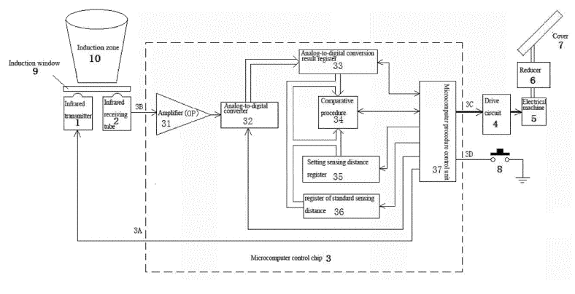
Note. From Trash can having sensing flip lid having settable sensing distance and control method therefor (European Patent No. 3 620 405 A1), 2020, European Patent Office, X. Wang et al. (sensing flip lid).

A clamshell trash can with an infrared sensing distance set by the user is described by Wang, Chen and Lin (2020) of Fujian Nashida Electronic. Figure 15 shows the circuit. The major components are an infrared transmitter and receiver underneath an induction window, a single microcomputer chip for the amplifier, analog-to-digital converter and distance registers, and a drive circuit to operate the motor and reducer. The motor flips the cover open only when the reading is above the standard distance value, and a distance the user picks with a setting button is stored for later comparisons.
This is the closest equivalent of the servo-lid of Smart-Bin that is triggered by an IR sensor. A hand near the induction window opens the lid and how near is up to the user. The patent covers nothing else: no fill or weight sensing, gas, tilt, display, wireless link or monitoring. Google Patents lists it as a published application (kind code A1), withdrawn in 2021 and never granted.
Smart Waste Bin Sensor Device and Methods (Kurani, 2023)
Figure 16
Overall Smart Waste Management System
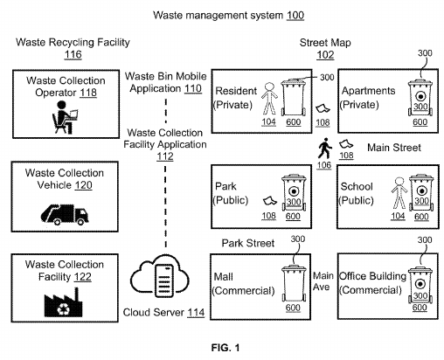
Note. From Smart waste bin sensor device and methods for waste management system (U.S. Patent No. 11,702,280), by H. B. Kurani, 2023, U.S. Patent and Trademark Office.

Kurani (2023) is the broadest patent of the twenty on sensing. Figure 16 gives the whole system for monitoring bins continuously to optimize collection and reduce littering. The bin is equipped with a battery powered smart sensor device carrying approximately a dozen sensors, including fill level, temperature, humidity/pressure, air quality, smoke, gas, motion, a pathogen biosensor and sterilizer, and an accelerometer. Readings are transmitted via a wireless network to a cloud server which creates real-time bin statistics and optimizes collection routes. The data is displayed in a bin app and a facility app, and biohazard and biosafety alerts are sent to nearby phones. The accelerometer detects when the bin has been tilted, and resets the fill level to zero when the bin tips over.
It matches Smart-Bin on sensing, cloud, apps and routes: fill, gas, temperature and tilt data go to a cloud server with mobile alerts and an optional touchscreen on the device. Its centre of gravity lies elsewhere, in litter, biohazard and pathogen sensing with a sterilizer. The parts read show no IR-actuated servo lid, remote lock, PIN collect mode or tamper alarm with a latch, and the tilt serves to reset the fill level and does not sound an alarm.
Smart City Garbage Management System (Yan & Chen, 2021)
Figure 17
Garbage Cans and the Monitoring Center
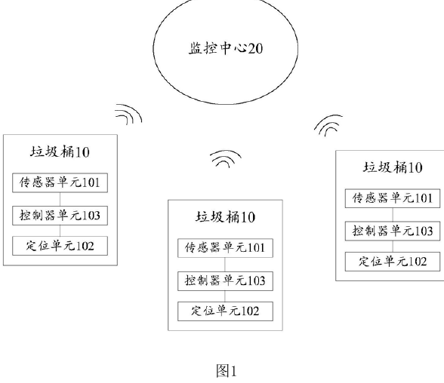
Note. From Smart city garbage management system (Chinese Patent No. CN 109324552 B), by S. Yan and J. Chen, 2021, China National Intellectual Property Administration. The labels in the original are in Chinese.

Yan and Chen (2021), for Shanghai Shuncom Smart Technology, patented a city-wide system. Figure 17 is the schematic of the garbage cans and the monitoring center. Each can has a positioning unit, a controller and sensors for weight, infrared height, odor and smoke, and the controller uploads the readings to the monitoring center. The center decides which cans need inspection (weight, height or odor above a threshold, or any smoke), generates the route of the truck. When a special-condition signal arrives, a nearby truck is rescheduled by priority, in the order fire, fault, pollution and full bin.
This patent is the closest in purpose. Weight, height and odor decide which cans are serviced first, as the priority tags of Smart-Bin do. It goes further by building routes for trucks with GPS, and Smart-Bin stops at ranking the bins. It also includes smoke sensing, which Smart-Bin does not have. No powered lid, tamper detection, PIN mode, on-bin display or phone alert appears in the text read.
Apparatus and Method for Waste Monitoring and Analysis (Balachandran & Talavera, 2023)
Figure 18
Waste Measurement System with Weighing Devices and Reports
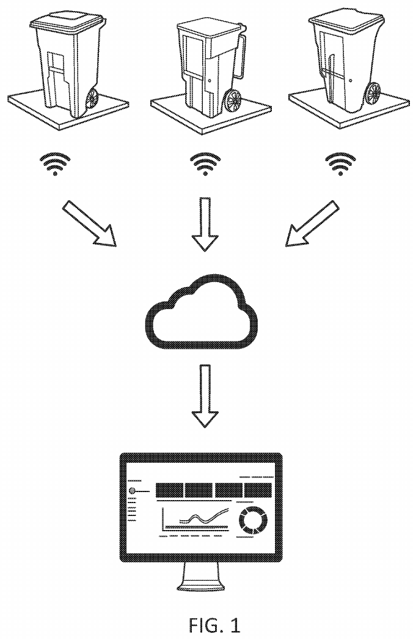
Note. From Apparatus and method for waste monitoring and analysis (U.S. Patent No. 11,788,877), by N. Balachandran and O. Talavera, 2023, U.S. Patent and Trademark Office.

Balachandran and Talavera (2023), for Zabble, cover waste audits. Figure 18 gives an overview of the measurement system: a series of weighing devices record the weight of the waste, the data go to networked storage, and the stored data are turned into visual reports for an operator. Claim 1, though, is about images: a method that acquires images of the contents of at least two containers of a waste generator, identifies characteristics of the contents and generates a report by computer. The disclosure adds load cells under a platform for two or more bins and gas sensors for compost bins.
The shared ground with Smart-Bin is remote monitoring of bin contents, with cloud upload and dashboards, and gas sensing in one special case. The aim is different. This patent is an audit and reporting service that tells a waste generator what is being thrown away, while Smart-Bin is a single bin that works out when it needs emptying. The claims do not cover a bin with fill, tilt, lid and lock control, a PIN collect mode or a collection priority list.
Capacity Inspection Garbage Bin With Infrared Induction (Yang et al., 2020)
Figure 19
Block Diagram of the Capacity-Detecting Bin
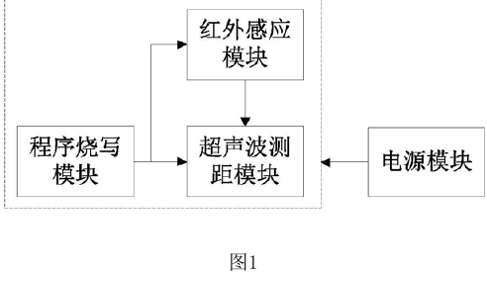
Note. From Capacity automated inspection garbage bin with infrared induction function (Chinese Patent No. CN 210504152 U), by S. Yang, D. Liao, R. Li, and Y. Yu, 2020, China National Intellectual Property Administration. The labels in the original are in Chinese.

Yang et al. (2020), for Sichuan Grid Environmental Protection Technology, is a utility model for a bin that shows how much capacity it has left. Figure 19 is a block diagram of the inside of the bin. The body holds an infrared induction module, an ultrasonic ranging module, a programming module and a power module. The ultrasonic module is connected to the infrared and programming modules, and the power module supplies all three. The ultrasonic module measures the remaining capacity and two nixie-tube digits show it on the bin, while the infrared module detects a nearby user to wake the system. Google Patents lists the rights as terminated for non-payment of fees.
This utility model matches the local side of Smart-Bin: an ultrasonic ranging module, a wake-up by a nearby user, and the capacity shown on the bin itself, where Smart-Bin shows it as a percentage on its touchscreen. Little else carries over. The device is stand-alone, with no weight, gas, tilt, lid actuator, wireless link, server, route planning or phone app.
Garbage Bin Intelligent Controller and Supervisory System (Wang, Zhang, et al., 2020)
Figure 20
Electrical Block Diagram of the Bin Intelligent Controller
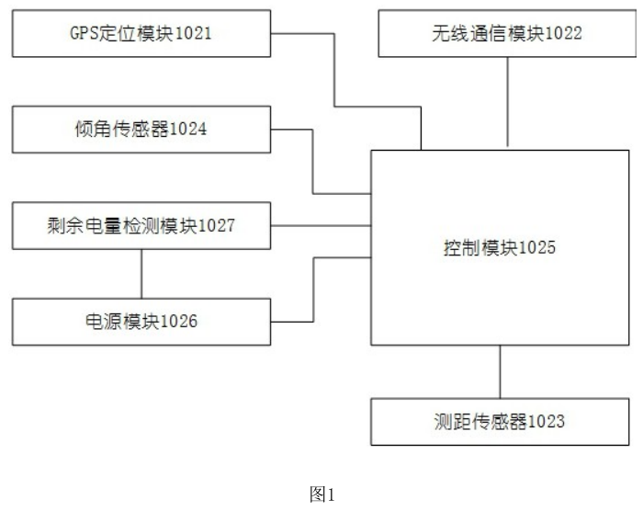
Note. From Garbage bin intelligent control ware and garbage bin supervisory systems (Chinese Patent No. CN111559590A), by X. Wang, Y. Zhang, and Z. Wang, 2020, China National Intellectual Property Administration. The labels in the original are in Chinese.

Wang, Zhang, and Wang (2020), for Weihai Jingxun Changtong Electronic Technology, published an application for a bin controller that can be installed on top of the bin or at its side. Figure 20 is its electrical block diagram, with a wireless communication module, a control module and a distance sensor in one housing. In top mode the controller works out the height of the garbage, in side mode it reports the distance to the opposite wall, and either value is uploaded to monitor whether the bin is full. In the description, an ultrasonic module measures the distance, an inclination sensor raises a tip-over or movement alarm, the data go by NB-IoT and alerts reach the phones of workers.
The overlap with Smart-Bin is strong on the alert side: a distance sensor for fill, an inclination sensor for tip-over alarms, wireless upload and alerts on a phone. The patent has no weight or gas sensing, powered lid, lock, PIN or touchscreen collect mode, priority list or time to full, and in the parts read the inclination alarm has no countdown or latch, which Smart-Bin adds. Google Patents lists the application as withdrawn.
Measuring the Fill Level of a Trash Can Using a Sensor (Keller et al., 2024)
Figure 21
Automatic Alerting System for a Trash Can
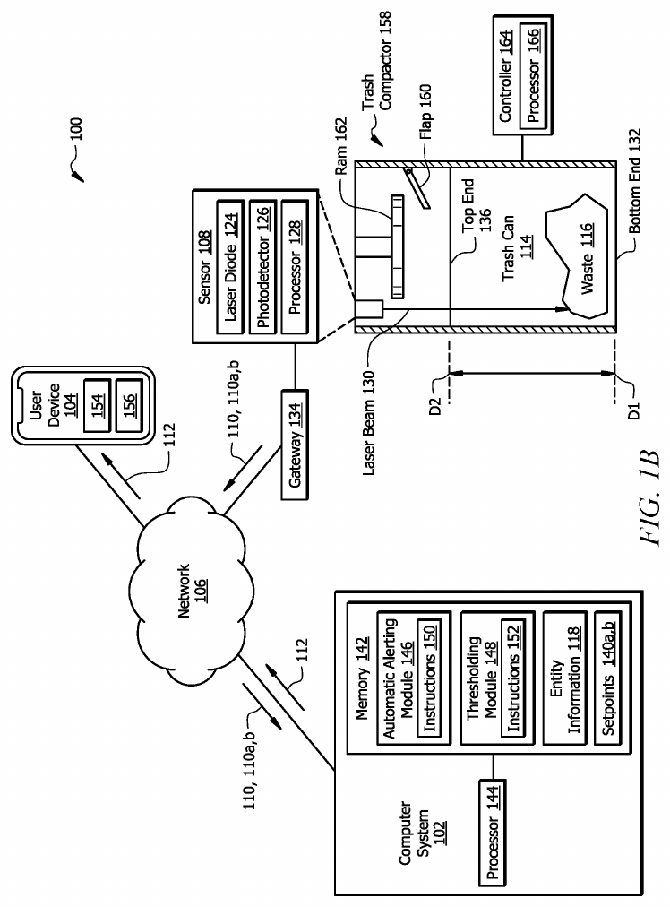
Note. From System and method for measuring the fill level of a trash can using a sensor (U.S. Patent No. 12,125,361), by J. R. Keller, M. O. Redmond, and S. A. Mirza, 2024, U.S. Patent and Trademark Office.

Keller et al. (2024), for 7-Eleven, patented a way to turn a distance reading into a fill percentage. Figure 21 shows the automatic alerting system: a sensor above the container, a gateway and network, and a computer system with its modules and a user device. In claim 1 a sensor above the can holds a laser diode that sends a pulse toward the bottom and measures the time of flight. A computer converts the distance to a percentage of waste with two calibration setpoints, picks a threshold for the current time period from stored information about the owner of the can, and alerts a user device when the threshold is exceeded. Alerts can be email or text on a smartphone.
The two setpoint calibration is identical to that of Smart-Bin: the empty distance (default: 30cm) and the full distance (default: 5cm) are programmed from the interface, and the fill percentage is scaled between the two. A threshold-based alert reaches a phone in both. Everything else in the patent is narrower: a single laser sensor, no weight, gas, tilt or tamper sensing, no lid control or lock, no touchscreen collect mode and no priority list.
Waste Bin Collection and Monitoring Method Using Bin Sensors (Sait et al., 2025)
Figure 22
Network of Waste Bins, Cloud Server and Vehicles
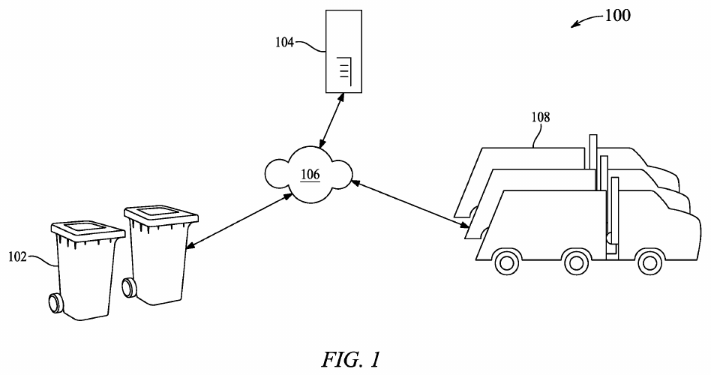
Note. From Waste bin collection and monitoring method using waste bin sensors (U.S. Patent No. 12,450,575), by S. Sait, F. M. Aliyu, S. Bukar, B. S. Maina, and D. U. Lawal, 2025, U.S. Patent and Trademark Office.

Sait et al. (2025), from King Fahd University of Petroleum and Minerals, is the newest patent in the set. Figure 22 is a network diagram of the waste bins, the cloud server, the cloud network that connects them and the waste vehicles. Claim 1 describes a method to monitor and control the CO2 and CH4 emissions of a collection system. The methane, humidity, waste level, location and temperature are sensed under every separate bin lid and transmitted to a cloud server. One processor calculates the time in which the methane limit will be reached and a second processor calculates the time in which the fill limit will be reached, and a third processor, based on the CO2 and CH4 readings of the vehicles, prepares the collection schedule and routes. Two neural networks make the time estimates, and a mobile app sets parameters and shows data.
It is the nearest to Smart-Bin in using a time to full, in sensing fill, gas, temperature and humidity inside the bin, and in sending them to a cloud server with a display and a mobile app. The estimate is made differently. Neural networks work from methane and fill data, while Smart-Bin uses the fill rate of the last 15 minutes with no trained model. The patent is centered on methane prediction and routing based on emissions. It has no load cell, tilt or tamper alarm, IR sensor lid, remote lock or PIN collect mode, and weight and tilt appear only in a list of possible sensors.

Related Literature and Studies
Thirty studies from 2023 to 2026 were reviewed. Each of them is listed in Table 2 with its hardware, the main reported result and what it is lacking in comparison with Smart-Bin. The table marks any figure that comes from training data or a synthetic data set, since such figures do not describe a system in real use. Each study is then taken in turn under one of four headings, according to what it puts the most weight on: level-sensing bins with lids and alerts, bins that add weight, gas or access control, collection routes and priority, and cameras, sorting and system design. A figure is shown wherever the source is open access and has a drawing or photograph that helps, with the licence of the figure in the note under it. The other studies are text only, because their publishers do not allow the figures to be reused.
Table 2
Related Studies From 2023 to 2026
Study | Hardware and platform | Reported result | What it lacks
Saad et al. (2023) | NodeMCU ESP8266 and Arduino Nano, HC-SR04, HX711 load cell, GPS, SG90 lid, WhatsApp through Twilio | Lid opens within 50cm. Full at 3cm of free space or 4,000g. Height error 0.4%, weight error 0.15%, message in 2.61s. | Dashboard, air quality, tamper detection, cloud history, roles
Abdullahi et al. (2024) | Arduino with HC-SR04 and SIM800L GSM, servo lid, cloud server | Lid opens only when the bin is not full. Full at 20cm. No performance figures are given. | Weight, air quality, tamper detection, dashboard, app
Alnuaimi et al. (2024) | Simulation of smart-bin collection as a travelling salesman problem (AnyLogic) | Shorter travel distance and lower emissions than static routes. No figures are given. | Bin hardware, alerts, app
Ayyanagoudar et al. (2024) | Ultrasonic and weight sensors, web page for each bin level | Real-time level tracking for each bin on a web page. No measured results are given. | Air quality, tamper detection, app, alerts
Azmi et al. (2024) | Arduino Uno with LoRa, HC-SR04, DHT11, GPS, ThingSpeak dashboard | Ultrasonic accuracy 89.9% at half full, humidity 96.9%, temperature 94.4%. Alerts are dashboard indicators only. | Weight, app, push alerts, on-bin display
Enache et al. (2024) | ESP32-CAM nodes with solar cell, ESP-MESH, server image processing | Fill ratio estimated from hourly bin photographs. Relative error 11.43% to 30.00% on five bins. | Weight, air quality, tamper detection, app
González et al. (2024) | ESP32 and ESP32-CAM, ultrasonic fill, simulated weight, Oracle APEX dashboard, App Inventor app | Camera classifies waste; weight is simulated with potentiometers. No accuracy figures. | Real weight sensing, air quality, tamper detection, priority list
Kuzhin et al. (2024) | IoT sensors with route analytics; no hardware described | The results are 20% fewer overfilled bins, 15% fewer collection trips, 25% shorter trips, and 10% less fuel. | Any bin hardware; setting and sample are not given
Mehta and Rathour (2024) | Ultrasonic, temperature, weight and tilt sensors and data software. | 6-month pilot: approximately 50% improvement in collection efficiency, 25% reduction in cost, and 83.3% reduction in overflows. | Detail on site and method; air quality, app, on-bin display
Muthukumar et al. (2024) | Camera-based AI segregation bin with a staff app for fill level and temperature and humidity | Classifier test accuracy 92.3% (training accuracy 71.8%). The scalability claim is not tested. | Weight, air quality, tamper detection, collection priority; main aim is segregation
Rathnayake et al. (2024) | Three ESP32 bins with ultrasonic and methane sensors, Node-RED cloud, machine learning | 4-month pilot: fill accuracy 95%, methane detection 92%. Route simulation 15% more path-efficient. | Weight, tilt, app, on-bin display
Salleh et al. (2024) | Using NodeMCU ESP8266, ultrasonic sensor and ThingSpeak dashboards. | Live container levels support need-based collection scheduling. Proteus simulation and PCB layout are included. | Weight, air quality, tamper detection, app
Shaharil and Po’ad (2024) | Arduino, ultrasonic lid sensor, IR fill sensor, load cell, MQ-2, LCD, Blynk | Weight errors of −5g to +10g on four items. The Blynk app shows a full-bin notification. No numbers for the IR or gas sensors. | Web dashboard, collection priority, tamper detection
Thangam et al. (2024) | Use of ESP8266, ultrasonic and soil-moisture sensors | Analytics are meant to let authorities adjust routes. No results are reported. | Weight, air quality, tamper detection, app
Aasish et al. (2025) | Dual-core ESP32 on FreeRTOS, ultrasonic, DHT sensor, RFID bin tags, LCD or OLED, cloud server | Splits sensing and cloud communication across tasks. No measured results. | Weight, tamper detection, app, test data
Alnanih et al. (2025) | Arduino Uno and ESP8266 with GSM, HC-SR04, flame sensor, GPS, LCD, Firebase, web app, Flutter app | 6-month, 50-bin campus pilot: 99.5% uptime, fill error within ±3%. Smoke Test fire alarm in 5s. | Weight, humidity, tamper detection, time to full, UI calibration
Alourani et al. (2025) | Arduino Nano and ESP8266, ultrasonic sensor, Firebase, Android app, VGG-19 classifier | App alerts collectors at a fill threshold. Classifier 99.7% training accuracy. | Weight, air quality, tamper detection, priority list
Banciu et al. (2025) | GPS and RFID bin locations; Nearest Neighbor, OR-Tools and genetic algorithm | Three real routes with 735 locations: up to 52% shorter distance, over 14kg less CO₂. | Any bin sensing; the study is about routing
Gajula et al. (2025) | ESP32, HC-SR04, Moisture sensor, Servos and Arduino IoT Cloud. | Separates dry and wet waste by moisture. No figures are given. | Fill-level role of the ultrasonic sensor, weight, tamper detection, app
Gupta et al. (2025) | Microcontroller with ultrasonic sensor and Wi-Fi, cloud platform | 30-day, 50-bin pilot: 58.9% less distance, 59.2% less fuel, 95% fewer overflows, 99.8% uptime. | Weight, air quality, tamper detection, app detail
Ishaq et al. (2025) | Ultrasonic sensors in bins at ten hospitals, cloud monitoring station | Alerts led to pickups 3 to 16 minutes later. Biomedical waste about 43.6% to 52.5% of hospital waste. | Weight, air quality, tamper detection, app (proposed only)
Karthi et al. (2025) | ESP32, RFID reader, ultrasonic sensor, metal detector, MQ135, Blynk | 95% fill accuracy, 92% RFID reliability, 40% less manual intervention. | Weight, tamper detection, priority list, web dashboard
Kumar et al. (2025) | Using ESP32, ultrasonic sensors, Ant Colony Optimization, machine learning, and map. | Prioritizes filled bins and builds depot-to-depot routes. No numbers are reported. | Weight, air quality, tamper detection, app, alerts
Maulida et al. (2025) | ESP32, HC-SR04, MQ-2, HX711, SG90 lid, Firebase, Android app | Level accuracy about 95%, weight about 93%, 92% of spoiled-food cases flagged, usability score 86 (15 officers). | Tamper detection, collection priority, web dashboard, roles
Mehta et al. (2025) | ESP8266 with ultrasonic sensor, MQ4, MQ136, MQ137 and GPS, Firebase and React Native Application | Gas sensors 96% to 98% accurate against a reference. Field test of 28-bin samples cut trucks from 3 to 2. The 100-bin results are synthetic. | Weight, tilt, on-bin display; some tables conflict
Sadikin et al. (2025) | ESP32 with ultrasonic, infrared and GPS, Firebase, Kotlin Android app | Ranking by distance, vehicle capacity and fill level (greedy). 69 respondents: 92.37% effectiveness, 89.92% satisfaction. | Weight, air quality, tamper detection, on-bin display
Shahibollah et al. (2025) | ESP32, ultrasonic sensors, servo lid, tri-colour LED, Blynk | Tested by simulation and on hardware. No figures are given. | Weight, air quality, tamper detection, priority list
Yogesh et al. (2025) | ESP32, HX711 load cell, ultrasonic sensor, Firebase, App Inventor app, LCD | Weight and fill percentage with full-bin alerts. No measured results are reported. | Air quality, tamper detection, priority list, test data
Awotayo and Dodo (2026) | ESP32, two HC-SR04, MG90S servo lid, LEDs and buzzer, Blynk email | Fill zones at 40% and 60%; email when full. No accuracy or response-time results. | Weight, air quality, tamper detection, dashboard, app
Mugaruka et al. (2026) | LoRaWAN-style network of ultrasonic sensors in seven 120-L bins | 12-week pilot: 57% of sensors at or below −107dBm; mass and route times are estimates. | Weight, air quality, tamper detection, app
Note. Results are as reported by the authors. Lacks means that the feature is not described in the study.
A. Level-Sensing Bins with Lids and Alerts
Smart Bin with Automatic Lid Control (Abdullahi et al., 2024)
Figure 23
Block Diagram of the Smart Waste Management System
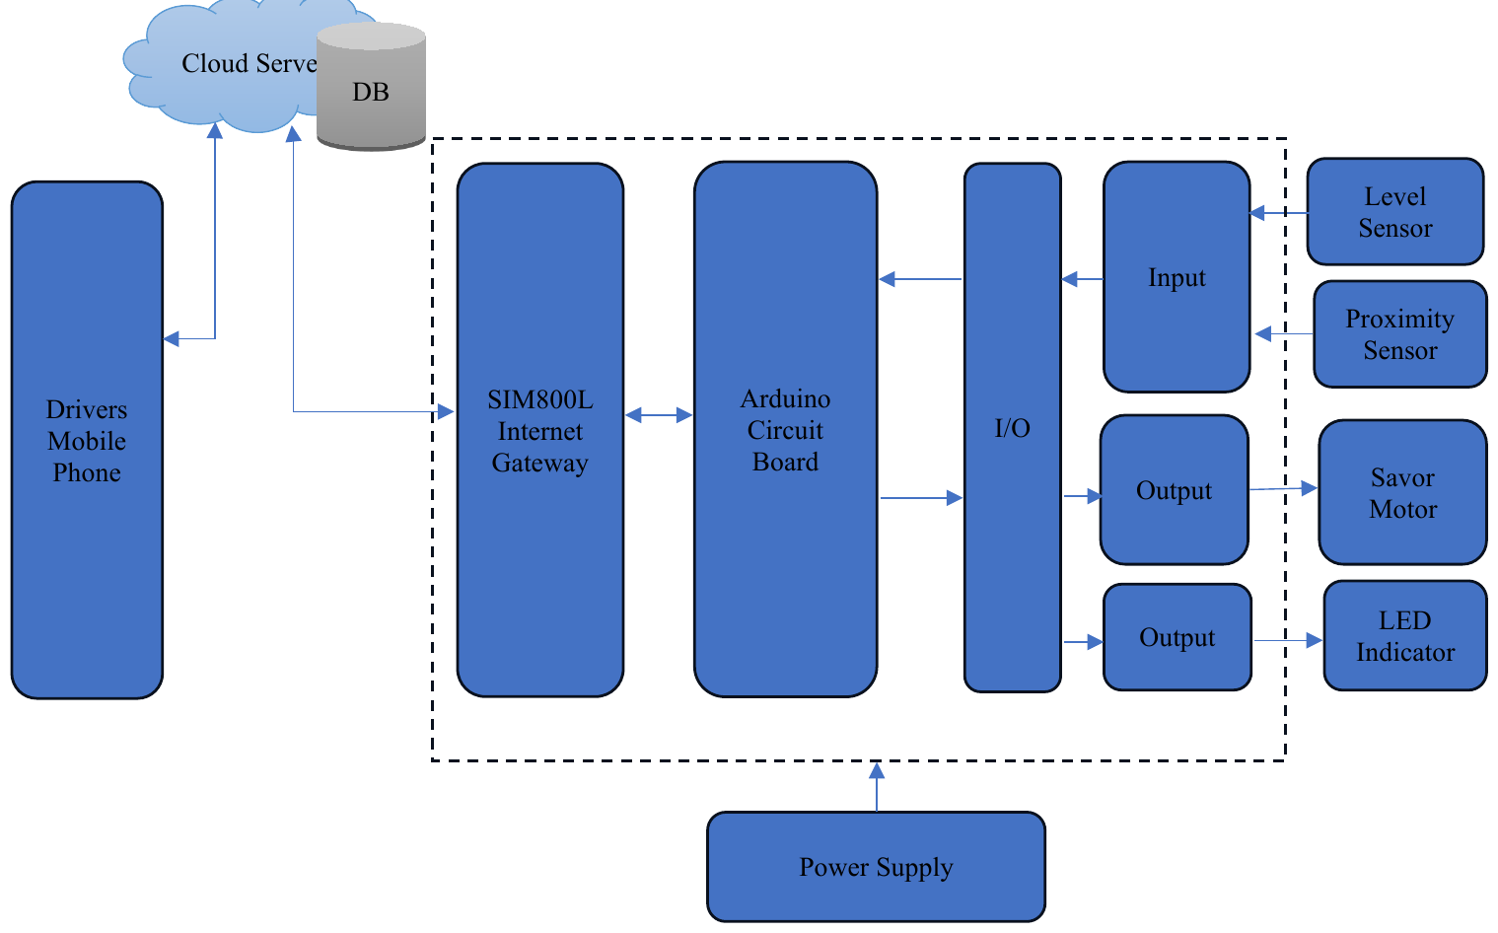
Note. From “Development of a smart waste management system with automatic bin lid control for smart city environment,” by A. Abdullahi, A. Mohammed, M. U. Bonet, A. El-Suleiman, R. B. Ahmad, and T. D. Chollom, 2024, EAI Endorsed Transactions on Smart Cities, 7(3). CC BY-NC-SA 4.0.

Abdullahi et al. (2024), of the Air Force Institute of Technology in Kaduna, Nigeria, built a bin whose lid opens only when the bin is not full. Figure 23 is their block diagram. The fill level is measured by an ultrasonic sensor (HC-SR04) and an Arduino, which also detects the approaching user, and the lid is opened by a servo motor that rotates 0-90 degrees. The thresholds are 20cm for a full bin, and 12cm for a user. A SIM800L GSM module sends the status to a cloud server, which stores the data and sends full-bin notifications to the collection team.
No performance figures are given, and the board is inconsistent: one figure shows an Uno and another a Nano. The diagram has a phone block, but the text never mentions an app. Smart-Bin shares the ultrasonic fill sensor and servo lid, and adds weight, air sensing, tilt, a dashboard and a phone app, all of which this study lacks.
Smart Waste Management System Using LoRa (Azmi et al., 2024)
Figure 24
Circuit Setup of the LoRa Bin Unit
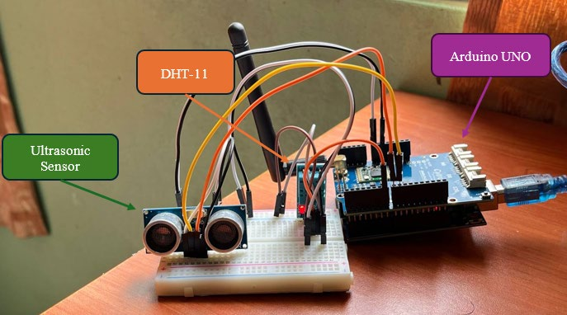
Note. From “Smart waste management system using LoRa technology,” by A. Z. Azmi, N. M. Sahar, and M. T. Islam, 2024, E3S Web of Conferences, 599, Article 04007. CC BY 4.0.

Azmi et al. (2024) installed a LoRa connection between the bin and the receiver. The setup for their circuit is shown in Figure 24. The ultrasonic fill distance, DHT11 temperature and humidity and GPS position are transmitted through a bin-side Arduino Uno with LoRa shield to a second Arduino Uno with LoRa receiver, and then relayed to a NodeMCU which updates a ThingSpeak dashboard with indicators when thresholds are reached. The tests indicated an ultrasonic accuracy of 89.9% at half full, a humidity accuracy of approximately 96.9% and a temperature accuracy of approximately 94.4%.
The authors report that the ultrasonic sensor was not successful in a narrow, shallow bin, and the DHT11 temperature sensor error exceeded the sensor's specified error. They claim a LoRa range of several kilometers but did not measure it, and the abstract mentions air quality monitoring, but does not go into any detail about it in the body of the paper. Smart-Bin also senses temperature and humidity (with a BME680, not a DHT11) and uses ThingSpeak. The study has no weight sensing, push alerts, phone app or display on the bin.
Ultrasonic Trash Can Surveillance with ThingSpeak Dashboards (Salleh et al., 2024)
Salleh et al. (2024) developed a prototype for waste collection based on demand at a low cost. An ultrasonic distance sensor mounted in each container is read by a NodeMCU ESP8266 module which uploads the fill level to ThingSpeak so that live dashboards indicate the status of each container and enable container status-based scheduling. Also included is a Proteus simulation and a PCB layout. No results are reported, and the authors view this work as a scheduling tool, rather than a validated route planning method.
Smart-Bin also uses ThingSpeak for charts and analysis, but only as an optional second cloud beside Firebase. It adds weight, air quality, tamper detection and a phone app, which this study lacks.
ESP8266 Waste Monitor With Moisture Sensing (Thangam et al., 2024)
Thangam et al. (2024) of Amrita Vishwa Vidyapeetham, Bangalore, built an ESP8266 monitor with ultrasonic fill sensors and soil-moisture sensors that judge the waste composition. The real-time data are meant to let authorities adjust routes and cut trips and gas. The route claim is a stated aim but not a measured result, as no quantitative results are reported in the abstract.
Smart-Bin senses the fill with the same type of ultrasonic sensor and adds weight, air quality, tamper detection and a phone app. It does not judge the composition of the waste.
Smart Bins for Hospital Waste in Kaduna (Ishaq et al., 2025)
Figure 25
Proposed System Architecture for Hospital Waste Monitoring
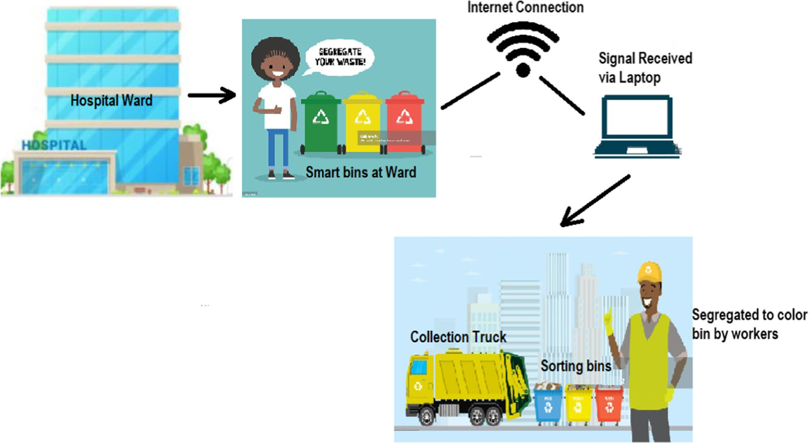
Note. From “Smart waste bin monitoring using IoT for sustainable biomedical waste management,” by A. Ishaq, S. J. Mohammad, A. D. Bello, S. A. Wada, A. Adebayo, and Z. T. Jagun, 2025, Environmental Science and Pollution Research, 32(32), 19434–19449. CC BY 4.0.

Ishaq et al. (2025) put ultrasonic fill-level sensors in bins at ten hospitals in Kaduna, Nigeria. Figure 25 is the proposed system architecture, from the hospital ward to the smart bins, an internet link, a laptop at the monitoring station and the collection truck. The bins connect wirelessly through the routers of the hospitals to a central cloud monitoring station, which alerts waste collectors when a bin is full. The authors also measured waste generation. Biomedical waste made up about 43.6% to 52.5% of hospital waste, at an average of 69.14kg per day and 1.52kg per bed per day, and they analysed the data with principal component analysis.
Alerts led to pickups 3 to 16 minutes later. The phone app appears only in the proposed system and is not described as built, and no microcontroller is named for the authors' bins. The study shows what level sensing is worth in a place where overflow carries a health risk. Smart-Bin senses more than level, but it has not been tested in any such site.
IoT-Enabled Smart Dustbin for Real-Time Monitoring (Shahibollah et al., 2025)
Shahibollah et al. (2025), from Universiti Teknologi MARA in Terengganu, built an ESP32 dustbin with ultrasonic sensors for fill level and for proximity, a servo-driven lid and a tri-colour LED for local status. Data go over Wi-Fi to the Blynk platform, which alerts the maintenance staff. The authors tested the bin by simulation and with hardware, but the abstract gives no ranges or accuracy figures and describes the result as prototype function and not as municipal-scale reliability.
Smart-Bin uses the same ESP32 family and a servo lid. Its touchscreen takes the place of the LED, and it adds weight, air quality, tamper detection and a priority list.
IoT Smart Bin for Real-Time Fill Level Monitoring (Awotayo & Dodo, 2026)
Awotayo and Dodo (2026) of Baze University, Abuja built an ESP32 bin with two HC-SR04 sensors. One faces outward and opens a servo lid (MG90S, 0 to 90 degrees) when someone comes within 30cm. The other measures the fill, with a green LED when the fill level is between 0 and 39%, a yellow LED when the fill level is between 40 and 59%, and a red LED and buzzer when the fill level is between 60 and 100%. Blynk sends an e-mail when the bin is full. Two 3.7V Li-ion cells (7.4V, 3500mAh) power the unit. No accuracy or response-time results are reported.
The local feedback is LEDs and a buzzer and not a screen. Smart-Bin adds a touchscreen, weight sensing, air quality, tamper detection, a dashboard and a phone app, none of which this study has.
LoRaWAN Network for Waste Collection in Bukavu (Mugaruka et al., 2026)
Figure 26
Proposed Network Architecture for Waste Collection in Bukavu
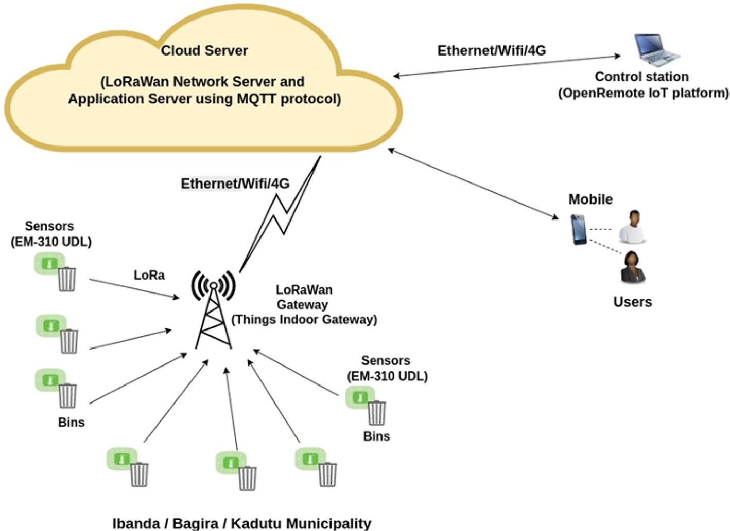
Note. From “Design of an IoT sensor-based network architecture for waste collection in Bukavu city (DRC),” by O. M. Mugaruka, J. R. Kala, J. Ndikumagenge, R. van Schadewijk, and R. Nibitanga, 2026, Discover Internet of Things, 6(1), Article 168. CC BY-NC-ND 4.0.

Mugaruka et al. (2026) designed a LoRaWAN-style network for waste collection in Bukavu, in the Democratic Republic of the Congo. Figure 26 shows the proposed network. EM310-UDL ultrasonic sensors on the bins talk over LoRa to a gateway, the gateway reaches a cloud server by Ethernet, Wi-Fi or 4G, and users view the data on a control station and on mobile phones. The authors tested it in a 12-week pilot with seven 120-litre prototype bins in residential, dense and peri-urban areas.
The results concern the network more than the bins. Of the sensors, 57% had a signal at or below −107dBm, and the mass collected (an estimated 641kg over 14 days in one area) and the route times are estimates from sensor data and not direct measurements. The authors also report an energy autonomy above 90% for most units after 11 months, a period that the paper does not clearly tie to the 12-week pilot. Smart-Bin does not use LoRa at present, and the study is a reminder of the opportunity listed in the SWOT analysis: LoRa for places without Wi-Fi.
B. Bins That Add Weight, Gas or Access Control
IoT-Based Smart Dustbin Prototype (Saad et al., 2023)
Figure 27
Prototype of the Smart Dustbin
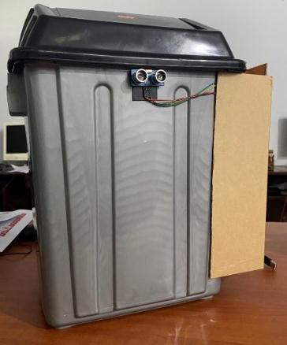
Note. From “IoT-based smart dustbin prototype,” by A. M. Saad, B. O. Jul, A. Basalamah, and S. Sayuti, 2023, PROtek: Jurnal Ilmiah Teknik Elektro, 10(2), 120–125. CC BY-NC-SA 4.0.

Saad et al. (2023) built the smart dustbin shown in Figure 27. An Arduino Nano with an ultrasonic sensor opens an SG90 servo lid to anyone who is within 50cm, while a NodeMCU ESP8266 reads the waste height with an HC-SR04, the weight with an HX711 load cell and the position with a NEO-6M GPS. Once the bin is full (either by level (3cm free space) or weight (4,000g), the NodeMCU will send a WhatsApp message via Twilio with a Google Maps link.
The tests reported a height error of 0.4%, a weight error of 0.15% and a message delay of 2.61s. This is the nearest study to the pairing of fill and weight with a servo lid in Smart-Bin. Its lid is triggered by an ultrasonic sensor, where Smart-Bin uses an IR obstacle sensor. The study has no dashboard, air quality sensing, tamper detection, cloud history or roles.
Smart Bin With Real-Time Garbage Level Tracking (Ayyanagoudar et al., 2024)
Ayyanagoudar et al. (2024) propose a smart bin that uses weight sensors and ultrasonic transducers to track the fill level in real time and shows the level of each bin on a web page. The abstract also states that it can classify trash based on its weight, which is used for planning transportation. The abstract does not mention any microcontroller or cloud platform and does not provide any results of measurements.
Smart-Bin also pairs weight with an ultrasonic level, and it adds air sensing, tamper detection and a phone app, which this study lacks.
Efficiency of IoT-Enabled Smart Bins (Mehta & Rathour, 2024)
Mehta and Rathour (2024) describe IoT smart bins equipped with ultrasonic, temperature, weight and tilt sensors and software to collect and process the data. They claim a 6-month pilot in one city where collection efficiency has improved by approximately 50%, operating costs have decreased by approximately 25% and there have been approximately 83.3% fewer overflow incidents, while also offering reduced emissions through route optimization and increased satisfaction of citizens. The abstract gives no location, method or sample size for these measures, so the figures are the authors' claims only.
This is the only study that mentions a tilt sensor, but it describes no tamper alarm. Smart-Bin has one: a 10-second countdown followed by a siren that latches.
Dual-Sensing Bins for Fill Level and Methane (Rathnayake et al., 2024)
Rathnayake et al. (2024) built dual-sensing bins that pair an ultrasonic fill sensor with a methane sensor to detect spoilage. ESP32 modules send the data over Wi-Fi to a cloud platform, where Node-RED processes it and ML algorithms predict waste and optimize routes. Three bins were deployed in a four-month pilot in Dehiwala, Sri Lanka and reported a 95% fill-level accuracy; methane-detection accuracy was 92% and simulated routes were 15% more path-efficient than fixed routes. The abstract does not define these accuracies, and the 15% comes from a simulation.
Smart-Bin shares the ESP32 and the ultrasonic level. Its gas channel gives an air-quality estimate, not a methane reading. This study has no weight sensing, tilt alarm, phone app or on-bin display.
Arduino-Based Smart Dustbin (Shaharil & Po’ad, 2024)
Figure 28
Block Diagram of the Arduino-Based Smart Dustbin
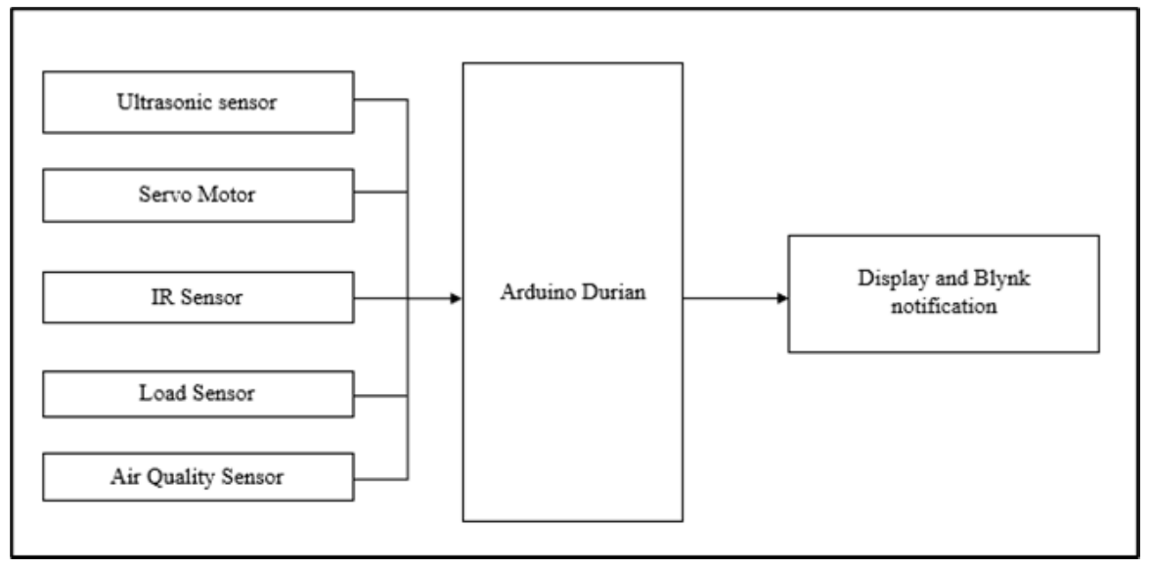
Note. From “Arduino-based smart dustbin with ultrasonic sensor for efficient waste management,” by M. H. F. Shaharil and F. A. Po’ad, 2024, Evolution in Electrical and Electronic Engineering, 5(2), 92–97. CC BY-NC-SA 4.0.

Shaharil and Po’ad (2024) built a household-scale bin and show its block diagram in Figure 28. An ultrasonic sensor opens the servo lid when a person is within 30cm, an infrared sensor detects how full the bin is, a load cell gives the weight shown on the LCD, and a buzzer sounds when an MQ-2 sensor finds poor air quality. The Blynk app shows a notification when the bin is full.
The testing is small: 15 distance trials and four weighed items with errors from −5g to +10g, and no numbers for the infrared or gas sensors. The bin is the closest study to the local side of Smart-Bin, with a lid, weight, gas and a display on the bin. It has no web dashboard, no collection priority and no tamper detection.
IoT-Driven System with Fire Detection and Role-Based Apps (Alnanih et al., 2025)
Figure 29
Data Communication Structure of the Smart Waste Management System
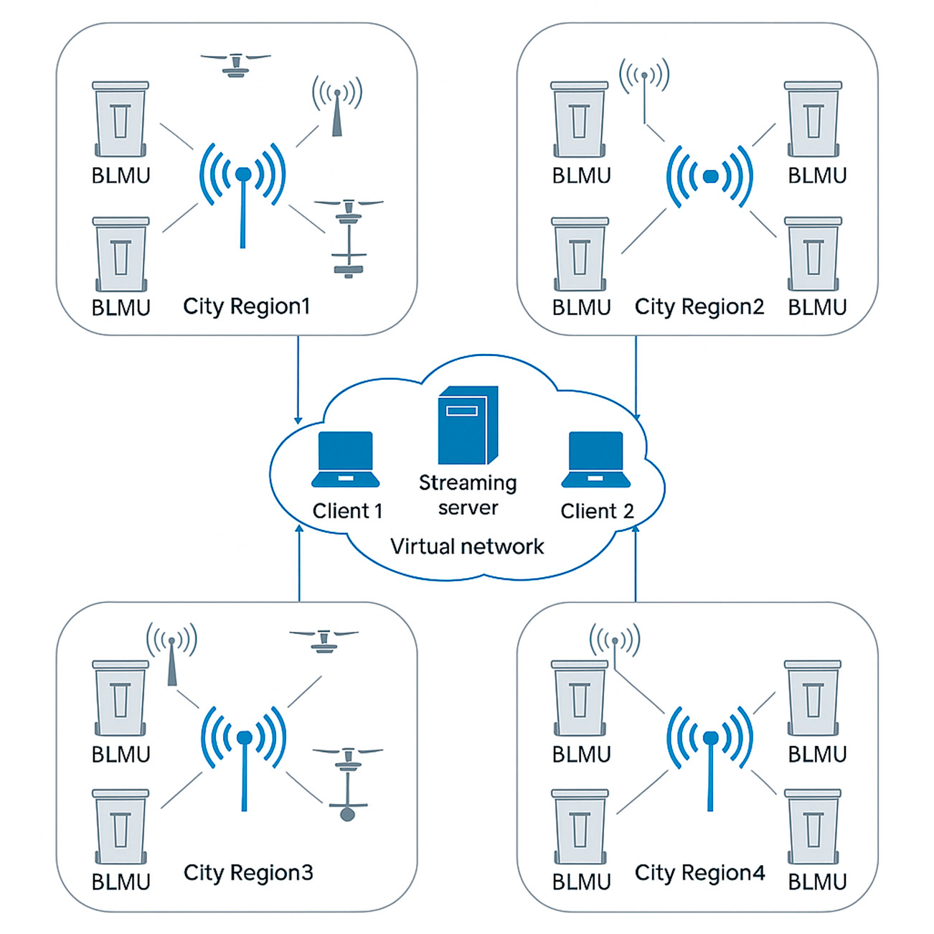
Note. From “Advancing sustainability through an IoT-driven smart waste management system with software engineering integration,” by R. Alnanih, L. Elrefaei, and A. Al-Ahwal, 2025, Sustainability, 17(21), Article 9803. CC BY 4.0.

Alnanih et al. (2025) combine fill and fire sensing in one bin unit. Figure 29 shows their data communication structure. An HC-SR04 measures the fill level, a flame sensor detects fire, smoke and gas, and an Arduino Uno with an ESP8266 and GSM collects the readings, with an LCD and a buzzer. Firebase and Firestore send the alerts, and a central command center coordinates routes. Administrators use a desktop web app and workers a Flutter Android app, each with views for their role.
A 6-month campus pilot with 50 bins reached 99.5% uptime, a fill error within ±3% and a fire alert within 5s in a smoke test. It is one of the longest field pilots among the studies that built their own bins. Like Smart-Bin, it has Firebase, a web app, a phone app and different views for different users. Its hardware list has no weight, tilt or lid feature, and nothing is calibrated from the interface.
ESP32 Smart Trash Bin with Firebase (Maulida et al., 2025)
Figure 30
Prototype of the SmartTrashBin
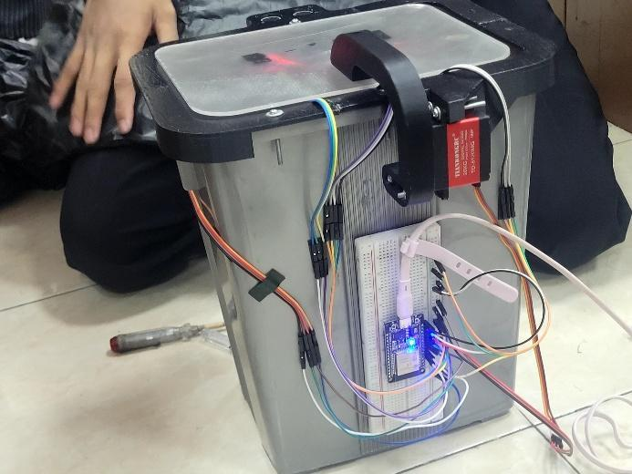
Note. From “Design of IoT-based smart trash bin monitoring using ESP32 and Firebase,” by A. Maulida, C. S. Fayzalmi, F. A. C. Anaam, D. Ardiansyah, M. A. Gunawan, and N. Ridwan, 2025, Jurnal Komputer, Teknologi Informasi dan Sistem Informasi (JUKTISI), 4(2), 420–428. CC BY 4.0.

The SmartTrashBin in Figure 30 was created by Maulida et al. (2025) from Politeknik Negeri Semarang. An HC-SR04 detects the hand and the fill level, an MQ-2 detects odour and a load cell (HX711) gives the weight, all read by an ESP32 that opens the lid with a servo (SG90). Data are stored in the Firebase Realtime Database and sent to an Android app with notifications.
They claim a level accuracy of approximately 95%, a weight accuracy of approximately 93% (+/- 320g on 20kg), 92% of cases of spoiled food identified and 98% of notification reliability and a System Usability Scale score of 86 from 15 sanitation officers. The numbers need care, since the paper names both Android Studio and Flutter and gives two notification thresholds. In parts it is the closest study to Smart-Bin: ESP32, ultrasonic sensor, load cell, servo lid, Firebase and an Android app. It has no tamper detection, collection priority, web dashboard or roles.
Real-Time Sensing and Methane Mapping (Mehta et al., 2025)
Figure 31
Data Flow of the Garbage Monitoring System
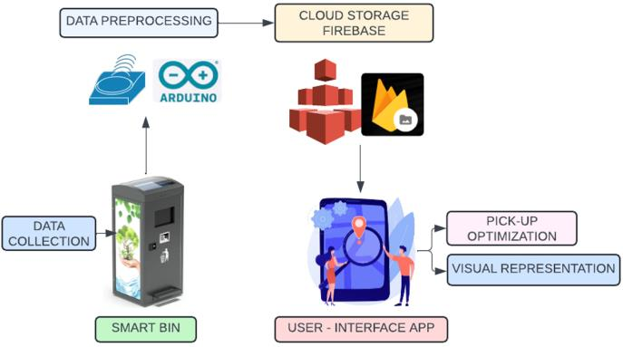
Note. From “Smart bins, smarter cities: IoT-driven waste collection with real-time sensing and methane mapping,” by H. Mehta, V. Deriya, D. Sankhe, P. Kanani, G. Pandya, and V. Shelke, 2025, Mathematical Modelling of Engineering Problems, 12(6), 2110–2122. CC BY 4.0.

Mehta et al. (2025) show the data flow of their system in Figure 31. Each bin has the ESP8266 equipped with an ultrasonic fill sensor, MQ4, MQ136 and MQ137 gas sensors, GPS and uploads data to Firebase every 10s. A React Native application displays a bin map, a methane and odor heatmap and truck routes that are ranked based on a priority score derived from fill and gas.
Gas sensor accuracy was 96% to 98% against a reference. The numbers do not agree: the truck counts differ, the field sample has 28 bins in Malad against 100 bins in the results (which use synthetic data), and some tables clash. Like Smart-Bin, the study uses Firebase and a mobile app, with role-based views and priority-driven collection. It has no weight or tilt sensing and no display on the bin.
ESP32 Smart Dustbin with Weight and Level Monitoring (Yogesh et al., 2025)
Yogesh et al. (2025) built “Eco Bin”, an ESP32 dustbin with an HX711 load cell and an ultrasonic sensor. Weights and fill percentage are sent to Firebase Realtime Database and a phone app, designed with MIT App Inventor, for full-bin alerts, and a 16×2 I2C LCD displays the alerts on the bin. The paper reports no measured results, so it is included as a hardware precedent and not for performance.
Its parts nearly match Smart-Bin: ESP32, load cell, ultrasonic sensor, Firebase, Android app and a local display. Smart-Bin brings in air quality, tamper detection, a priority list and a web dashboard.
RFID Access Control and Blynk Integration (Karthi et al., 2025)
Karthi et al. (2025) built an ESP32 dustbin whose servo lid opens only for an authorized RFID user. An ultrasonic fill sensor, a metal detector and an MQ135 air-quality sensor take the readings, which go to the Blynk platform. In the abstract, the authors state 95% fill level accuracy, 92% RFID authentication reliability, 40% less manual work and 35% more efficient collection.
It is the only study found that controls who can open the bin. Smart-Bin controls access on the collection side, with a PIN collect mode and remote lock, and adds weight, tamper detection and a priority list. This study has no web dashboard.

C. Collection Routes and Priority
Smart-Bin Collection as a Travelling Salesman Problem (Alnuaimi et al., 2024)
Alnuaimi et al. (2024), from the University of Sharjah, UAE, treat municipal waste collection as a travelling salesman problem (TSP). Bins report their fill level, and the route is planned with the Nearest Neighbor heuristic within an AnyLogic simulation. The abstract claims that there are savings in travel distance and carbon emissions when compared to traditional static routes, but it does not provide figures and there is no description of hardware. The work is a simulation, not a field deployment.
This study starts where Smart-Bin stops. Smart-Bin ends with a list of bins sorted by fill and by time to fill, and a planner like this one could take that list as input.
Waste Management Optimization Through IoT and Analytics (Kuzhin et al., 2024)
According to Kuzhin et al. (2024), a case study of IoT sensor real-time data and analytics for route optimization has resulted in a 20% reduction in overfilled bins, a 15% reduction in collection frequency, a 25% reduction in the distance traveled, a 10% reduction in fuel consumption, and a 15% increase in recyclables collected. The abstract gives no location, sample size, hardware or time frame, and does not say whether the values come from a field experiment, so the evidence is weak.
The study shows the size of the gain that people expect from collecting by priority. It gives no design that Smart-Bin could borrow.
Route Optimization With GPS and RFID Bin Locations (Banciu et al., 2025)
Banciu et al. (2025), from Lucian Blaga University of Sibiu, collect bin locations with GPS and RFID, build distance matrices and compare the Nearest Neighbor heuristic, Google OR-Tools and a genetic algorithm on three real routes with 735 locations. The genetic algorithm did best, with up to 52% shorter travel distance and more than 14kg less CO₂. RFID here only records the location of a bin when it is emptied, and the study senses no fill level.
It sits entirely on the routing side. Smart-Bin supplies the part that this study takes for granted, which is knowing which bins are worth a visit now.
IoT E-Tracking System for Waste Management (Gupta et al., 2025)
Gupta et al. (2025) propose an IoT system in which bins carry an ultrasonic fill sensor, a microcontroller (Arduino-based, going by the figure captions) and a Wi-Fi module that sends data to an unnamed cloud platform for on-demand routes. They report that a 30-day trial with 50 bins gave 58.9% less distance, 59.2% less fuel, 95% fewer overflows and 99.8% uptime.
These are among the highest figures in the review, yet the paper gives no pilot dates, routing method or accuracy protocol, so they stand as the authors' report and not an independent result. The bins sense level only. Smart-Bin adds weight, air, tilt and a user interface to the same reading.
Ant Colony Route Optimization With Machine Learning (Kumar et al., 2025)
Kumar et al. (2025) design a system in which ultrasonic sensors on ESP32 boards send fill data to a central database. Ant Colony Optimization plans depot-to-depot routes that stop only at filled bins, machine learning forecasts waste from past data, and collection teams work from a Folium map. The abstract gives no figures, so no fuel or cost saving can be quoted.
Smart-Bin also has the ESP32, the ultrasonic fill sensing and the concept of only going to bins that need it. It sets that priority from the fill and the time to full and not from a learned model. This study has no weight, air quality, tamper detection or phone app.
TrashTrack Collection Ranking (Sadikin et al., 2025)
Sadikin et al. (2025), from Telkom University in Bandung, built TrashTrack, an Android app in Kotlin and Jetpack Compose. ESP32 bins are equipped with ultrasonic, infrared and GPS sensors and upload the collected data to a Firebase database; a modified constraint-based greedy algorithm is used to rank the collection based on the distance of the bin, vehicle capacity and fill level. A usability test with 69 respondents gave 92.37% for effectiveness, 92.29% for usefulness and 89.92% for satisfaction.
Smart-Bin uses the same ESP32, Firebase and a Kotlin Android app. It ranks by fill and time to full, not by distance or vehicle capacity, since it does not plan roads. This study has no weight, air quality, tamper detection or on-bin display.
D. Sorting and System Design
Camera-Based Fill Level Detection (Enache et al., 2024)
Figure 32
Power Chain of the ESP32-CAM Node
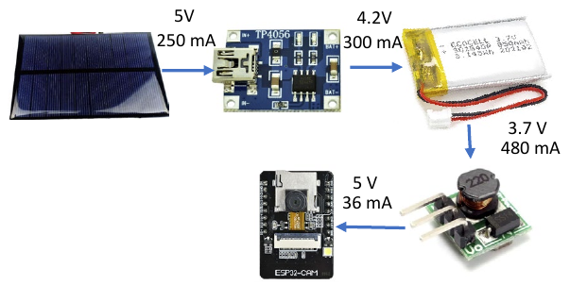
Note. From “Intelligent trash level detection for sustainable urban waste management,” by B.-A. Enache, C.-K. Banica, and A. G. Bogdan, 2024, The Scientific Bulletin of Electrical Engineering Faculty, 24(1), 56–59. CC BY-NC-ND 4.0.

Enache et al. (2024), from the University Politehnica of Bucharest, estimate the fill level from photographs. Figure 32 shows the power chain of one node. A 5V solar cell feeds a TP4056 charger, which charges a 3.7V LiPo battery of 850mAh, and a step-up converter brings the voltage back to 5V for the ESP32-CAM. The battery was sized for 24 hours of operation. Each node takes one image per hour and sends it over an ESP-MESH network to a server, where a Python script with OpenCV and an SQL database estimates the fill ratio.
On five test bins the relative error of the estimated fill ratio ran from 11.43% to 30.00%, and the authors name the angle of the camera, the light, the kind of waste and the placement of the bag as causes. The figure matters to Smart-Bin because it shows what a stand-alone node needs between the source and the board: a charger, a battery and a converter. Smart-Bin builds the same chain with its battery shields and 18650 cells. Smart-Bin uses distance and weight, not a camera, and this study has no weight, air quality, tamper detection or phone app.
AI-Based Waste Segregation With Monitoring (Muthukumar et al., 2024)
At M. Kumarasamy College of Engineering in Karur, Muthukumar et al. (2024) built a bin with a camera and AI that identify plastic, glass, metal and paper and drop each into its own compartment. A mobile app shows the fill level, temperature and humidity, notifies cleaning staff and lets one team claim each task. About 1500 images per class were used, and the paper reports 71.8% training accuracy and 92.3% test accuracy, but does not explain the difference between these. The microcontroller and the cloud service are not named.
Segregation is outside the scope of Smart-Bin. The claim-a-task feature of the app echoes the collector role in Smart-Bin, and the study has no weight, air quality, tamper detection or collection priority.
Smart Trash Bins With IoT and AI (González et al., 2024)
González et al. (2024) built a bin around an ESP32 and an ESP32-CAM, with ultrasonic sensors for the fill level, AI that detects waste in the camera images, and potentiometers in place of a weight sensor. Readings go over Wi-Fi to a central server and appear on Oracle APEX dashboards, and an MIT App Inventor app records the status by hand. The abstract does not contain any accuracy figures.
The weight is simulated, so the study shows a dashboard design without real weighing. Smart-Bin has a real load cell and keeps simulation as an option for testing, both set from the interface. This study has no air quality sensing, tamper detection or priority list.
Smart Waste Classification with IoT and Deep Learning (Alourani et al., 2025)
Alourani et al. (2025) propose iSSWMs, a framework that joins an IoT smart bin to a deep-learning classifier. The bin has an ultrasonic level sensor on an Arduino Nano and an ESP8266 that sends its status to Firebase, and an Android app alerts the collectors at a threshold. A VGG-19 classifier sorts plastic, glass and metal and reached 99.7% accuracy on about 1,530 TrashNet images over 100 epochs. That figure is training accuracy, and the authors report no field test.
Smart-Bin shares the ultrasonic level, Firebase and an Android app with alerts for collectors. Image classification is outside its scope, and this study has no weight, air quality, tamper detection or priority list.
ESP32 Smart Bin That Separates Dry and Wet Waste (Gajula et al., 2025)
Gajula et al. (2025) built an ESP32 dustbin that senses how wet the waste is and separates dry from wet waste with an SG90 and an MG90 servo. An HC-SR04 ultrasonic sensor and a moisture sensor report to the Arduino IoT Cloud, which triggers the separation. The abstract gives no measured numbers.
The study is about sorting, not monitoring, and it shares only the ESP32, a servo and the cloud link with Smart-Bin. It has no weight measurement, tamper detection or phone app.
FreeRTOS-Based Smart Waste Management (Aasish et al., 2025)
Aasish et. al (2025) present a FreeRTOS system on a dual-core ESP32. An ultrasonic sensor tracks the bin level and a DHT11/DHT22 measures temperature and humidity, with an optional LCD or OLED display. Readings go over Wi-Fi to a cloud server for alerts, dashboards and dynamic collection scheduling, and RFID modules identify each bin. The basic concept is to separate the sensor acquisition and actuation tasks, from the cloud communication tasks, so that a slow upload does not block a reading. No results are stated, and the RFID only identifies bins; it is not used for access control.
The task split is a design to consider for the Smart-Bin firmware, as it is also based on the ESP32 family. The study has no weight sensing, tamper detection or phone app.
Commercial Systems
Commercial systems already exist. Bigbelly's CLEAN software provides the data from the bins on a console and uploads it to a collector app (Bigbelly, n.d.). According to its website, Ecube Labs offers ultrasonic fill sensors and a cloud platform that provides fire event notification and route optimization, and claims to predict bin status up to 24 hours in advance (Ecube Labs, n.d.). Sensoneo's platform displays a map of each bin's fill and predicted full time, and plans routes from them (Sensoneo, n.d.). Nordsense has a driver app with dynamic routing (Nordsense, n.d.), and Evreka's sensor adds temperature and motion to flag fires (Evreka, 2020). Compology monitors containers with cameras (Compology, n.d.), and Bin-e is a segregating bin with a touch-free lid (Greenwalt, 2020). In the Philippines, students of the University of the Cordilleras built the Baraki bins for the DOST-TAPI Regional Invention Contest, which open automatically and report to an information center (Asido, 2024). Table 3 summarizes what the vendor pages state.
Table 3
Commercial and Student Systems as Described by Their Own Pages
System | Sensing described | Who sees the data | Collection priority or route
Bigbelly | Fill level, collection events and GPS; sensor type not named | Management console and collector app | Not stated
Ecube Labs | Ultrasonic fill level, battery level and fire events | Cloud dashboard | Route optimization; predicts status up to 24h ahead
Sensoneo | Ultrasonic or radar fill level | Dashboard with a map and predicted full time | Semi-automated route planning
Nordsense | Page covers routing, not sensors | Driver app | Dynamic routing
Evreka | Ultrasonic fill level, temperature, motion and location | Web platform with SMS and email alarms | Route optimization
Compology | Camera: fullness, location and motion | Web dashboard | Not described
Bin-e | Fill level, motion for the flap and waste type | Mobile app | Not covered
Baraki | Automatic sensors; types not stated | Information center | Not stated
Note. Sources: Bigbelly (n.d.), Ecube Labs (n.d.), Sensoneo (n.d.), Nordsense (n.d.), Evreka (2020), Compology (n.d.), Greenwalt (2020) and Asido (2024).
All of them sell by quotation, and none of these pages mentions weight, gas or tilt sensing, or a price. That does not mean the products lack these features, only that vendor pages are short and written to sell. What it shows is that a small system with those features at about ₱4,900 for two bins (Appendix B) occupies a different place from these services. Smart-Bin does not compete with them on scale, and it cannot, but it can show what a bin that senses more costs to build.

Technical Merit
Seven design choices in Smart-Bin decide how much its readings can be trusted. Table 4 gives the reason for each. Each one is also a place where a measured result could differ from the real condition of the bin, which is what the tests of the project will have to check.
Table 4
Technical Basis of the Main Design Choices
Design choice | What Smart-Bin does | Why it is sound
BME680 for the air check | One I2C chip gives temperature, humidity, pressure and a gas resistance reading, from which the firmware estimates an air-quality index. | In Table 2, the studies that sense gas use MQ-series modules, which only provide a reading for the gas. Bosch Sensortec (n.d.) states that the BME680 uses 0.09 to 12mA during its different modes. The index is an estimate and needs about 5 minutes to settle.
Median distance reading is calculated from five distance readings. | The firmware makes five measurements using the HC-SR04 and uses the middle measurement. | When the echo bounces off an edge or soft material, a single reading from the ultrasonic can be spiked. One or two of such readings will be ignored without delaying the update, this is the median.
Two-point calibration | The full distance (5cm by default) and empty distance (30cm by default) are defined from the interface and the fill percentage is the distance between them. | The two setpoints are the same as in Keller et al., 2024. Other heights of bins do not require new firmware.
Weight as a second check | The HX711 and a 5kg load cell weigh the contents next to the fill percentage. | Level and weight are also combined in Saad et al. (2023) and Maulida et al. (2025). A loose pile in a bin is light but a full bin is heavy.
Tilt with a countdown | If the tilt is over 30° a countdown of 10s begins. When the bin is steady again the alarm will clear, or if not, the alarm will latch and need to be reset by an operator. | Countdown will not allow for a bump or moving bin to cause a false alarm and an overturned bin or carried away bin will still sound.
Local and cloud together | The bin responds on its local WiFi within ~1s, and to Firebase and ThingSpeak. | Fast control and calibration with local path, history, remote commands and alerts when phone is away with cloud path. The data is uploaded every 30s, which is half the frequency ThingSpeak can accommodate on its free plan of 1 write every 15s
Calibration and simulation from the interface | Distances, limits can be changed, without re-flashing, any sensor can be set to a test value. | None of the 30 studies describes this. It lets a test be repeated at a chosen reading and keeps demonstrations safe.
Note. Defaults are those set in the firmware and can be changed in the settings.

SWOT Analysis
The strengths, weaknesses, opportunities and threats of Smart-Bin are presented in Figure 33. The strengths and weaknesses are related to the construct itself, while the opportunities and threats are related to the literature mentioned above and to the situation in the Philippines. The count of studies that sense tilt or offer role-based views comes from this review. RA 9003 puts segregation and collection at the barangay level and leaves the collection of non-recyclable and special waste to the municipality or city (Ecological Solid Waste Management Act of 2000, 2001), and the World Bank (2022) puts the share of Metro Manila waste that is collected at about 60%.
Figure 33
SWOT Analysis of Smart-Bin
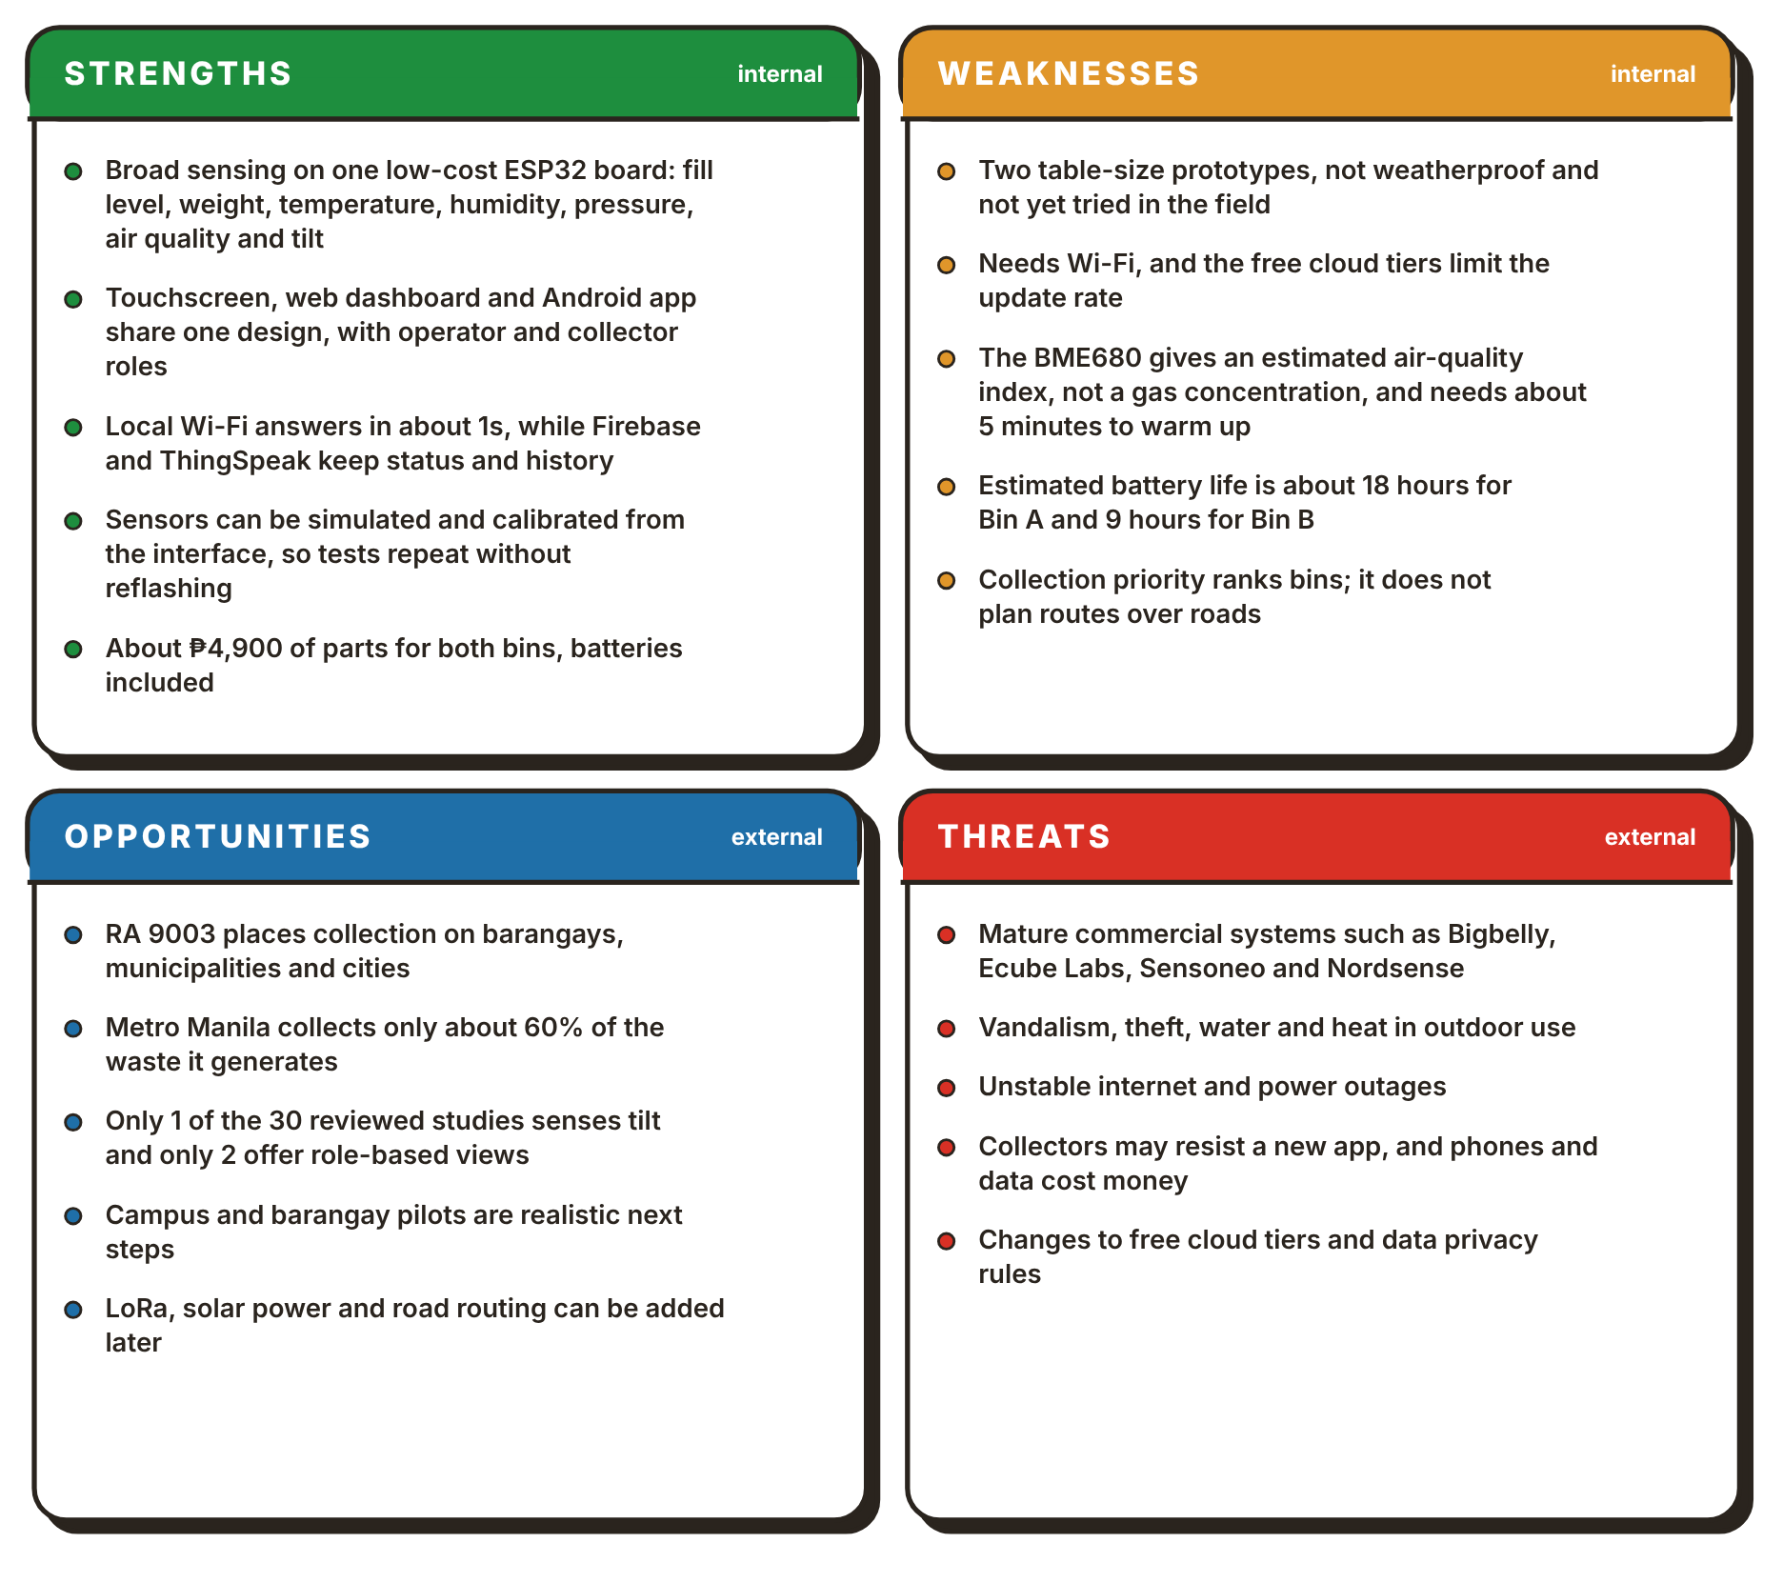
The weaknesses set the limits of what the tests of this project can claim. The tests can show that the bins work on a bench, not that a table-size prototype that has never been outside would last on the street, where Bin A runs about 18 hours and Bin B 9 hours on battery. The opportunities answer these weaknesses: pilots on campus or in a barangay hall, LoRa for where there is no Wi-Fi, solar power and road routing.

Synthesis of the Review
The patents, studies and products reviewed above converge on four points. First, the problem is a documented one. The Ecological Solid Waste Management Act of 2000 (2001) leaves the collection of non-recyclable and special waste to the municipality or city, and the World Bank (2022) puts the share of Metro Manila waste that is collected at about 60%. A bin that overflows between collections is therefore an expected condition of the system that these sources set out to monitor.
Second, sensing the fill level is a solved problem. 27 of 30 studies measure it, often with an HC-SR04, and patents have done it with hydraulic pressure (Neumann & Allison, 1991), capacitive plates (Di Giugno et al., 2016), an infrared beam (Devitt & Walsh, 2021) and an ultrasonic sensor (Kekalainen & Engstrom, 2018) and a laser (Keller et al., 2024). The commercial services in Table 3 sell the same measurement with a cloud console on top.
Third, the other sensors exist, but they are added one or two at a time. Saad et al. (2023) and Maulida et al. (2025) add weight, Mehta et al. (2025) add gas, Alnanih et al. (2025) add a flame sensor and Azmi et al. (2024) add temperature and humidity. Only Mehta and Rathour (2024) mention a tilt sensor, and they describe no alarm. Among the patents, Mullaney (2016) weighs contents, and Kurani (2023) lists about a dozen sensors but is aimed at litter and pathogens, not the user of the bin.
Fourth, more of the work goes into the route than into the bin. Twelve of the 30 studies report on routes or collection priority, and they report the biggest gains: up to 52% shorter distance in Banciu et al. (2025) and 58.9% in a pilot of Gupta et al. (2025) with no date or method provided. The bins themselves stay simple: ten studies have a phone app, two give different users different views, and none of them describes calibration or simulation from the interface of the bin.
None of the sources brings these pieces together in one bin. The studies that weigh the waste have no tilt alarm, the one that lists a tilt sensor describes no alarm, the ones with phone apps and roles have no weight, and the route studies take the readings of the bin for granted. Table 5 sets the four closest patents against Smart-Bin, feature by feature, and Figure 34 counts the features found in the studies. None of the twenty patents, as far as their text was read, combines a latched tamper alarm, a PIN collect mode on a touchscreen, a remote lock and sensor simulation and calibration from the interface with fill, weight and air sensing in one bin. A search of this size cannot prove that no such patent exists, so this is a statement about what was found and not about what exists.

Table 5
The Four Closest Patents Compared With Smart-Bin
Feature | Shahabdeen  (2016) | Yan and Chen  (2021) | Kurani  (2023) | Sait et al.  (2025) | Smart-Bin
Fill level | Yes (range finder) | Yes (infrared height) | Yes | Yes | Yes
Weight | Yes (or fill level) | Yes | Yes | Not found | Yes
Gas or odor | Yes | Yes | Yes | Yes (methane) | Yes
Temperature and humidity | Not found | Not found | Yes | Yes | Yes
Tilt or tamper alarm | Not found | Not found | Accelerometer listed | Not found | Yes
Motorized lid | Not found | Not found | Not found | Not found | Yes
Remote lock or PIN collect | Not found | Not found | Not found | Not found | Yes
On-bin display | Not found | Not found | Not found | Not found | Yes
Phone alert | Not found | Not found | Yes | Not found | Yes
Priority or route | Not found | Yes (truck route) | Yes (route) | Yes (route) | Yes (priority)
Note. Counts are derived from the hardware and the function described in each study (Table 2).
Figure 34
Features Found in the 30 Related Studies
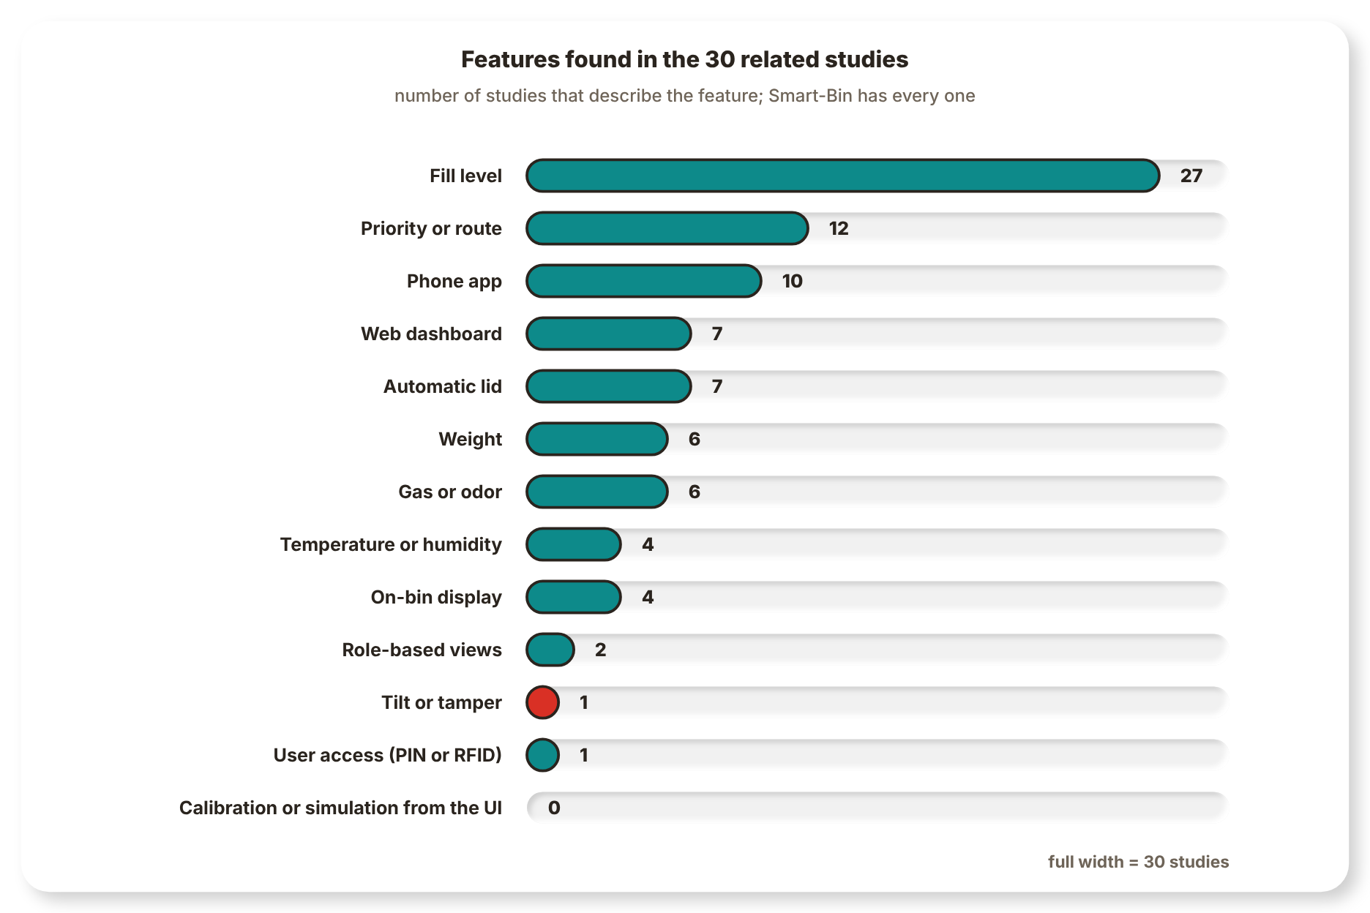
Note. Counts come from the hardware and function each study describes (Table 2).

Research Gap
There are 30 studies; 27 sense fill level. None has all of weight, gas, temperature, humidity and tilt in one bin; 6 add weight, 6 add gas, 4 sense temperature/humidity and 1 senses tilt. Two give role-based views, and one of them uses RFID access control. None offers simulation or calibration from the interface. In the patents and commercial systems the bin reports its fill level, and the focus is on routes and fleet software. None of the four most closely related patents have all ten of the features listed in Table 5.
The gap is therefore not a missing sensor but the combination of fill, weight, air and tilt sensing, alerts to the operator, collector and person at the bin, collection priority from the fill and time to fill, and interfaces that calibrate and test the bin without re-flashing, in one low-cost bin. Table 6 gives the gap by capability and the specific objective in Section 1.4 that addresses it.
Table 6
The Research Gap by Capability
Capability | Related studies | Patents and products | Smart-Bin | Objective
Sensing breadth on one board | 27 fill, 6 weight, 6 gas, 4 temperature or humidity, 1 tilt; none has all | Kurani (2023) lists about a dozen sensors; the others are narrower | Fill, weight, temperature, humidity, pressure, air quality and tilt on one ESP32 | SO1
Tamper detection | One study lists a tilt sensor | No latched tamper alarm found in the four closest patents | Tilt beyond 30° starts a 10s countdown, then a latched siren until RESET TAMPER | SO1
Alerts to each kind of user | 10 studies have a phone app and 7 a web dashboard | Phone alerts in Kurani (2023) | Buzzer, LED and touchscreen on the bin, web dashboard, Android app and push alerts | SO2
Roles and access | 2 studies have role-based views; 1 uses RFID | None found | Operator and collector views, remote lock, PIN collect mode | SO2, SO3
Collection priority | 12 studies are about routes or priority, mostly with GPS and algorithms | Route planning in the closest patents | Fullest first, with a time to full from the recent fill rate; no road routing | SO3
Testing and demonstration | No study describes simulation or calibration from the interface | None found | Per-sensor simulation and calibration from the dashboard and app | SO3

1.4 Objectives

General Objective
To design and develop Smart-Bin, an IoT based Waste Bin Monitoring System which will monitor the fill level, weight and air quality of the waste bin, detect tampering and give real time monitoring and alerts to the concerned entities via Web Based Dashboard, Android App and On-Bin Touchscreen.

Specific Objectives
- Sensor Monitoring and Detection
To develop 2 Smart-Bin units, which include sensors to measure fill level, weight, temperature, humidity and air quality, as well as to detect bin tilting and tampering and open the lid automatically when hand movement is detected.
- Real-Time Monitoring and Alerts
To develop a web dashboard and an Android application to display real-time data from the sensors, bin status, retrieve data from Thingspeak/Firebase and notify the operators and collectors when the bin is full, poor air quality, high temperature, tampered sensor reading and when the bin is not online.
- Bin Control and Collection Prioritization
To implement Collection Prioritization, based on bin fullness and estimated time to fullness, remote bin locking and unlocking, on-bin collection functions (via PIN), sensor simulation and system interface sensor calibration. This will lead to the prioritization of collections and will also help with efficient collection routes and fuel gas efficiency.

1.5 Conceptual Framework
The framework of Smart-Bin is shown in two parts. The first one which is below describes the process of a reading going from the sensor to the person who is going to respond to it and it is known as the Input-Process-Output (IPO) model. The second, under IoT Level, shows how the parts are deployed and connected. Both refer to the same system and both result in the three specific objectives listed in Section 1.4 above.

Input-Process-Output Model
Figure 35
Input-Process-Output Model of Smart-Bin
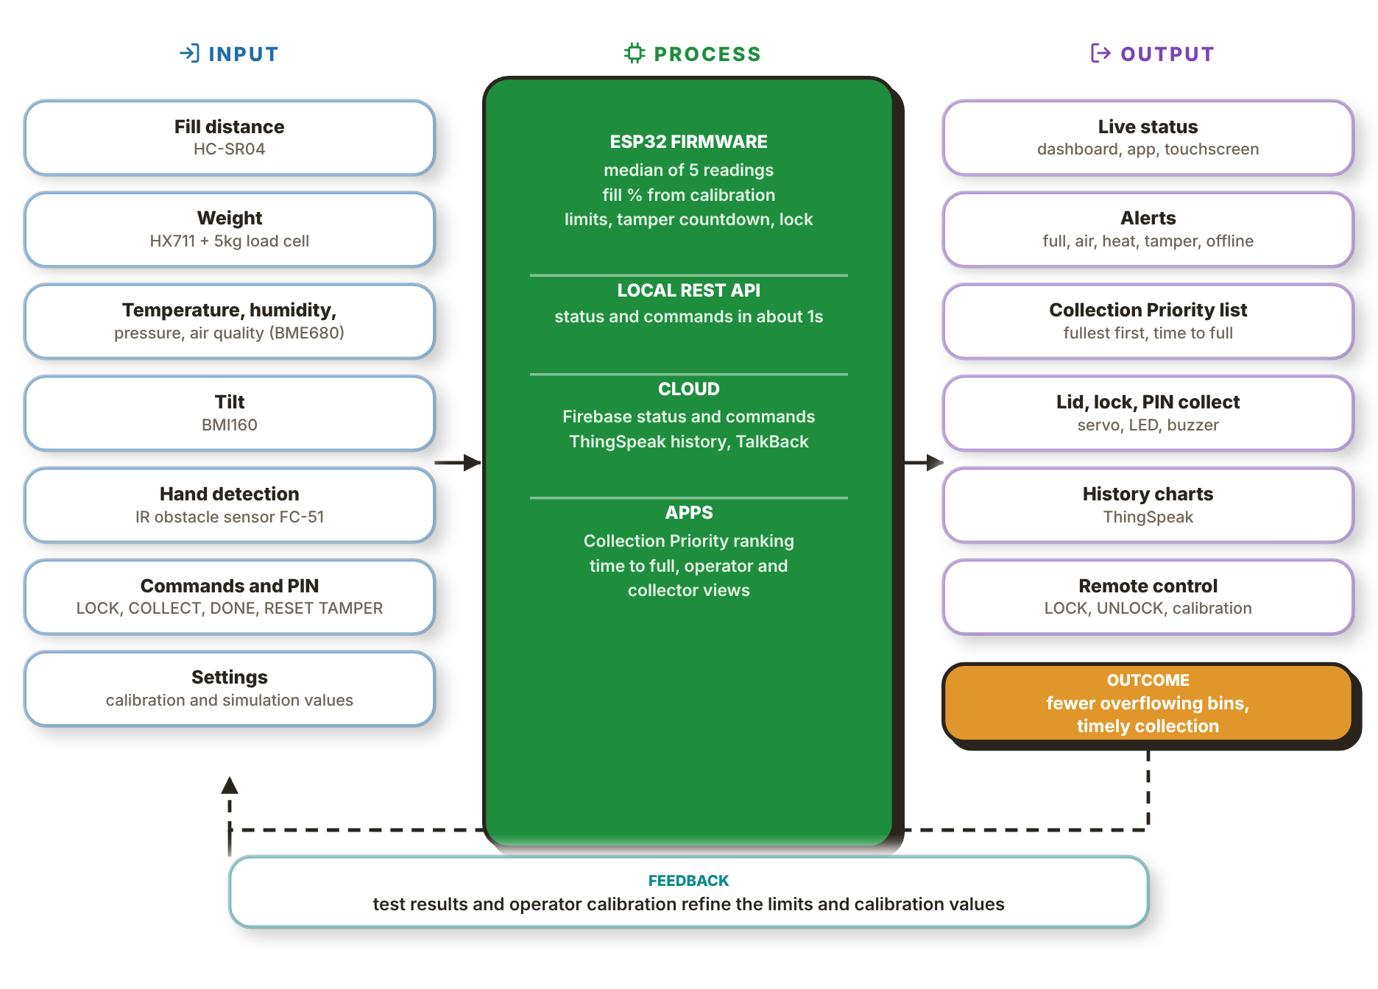

The input column has seven items. The distance to the trash is measured by the HC-SR04 sensor, the weight is measured by the HX711 sensor (which includes a 5kg load cell), the BME680 sensor provides temperature, humidity, pressure and an estimate of the air quality, the BMI160 sensor gives the tilt, and the IR sensor detects a hand. The final two inputs are from the people: commands input on the touchscreen, in the dashboard or in the app, and the settings, which contain the calibration and simulation values. All of these inputs are related to Specific Objective 1, and commands and settings are related to Specific Objective 3.
The process column is how the ESP32 firmware and the cloud use them. The firmware takes the median of five readings, converts the distance to a fill percentage from the calibration limits, compares the readings with their thresholds, runs the tamper countdown and applies the lock. The local REST API answers in about 1s, Firebase holds the live status, and ThingSpeak keeps the history and relays commands. The apps rank the bins by fill and by time to full and give the operator and collector their own views. Specific Objectives 2 and 3 are addressed in this column.
The output column is what people see and do: live status on the touchscreen, the dashboard and the app, alerts for a full bin, bad air, heat, tamper or an offline bin, the Collection Priority list, the lid, lock and PIN collect on the bin, history charts and remote control. The outcome is fewer overflowing bins and timely collection, which is the problem stated in Section 1.1. Feedback closes the loop; the results of the test and the operator's calibration will improve the limits and calibration values used by the firmware next.

IoT Level
Figure 36
System Architecture of Smart-Bin
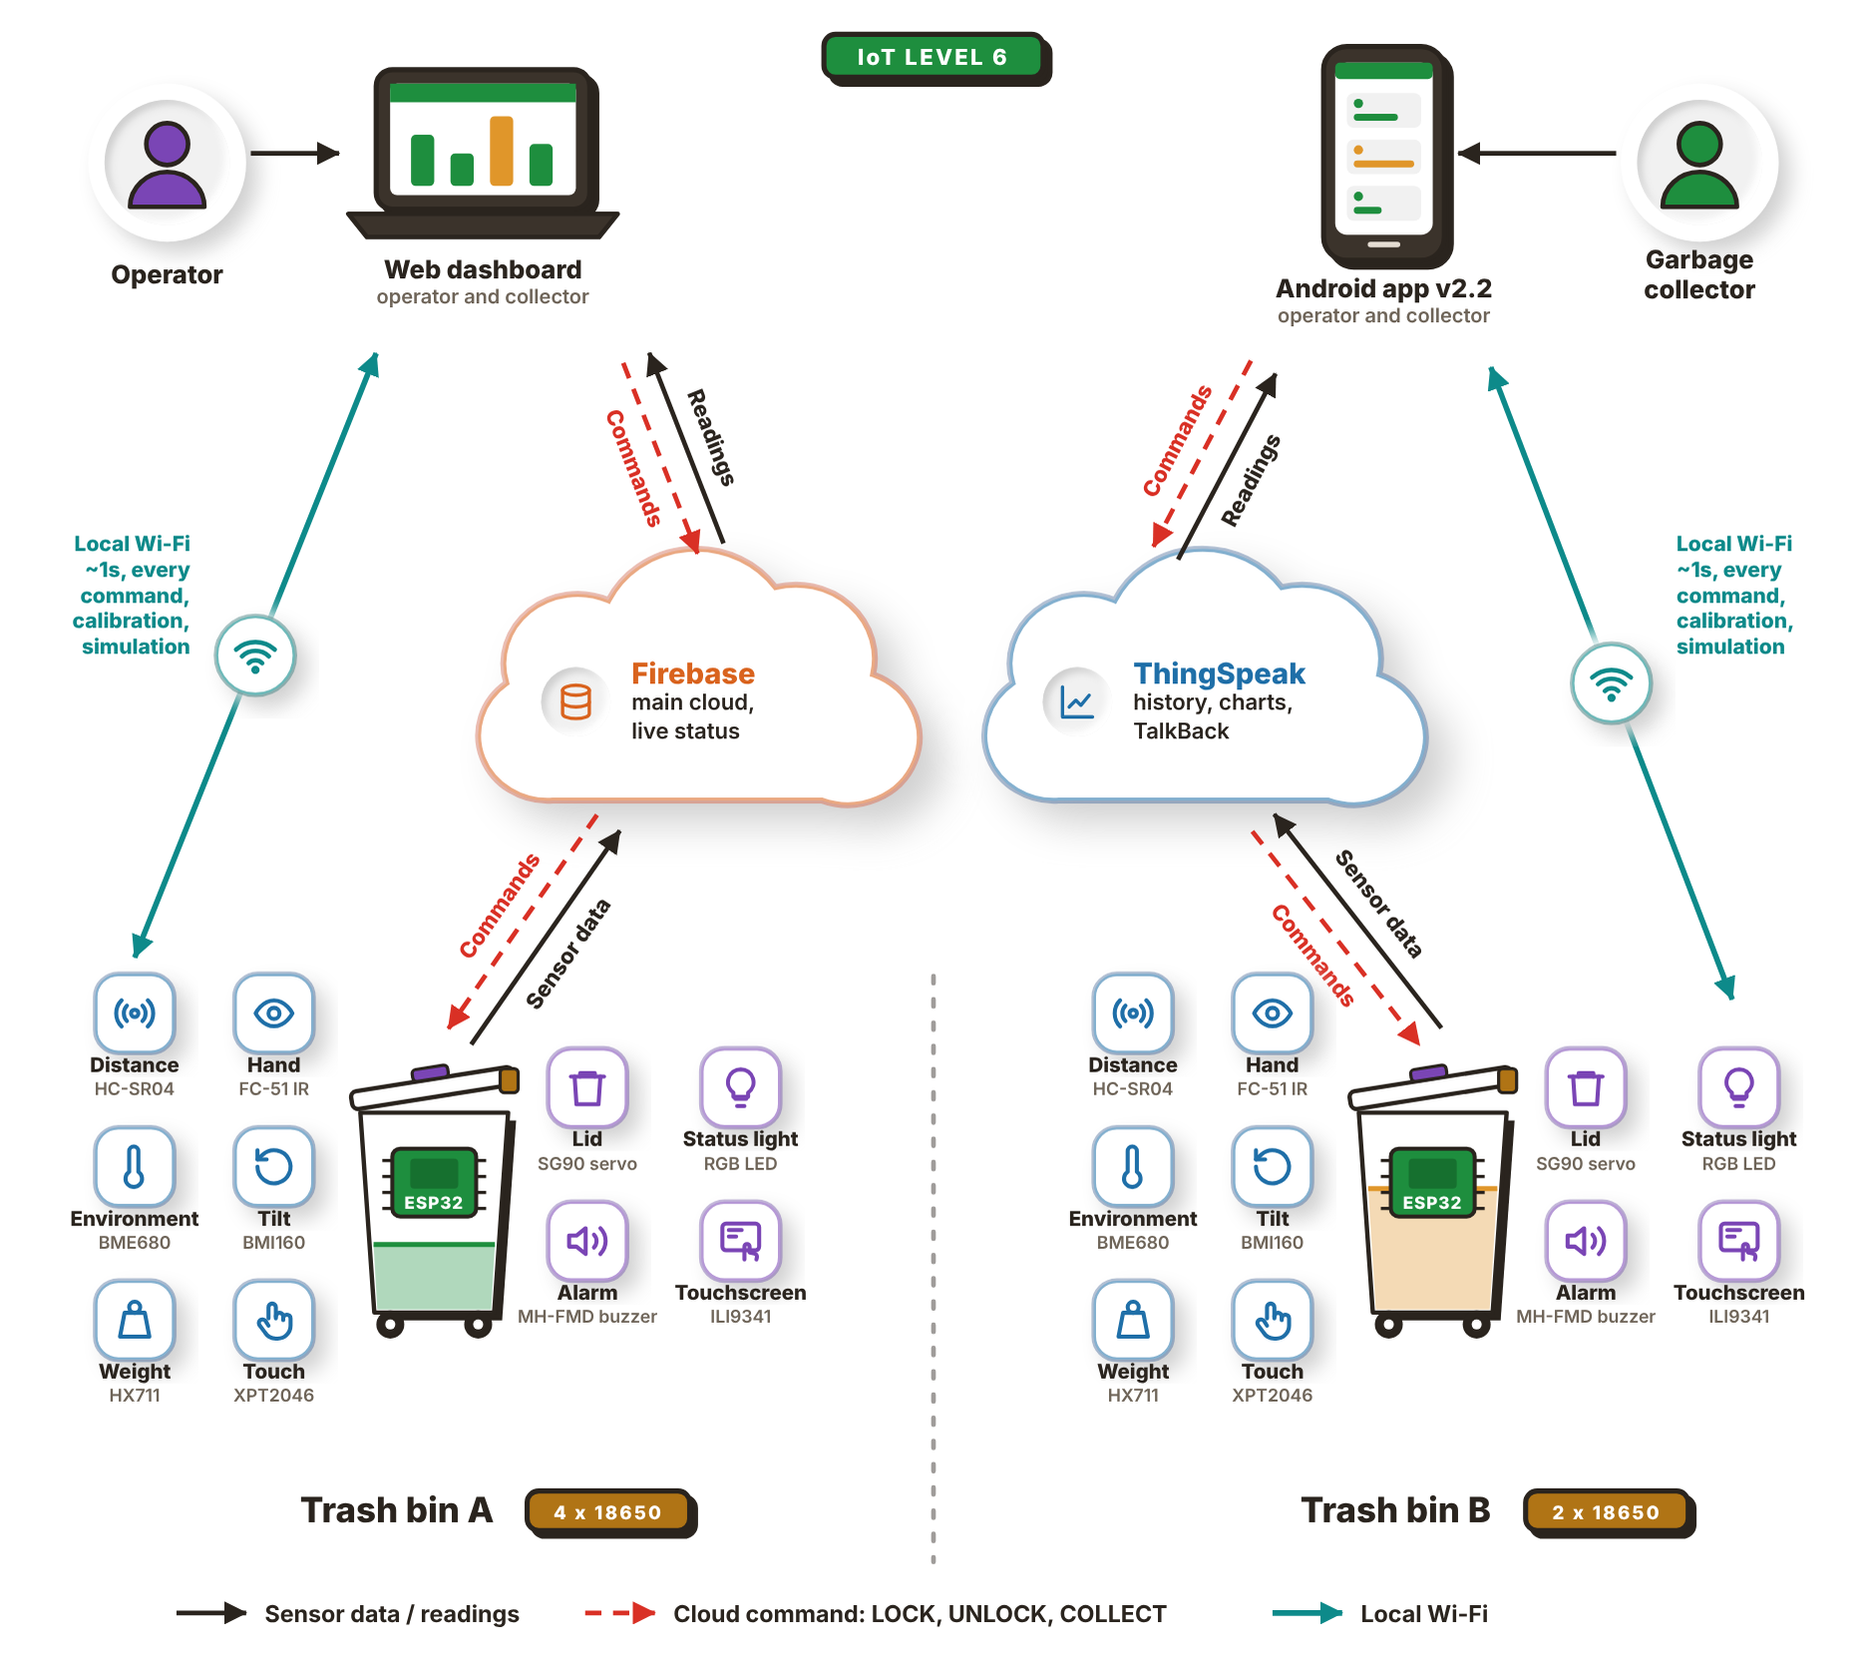
The connections between the parts of Smart-Bin are shown in Figure 36. The readings are sent from the cloud to the two apps at the top: the web dashboard (primarily for the operator) and the Android app (primarily for the garbage collector). Both apps can also reach a bin directly over the local Wi-Fi in about 1s for any command, calibration, or simulation.
There are two end nodes at the bottom: Trash bin A and Trash bin B. Both have the same ESP32 and six input sensors (HC-SR04, IR sensor, BME680, BMI160, load cell, touch panel) and four output actuators (servo, RGB LED, buzzer, TFT). Bin A is powered by 4x 18650 cells, Bin B by 2x.
Each bin sends its sensor data up to two cloud services and receives the LOCK, UNLOCK and COLLECT commands from them. Firebase is the primary cloud and stores the live status, ThingSpeak stores the history and charts and relays commands via TalkBack.
Smart-Bin fits IoT Level 6 of the deployment templates in Bahga and Madisetti (2014). A Level 6 system has several independent end nodes that sense or actuate and send their data to the cloud, where it is stored and shown by a cloud-based application. An analytics component works on that data and keeps its results in the cloud as well, and a centralized controller knows the status of every end node and sends control commands back to them. Trash bin A and Trash bin B are the end nodes in Figure 36. Both have their own ESP32, they read their own sensors and update their own status to Firebase and ThingSpeak, they don't depend on each other and there is no gateway between them and the cloud.
Cloud side is Firebase for live status, and ThingSpeak for stored history. ThingSpeak keeps the readings of every bin and plots and analyses them over time, and the apps use the same data to rank the bins by fill level and estimated time to fill in the Collection Priority list. The web dashboard and the Android app take the role of the centralized controller. They show the state of both bins side by side and send LOCK, UNLOCK and COLLECT back through the cloud, and calibration and simulation commands go to a bin directly over the local Wi-Fi. Both read the lock, collect, calibration and tamper flags that the bin itself reports, so a bin locked or put into calibration from one of them shows the same state and the same buttons on the other.

1.6 Target Beneficiaries
- Waste Collectors and Utility Staff
Smart-Bin tells waste collectors and utility workers which bins are fullest and should be emptied first. It also saves trips to bins that are not yet full and gives PIN access to the bin during collection.
- Facility Managers and Operators
The web dashboard can be used by facility managers or barangay hall, school, office or mall operators to monitor the status of the bins, review the data and set sensor thresholds, and they receive alerts on overflowing bins, poor air quality, high temperature, and even possible tampering.
- Barangay and Local Government Unit (LGU) Sanitation Offices
The sanitation offices of barangays and LGUs can use Smart-Bin's readings to schedule and manage garbage collection. The percentage of fullness and time to be full will help them optimize their collection routes and save fuel by skipping unneeded collections.
- Filipino Citizens
Residents, employees and students in schools, offices and other places gain a cleaner environment with fewer overflowing bins and more awareness of their waste. The hands-free lid also makes throwing away waste easier and more sanitary.

II. PROTOTYPE DESIGN AND DEVELOPMENT

2.1 Development Methodology
Smart-Bin was developed with a hybrid software development life cycle (SDLC) called Water-Scrum-Fall. Samolovac (2023) describes it as a combination of Waterfall and Scrum in which the project begins and ends with Waterfall, while the execution phase is done in iterative sprints until the final deliverable is complete. Figure 37 shows the model as the group used it. Each phase is labeled with what it covered in this project and with its dates from the Gantt chart in Appendix A.
The course decided the two ends. The topic, objectives and chapters had to be settled in order, and the paper and presentation are due on November 6, 2026, so neither the start nor the finish could move. The middle was different. One unit joins an ESP32, five sensors, a servo, a touchscreen, a web dashboard, an Android app and two cloud services, and a fault in one part often showed only after another part was connected to it. Planning that stretch once and following it to the end would not have survived the first built bin.
Figure 37
Water-Scrum-Fall Development Life Cycle of Smart-Bin
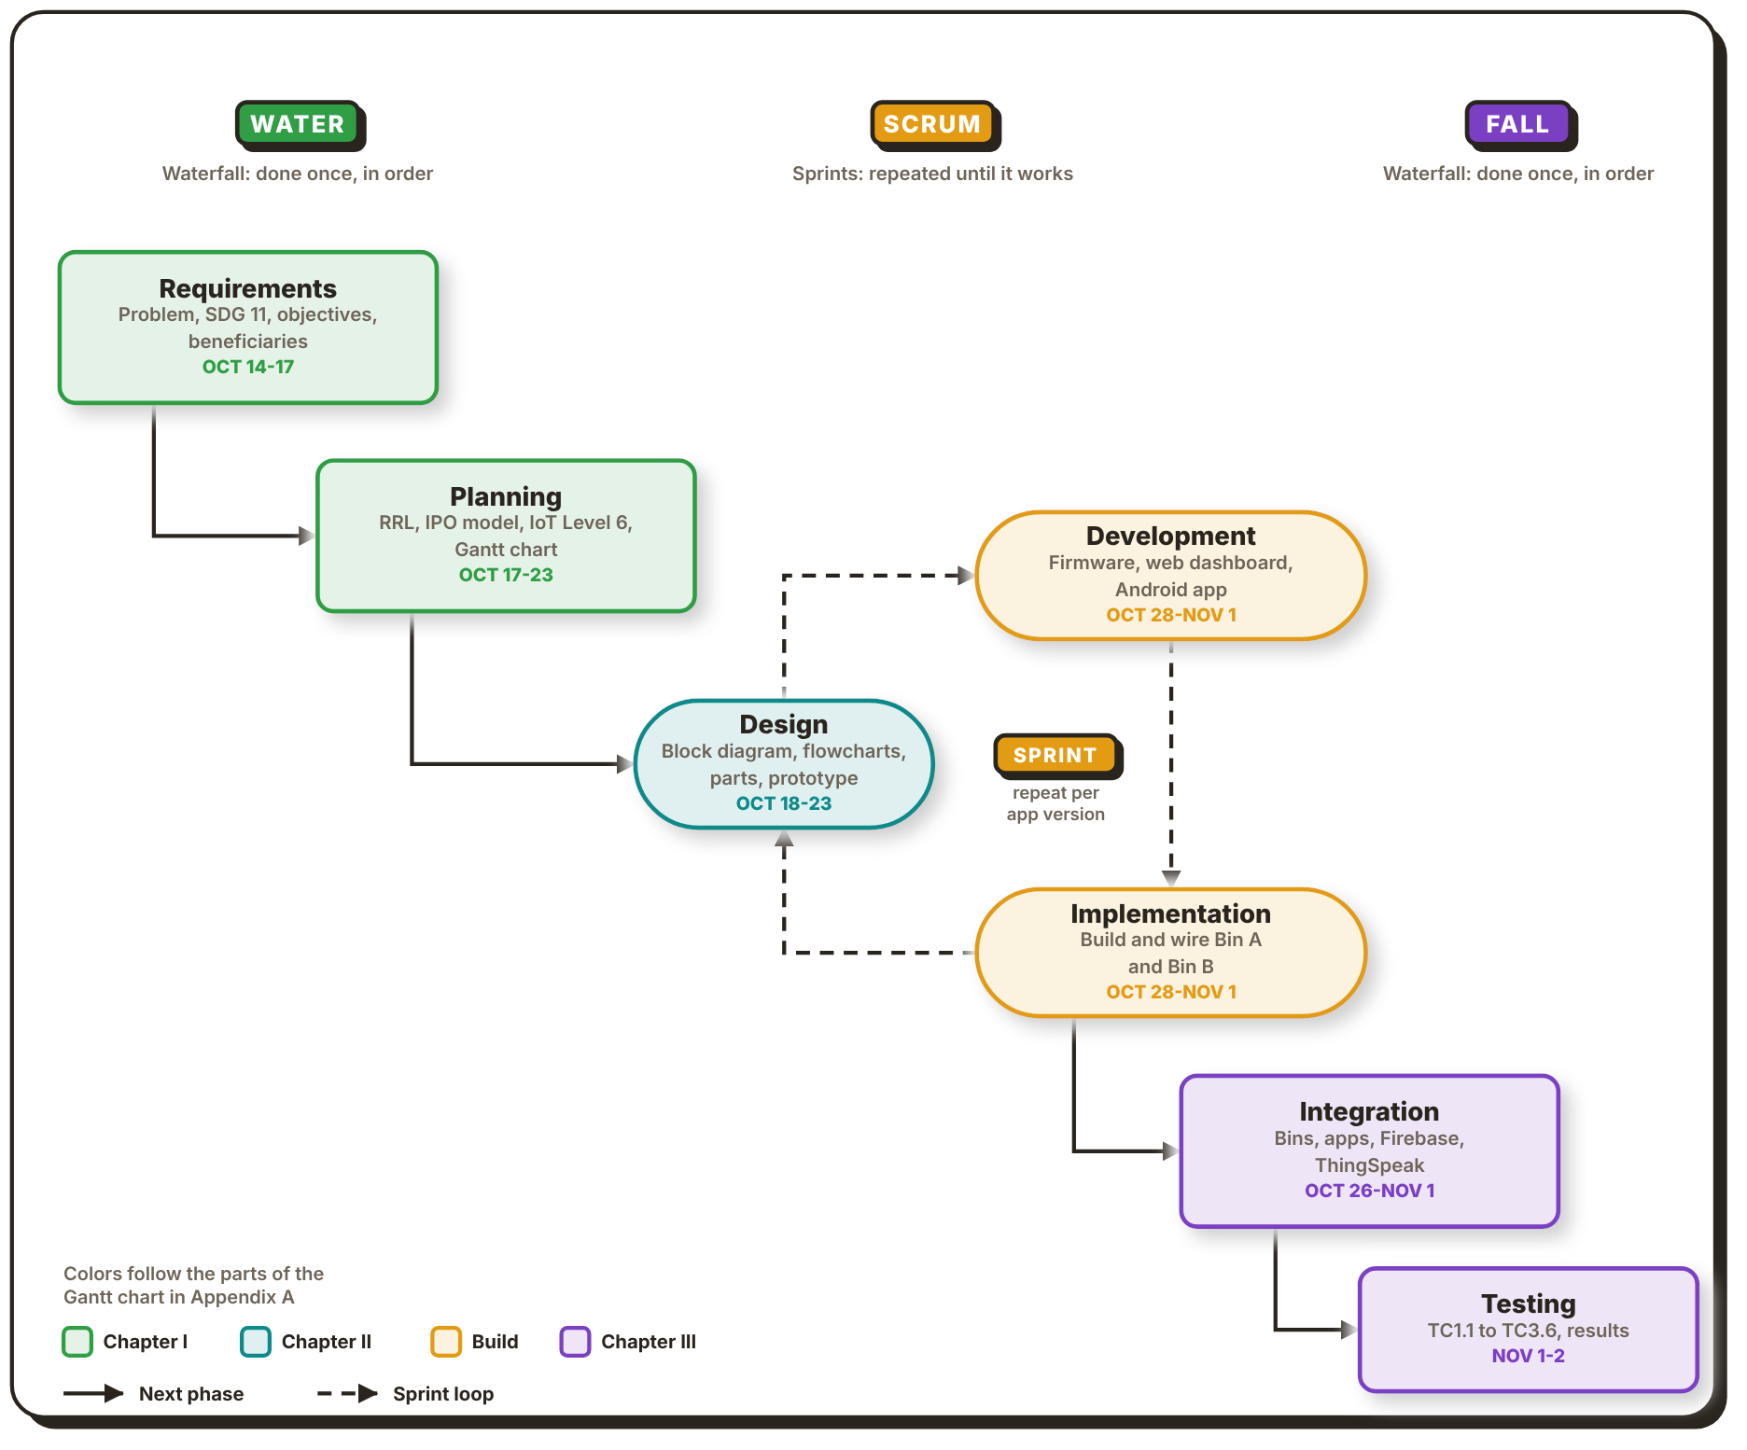
Note. Adapted from What Is Hybrid Project Management?, by J. Samolovac, 2023, Plaky (https://plaky.com/learn/project-management/hybrid-project-management/). The phase dates are from the Gantt chart in Appendix A, and the colors follow its parts.

Water: Requirements and Planning
Requirements ran from October 14 to 17. Banogbanog and Reyes wrote the objectives, the SDG and the target beneficiaries, while Banogbanog and Celeste wrote the introduction and the problem. Their output was the general objective and the three specific objectives in Section 1.4, which the group treated as fixed. Each specific objective later became one group of test cases in Chapter III: TC1.1 to TC1.6 for sensing and detection, TC2.1 to TC2.6 for monitoring and alerts, and TC3.1 to TC3.6 for bin control and collection priority.
Planning followed from October 17 to 23. Gunayan and Pepito reviewed the related patents and the studies from 2023 onward, wrote the SWOT analysis and the research gap, and built the IPO model and the IoT Level 6 framework in Section 1.5. The plan behind the build came from the same work. The implementation plan fixed the parts, the local REST API of the bin and the cloud channels, and the Gantt chart fixed who did what and by when. From October 21 to 23 the whole group merged Chapters I and II and checked them against APA 7.

Scrum: Design, Development and Implementation Sprints
The middle of the project ran as sprints. A sprint went through design, development and implementation, put the result on a real board or bin, and carried what it found back into the next design. The first designs were made from October 18 to 23: the block diagram by Reyes, the component materials by Celeste, the system flowchart by Reyes and Celeste, and the prototype design by Banogbanog. They appear in this chapter as Figures 38 to 56.
The Gantt chart gives development the window from October 28 to November 1, with Reyes on the firmware and the dashboard and Celeste on the Android app. The code itself started sooner. Working firmware, the live web dashboard and version 2.0 of the app were in the project repository by October 17, and app version 2.2 followed on October 18. Until a bin existed, the two apps could only be tried on demo data, so the bar on the chart marks the time in which they had to work on real hardware.
Implementation, the build and wiring of the two bins, was given to Banogbanog and Gunayan for the same window. The first bin was built and tested on October 28, and that test started the busiest sprints of the project. The tamper alarm went off soon after power-up, because the upright angle saved earlier no longer matched the bin. The fix went back through design and development the same day as app version 3.0: the bin now saves its upright angle at every power-up, the lid stays shut for 2s after it closes so it does not flicker, and the bin reports locked, pickup, calibrating and tamper as separate flags so the touchscreen, the dashboard and the app show the same state. The cloud test on Bin 01 on October 29 found two more problems. ThingSpeak carried only a short status word, which version 3.1 replaced with the full set of flags, and the lid kept reopening after it closed because the servo retriggered the PIR sensor. On October 30 the PIR sensor was replaced with the FC-51 IR obstacle sensor, and both bins were finished that day. The drawing in Figure 38 was corrected once more on October 31, after the built bins showed that the electronics sit in a bay behind the front wall.

Fall: Integration and Testing
Integration joins what the sprints produced: the two bins, the web dashboard, the Android app, Firebase and ThingSpeak. On the Gantt chart it runs from October 26 to November 1 and overlaps the last sprints, because every sprint already ended with a check on the connected system. The Bin 01 cloud test is one such check, with the bin signed in to Firebase under its own account and writing to ThingSpeak channel 3556235. In the model, integration is where the loop stops. Once the bins and both apps carry the same version, changes are limited to fixing faults.
Testing closes the project as a single Waterfall pass. The Gantt chart sets November 1 and 2 for it: Banogbanog and Reyes write the test cases from the three specific objectives, and the whole group runs them and records the results that Chapter III reports. The final review, the PDF and the slides take November 3 to 5, and the presentation is on November 6.
The method had a cost on paper. Every sprint that changed the bin also changed this document: the system and operator flowcharts were redrawn on October 18 and again on October 28, and the prototype drawing on October 31. The fixed requirements kept that cost bounded. The sprints changed parts, settings and screens, but the three specific objectives stayed the same, so the test cases written from them still applied at the end.

2.2 Prototype Design
The physical design of one Smart-Bin unit is shown in Figure 38. The group builds the same unit twice, as Bin A and Bin B, and the only difference between the two is the battery shield: Bin A runs on four 18650 cells and Bin B on two. Each unit is a table-size model, about 30 to 40cm tall. Inside, a divider wall stands a short distance behind the front wall and splits the bin into two parts. The larger part at the back is the trash chamber, which holds the lid and the sensors that have to face the trash. The narrow bay behind the front wall holds the electronics: the perfboard with the ESP32 and the battery shield, so neither the board nor the power supply touches the trash.
Figure 38
Front View and Side Cross-Section of One Smart-Bin Unit
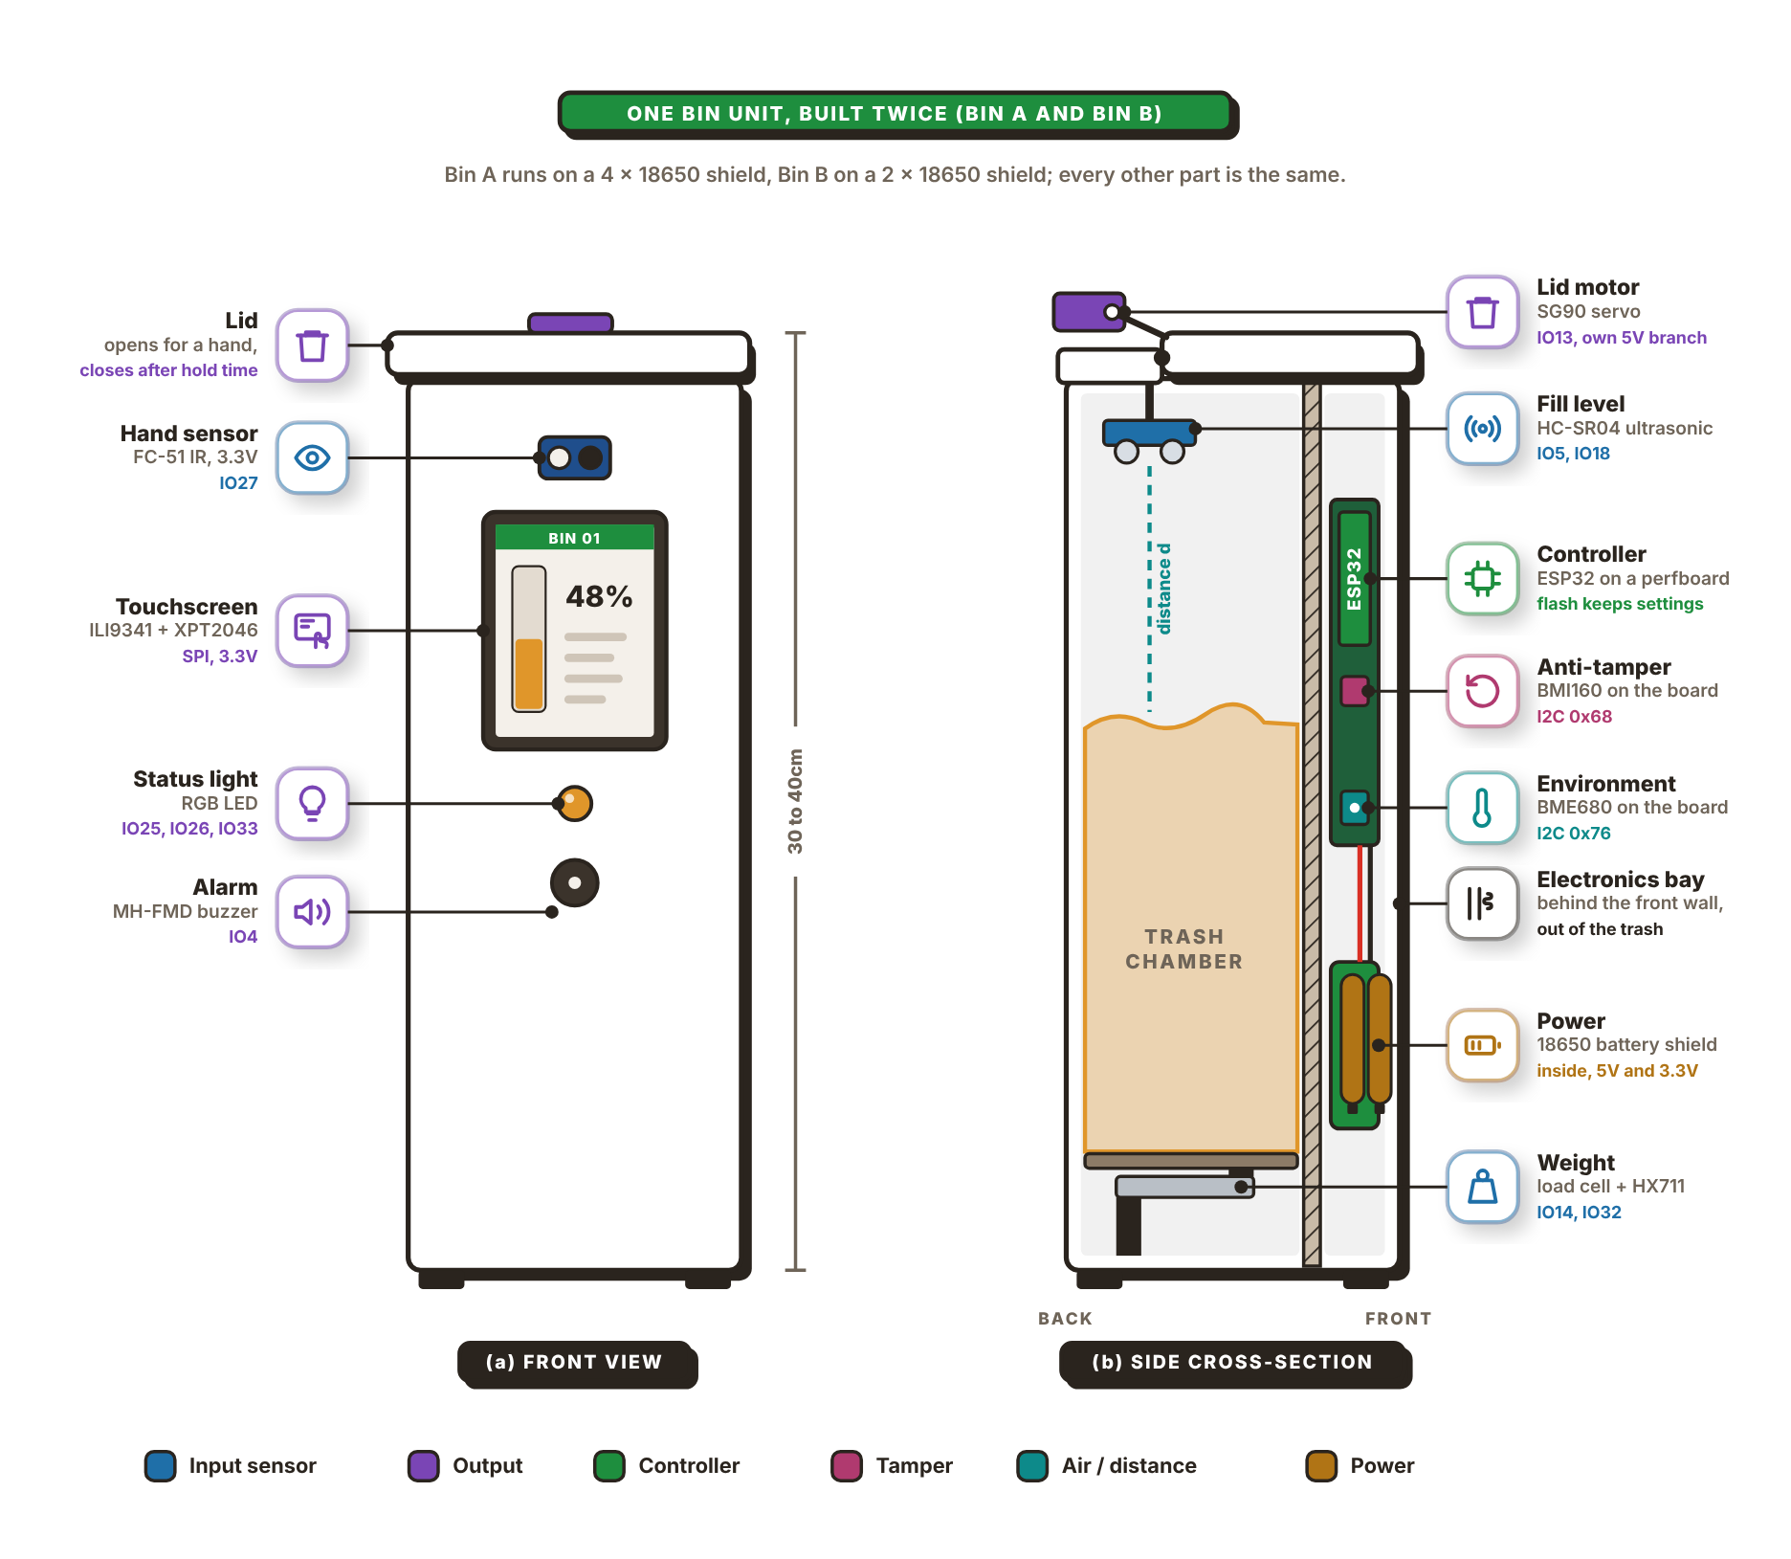
The front view (a) shows what a user sees first. Near the top is the FC-51 IR obstacle sensor on GPIO 27. When it sees a hand, the SG90 servo lifts the lid, which closes again after the open time the operator sets (5s by default). Once shut, it stays shut for a close time (2s by default), so a hand still in front of the sensor does not make it flick open again. Below it is the 2.4-in. touchscreen (ILI9341 with XPT2046 touch), mounted in portrait so that its fill bar rises the same way the trash does. The screen shows the fill level, weight, temperature, humidity and IAQ estimate, and it takes the PIN before a collection. Under the screen are the RGB status light and the MH-FMD buzzer on GPIO 4. The light stays green while the bin is below 50%, turns amber from 50%, and blinks red when the bin is full or tampered with.
The side cross-section (b) shows the inside. The HC-SR04 ultrasonic sensor hangs from a fixed strip at the back of the top, behind the lid hinge, so it stays still when the lid moves. It points down and measures the distance d to the top of the trash; the firmware takes the median of five readings and turns it into a fill percentage. The servo sits on the same strip and pushes the lid open with its arm. The electronics bay sits right behind the front wall, so the touchscreen, the IR sensor, the status light and the buzzer connect to the board through the wall with short wires. In the bay the ESP32 sits on a perfboard, with the BMI160 and BME680 modules soldered on the same board. The board is fixed to the bin, so the BMI160 moves together with the bin body, which the tilt check needs. The battery shield sits in the same bay below the board, and the bin has no charging port on the outside. The trash rests on a platform over the 5kg load cell, and the HX711 amplifier turns the strain into a weight in grams.

2.3 Block Diagram
The block diagram of one Smart-Bin unit and the network around it is shown in Figure 39. It has two separate ESP32 microcontrollers, one in each of the two bins, both bins reporting to the same cloud services and user apps.
Figure 39
Block Diagram of the Smart-Bin System
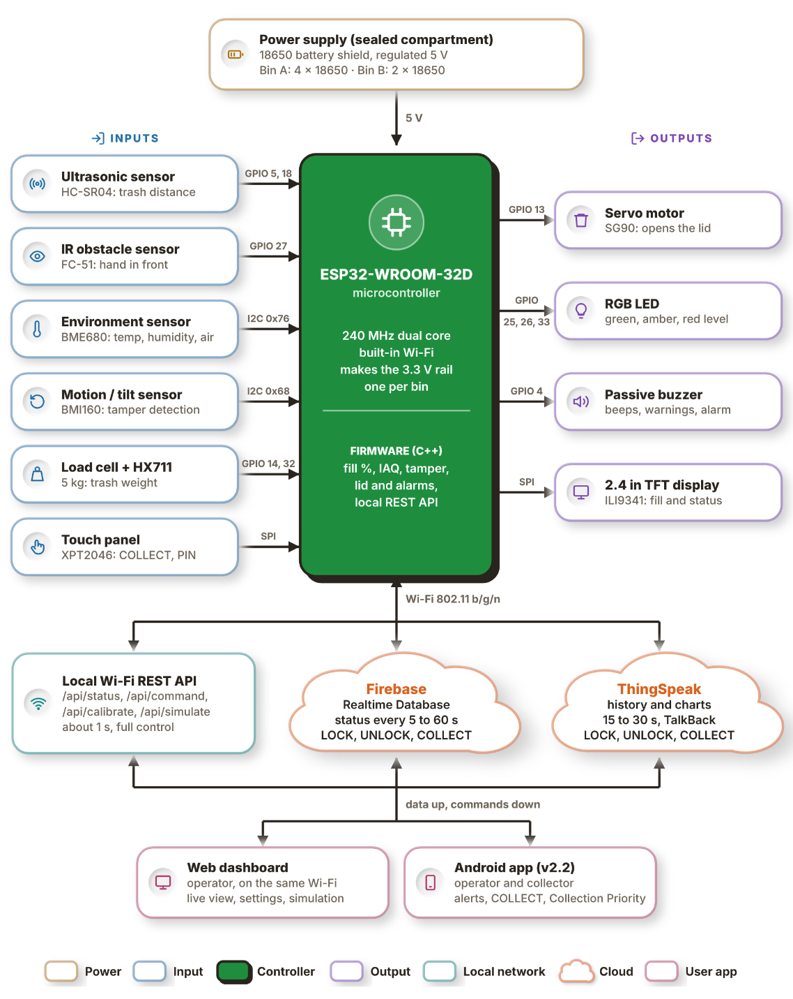
The power supply is at the top of the diagram: an 18650-battery shield in a closed compartment that gives the circuit a regulated 5V. Bin A is powered by 4x 18650 cells and Bin B by 2x. The 5V is fed to the ESP32-WROOM-32D which supplies the 3.3V needed by the sensors, display and buzzer; the servo and HC-SR04 operate directly from the 5V. The ESP32 is a 240MHz dual-core microcontroller with Wi-Fi. Its C++ firmware works out the fill percentage, indoor air quality (IAQ) estimate and tamper state, controls the lid and alarms and provides a local REST API.
The inputs are on the left. The HC-SR04 ultrasonic sensor on GPIO 5 and 18 measures the distance down to the trash, which gives the fill level, and the FC-51 IR obstacle sensor on GPIO 27 senses a hand held in front of the bin. The BME680 (address 0x76) for temperature, humidity and air quality and the BMI160 (address 0x68) for motion and tilt (tamper detection) share the I2C bus. A 5kg load cell connects to GPIO 14 and 32 through an HX711 amplifier module to weigh the trash. On the SPI bus, the XPT2046 touch panel takes the COLLECT and PIN inputs.
The outputs are to the right. The lid is opened and closed by the SG90 servo on GPIO 13 (PWM). The fill level is indicated by an RGB LED (GPIO 25, 26 and 33) in green, amber or red. Beeps, warnings and the tamper siren come from a passive buzzer on GPIO 4. The fill level and the bin status are displayed on the 2.4 in. ILI9341 TFT display (also SPI).
The bottom half shows three data paths that leave the bin over Wi-Fi (802.11 b/g/n). The local REST API (/api/status, /api/command, /api/calibrate and /api/simulate) responds in ~1s and provides full control of the bin. The status is sent to the Firebase Realtime Database every 5 to 60s and to ThingSpeak every 30s while the readings change and at least once every 5 minutes, and the LOCK, UNLOCK and COLLECT commands come back down (from ThingSpeak through its TalkBack feature). Two user apps receive the data and send the commands. The web dashboard runs in a browser on the same Wi-Fi and gives the operator a live view, settings and simulation, while the Android app gives operators and collectors alerts, the COLLECT command and the Collection Priority list.

2.4 System Flowchart
Figure 40
System Flowchart of the Smart-Bin
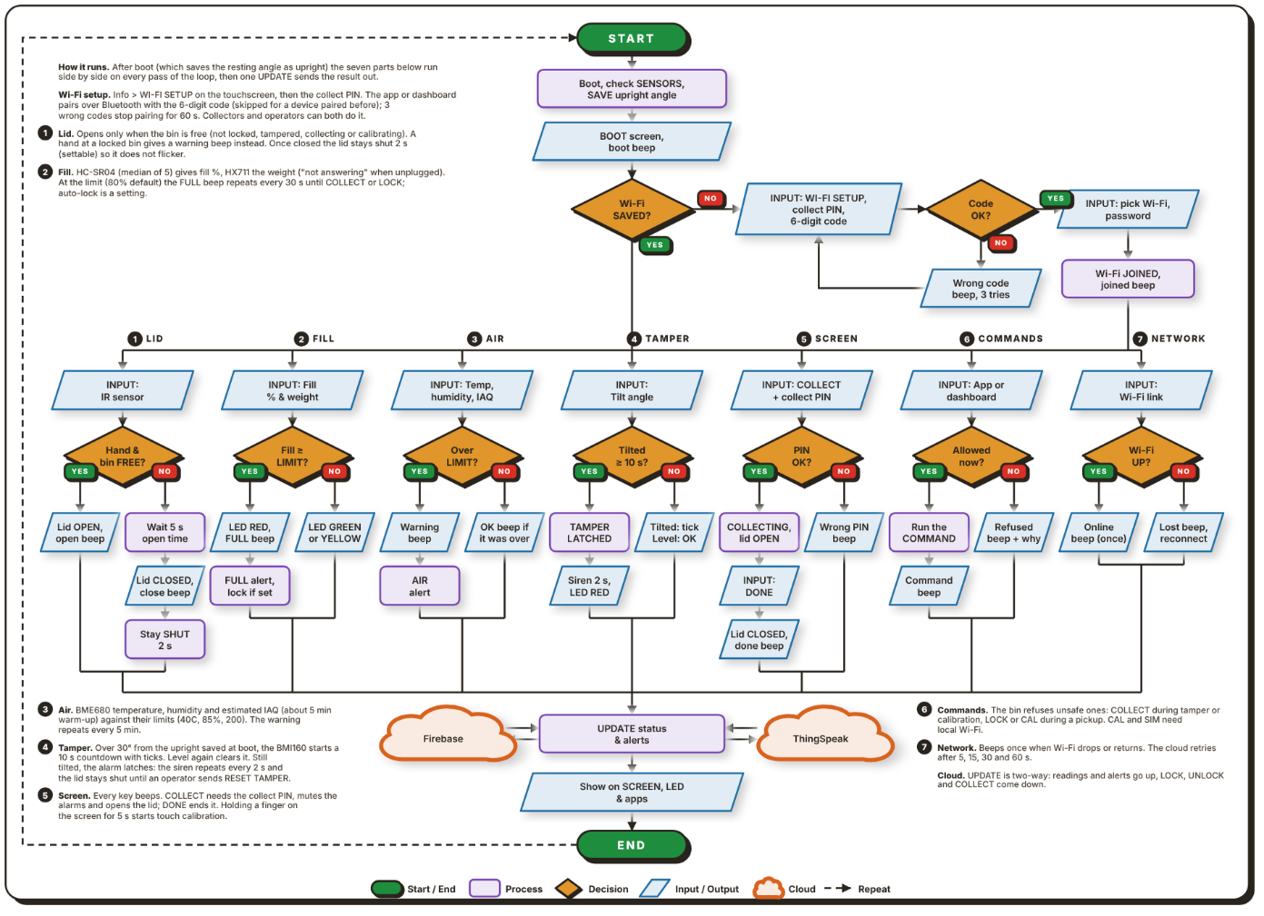
Note. Figure 40 shows the main program loop that runs on each bin. After start-up, seven parts run side by side on every pass of the loop, and their results meet at one update step.
Upon powering on the bin, the ESP32 starts, checks its sensors and loads its saved settings, with a boot screen and a beep. It also saves the angle it is resting at as the upright position, so the tamper check starts from the way the bin is standing. It then checks if a Wi-Fi network is saved. If not, the user opens WI-FI SETUP on the touchscreen and enters the collect PIN, and the app or dashboard pairs with the bin over Bluetooth. The 6-digit code on the bin's screen is typed into the pairing box (a device paired before skips it, and three wrong codes stop pairing for 60s). The bin returns a list of all the Wi-Fi networks within its range, and the user selects one and enters its password, and the bin beeps when it joins. The loop then splits into 7 parallel parts (1-7 on the chart).
The lid part (1) reads the IR sensor. If the bin is free (not locked, tampered with, collecting or being calibrated), it beeps and opens the lid. Otherwise the lid stays closed, and the bin beeps when it sees a hand. The lid beeps and closes 5 seconds after the hand is gone, and then stays shut for at least 2 seconds before a hand can open it again. The fill part (2) reads the weight from the HX711 (or reports that the HX711 is not answering when it is unplugged), and takes the median of 5 HC-SR04 readings for the fill percentage. When the fill reaches the limit (80% by default), the LED flashes red and an alert is sent every 30s until the bin is collected or locked. With auto-lock on, the bin also locks itself. Below the limit the LED is green or amber. The air part (3) compares the measured temperature, humidity and estimated air quality of the BME680 with their limits (40C, 85% and an index of 200). The air quality is an approximation based on the gas reading and needs about 5 minutes to warm up. Over a limit the buzzer sounds and an alert is sent every 5 minutes, and a short beep marks the reading falling back under.
The tamper part (4) watches the BMI160 tilt angle. If the tilt from the upright position saved at power-up exceeds 30°, a countdown of 10 seconds begins with a "tick" every second. If the bin is steady again, the alarm resets by itself. If it stays tilted, the alarm latches until an operator sends RESET TAMPER: the siren sounds every 2s, the LED is red, the lid remains closed and an alarm message is generated. The screen part (5) handles COLLECT on the touchscreen. The right collect PIN opens the lid and mutes alarms until DONE is pressed, which closes the lid and resets the fill level; a wrong PIN gives an error beep. Holding a finger on the screen for 5s starts touch calibration. The command part (6) takes LOCK, UNLOCK, COLLECT, calibration (CAL) and simulation (SIM) from the app or dashboard. The bin beeps at an unsafe command, such as COLLECT during a tamper alarm, and CAL and SIM work over Wi-Fi only. The network part (7) beeps once when the Wi-Fi is lost and once when it returns.
All seven paths then lead to an UPDATE step. The two arrows between this step and each cloud show the readings and alerts going up to Firebase and ThingSpeak and the LOCK, UNLOCK and COLLECT commands coming back. The new status then shows on the screen, the LED and the apps, and the loop repeats.
Figure 41
Operator Flowchart of the Smart-Bin Apps
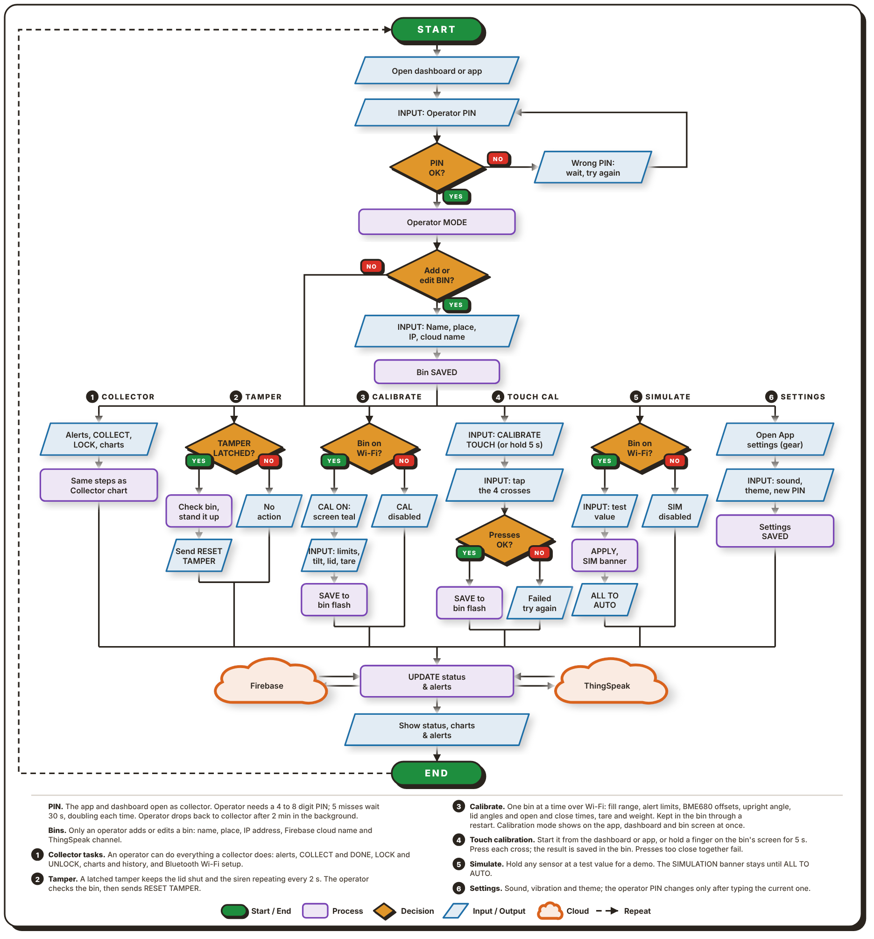
Note. As seen in Figure 41, an operator can do the following actions in the Web Dashboard or in the Android App
.
In both apps, the collector mode is the default, and the operator enters a 4- to 8-digit PIN. After 5 wrong PINs the app waits 30s before the next try, and the wait doubles with each further failure. The right PIN switches the app to operator mode. The operator can then add or edit a bin, giving it a name, a place, the IP address and cloud name for Firebase and ThingSpeak, and the bin is saved in the app.
There are five tasks branching out from there. Collector (1) covers everything a collector can do (Figure 42): alerts, COLLECT and DONE, LOCK and UNLOCK, charts and history, and setting up the Wi-Fi over Bluetooth. Tamper (2) is for a bin with an alarm that latched. The operator checks the bin and stands it up and then sends a RESET TAMPER to clear the alarm. Calibrate (3) needs the bin on the same Wi-Fi. The operator sets new limits (fill range, alert limits, BME680 offsets, the BMI160 upright angle, lid angles and open and close times, weight tare and more) and these limits are stored in the flash memory of the bin. The bin reports when it is in calibration mode, so turning it on from the dashboard, the app or the bin’s screen shows on the other two as well. The touch calibration (4) can be initiated from the dashboard or app or by holding a finger on the bin's screen for 5s. The operator presses four crosses in turn and the result is stored on the bin; if the presses are too close together, the operator tries again.
Simulate (5) holds any sensor at a set value for a demonstration, and a SIMULATION banner stays on the screen until the operator sets everything back to AUTO. The sound, vibration and theme are set by Settings (6) and the operator can change the PIN in the settings after entering the PIN. Every task then goes through the same two-way UPDATE step with Firebase and ThingSpeak, and the app shows the new status, charts and alerts.
Figure 42
Collector Flowchart of the Smart-Bin Apps
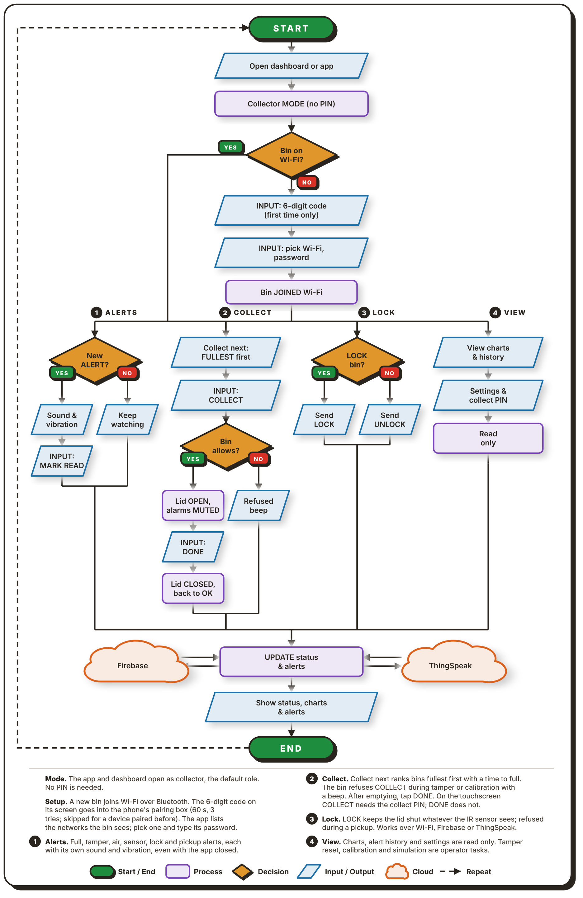
Note. As seen in Figure 42, the collector's job in the web dashboard or in the Android app.
The apps open in collector mode, the default, which needs no PIN. If the bin is not yet on Wi-Fi, the collector sets it up over Bluetooth. The 6 digit code displayed on the screen of the bin is entered into the pairing box of the phone (the code is valid for 60s, three wrong tries lock pairing for 60s, and a device paired before needs no code). The app then lists the Wi-Fi networks the bin can see, and the collector picks one and enters its password. After the bin joins the network, there are four tasks available.
Alerts (1) are issued for a full bin, tampering, bad air, lock and pickup. Each has its own sound and vibration, and they arrive even when the app is not in use. The primary task is collect (2). The Collection Priority list ranks the bins, with a full bin or the one that will be full soonest at the top, and shows the time to fill of each. The collector taps COLLECT in the app or on the screen, and enters the collect PIN at the bin. The lid opens and alarms stop. After emptying the bin, the collector taps DONE (no PIN needed), and the lid closes and the fill level resets. A bin refuses COLLECT, with a beep, while a tamper alarm or a calibration is on.
Lock (3) lets the collector lock or unlock a bin, while resetting a tamper alarm, calibration and simulation stay with the operator. View (4) displays the charts, alert history, and status and collect PIN in read-only mode. Every task ends with the same UPDATE step through Firebase and ThingSpeak, and the app updates the status.

2.5 Schematic Design
The circuit of each unit is drawn as one schematic split into three sheets: the microcontroller, the actuators and outputs, and the sensors and inputs. They appear in that order as Figures 43, 44 and 45. Instead of long wires between sheets, each connection to the ESP32 has a net label (IO25, etc.) and pins with the same net label are joined.
Figure 43
Schematic Diagram, Sheet 1: Microcontroller
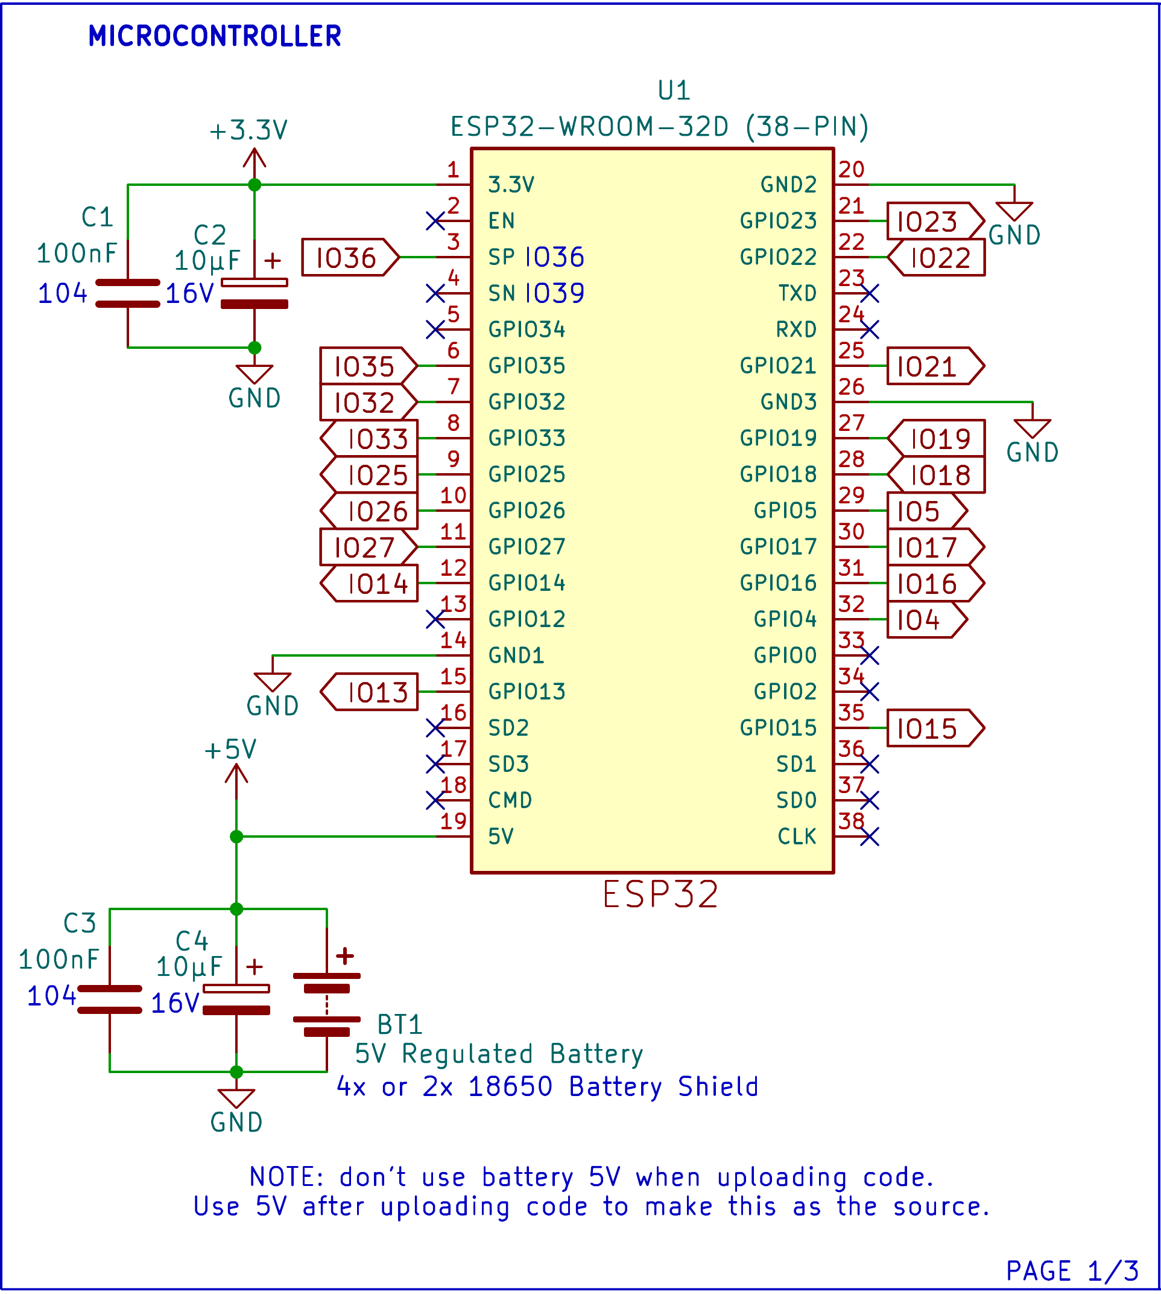
U1 is the ESP32-WROOM-32D on a 38-pin board. The 4x or 2x 18650-battery shield, BT1, provides the 3.3V rail for the sensors, the display and the buzzer (pin 1) and a regulated 5V to pin 19. C1 and C2 (100nF and 10µF) smooth the 3.3V rail, and C3 and C4 (100nF and 10µF) do the same at the battery input. The ground pins share one GND net. Unused pins (such as EN, TXD, RXD, GPIO0, GPIO2) are marked "no-connect". A note on the sheet says not to use the battery's 5V while code is being uploaded, only after the upload.
Figure 44
Schematic Diagram, Sheet 2: Actuators and Outputs
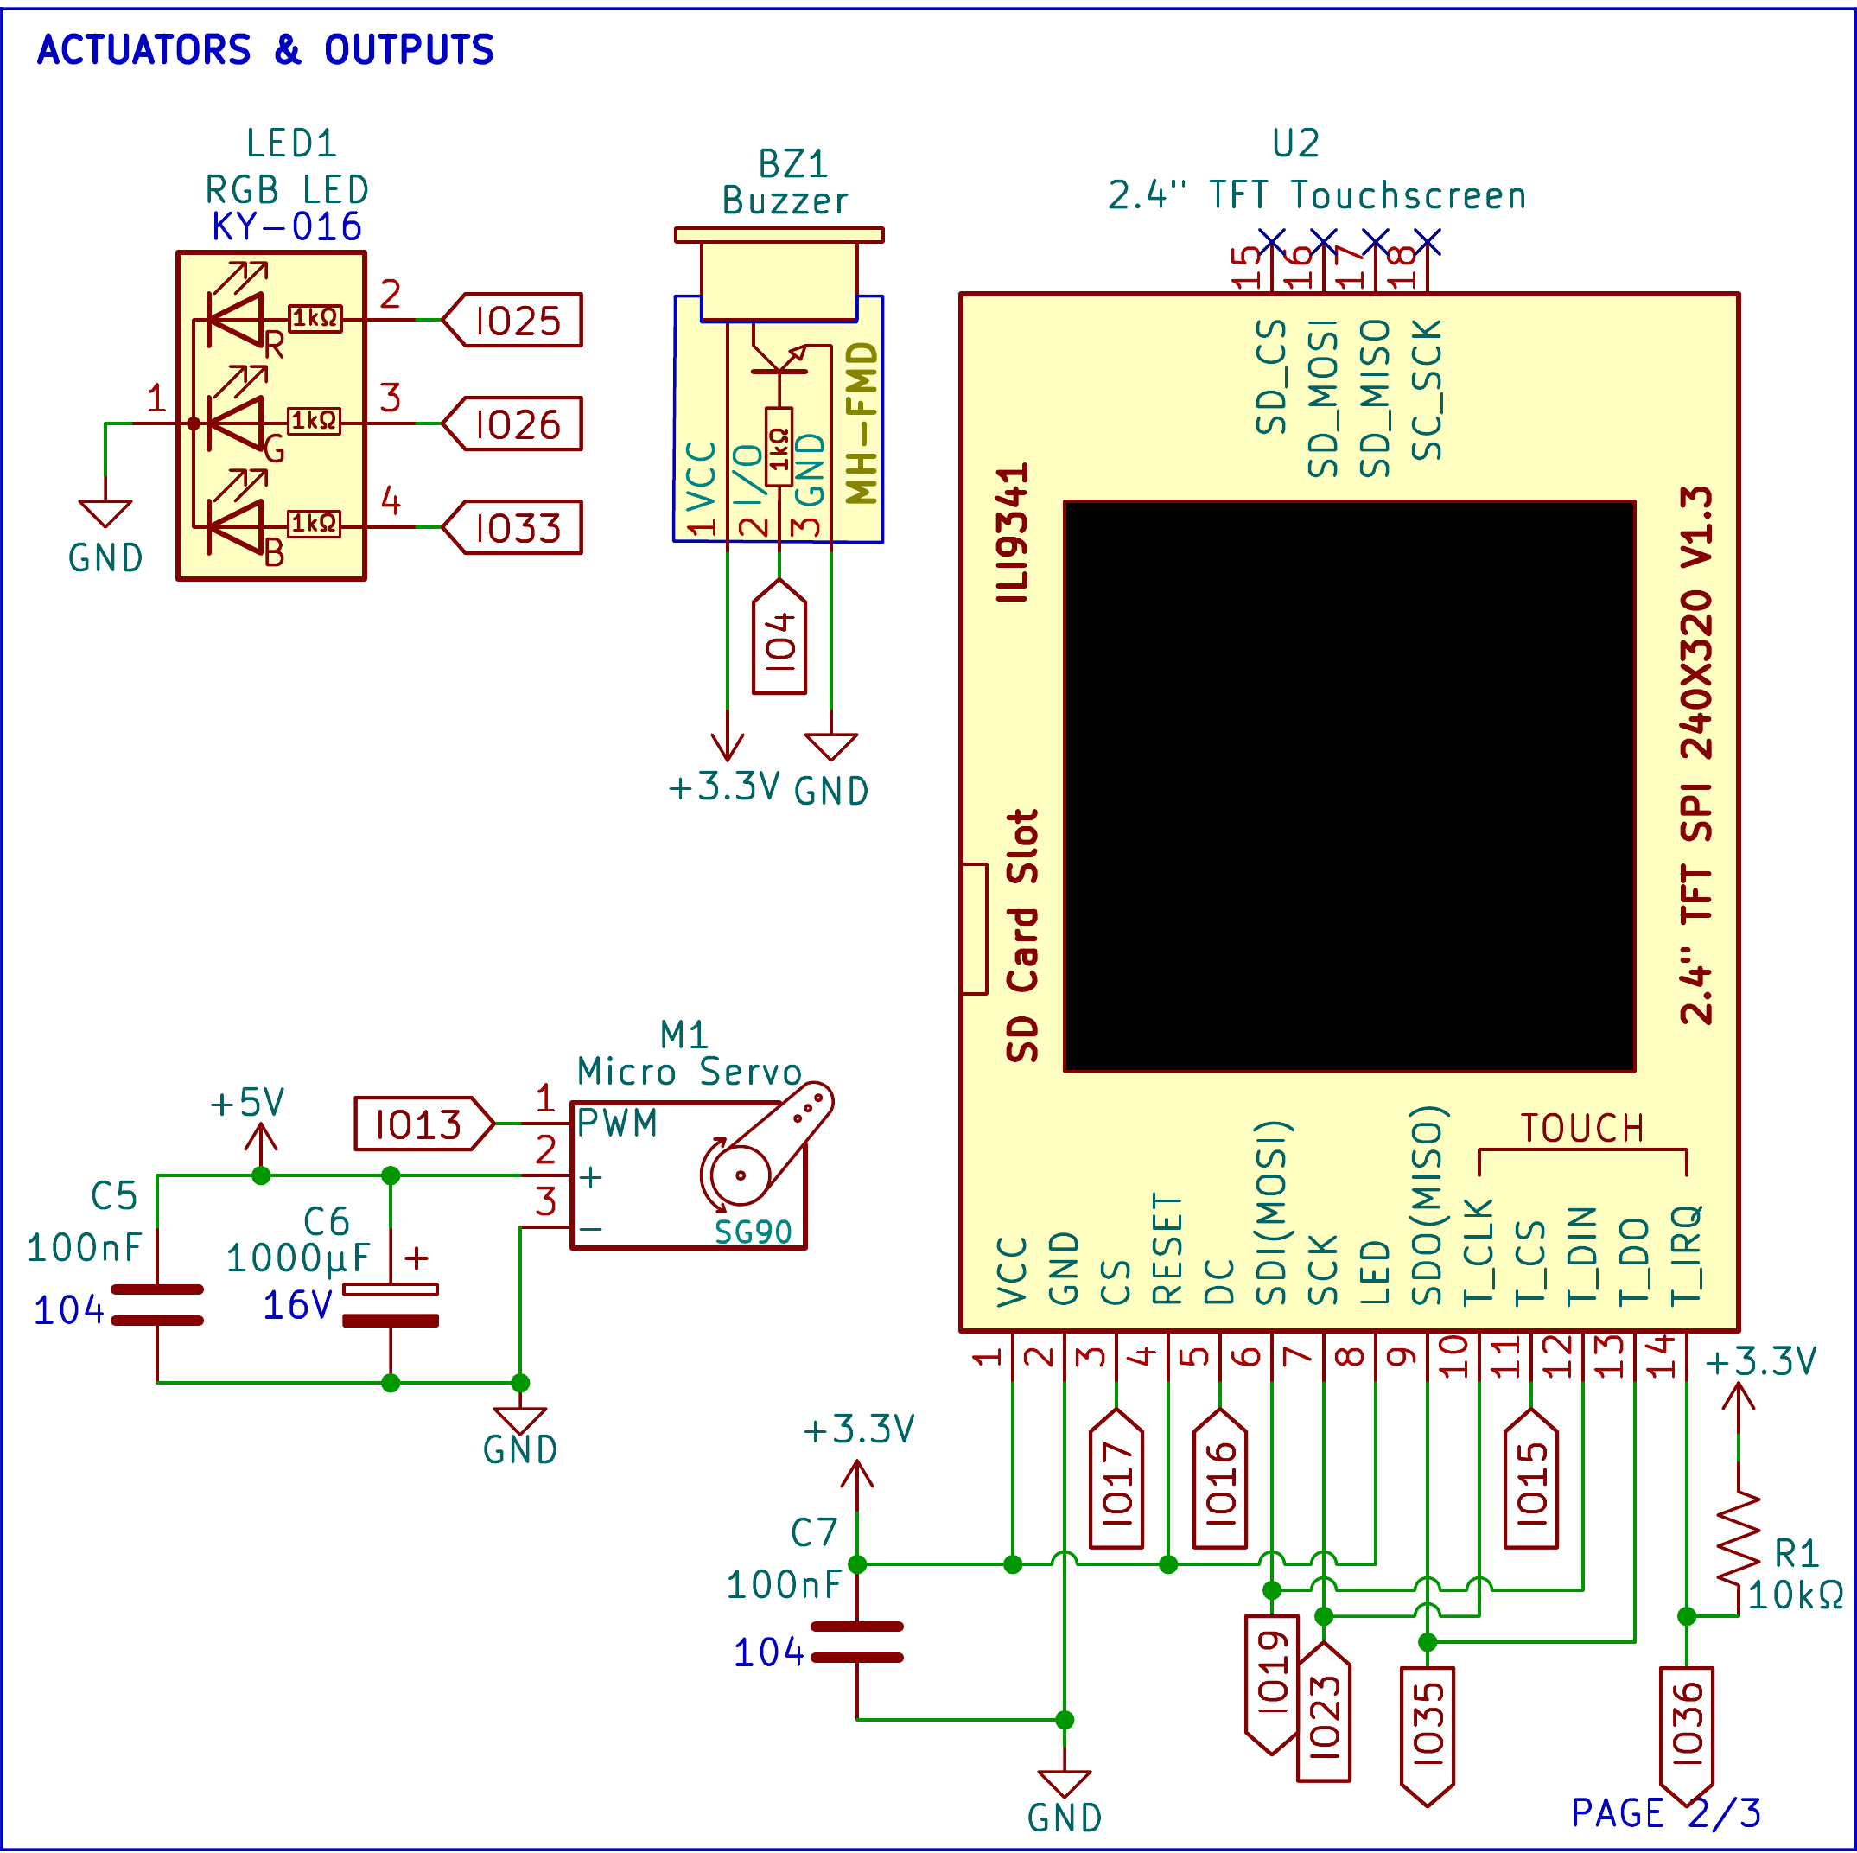
LED1 is a common cathode RGB LED KY-016. Its red, green and blue legs have 1kΩ resistors connected to IO25, IO26 and IO33. BZ1 is a buzzer module (MH-FMD) that operates on 3.3V and is controlled by IO4. The SG90 micro servo (M1) operates on the 5V power supply, and is controlled by IO13 via PWM, with C5 (100nF) and C6 (1000µF) placed across the power supply to filter current spikes as the servo moves.
U2 is the 2.4 in. ILI9341 touchscreen (240 × 320, SPI). It runs on 3.3V, with C7 (100nF) across its supply. The display and its touch controller share the SPI clock and data lines on IO19, IO23 and IO35, and each has its own chip select: IO17 for the display and IO15 for touch. DC goes to IO16 and the touch interrupt T_IRQ to IO36. R1 (10kΩ) pulls T_IRQ to 3.3V, so it stays high until a touch pulls it low. The RESET and the backlight pin (LED) are connected to 3.3V and the SD card pins are not connected.
Figure 45
Schematic Diagram, Sheet 3: Sensors and Inputs
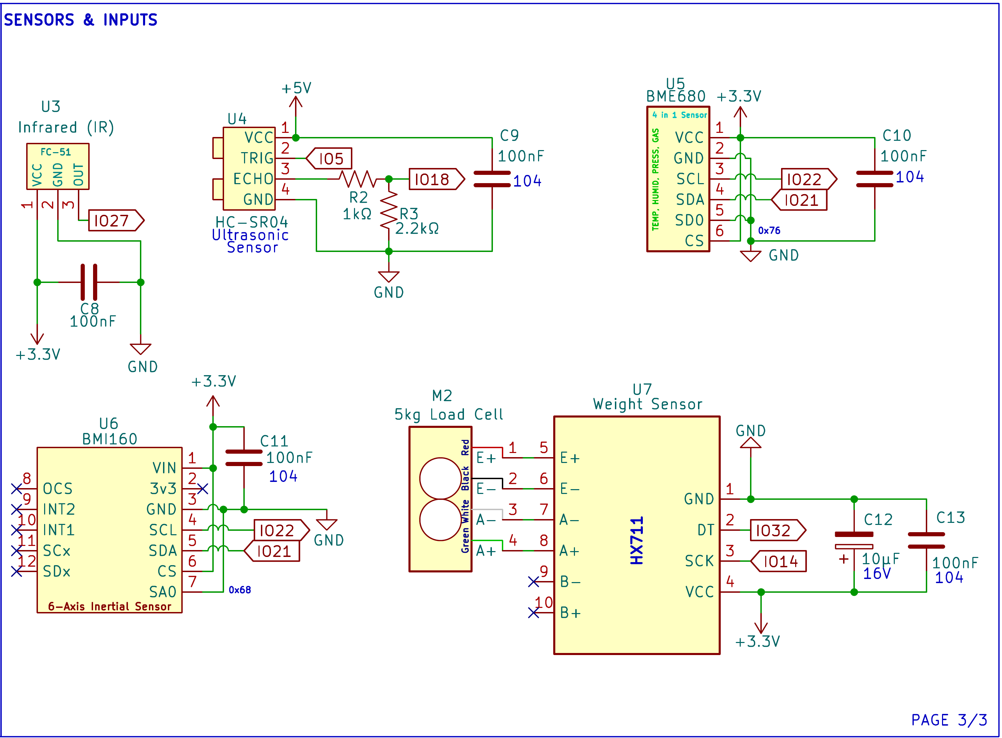
U3, the FC-51 IR obstacle sensor, runs on 3.3V and sends its active-low output to IO27, with C8 (100nF) across its supply. The HC-SR04 (U4) runs on 5V, with C9 (100nF) across its supply and TRIG on IO5. Its ECHO pin outputs a 5V pulse, which R2 (1kΩ) and R3 (2.2kΩ) divide to about 3.4V before IO18. That is close to the 3.3V level the ESP32 expects, and within the 3.6V it can tolerate.
U5 (BME680) and U6 (BMI160) both run on 3.3V, with C10 and C11 (100nF each) across their supplies, and share the I2C bus, with SCL on IO22 and SDA on IO21. Tying the BME680's SDO pin to ground sets its address to 0x76, and tying the BMI160's SA0 pin to ground sets its address to 0x68, so the two do not clash. M2, the 5kg load cell, connects its red, black, white and green wires to the E+, E−, A− and A+ inputs of U7, the HX711. The HX711 runs on 3.3V, with C12 (10µF) and C13 (100nF) across its supply, and sends its data on IO32 with its clock on IO14.

2.6 Component Materials
This section describes the main electronic parts used in each Smart-Bin unit. Both bins use the same parts except for the battery shield. Figures 46 to 56 show each part, followed by what it does and how the system uses it.
Figure 46
ESP32 DevKit V1 (38-Pin, ESP32-WROOM-32D)
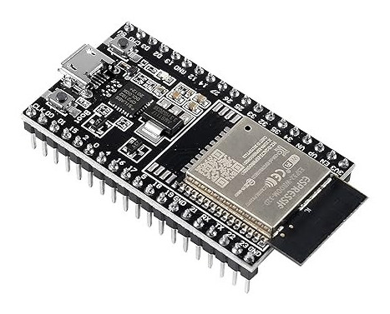
Note. Image from Sigmanortec (n.d.).
The ESP32 DevKit V1 is a development board built around the ESP32-WROOM-32D module. The module has a dual-core processor that runs at up to 240MHz, with Wi-Fi and Bluetooth on the same chip. The 38-pin board provides an additional USB connector for uploading code and power, a voltage regulator for 3.3V power and pin headers for breadboarding.
Each bin has one board, and that board runs everything in the bin. It reads all six inputs (the HC-SR04, IR sensor, BME680, BMI160, load cell and touchscreen), calculates the fill percentage, air quality reading and tamper state, and controls the servo, LED, buzzer and display. It serves the local REST API over Wi-Fi, takes commands from the dashboard and the Android app, and sends status updates to Firebase and ThingSpeak.
Figure 47
HC-SR04 Ultrasonic Distance Sensor
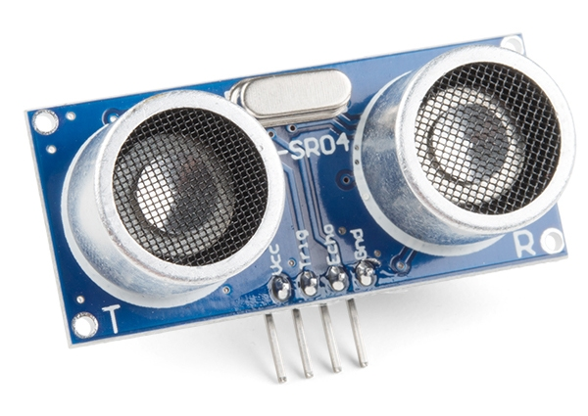
Note. Image from SparkFun Electronics (n.d.).
The HC-SR04 is a sound-based distance sensor. A short pulse on its TRIG pin makes it send a 40kHz ultrasonic burst, and it holds ECHO high until the echo returns. The width of that pulse gives the distance, from 2cm to 4m. The sensor runs on 5V.
In Smart-Bin it hangs behind the lid hinge and points down, so it measures the distance to the top of the trash. The firmware turns that distance into the fill percentage shown on the LED, the touchscreen and the apps, and starts the full-bin alert once the fill reaches the limit (80% by default). TRIG is wired to IO5, and ECHO is wired to IO18 through a divider of R2 (1kΩ) and R3 (2.2kΩ), which brings the 5V pulse down to about 3.4V, close to the 3.3V input level of the ESP32.
Figure 48
FC-51 IR Obstacle Avoidance Sensor
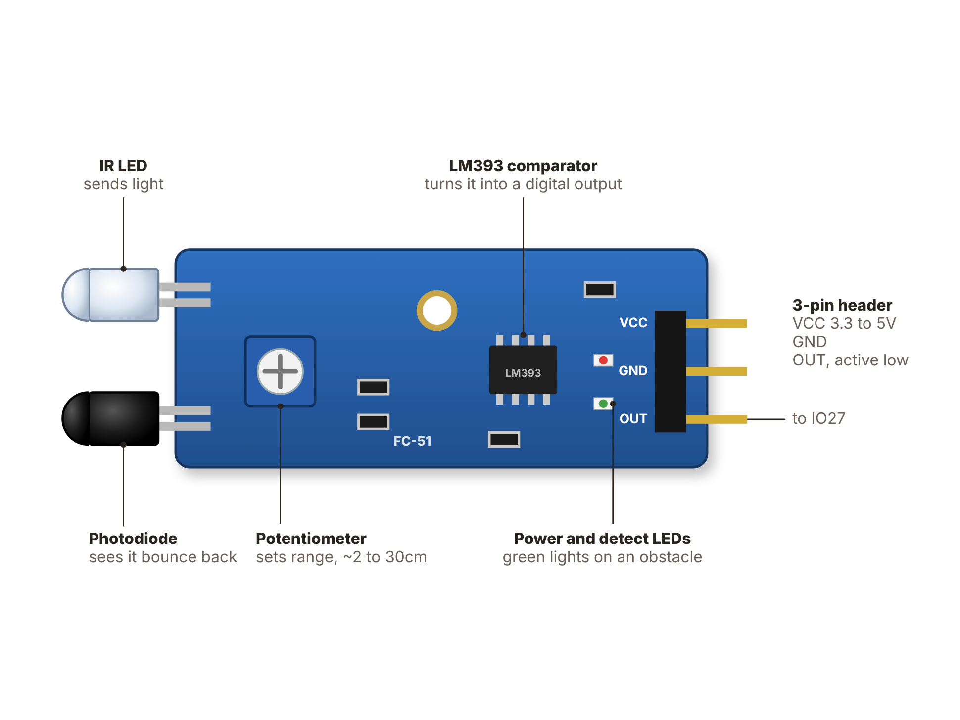
Note. Drawing of the module sold by Circuitrocks (n.d.-c).
The FC-51 is an infrared obstacle sensor. Its IR LED sends out light, a photodiode picks up what bounces back, and an LM393 comparator pulls the output "low" when something is in front. A blue trimmer sets the range (a few cm to about 30cm). It runs on 3.3V to 5V.
It is used by Smart-Bin to know when a hand is near the bin. When the output on IO27 goes low and the bin is available for opening, the bin beeps and the servo raises the lid and the user never has to touch it. The lid will close 5 seconds (user definable) after the hand leaves, and once closed it stays closed for 2 seconds (also user definable) so that it does not flicker open and shut. In COLLECT mode the sensor is ignored and the lid stays open while the collector works.
Figure 49
BME680 Environmental Sensor
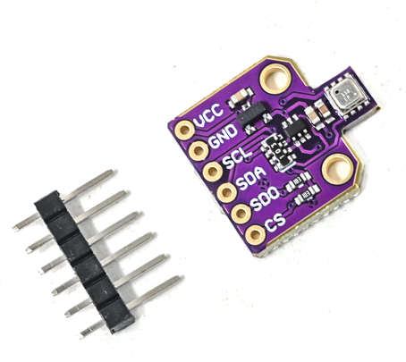
Note. Image from Robu.in (n.d.).
The BME680 is a single-chip sensor for temperature, humidity, VOC (volatile organic gases) and air pressure. Its gas reading gives an estimated indoor air quality (IAQ) rating. It is powered by 3.3V and communicates via I2C.
In Smart-Bin it monitors the air within the bin. When the temperature, humidity or estimated air quality goes over its limit, the firmware sounds an alarm and sends an alert, even if the bin isn't full yet, because a high temperature may mean a fire or hot material. It is located at I2C address 0x76 (SDO tied to ground).
Together, the temperature, humidity and gas reading (IAQ) tell the collector or operator how much trash is rotting in the bin, which matters in smell-sensitive areas. The IAQ value is an estimate from the gas reading, and it needs about 5 minutes after power-up to settle.
Figure 50
BMI160 Six-Axis Inertial Measurement Unit
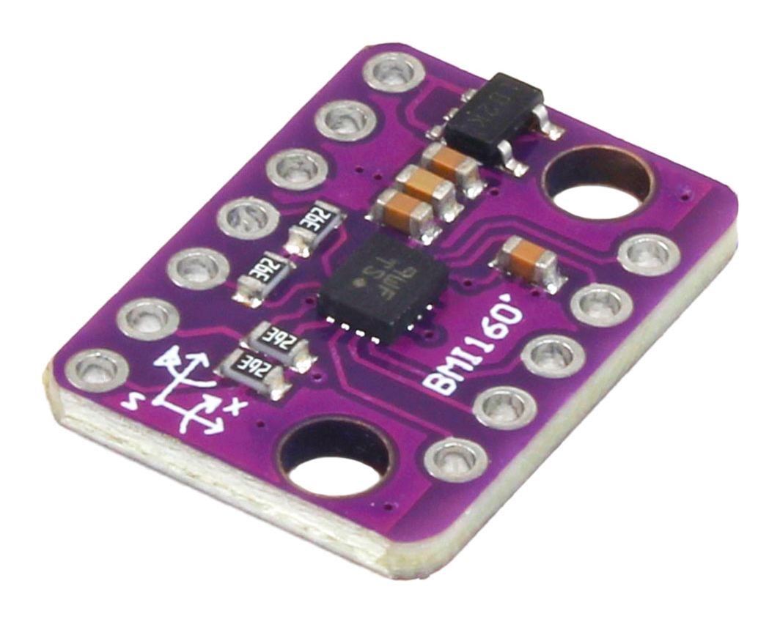
Note. Image from ElectroPeak (n.d.).
The BMI160 puts a 3-axis accelerometer and a 3-axis gyroscope on one chip. It senses acceleration and rotation, uses I2C and runs on 3.3V.
It is used by Smart-Bin for tamper detection. At every power-up the firmware saves the board’s pitch and roll as the upright position, so a bin that was set down at a slight angle does not start in the tamper alarm. The tilt is then measured from that saved position, and when it goes over the limit (30° by default) the firmware sets the Tamper alarm, activates the buzzer and prevents the lid opening. From the dashboard or the app an operator can see the saved angle, take the current angle as the new upright with USE NOW, type in a pitch and roll, or turn off the power-up capture to keep a fixed angle. It shares the I2C bus with the BME680 at address 0x68, set by tying SA0 to ground. The tamper check is paused during COLLECT mode.
Figure 51
HX711 Load Cell Amplifier and 5kg Load Cell
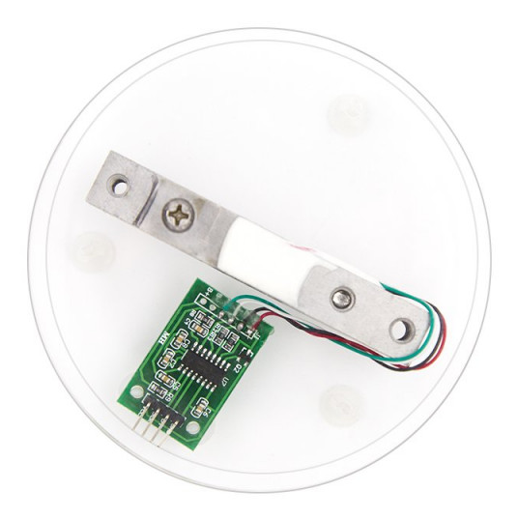
Note. The HX711 board and the 5kg load cell are shown on a display base. Image from ElectronicsComp.com (n.d.).
A load cell is a metal bar with strain gauges whose resistance changes slightly under load. This one is rated at 5kg. Its very small output voltage is amplified and converted by the 24-bit analog-to-digital converter on the HX711 board. The result is read by the ESP32 using two pins: DT (IO32) and SCK (IO14).
The two together measure the garbage. Weight is a second check on the fill level: wet waste can be heavy before the bin is full, and a bin full of light waste can be tall without being heavy. The weight is displayed on the dashboard and the app, and stored to the cloud with every measurement. The firmware also checks that the HX711 is connected. An unplugged board gives a flat or out-of-range reading, so after a few of these the bin reports “HX711 not answering” instead of a weight, the same way it flags a missing BME680 or BMI160.
Figure 52
SG90 Micro Servo Motor
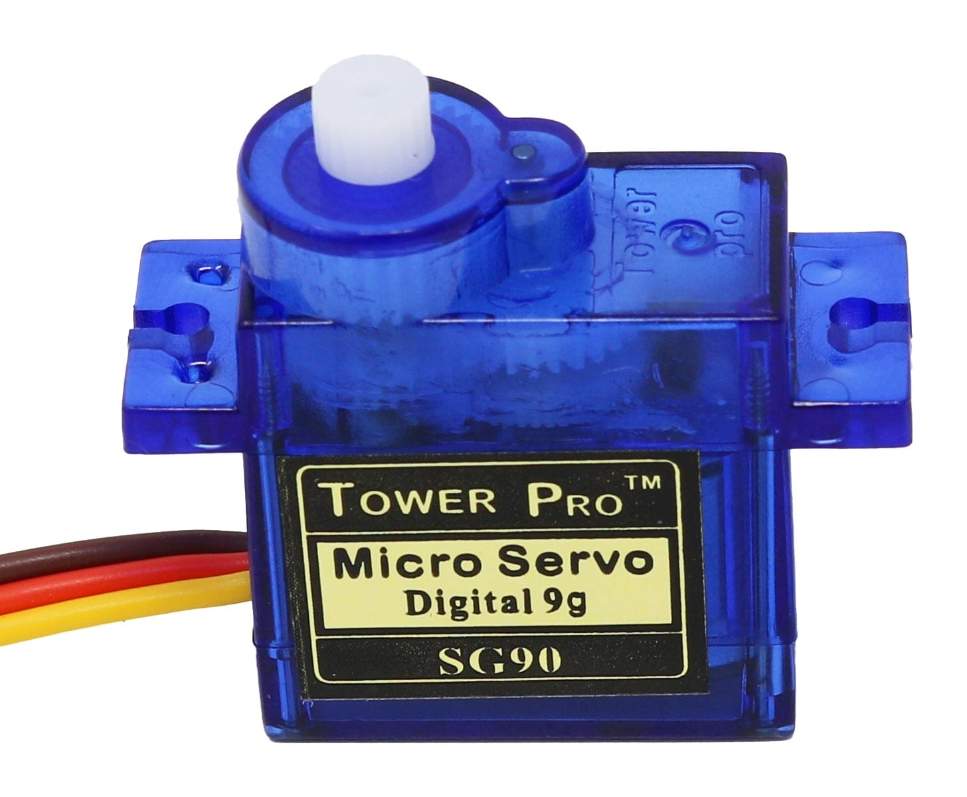
Note. Image from The Pi Hut (n.d.).
The SG90 is a small hobby servo that turns its arm to an angle set by the width of a PWM pulse, over a range of about 180 degrees. It runs on about 5V and mounts directly on the bin.
The servo opens and closes the lid under control of the ESP32. It opens when the IR sensor sees a hand or the collector taps COLLECT. It closes 5s (user settable) after the hand is gone or when the collector taps DONE, then stays closed for at least 2s (also user settable). When the bin is locked, full or flagged for tampering, the firmware keeps the servo in the closed position.
Figure 53
2.4-in. TFT Touchscreen (ILI9341 With XPT2046 Touch Controller)
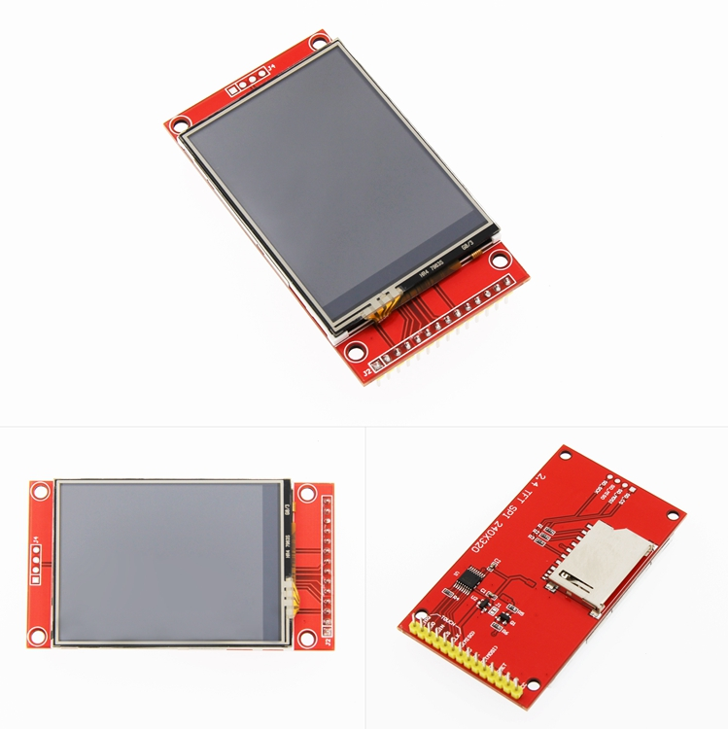
Note. Front, back, and angled views of the module. Image from LCDWIKI (n.d.).
This module is a 2.4 in., 240 × 320 color display driven by the ILI9341 controller over SPI. A separate XPT2046 controller on the same SPI bus reads the resistive touch layer on top. The board also has an SD card slot, which Smart-Bin does not use.
The display is the bin's own screen. It shows the fill level, sensor readings and the bin status (LOCKED and TAMPER). The touch layer provides the collector with the buttons COLLECT, PIN and DONE, making it possible to empty a bin without the app.
Figure 54
KY-016 RGB LED Module
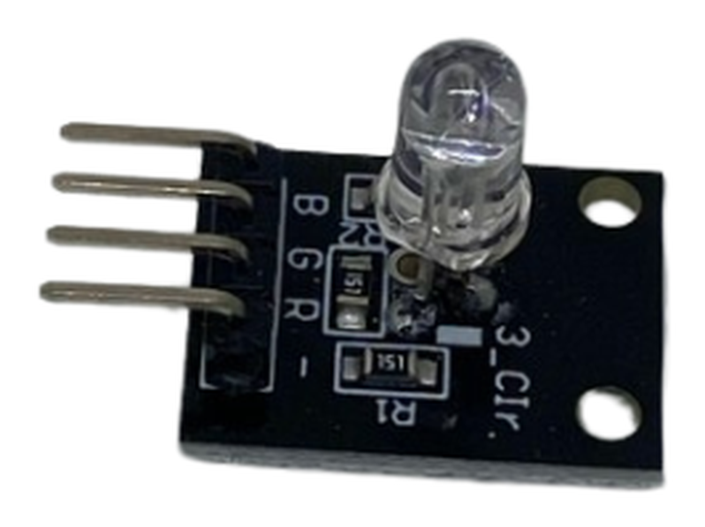
Note. Image from Circuitrocks (n.d.-d).
The KY-016 is a small board with a common-cathode RGB LED, a small package containing the red, green and blue chips. Mixing them gives other colors, such as amber (red + green). A 1kΩ resistor is used for each colour to control the current.
The LED shows the fill level: green while there is room, amber as the bin fills and red when it is full or a warning is on. It is driven from IO25, IO26 and IO33 and turns green again after the collector taps DONE.
Figure 55
Passive Buzzer Module (MH-FMD)
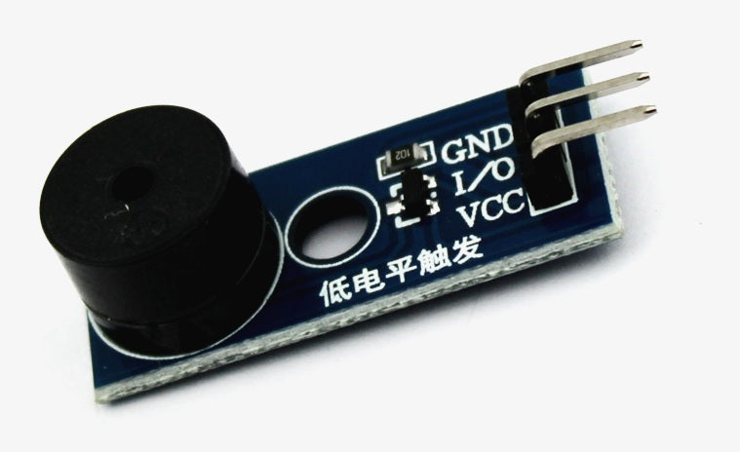
Note. Image from QuartzComponents (n.d.).
A passive buzzer has no built-in oscillator, so it sounds only when the controller drives it with a changing signal. That lets the firmware play different tones and patterns instead of a single beep.
Smart-Bin drives it from IO4 for sound feedback. It beeps when the lid opens, sounds an alert when the BME680 senses high temperature, high humidity or poor air, and plays the siren when the BMI160 senses tampering. It stays quiet in COLLECT mode.
Figure 56
18650-Battery Shields for Bin A (4-Cell) and Bin B (2-Cell)
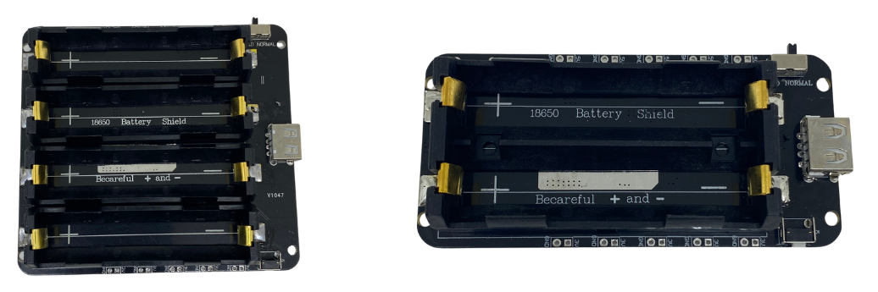
Note. Left: four-cell shield used in Bin A (Circuitrocks, n.d.-b). Right: two-cell shield used in Bin B (Circuitrocks, n.d.-a).
The 18650-battery shield holds lithium-ion 18650 cells and converts their voltage to a regulated 5V output. It also has a USB port for charging the cells. Bin A uses a four-cell V9 shield (5V/3A) and Bin B a two-cell shield.
The shield powers the whole bin without a wall outlet, so a bin can stand anywhere with Wi-Fi. It sits in a closed compartment and feeds the 5V of the ESP32, which supplies 3.3V to the sensors. As the schematic notes, the battery should not be connected while code is uploaded over USB.

III. TESTING, RESULTS, AND CONCLUSION

3.1 Test Cases
The tests in this chapter were run on the two built units, Bin A (bin01) and Bin B (bin02), in one day, November 2, 2026. Both ran firmware version 1.0.0 from the main branch of the project repository and were connected to the same 2.4GHz Wi-Fi router. The web dashboard was opened in Chrome on a laptop on that network, and the Android app, version 3.1, ran on a phone that used either the same Wi-Fi or mobile data, depending on the test. Unless a test says otherwise, the bins kept their default settings: an empty distance of 30cm and a full distance of 5cm, which leaves 25cm of usable height, a fill limit of 80%, a temperature limit of 40°C, a humidity limit of 85%, an IAQ limit of 200, a tilt limit of 30°, a lid open time of 5s and a lid close time of 2s.
Each specific objective in Section 1.4 is checked by six test cases, 18 in all, numbered TC1.1 to TC3.6. A test case names what is tested, the steps, the pass criterion and the number of trials. The criteria were fixed before the first trial. Some come straight from the firmware, such as the 10s tamper countdown and the 90s after which the apps call a bin lost. The others were set with related studies in mind, for example the fill error within ±3% reported by Alnanih et al. (2025) and the weight error of 0.15% in Saad et al. (2023), and were loosened a little for a table-size prototype with low-cost sensors. Table 7 lists the instruments used as references, and Figure 57 shows the two built units.
Table 7
Reference Instruments Used in the Tests
Instrument | Used for | Resolution
Steel ruler fixed to the inside wall of the chamber | Real fill height in TC1.1 and TC3.2 | 1mm
Digital kitchen scale | Checking the test masses before TC1.2 | 1g
Test masses (sealed bags of sand) | Known loads of 100, 500, 1000, 2000 and 4000g in TC1.2, and 500g in TC2.1 | 1g
Digital thermo-hygrometer | Reference temperature and humidity in TC1.3 | 0.1°C and 1%
Inclinometer app on a phone, laid on top of the bin | Tilt angle in TC1.5 | 0.1°
Phone camera at 60 frames per second | Response times of the lid, the screens and the apps in TC1.6, TC2.1 and TC3.3 | About 17ms
Stopwatch | Warm-up, alert, offline and time-to-full times in TC1.4, TC2.3, TC2.4 and TC3.2 | 0.01s

Figure 57
The Two Built Smart-Bin Units
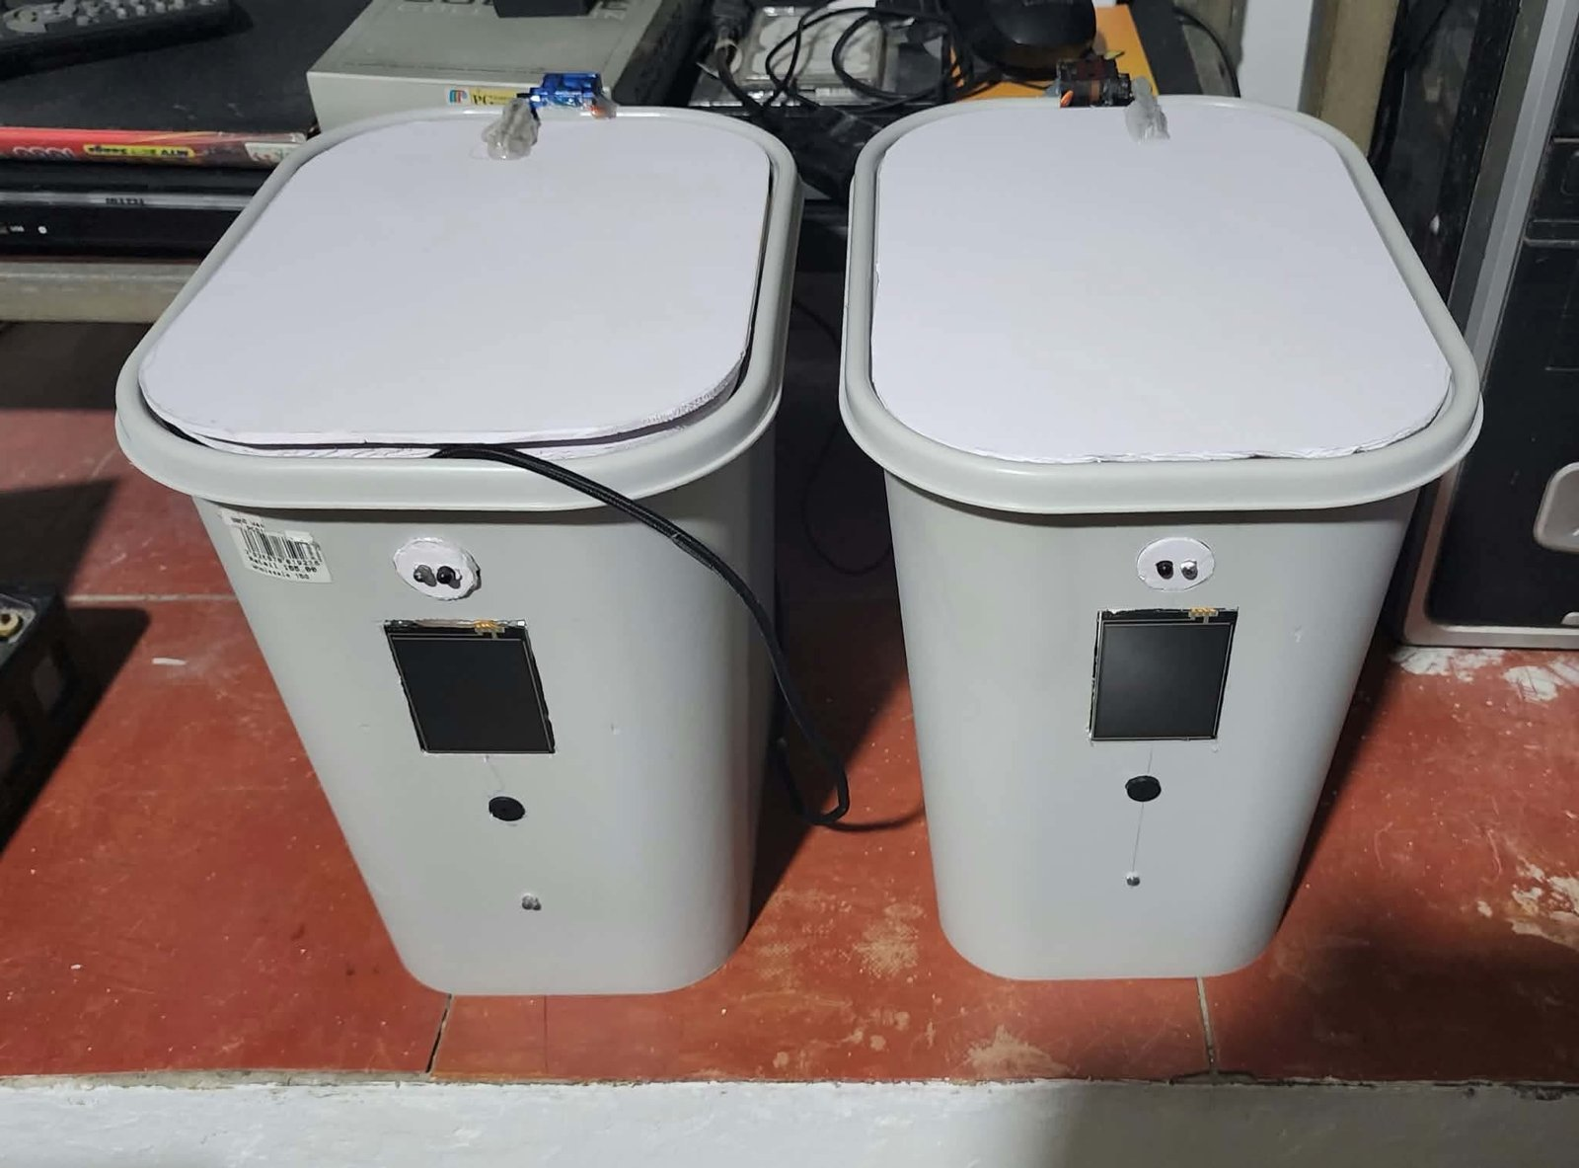

Figure 58 shows the inside of Bin A. From above (a), the servo and the HC-SR04 sit together on the strip at the hinge, with the sensor facing down into the chamber. The compartment (b) holds the perfboard with the ESP32, the BME680 and BMI160 modules beside it, and the battery shield with its four 18650 cells behind the board.
Figure 58
Inside Bin A: Trash Chamber From Above (a) and Controller and Battery Compartment (b)
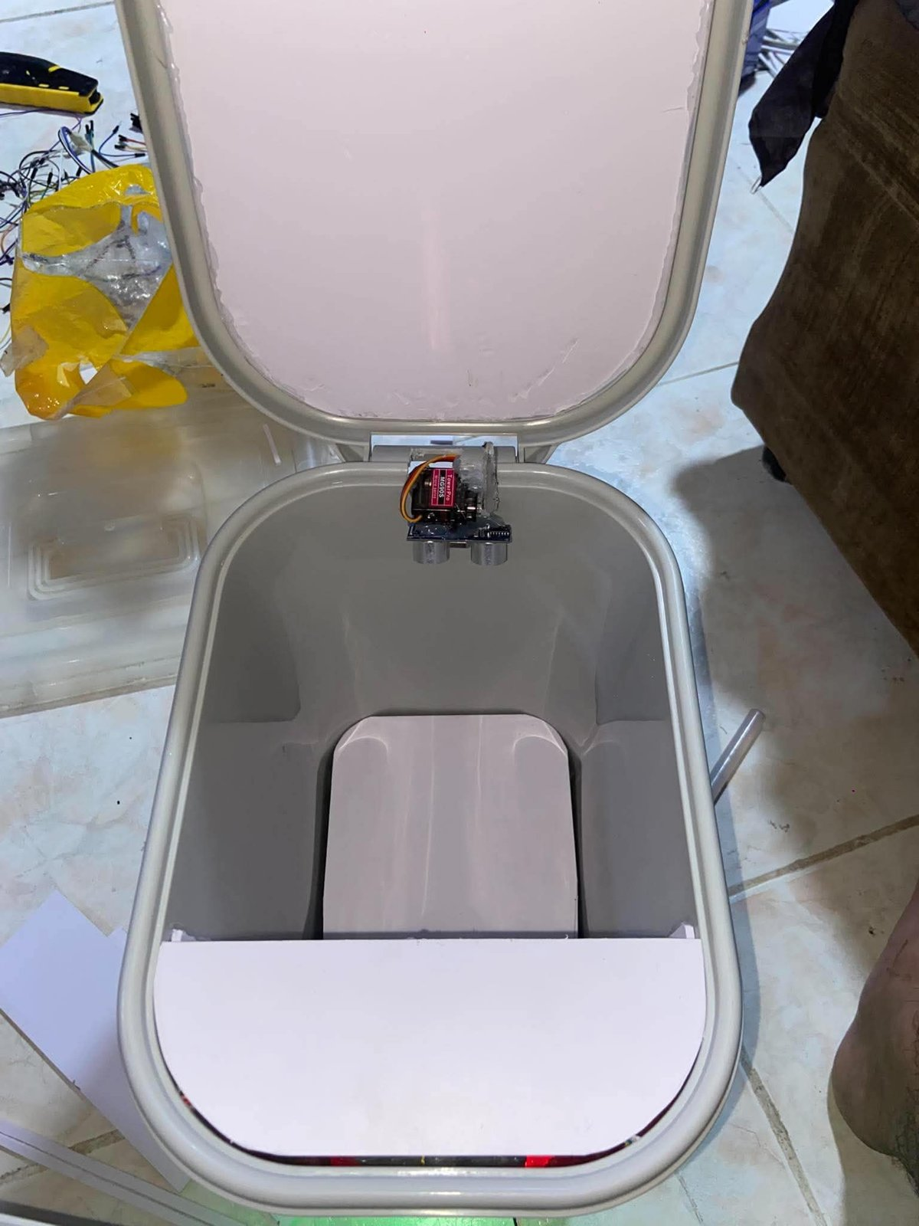  (a) | 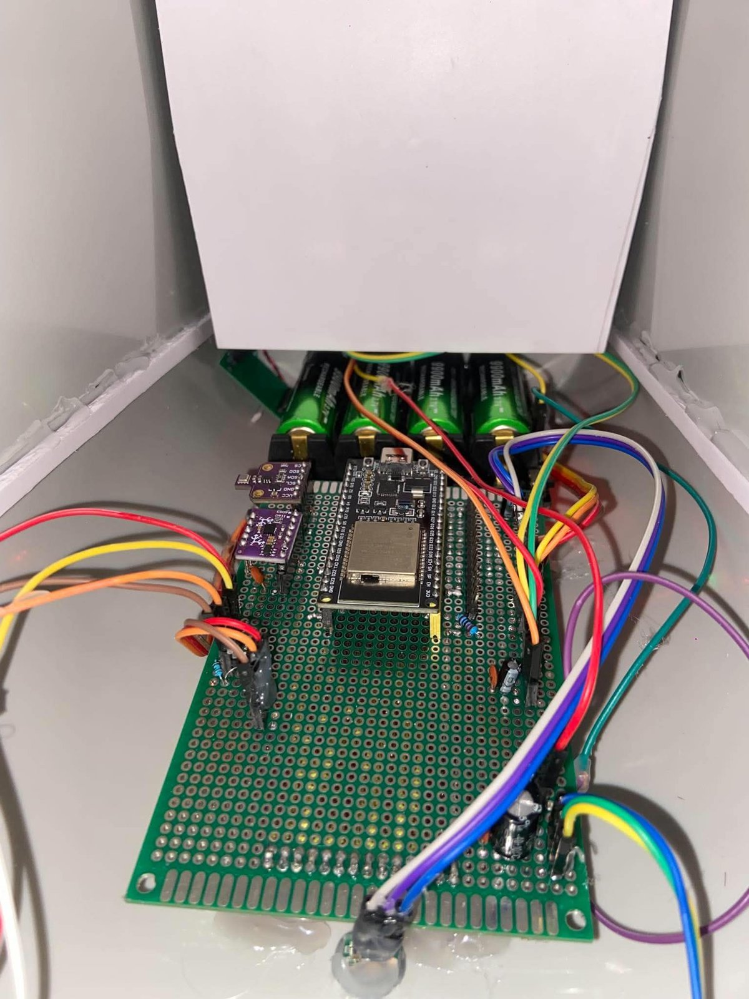  (b)

Specific Objective 1: Sensor Monitoring and Detection
The six test cases for the first objective check that each sensor reads close to a reference and that the lid and the tamper alarm act at the right moment (Table 8). Fill and weight are tested at five points across their range. The air test is a response test, not an accuracy test, because the IAQ value of the BME680 is an estimate made from the gas resistance and the project has no reference instrument for it.
Table 8
Test Cases for Specific Objective 1: Sensor Monitoring and Detection
ID | Test | Procedure | Pass criterion | Trials
TC1.1 | Fill accuracy | With the empty and full distances calibrated, fill the bin with crumpled paper to 0, 25, 50, 75 and 100% of the usable height, read on the ruler. At each level, record the fill percentage on the dashboard. | Error of at most 5 percentage points | 1 per level, per bin (10)
TC1.2 | Weight accuracy | Tare the bin, then place the test masses of 100, 500, 1000, 2000 and 4000g on the platform one at a time and record the weight on the dashboard. | Error of at most 50g | 1 per mass, per bin (10)
TC1.3 | Temperature and humidity | With the default temperature offset of −2°C, place the thermo-hygrometer inside the chamber and compare both readings every 20 minutes for an hour. | Temperature within ±1°C and humidity within ±5% | 3 per bin (6)
TC1.4 | Air quality response | Wait for the 5-minute warm-up to end. Place an open container of food scraps in the bin and close the lid. Repeat with an alcohol swab. | IAQ estimate rises past 200 and the air alert appears; no air alert during the warm-up | 1 per source, per bin (4)
TC1.5 | Tamper | Tilt the bin to 15, 25, 35 and 45° and set it upright again within 10s. Then hold it at 35° for more than 10s, set it upright and press RESET TAMPER. | No countdown at 15 and 25°. At 35 and 45° the 10s countdown starts and setting the bin upright clears it. A bin left tilted latches the siren, repeated every 2s, until RESET TAMPER | 1 per angle, per bin (8), and 1 held trial per bin (2)
TC1.6 | Automatic lid | Hold a hand in front of the IR sensor at 5, 15 and 25cm, then take it away. Watch for a second opening after the lid closes. | Lid opens within 1s, closes 5s ±0.5s after the hand leaves, and does not reopen by itself | 1 per distance, per bin (6)

Specific Objective 2: Real-Time Monitoring and Alerts
The second objective is about getting the readings to people. TC2.1 and TC2.2 time the path from a bin to the dashboard, the app and the two clouds. TC2.3 and TC2.4 check the alerts, including the one raised when a bin stops answering, and TC2.5 and TC2.6 check that each role sees the right controls and that two bins are never mixed up (Table 9). In TC2.3 the app is in the background, not swiped away, since Android ends the app's watch service, and with it the alerts, when the app is removed from the recent apps.
Table 9
Test Cases for Specific Objective 2: Real-Time Monitoring and Alerts
ID | Test | Procedure | Pass criterion | Trials
TC2.1 | Live latency | Place the 500g mass on the platform and time, on a 60 frames per second video, how long the dashboard and the app take to show the change. Repeat with the phone on mobile data, so that the app reads Firebase. | At most 2s over the local Wi-Fi and at most 10s through Firebase | 2 per path (6)
TC2.2 | Cloud logging | Run each bin for 30 minutes: 15 minutes with a reading changing every minute, then 15 minutes untouched. Compare the ThingSpeak entry times with the Firebase status. | An entry every 30s ±5s while readings change and every 5 minutes ±5s while they stay the same; Firebase matches the latest entry | 1 run per bin (2)
TC2.3 | Alert delivery | With the app in the background, raise a full bin, bad air and high temperature from the Simulation tab, and a real tamper by tilting the bin. Time from the event to the phone notification. | Notification on the phone and banner on the dashboard within 20s | 2 per alert type (8)
TC2.4 | Offline detection | Switch off one bin and time how long the apps take to call it lost, then switch it on again. | Bin shown as lost with an offline alert about 90s after its last reading, and shown as back after it reconnects | 1 per bin (2)
TC2.5 | Role access | Go through every control of the dashboard and the app as a collector, then again after entering the operator PIN. | A collector can see alerts and charts, run COLLECT and DONE, LOCK and UNLOCK and set up Wi-Fi, but cannot reach RESET TAMPER, calibration, touch calibration or simulation. An operator can reach all of them | 1 checklist per interface (2)
TC2.6 | Two bins at once | Put Bin A and Bin B in different states, for example Bin A full and Bin B tilted, and check every screen. | Each bin shows its own state with no mix-up | 3 combinations

Specific Objective 3: Bin Control and Collection Prioritization
The last six test cases cover what the operator and the collector do with the readings: the order of the Collection Priority list, the time-to-full estimate behind it, remote locking, the PIN collection on the touchscreen, simulation and calibration (Table 10). The priority tags follow the same rules in the dashboard and the app. A bin at or over the fill limit is tagged NOW, then SOON if it will reach the limit in under 2 hours, TODAY if under 8 hours, LATER if it will take longer and IDLE if it is not filling.
Table 10
Test Cases for Specific Objective 3: Bin Control and Collection Prioritization
ID | Test | Procedure | Pass criterion | Trials
TC3.1 | Priority order | Set fill pairs for the two bins in the Simulation tab, raising each fill step by step for at least 5 minutes so that the bins have a fill rate, and read the Collection Priority list on both interfaces. | A bin at or over the fill limit is first; otherwise the bin that reaches the limit first is on top, with the right tag | 10 combinations
TC3.2 | Time to full | Fill Bin A by hand at a steady rate from about 40%. After 15 minutes, note the estimated time to full, then record when the bin actually reaches 80%. | Error of at most 15% | 3 runs
TC3.3 | LOCK and UNLOCK | Lock the bin from the dashboard and hold a hand at the IR sensor, then unlock it and wave again. Repeat from the app on mobile data. Repeat with auto-lock on and the bin filled past 80%. | Lid stays shut while locked; the bin responds within 2s locally and within 10s through Firebase; with auto-lock on, the bin locks itself at the fill limit | 2 per path (4), and 2 auto-lock trials
TC3.4 | PIN collect | On the touchscreen, enter a wrong PIN, then the correct 4-digit PIN, empty the bin and press DONE. | Wrong PIN: error and the lid stays shut. Correct PIN: the lid opens and COLLECTING is shown. DONE: the lid closes, the pickup is logged and the bin is back to normal | 2 per bin (4)
TC3.5 | Simulation | Set the fill to MANUAL at 90% from the dashboard, then back to AUTO. Repeat for temperature, IAQ and tilt. | Simulation banner and the matching alert appear; the real reading returns on AUTO | 1 per sensor (4)
TC3.6 | Calibration | Change the empty and full distances, the fill limit and the lid open time in the settings, check that they apply, then restart the bin. | New values apply without reflashing and are still there after the restart | 1 per bin (2)

3.2 Results and Discussion
The results are reported by objective, with one table for each test case or group of related test cases, and all 18 are brought together in Table 24 at the end. Three measures are used. The mean absolute error (MAE) is the average of |shown − actual| over all trials of a test case. The percent error of a reading is |shown − actual| / actual × 100. The pass rate is the number of trials that met the pass criterion, divided by the number of trials, times 100.

Results for Specific Objective 1
Table 11 gives the fill readings. Both bins stayed within 2 percentage points at the three middle levels, and the MAE over all 10 trials was 1.8 points, or about 0.45cm of the 25cm usable height. The one failure came at 100% in Bin B, which showed 94% with the chamber full. Crumpled paper leaves gaps at the top, and the HC-SR04 can measure to the bottom of a gap as easily as to the top of a sheet. Pressing the paper down and reading again gave 98%, so the error came from the surface of the trash and not from the sensor or the calibration.
Table 11
Fill Level Readings Against the Ruler (TC1.1)
Real level (%) | Real distance (cm) | Bin A (%) | Bin B (%) | Max error (points) | Passed
0 | 30.0 | 1 | 2 | 2 | 2/2
25 | 23.8 | 27 | 24 | 2 | 2/2
50 | 17.5 | 52 | 49 | 2 | 2/2
75 | 11.3 | 76 | 74 | 1 | 2/2
100 | 5.0 | 99 | 94 | 6 | 1/2
Note. Real distance is from the sensor to the top of the paper. One percentage point is 0.25cm. MAE: Bin A 1.4 points, Bin B 2.2 points, both bins 1.8 points.
The load cell results are in Table 12. Every trial was inside the 50g band. The error grew with the mass, and Bin B read low by about 1% at every mass from 500g up. Its error grew in step with the mass, so the offset is in its calibration factor, not in noise. Repeating the weight calibration of Bin B with a heavier known mass would likely remove most of it. The worst trial, at 4000g, was 39g off. That still passes, but it leaves little margin near the 4500g capacity of the bin.
Table 12
Weight Readings Against the Test Masses (TC1.2)
Mass (g) | Bin A (g) | Bin B (g) | Max error (g) | Mean percent error (%) | Passed
100 | 102 | 97 | 3 | 2.5 | 2/2
500 | 504 | 493 | 7 | 1.1 | 2/2
1000 | 1008 | 991 | 9 | 0.9 | 2/2
2000 | 2013 | 1984 | 16 | 0.7 | 2/2
4000 | 4027 | 3961 | 39 | 0.8 | 2/2
Note. The masses were checked on the kitchen scale before the test. MAE: Bin A 10.8g, Bin B 14.8g, both bins 12.8g.
Table 13 compares the BME680 with the thermo-hygrometer. With the −2°C offset that the firmware applies by default, the temperature stayed within 1°C in all 6 readings. A check without the offset at the start of the hour showed the BME680 about 2°C warm, which is the heat of the ESP32 and the regulator near it. Humidity was within 5% in every reading. Bin B read a little further from the reference on both, but the gap between the bins, 0.2°C and 0.9%, is smaller than the 1% resolution of the reference for humidity.
Table 13
Temperature and Humidity Against the Thermo-Hygrometer (TC1.3)
Bin | Reference range | Temperature MAE (°C) | Temperature max error (°C) | Humidity MAE (%) | Humidity max error (%) | Passed
Bin A | 29.6 to 31.2°C, 58 to 66% | 0.4 | 0.8 | 2.1 | 3.9 | 3/3
Bin B | 29.4 to 31.0°C, 59 to 66% | 0.6 | 0.9 | 3.0 | 4.6 | 3/3
Note. One reading every 20 minutes for an hour, with the reference placed inside the chamber.
The air test is summarized in Table 14. During the first 5 minutes after power-up, both interfaces showed the air value as warming up and no air alert was raised, even in one extra trial where the swab went into the bin in the second minute. After the warm-up the IAQ estimate rested between 58 and 74. Food scraps took 6 to 8 minutes to push it past 200, and the air alert appeared every time. The alcohol swab crossed the limit in about a minute and pushed the estimate much higher, which fits a gas sensor that reacts strongly to alcohol vapor. This shows that the bin notices a smell building up in a closed chamber within minutes. It does not show what the smell is or how strong it is in standard units, and both apps label the value as an estimate for that reason.
Table 14
Air Quality Response After the Warm-Up (TC1.4)
Source | Bin | Resting IAQ | Peak IAQ | Time to pass 200 (s) | Air alert | Passed
Food scraps | Bin A | 61 | 268 | 370 | 1/1 | 1/1
Food scraps | Bin B | 74 | 241 | 460 | 1/1 | 1/1
Alcohol swab | Bin A | 58 | 412 | 45 | 1/1 | 1/1
Alcohol swab | Bin B | 70 | 389 | 65 | 1/1 | 1/1
Note. Times are from closing the lid on the source. The bin was aired out for 10 minutes between trials.
The tamper results are in Table 15. No countdown started at 15 or 25°, and every trial at 35 and 45° started one within 1s of passing the angle. It started a little later at 35° than at 45° because the firmware smooths the tilt reading, and a bin tipped slowly to 35° takes longer to read past the 30° limit. Setting the bin upright inside the 10s always cleared the countdown with the settle beep. In the two held trials, the siren latched and repeated every 2s, the tamper alert reached the app, and the siren kept going after the bin was upright until RESET TAMPER was pressed. The phone inclinometer and the BMI160 agreed within about 1° once the bin had stopped moving. The bins were switched on standing on the test table, since the upright reference is taken again at every power-up.
Table 15
Tamper Detection by Tilt Angle (TC1.5)
Tilt | Countdown started | Mean time to start (s) | Outcome | Passed
15°, set upright | 0/2 | – | No countdown, as expected | 2/2
25°, set upright | 0/2 | – | No countdown, as expected | 2/2
35°, set upright within 10s | 2/2 | 0.8 | Countdown cleared with the settle beep | 2/2
45°, set upright within 10s | 2/2 | 0.5 | Countdown cleared with the settle beep | 2/2
35°, held past 10s | 2/2 | 0.8 | Siren latched every 2s, alert in the app, cleared only by RESET TAMPER | 2/2
Note. Each row has 1 trial per bin. Angles were read on the phone inclinometer.
Table 16 gives the lid results, and Figure 59 shows one trial: a hand held in front of the IR sensor with the lid still shut (a), and the lid raised by the servo a moment later (b). The lid opened in all 4 trials at 5 and 15cm and in 1 of 2 at 25cm. The miss was on Bin B, with a dark palm held at an angle near the edge of the range, where too little of the IR light bounced back to the photodiode behind the front panel. The lid took 0.5 to 0.7s to open on average, most of it the servo travel. Measured from the moment the hand left, the lid closed after 5.1 to 5.2s, which is the 5s setting plus the 80ms the firmware waits before it accepts a change on the sensor output. The sensor has no hold time of its own, and the close matched the motion indicator on the dashboard within 0.2s. None of the 6 cycles reopened by itself, which confirms the change described next.
Table 16
Automatic Lid Response by Hand Distance (TC1.6)
Hand distance | Opened | Mean time to open (s) | Mean close after hand left (s) | Reopened by itself | Passed
5cm | 2/2 | 0.5 | 5.1 | 0 | 2/2
15cm | 2/2 | 0.6 | 5.2 | 0 | 2/2
25cm | 1/2 | 0.7 | 5.1 | 0 | 1/2
Note. Times were read from a 60 frames per second video. Each row has 1 trial per bin.
Figure 59
Lid Test: Hand in Front of the IR Sensor (a) and the Lid Opened (b)
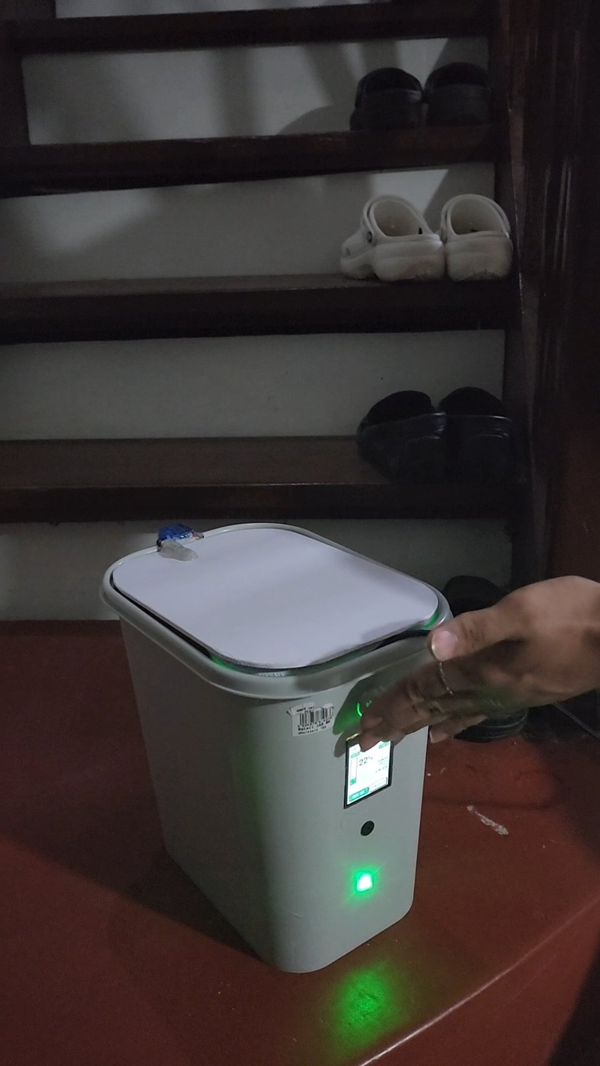  (a) | 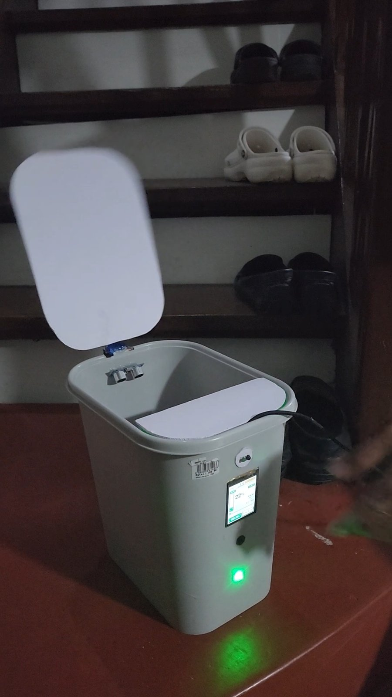  (b)

Lid Reopening Fix
The first cloud test on Bin 01, described under the results for Specific Objective 2, also showed the lid reopening by itself after it closed. The servo that closes the lid retriggered the PIR sensor, which then held its output high for a few seconds, and the firmware read that as a new person at the bin. The PIR was replaced with an FC-51 IR obstacle sensor that reacts only to something in front of it at that moment, so the closing movement no longer starts another cycle. Figure 60 shows Bin 01 during that first test, with the round PIR lens above the touchscreen and LID HOLDING (motion) on the screen while the lid stayed up.
Figure 60
Bin 01 With the Original PIR Sensor During the First Test
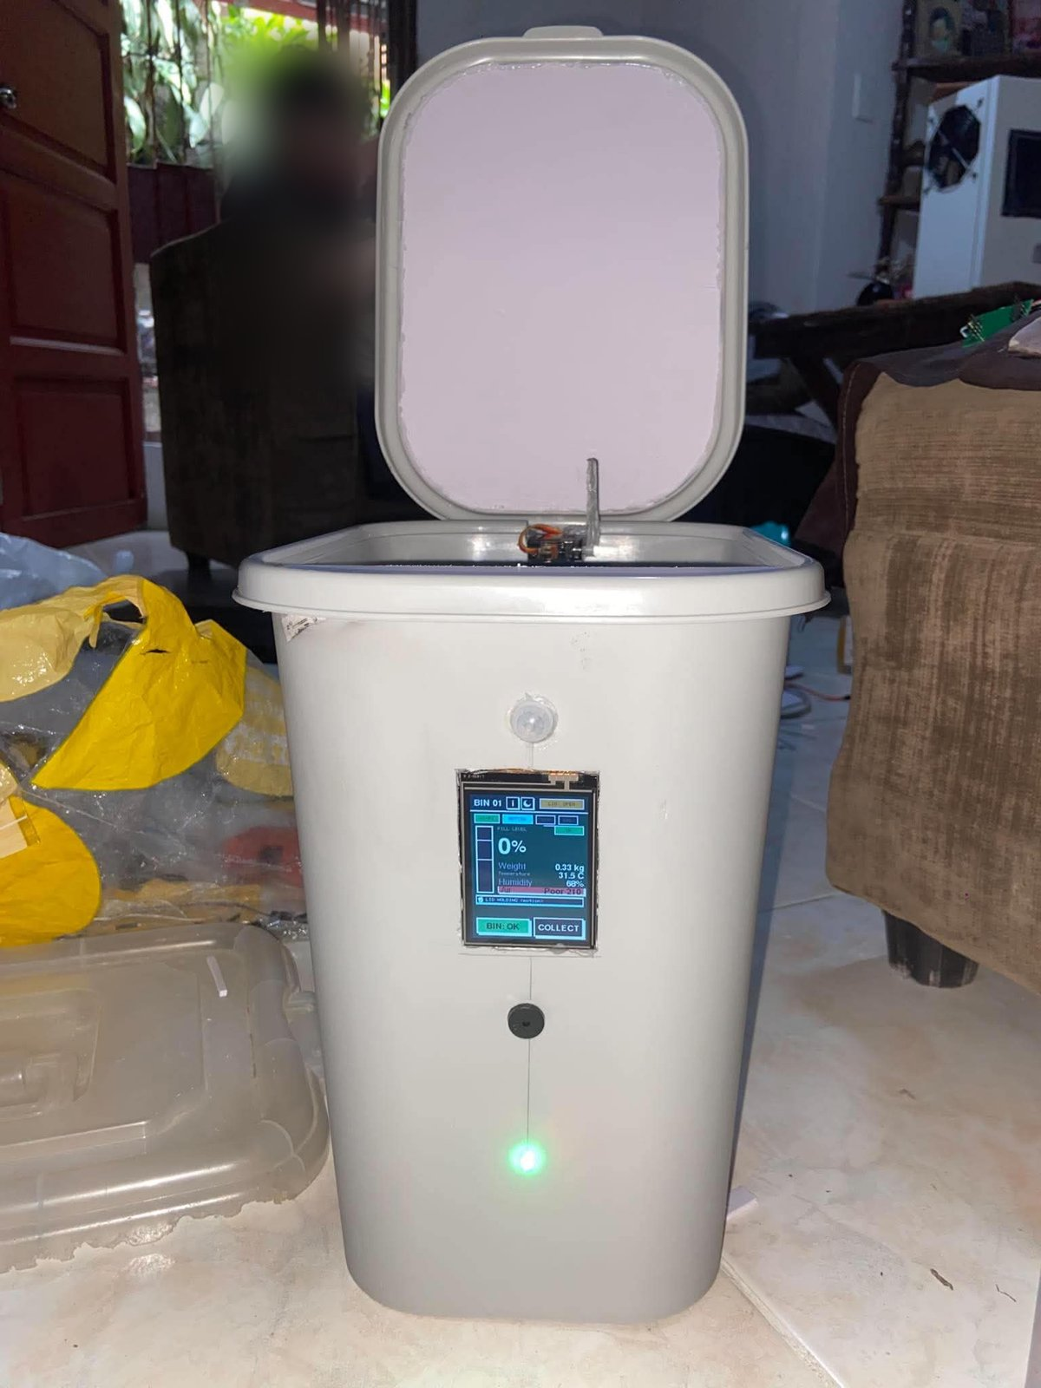

Results for Specific Objective 2
Table 17 gives the time from placing the 500g mass to seeing the new weight. Over the local Wi-Fi both interfaces were inside the 2s limit in every trial. Most of that time is the wait between two requests of the dashboard or the app to the bin, not the bin itself. Through Firebase the app took 4.6s on average. That follows from the firmware, which writes its status to Firebase every 5s while someone is watching, so a change waits up to one write cycle before it reaches the cloud.
Table 17
Time to Show a New Reading (TC2.1)
Path | Trials | Mean (s) | Max (s) | Limit (s) | Passed
Dashboard, local Wi-Fi | 2 | 1.1 | 1.5 | 2 | 2/2
Android app, local Wi-Fi | 2 | 1.3 | 1.6 | 2 | 2/2
Android app, Firebase on mobile data | 2 | 4.6 | 5.9 | 10 | 2/2

The 30-minute logging runs are in Table 18. While a reading changed every minute, Bin A wrote to ThingSpeak every 30 to 32s, and once the bin was left alone it wrote every 5 minutes, as the firmware intends. Bin B missed one entry. At about minute 9 it lost the Wi-Fi for roughly 20s, reconnected, and wrote on the next turn, which left a 61s gap. Firebase kept the latest status through the drop and matched the newest ThingSpeak entry in all 10 spot checks. The firmware never writes to ThingSpeak more often than once every 15.5s, so the free plan's limit of one write per 15s was never hit.
Table 18
ThingSpeak Logging Over 30 Minutes (TC2.2)
Bin | Phase | Expected entries | Entries | Interval range (s) | Intervals in limit
Bin A | Reading changing, 15 minutes | 30 | 30 | 30 to 32 | 30/30
Bin A | Untouched, 15 minutes | 3 | 3 | 300 to 301 | 3/3
Bin B | Reading changing, 15 minutes | 30 | 29 | 30 to 61 | 29/30
Bin B | Untouched, 15 minutes | 3 | 3 | 300 to 302 | 3/3
Note. Bin A wrote to ThingSpeak channel 3556235. Firebase was spot-checked 5 times per bin.

Cloud Connection Test on Bin 01
Firebase and ThingSpeak were tested on the first built bin, Bin 01, running the firmware from the main branch. For Firebase the bin signs in with its own account, bin01@smartbin.test. The operator account is meant only for the dashboard, and Firebase refuses the bin's writes when the operator account is used on the bin. Signed in with its own account, the bin wrote its status, its calibration and its alerts to the Realtime Database, under sb/bins/bin01/status, sb/bins/bin01/cal and sb/alerts/bin01. LOCK and UNLOCK sent from the web dashboard reached the bin within a few seconds.
ThingSpeak channel 3556235 received all eight fields from the same bin: fill, weight, temperature, humidity, IAQ, pressure, tilt and a flags field that packs the motion, lid and status bits into field 8. The bin writes to the channel every 30s while the readings change and at least once every 5 minutes when they stay the same. Bluetooth Wi-Fi setup from the app also worked end to end on Bin 01.
Memory was the main obstacle. The ESP32 does not have enough free RAM to hold two HTTPS connections at once, or to run Bluetooth and an HTTPS connection together. Three changes made both clouds work. ThingSpeak was moved to plain http, which leaves the one HTTPS connection to Firebase. The stack of the web server task was made smaller in build_opt.h. Bluetooth setup now restarts the bin once when it starts and once when it ends, so each part begins with a clean memory, and the screen tells the user that the restart is expected.
Alert times are in Table 19. Every notification reached the phone well inside the 20s limit, at 5.5s on average across the four types. The tamper alert is timed from the moment it latched, after the 10s countdown, which is why it looks faster than the others. These times are longer than the 2.61s message delay that Saad et al. (2023) reported for WhatsApp messages, because the app learns of an alert by reading the bin or Firebase every few seconds rather than receiving a push from a server. For a bin that fills over hours, a delay of a few seconds does not change when a collector is sent.
Table 19
Alert Delivery to the Phone (TC2.3)
Alert | Trials | Mean (s) | Max (s) | Passed
Full bin (fill set to 90%) | 2 | 5.8 | 7.9 | 2/2
Bad air (IAQ set to 260) | 2 | 6.1 | 8.6 | 2/2
High temperature (set to 45°C) | 2 | 5.9 | 9.1 | 2/2
Tamper (bin tilted and held) | 2 | 4.3 | 5.2 | 2/2
Note. The app was in the background on the phone. The dashboard banner appeared within 2s of the phone notification in every trial.
The remaining three test cases of this objective are pass or fail checks, and Table 20 lists them. A switched-off bin was called lost after 92 and 94s, which is the 90s rule of the apps plus the time since the last reading, and the offline alert sounded each time. After power came back, the bin was shown again 10 and 12s later, the time it needs to boot and join the Wi-Fi. The role checklists matched on both interfaces: a collector could do the daily work and none of the operator settings, and the operator PIN opened everything. In the three two-bin combinations, each card, chart and alert named the right bin.
Table 20
Offline Detection, Role Access and Two-Bin Results (TC2.4 to TC2.6)
Test | Trials | Result | Passed
TC2.4 Offline detection | 2 | Lost after 92 and 94s (mean 93s), offline alert both times; shown back 10 and 12s after power-on | 2/2
TC2.5 Role access, dashboard | 1 checklist | Every control matched the role | 1/1
TC2.5 Role access, app | 1 checklist | Every control matched the role | 1/1
TC2.6 Two bins at once | 3 | Each bin showed its own state on every screen | 3/3

Results for Specific Objective 3
All 10 priority combinations put the right bin on top, with the right tags, on both the dashboard and the app. Table 21 shows five of them. The fourth row is the one the feature exists for. Bin A was fuller, at 70%, but Bin B was filling fifteen times faster and was going to reach the limit first, so it was listed first with SOON while Bin A got TODAY. In the fifth row Bin A was half full but not filling, so it dropped below an emptier bin that was.
Table 21
Collection Priority Order for Five of the Ten Combinations (TC3.1)
No. | Bin A fill, rate | Bin B fill, rate | Expected first | Shown first | Tags (A, B) | Passed
1 | 92%, any | 45%, 10%/h | Bin A | Bin A | NOW, TODAY | Yes
2 | 30%, 6%/h | 85%, any | Bin B | Bin B | LATER, NOW | Yes
3 | 60%, 15%/h | 60%, 5%/h | Bin A | Bin A | SOON, TODAY | Yes
4 | 70%, 2%/h | 40%, 30%/h | Bin B | Bin B | TODAY, SOON | Yes
5 | 50%, 0%/h | 20%, 4%/h | Bin B | Bin B | IDLE, LATER | Yes
Note. Fill limit 80%. The other five combinations also passed on both interfaces.
The time-to-full estimate is less certain, as Table 22 shows. The firmware works out the fill rate from one fill sample per minute, and the apps divide what is left to the 80% limit by that rate. Runs 1 and 2 came within 15%. Run 3 did not: the paper went in quickly during the first minutes and then more slowly, so the rate at minute 15 was too high and the bin filled later than estimated. The estimate assumes the rate stays the same, and filling by hand does not keep it the same. Real bins fill unevenly too, which is a reason to read the time as a guide to order the bins rather than as a promise. The mean error over the three runs was 12.2%.
Table 22
Estimated and Actual Time to Reach the 80% Fill Limit (TC3.2)
Run | Fill at minute 15 (%) | Estimated time to full (min) | Actual time to full (min) | Error (%) | Passed
1 | 52 | 35 | 38 | 7.9 | Yes
2 | 49 | 52 | 47 | 10.6 | Yes
3 | 58 | 18 | 22 | 18.2 | No
Note. Each run started at about 40% fill on Bin A. Times are counted from minute 15.
The control tests in Table 23 passed in every trial. A locked bin kept its lid shut against the IR sensor every time, and unlocking took 0.9s on average over the local Wi-Fi and 3.8s through Firebase, where the bin checks for new commands every 2s while someone is watching. With auto-lock on, both bins locked themselves at 80 or 81% and unlocked again after the collector pressed DONE. On the touchscreen a wrong PIN showed the error and left the lid shut, and the right PIN opened it with COLLECTING on the screen. Simulation raised the matching banner and alert in all 4 trials and gave back the real reading on AUTO. The changed settings applied at once and were still there after a restart. Figure 61 shows the home screen of Bin 01. Pressing COLLECT there brings up the PIN pad used in TC3.4.
Table 23
Lock, PIN Collection, Simulation and Calibration Results (TC3.3 to TC3.6)
Test | Trials | Result | Passed
TC3.3 LOCK and UNLOCK, local Wi-Fi | 2 | Lid stayed shut while locked; unlock in 0.9s mean, 1.3s max | 2/2
TC3.3 LOCK and UNLOCK, Firebase | 2 | Lid stayed shut while locked; unlock in 3.8s mean, 4.9s max | 2/2
TC3.3 Auto-lock | 2 | Locked itself at 80 to 81%; unlocked after DONE | 2/2
TC3.4 Wrong PIN | 2 | Error shown, lid stayed shut | 2/2
TC3.4 Correct PIN and DONE | 2 | Lid opened with COLLECTING; DONE closed it and logged the pickup | 2/2
TC3.5 Simulation | 4 | Banner and matching alert in every trial; real reading back on AUTO | 4/4
TC3.6 Calibration | 2 | Applied without reflashing; kept after the restart | 2/2

Figure 61
Home Screen of Bin 01, With the IR Sensor Above It
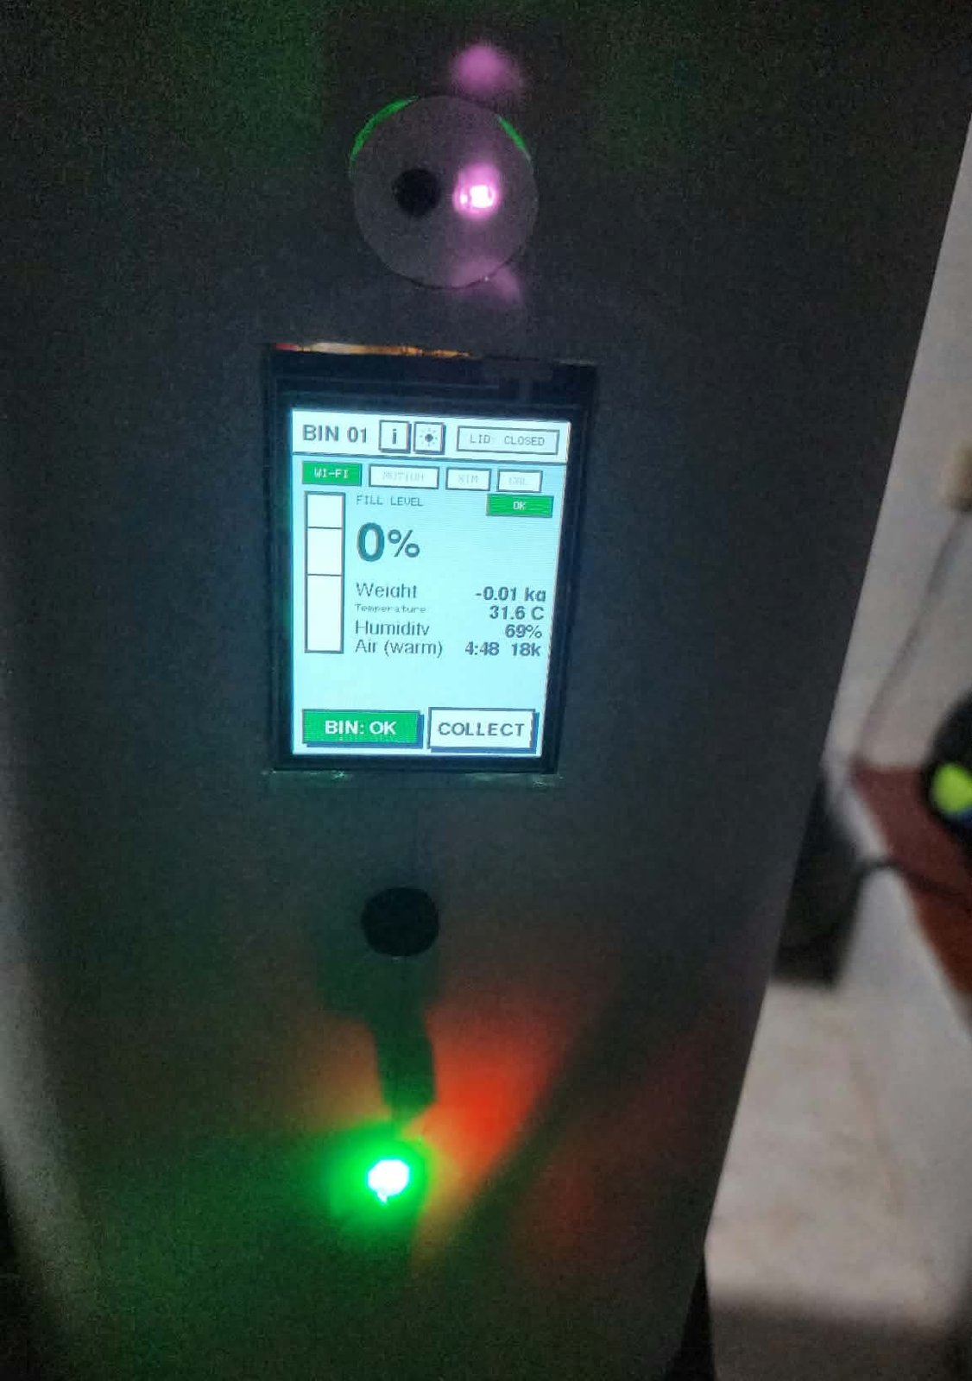

Summary of Results
Table 24 brings the 18 test cases together. Of the 98 trials, 94 met their criterion, a pass rate of 95.9%. Fourteen test cases passed every trial. The four that did not were the fill level at 100% (one trial), the lid at 25cm (one trial), ThingSpeak logging on Bin B (one run) and the time-to-full estimate (one run). None of the four failed trials came from a fault in the firmware logic. They came from the surface of the trash, the position of the hand, a short Wi-Fi drop and an uneven filling rate, and each of them points to one of the recommendations in Section 3.4.
Table 24
Summary of Test Results
ID | Test | Trials | Passed | Pass rate (%) | Main measure
TC1.1 | Fill accuracy | 10 | 9 | 90.0 | MAE 1.8 points
TC1.2 | Weight accuracy | 10 | 10 | 100 | MAE 12.8g
TC1.3 | Temperature and humidity | 6 | 6 | 100 | MAE 0.5°C and 2.6%
TC1.4 | Air quality response | 4 | 4 | 100 | 45 to 460s to pass 200
TC1.5 | Tamper | 10 | 10 | 100 | Countdown within 1s
TC1.6 | Automatic lid | 6 | 5 | 83.3 | Opens in 0.6s mean
TC2.1 | Live latency | 6 | 6 | 100 | 1.1s local, 4.6s Firebase
TC2.2 | Cloud logging | 2 | 1 | 50.0 | One run with a 61s gap
TC2.3 | Alert delivery | 8 | 8 | 100 | 5.5s mean
TC2.4 | Offline detection | 2 | 2 | 100 | Lost after 93s mean
TC2.5 | Role access | 2 | 2 | 100 | All controls matched
TC2.6 | Two bins at once | 3 | 3 | 100 | No mix-up
TC3.1 | Priority order | 10 | 10 | 100 | Right order and tags
TC3.2 | Time to full | 3 | 2 | 66.7 | Mean error 12.2%
TC3.3 | LOCK and UNLOCK | 6 | 6 | 100 | 0.9s local, 3.8s Firebase
TC3.4 | PIN collect | 4 | 4 | 100 | Wrong PIN always refused
TC3.5 | Simulation | 4 | 4 | 100 | Real reading back on AUTO
TC3.6 | Calibration | 2 | 2 | 100 | Kept after restart
 | Total | 98 | 94 | 95.9
Note. For TC2.2 a trial is one 30-minute logging run.

Limitations
ThingSpeak's write key travels over plain http, so it can be read by anyone who can see the network traffic between the bin and ThingSpeak. Firebase still uses HTTPS. Bluetooth Wi-Fi setup needs two restarts of the ESP32 for the same memory reason.
The tests themselves have limits as well. They ran indoors, on a table, in one day, with two bins and the people of the group as users. They do not show how the bins behave in rain, in direct sun or in the hands of strangers. Battery life was not measured over a full discharge, so the 18 hours of Bin A and the 9 hours of Bin B remain estimates. The IAQ value had no reference instrument, and the time-to-full estimate was tested only with hand filling.

3.3 Conclusion
The first specific objective was met. Both bins measured the fill level with a mean error of 1.8 percentage points and the weight with a mean error of 12.8g, inside the limits set before testing. Temperature and humidity stayed within 1°C and 5% of the reference once the default offset was applied, and the air estimate rose past its limit and raised the alert in every trial after the warm-up. The tamper alarm ignored tilts under 30°, started its countdown within 1s above it and latched until it was reset, and the lid opened for a hand in 5 of 6 trials without ever reopening by itself.
The second specific objective was also met. New readings reached the dashboard and the app in under 2s over the local Wi-Fi and in under 8s through Firebase. ThingSpeak was written every 30s while the readings changed and every 5 minutes when they did not, with one entry missed during a Wi-Fi drop. Alerts for a full bin, bad air, high temperature and tampering reached the phone in 5.5s on average, a bin that went silent was reported lost after about 90s, and each role saw only the controls meant for it.
The third specific objective was met, with one reservation. The Collection Priority list ordered the bins correctly in all 10 combinations, remote LOCK and UNLOCK, the PIN collection, simulation and calibration worked in every trial, and auto-lock closed a full bin by itself. The time-to-full estimate was within 15% in two of three runs, and it is best read as a guide for ordering the bins, not as an exact time.
Taken together, the results show that Smart-Bin does what the general objective set out to do. It monitors the fill level, weight and air of a bin, detects tampering, and alerts the operator and the collector through the web dashboard, the Android app and the on-bin touchscreen. With 94 of 98 trials passed, it is ready to be shown as a working prototype, and the failures that remain point to clear next steps.

3.4 Recommendations
The first recommendations come straight from the failed trials. The HC-SR04 should sit higher above the trash, or the firmware should take the median of more readings near the top of the bin, so that gaps in loose trash are not read as empty space. The IR sensor of Bin B should have its range turned up a little or be moved forward in the front panel, since the lid miss came at the edge of its range. The weight of Bin B should be calibrated again with a heavier known mass. A short buffer that keeps the last ThingSpeak reading and sends it as soon as the Wi-Fi returns would close the kind of gap seen in TC2.2.
Security is next. ThingSpeak's write key travels over plain http because the ESP32 cannot hold a second HTTPS connection beside Firebase. Moving to an ESP32 with more memory, such as a module with PSRAM, would let both clouds use HTTPS and would also remove the two restarts that Bluetooth Wi-Fi setup needs.
Range and power limit where the bin can stand. Smart-Bin needs Wi-Fi, so a bin outside a building has no way to report. A low-power long-range link such as LoRa would let a bin sit wherever it is needed, and related studies already use it (Azmi et al., 2024; Mugaruka et al., 2026). The estimated battery life, about 18 hours for Bin A and 9 hours for Bin B, is enough for a demonstration and not for a street. A small solar panel, larger cells, or longer sleep between readings when nobody is watching would stretch it, and a full discharge test should confirm the real figure.
The enclosure has to change for outdoor use. A waterproof, vandal-resistant shell and a heat-proof mounting for the sensors would answer the threats listed in the SWOT analysis, and the tamper alarm could then be tested against real handling instead of a tilted bin on a table.
Collection priority could grow into route planning. Adding GPS and a road map would turn the ranking of the bins into a route for the truck, which is where the largest savings in the related studies were reported, for example 58.9% less distance in Gupta et al. (2025) and up to 52% shorter routes in Banciu et al. (2025). A field pilot with more bins, such as the 50 bins of Alnanih et al. (2025), would show how the system behaves at a scale where the free plans of ThingSpeak and Firebase may no longer be enough.
Two more tests would add evidence this paper does not have. A user evaluation with real operators and collectors, for instance with the System Usability Scale that Maulida et al. (2025) used with 15 sanitation officers, would check how easy the apps are to use. A comparison of the BME680 air estimate with a reference gas sensor would show how far the estimate can be trusted for odors.
The data the bins already send could do more. ThingSpeak keeps every reading, so a weekly report of the fill rate of each bin, by day and by hour, would show the barangay or the campus which bins fill fastest and on which days, and collection days could be planned from that instead of from habit. The Collection Priority list itself uses only the fill readings. A bin with food waste can smell long before it is full, so a later version could raise a bin in the list when its IAQ estimate or its temperature stays high, even if its fill level is still low.
Finally, Bin A and Bin B were built by hand, one at a time. A perfboard that carries every sensor header, including the HC-SR04 that was missing from the first board, and a fixed mounting for each sensor would make the two units identical and would let more units be built and calibrated in the same way.

REFERENCES
Aasish, V. G., Mari Shankar, C., & Shanmugasundaram, M. (2025). FreeRTOS based smart waste management system. In 2025 Innovations in Power and Advanced Computing Technologies (i-PACT) (pp. 1–7). IEEE. https://doi.org/10.1109/i-PACT65952.2025.11307820
Abdullahi, A., Mohammed, A., Bonet, M. U., El-Suleiman, A., Ahmad, R. B., & Chollom, T. D. (2024). Development of a smart waste management system with automatic bin lid control for smart city environment. EAI Endorsed Transactions on Smart Cities, 7(3). https://doi.org/10.4108/eetsc.4385
Alnanih, R., Elrefaei, L., & Al-Ahwal, A. (2025). Advancing sustainability through an IoT-driven smart waste management system with software engineering integration. Sustainability, 17(21), Article 9803. https://doi.org/10.3390/su17219803
Alnuaimi, A. N., Aydin, R., & Al-Shihabi, S. (2024). Optimizing municipal solid waste collection using smart bins: A case study in United Arab Emirates. In 2024 IEEE International Conference on Technology Management, Operations and Decisions (ICTMOD) (pp. 1–6). IEEE. https://doi.org/10.1109/ICTMOD63116.2024.10878234
Alourani, A., Ashraf, M. U., & Aloraini, M. (2025). Smart waste management and classification system using advanced IoT and AI technologies. PeerJ Computer Science, 11, Article e2777. https://doi.org/10.7717/peerj-cs.2777
Asido, D. (2024, January 19). Baguio students develop smart garbage bins. The Post. https://thepost.net.ph/news/campus/baguio-students-develop-smart-garbage-bins/
Awotayo, M. M., & Dodo, U. A. (2026). Design and implementation of an IoT-based smart bin for real-time fill level monitoring. Journal of Science Technology and Education, 14(1), 344–351. https://www.researchgate.net/publication/400748751
Ayyanagoudar, A., Mohankar, A., Gharte, J., Pasnsare, P., Ainapure, B., & Appasani, B. (2024). A smart bin with real-time monitoring and garbage level tracking using IoT. In 2024 11th International Conference on Reliability, Infocom Technologies and Optimization (Trends and Future Directions) (ICRITO) (pp. 1–7). IEEE. https://doi.org/10.1109/ICRITO61523.2024.10522263
Azmi, A. Z., Sahar, N. M., & Islam, M. T. (2024). Smart waste management system using LoRa technology. E3S Web of Conferences, 599, Article 04007. https://doi.org/10.1051/e3sconf/202459904007
Bahga, A., & Madisetti, V. (2014). Internet of things: A hands-on approach.
Balachandran, N., & Talavera, O. (2023). Apparatus and method for waste monitoring and analysis (U.S. Patent No. 11,788,877). U.S. Patent and Trademark Office. https://patents.google.com/patent/US11788877B2
Banciu, C., Florea, A., & Popa, M. (2025). IoT-enabled waste collection: Route optimization and environmental impact reduction using smart technologies. In 2025 29th International Conference on System Theory, Control and Computing (ICSTCC) (pp. 782–788). IEEE. https://doi.org/10.1109/ICSTCC66753.2025.11240462
Bigbelly. (n.d.). CLEAN software. Retrieved October 19, 2026, from https://bigbelly.com/products/clean-software
Bosch Sensortec. (n.d.). BME680 gas sensor (Document No. BST-BME680-DS001) [Data sheet]. Retrieved October 19, 2026, from https://www.bosch-sensortec.com/media/boschsensortec/downloads/datasheets/bst-bme680-ds001.pdf
Brown, W. J. (2006). Compactor service and monitoring system (U.S. Patent No. 7,145,450). U.S. Patent and Trademark Office. https://patents.google.com/patent/US7145450B2
Circuitrocks. (n.d.-a). 2 channel 18650-battery holder protection board. Retrieved October 15, 2026, from https://circuit.rocks/products/2-channel-18650-battery-holder-protection-board
Circuitrocks. (n.d.-b). 4 channel 18650-battery holder protection board. Retrieved October 15, 2026, from https://circuit.rocks/products/4-channel-18650-battery-holder-protection-board
Circuitrocks. (n.d.-c). IR proximity obstacle avoidance sensor module. Retrieved October 30, 2026, from https://circuit.rocks/products/product-2201
Circuitrocks. (n.d.-d). KY-016 RGB 3 color full-color LED module. Retrieved October 15, 2026, from https://circuit.rocks/products/ky-016-rgb-3-color-full-color-led-module
Compology. (n.d.). Image-based container monitoring built for waste. Retrieved October 19, 2026, from https://compology.com/
Devitt, S., & Walsh, B. (2021). Techniques for optimally sensing full containers (U.S. Patent No. 11,054,545). U.S. Patent and Trademark Office. https://patents.google.com/patent/US11054545B2
Di Giugno, M., Giovanelli, F., Tiraboschi, S., & Villa, P. (2016). Measuring device, container means and system for monitoring and managing container means (European Patent No. 2516974). European Patent Office. https://patents.google.com/patent/EP2516974B1
Ecological Solid Waste Management Act of 2000, Republic Act No. 9003 (2001). https://lawphil.net/statutes/repacts/ra2001/ra_9003_2001.html
Ecube Labs. (n.d.). Waste analytics platform: CleanCityNetworks (CCN). Retrieved October 19, 2026, from https://www.ecubelabs.com/waste-analytics-platform/
ElectronicsComp.com. (n.d.). 5 kg load cell with HX711 module shell and 4P DuPont wire kit. Retrieved October 15, 2026, from https://www.electronicscomp.com/5-kg-load-cell-with-hx711-module-shell-and-4p-dupont-wire-kit
ElectroPeak. (n.d.). GY-BMI160 module 6DOF 6 axis angular velocity. Retrieved October 15, 2026, from https://electropeak.com/gy-bmi160-module-6dof-6-axis-angular-velocity
Enache, B.-A., Banica, C.-K., & Bogdan, A. G. (2024). Intelligent trash level detection for sustainable urban waste management. The Scientific Bulletin of Electrical Engineering Faculty, 24(1), 56–59. https://doi.org/10.2478/sbeef-2024-0010
Evreka. (2020). Fill level sensor. Retrieved October 19, 2026, from https://evreka.co/solutions/fill-level-sensor/
Gajula, R., Karanam, M., Vakkapatla, D. C., Endrapu, K. R., Raju, V. V. R., Reddy, S. B., Aljanabi, S. O., Koli, S., & Mahajan, S. (2025). Sustainable waste management solution: ESP32-powered smart bin. AIP Conference Proceedings, 3263(1), Article 140006. https://doi.org/10.1063/5.0261359
González, G. E., Escobar, E. R., Carvajal, I. I., & Bento, A. C. (2024). Smart trash bins: Integration of IoT with AI for efficient waste management. In 2024 IEEE International Humanitarian Technologies Conference (IHTC) (pp. 1–6). IEEE. https://doi.org/10.1109/IHTC61819.2024.10855147
Greenwalt, M. (2020, June 2). Bin-e creates contactless smart bin. Waste360. https://www.waste360.com/recycling/bin-e-creates-contactless-smart-bin
Gupta, S., Gautam, R., & Muneer, A. (2025). IoT-based e-tracking system for waste management. In 2025 12th International Conference on Reliability, Infocom Technologies and Optimization (Trends and Future Directions) (ICRITO) (pp. 1–6). IEEE. https://doi.org/10.1109/ICRITO66076.2025.11241930
Ishaq, A., Mohammad, S. J., Bello, A. D., Wada, S. A., Adebayo, A., & Jagun, Z. T. (2025). Smart waste bin monitoring using IoT for sustainable biomedical waste management. Environmental Science and Pollution Research, 32(32), 19434–19449. https://doi.org/10.1007/s11356-023-30240-1
Karthi, S. P., Aravind, A., Dharineesh, V., Dhayanidhi, J. V., & Dinesh Kumar, J. R. (2025). IoT enabled smart dustbin with RFID-based access control and Blynk integration. In 2025 IEEE First International Conference on Innovations in Engineering and Next-Generation Technologies for Sustainability (ICINVENTS). IEEE. https://doi.org/10.1109/ICINVENTS64613.2025.11402326
Kekäläinen, F. (2018). Method and system for monitoring and communicating fill rate of container (U.S. Patent No. 9,930,429). U.S. Patent and Trademark Office. https://patents.google.com/patent/US9930429B2
Kekalainen, F., & Engstrom, J. (2014). Smart waste collection system and method (International Patent Application Publication No. WO 2014/079586 A1). World Intellectual Property Organization. https://patents.google.com/patent/WO2014079586A1
Kekalainen, F., & Engstrom, J. (2018). Sensor device for smart waste collection systems and method (U.S. Patent No. 9,927,278). U.S. Patent and Trademark Office. https://patents.google.com/patent/US9927278B2
Keller, J. R., Redmond, M. O., & Mirza, S. A. (2024). System and method for measuring the fill level of a trash can using a sensor (U.S. Patent No. 12,125,361). U.S. Patent and Trademark Office. https://patents.google.com/patent/US12125361B2
Kumar, K. R., Pavan, O. S., Azeez, S. A., Suresh, C. V., Sree, K. R., & Reddy, P. U. (2025). IoT enabled route optimization for smart waste management using machine learning. i-manager's Journal on IoT and Smart Automation, 3(2), 11-23. https://doi.org/10.26634/jiot.3.2.21684
Kurani, H. B. (2023). Smart waste bin sensor device and methods for waste management system (U.S. Patent No. 11,702,280). U.S. Patent and Trademark Office. https://patents.google.com/patent/US11702280B2
Kuzhin, M. F., Joshi, A., Mittal, V., Khatkar, M., & Guven, U. (2024). Optimizing waste management through IoT and analytics: A case study using the Waste Management Optimization Test. BIO Web of Conferences, 86, Article 01090. https://doi.org/10.1051/bioconf/20248601090
LCDWIKI. (n.d.). 2.4inch SPI module ILI9341 SKU:MSP2402. Retrieved October 15, 2026, from https://www.lcdwiki.com/2.4inch_SPI_Module_ILI9341_SKU:MSP2402
Leones, J. R. (2025, March 3). Philippines ministerial statement [Paper presentation]. High-Level 12th Regional 3R and Circular Economy Forum in Asia and the Pacific, Jaipur, India. https://uncrd.un.org/sites/uncrd.un.org/files/12th3r_ps1-philippines.pdf
Maulida, A., Fayzalmi, C. S., Anaam, F. A. C., Ardiansyah, D., Gunawan, M. A., & Ridwan, N. (2025). Design of IoT-based smart trash bin monitoring using ESP32 and Firebase. Jurnal Komputer, Teknologi Informasi dan Sistem Informasi (JUKTISI), 4(2), 420-428. https://doi.org/10.62712/juktisi.v4i2.420
Mehta, H., Deriya, V., Sankhe, D., Kanani, P., Pandya, G., & Shelke, V. (2025). Smart bins, smarter cities: IoT-driven waste collection with real-time sensing and methane mapping. Mathematical Modelling of Engineering Problems, 12(6), 2110–2122. https://doi.org/10.18280/mmep.120626
Mehta, S., & Rathour, A. (2024). Innovative waste management: The efficiency of IoT-enabled smart bins. In 2024 7th International Conference on Circuit Power and Computing Technologies (ICCPCT) (pp. 467–471). IEEE. https://doi.org/10.1109/ICCPCT61902.2024.10672653
Mugaruka, O. M., Kala, J. R., Ndikumagenge, J., van Schadewijk, R., & Nibitanga, R. (2026). Design of an IoT sensor-based network architecture for waste collection in Bukavu city (DRC). Discover Internet of Things, 6(1), Article 168. https://doi.org/10.1007/s43926-026-00479-4
Mullaney, G. (2016). Refuse container with weight indicator and danger alerting (U.S. Patent No. 9,347,821). U.S. Patent and Trademark Office. https://patents.google.com/patent/US9347821B1
Muthukumar, K., Siddarth, T., Udhayakumar, K., & Saratha, M. (2024). Smart bin: AI-based waste segregation with monitoring system. International Journal of Innovative Research in Technology, 11(6), 1293–1298. https://ijirt.org/Article?manuscript=169606
Neumann, R. H., & Allison, C. B. (1991). Automated trash management system (U.S. Patent No. 5,016,197). U.S. Patent and Trademark Office. https://patents.google.com/patent/US5016197A
Nordsense. (n.d.). Intelligent routing. Retrieved October 19, 2026, from https://nordsense.com/intelligent-routing/
Philippine Statistics Authority. (2026). Highlights of the Compendium of Philippine Environment Statistics 2016–2025, Component 3: Residuals. https://psa.gov.ph/statistics/environment-statistics/highlights/component-3-residuals
Poss, J., Satwicz, J., Richmond, B., & Taylor, M. (2006). Solar powered compaction apparatus (U.S. Patent No. 7,124,680). U.S. Patent and Trademark Office. https://patents.google.com/patent/US7124680B2
QuartzComponents. (n.d.). Passive buzzer module with PCB. Retrieved October 15, 2026, from https://quartzcomponents.com/products/passive-buzzer-module
Rathnayake, R. M. P. M. D., Chanaka, T. M. M., Dabare, P. T. R., & Hewagamage, K. P. (2024). IoT-enabled dual-sensing smart waste management system: Enhancing urban cleanliness and sustainability in smart cities. In 2024 8th SLAAI International Conference on Artificial Intelligence (SLAAI-ICAI). IEEE. https://doi.org/10.1109/SLAAI-ICAI63667.2024.10844960
Robu.in. (n.d.). BME680 digital temperature humidity pressure sensor CJMCU-680 high altitude sensor module development board. Retrieved October 15, 2026, from https://robu.in/product/bme680-digital-temperature-humidity-pressure-sensor-cjmcu-680-high-altitude-sensor-module-development-board/
Saad, A. M., Jul, B. O., Basalamah, A., & Sayuti, S. (2023). IoT-based smart dustbin prototype. PROtek: Jurnal Ilmiah Teknik Elektro, 10(2), 120–125. https://doi.org/10.33387/protk.v10i2.6035
Sadikin, F. R., Hikmawati, E., & Aulia, S. (2025). TrashTrack: A smart waste monitoring system with constraint-based greedy algorithm for optimized collection routes. In 2025 IEEE International Conference on Artificial Intelligence for Learning and Optimization (ICoAILO) (pp. 262–268). IEEE. https://doi.org/10.1109/ICoAILO66760.2025.11155998
Sait, S., Aliyu, F. M., Bukar, S., Maina, B. S., & Lawal, D. U. (2025). Waste bin collection and monitoring method using waste bin sensors (U.S. Patent No. 12,450,575). U.S. Patent and Trademark Office. https://patents.google.com/patent/US12450575B1
Salleh, A., Mohamad, N. R., & Hashim, N. M. Z. (2024). Optimizing waste collection efficiency by NodeMCU enabled ultrasonic trash can surveillance and ThingSpeak dashboards. International Journal of Latest Technology in Engineering, Management & Applied Science, 12(12), 19-26. https://doi.org/10.51583/ijltemas.2023.121202
Samolovac, J. (2023, January 25). What is hybrid project management? Plaky. https://plaky.com/learn/project-management/hybrid-project-management/
Sensoneo. (n.d.). Waste management system. Retrieved October 19, 2026, from https://www.sensoneo.com/products/waste-management-system/
Shahabdeen, J. A. (2016). Smart garbage bin (U.S. Patent Application Publication No. 2016/0176630 A1). U.S. Patent and Trademark Office. https://patents.google.com/patent/US20160176630A1
Shaharil, M. H. F., & Po’ad, F. A. (2024). Arduino-based smart dustbin with ultrasonic sensor for efficient waste management. Evolution in Electrical and Electronic Engineering, 5(2), 92–97. https://periodical.uthm.edu.my/index.php/eeee/article/view/17147
Shahibollah, R. A., Fadzal, N., Fadzal, A. N., Omar, S., Jaafar, A. N., & Ahmad, N. (2025). IoT-enabled smart dustbin for real-time waste monitoring and scalable hygiene management. In 2025 IEEE 16th Control and System Graduate Research Colloquium (ICSGRC) (pp. 75–80). IEEE. https://doi.org/10.1109/ICSGRC65918.2025.11159745
Shin, H. (2016). Inputting device for quantity and weight loss of food garbage container (Korean Patent No. 10-1581944). Korean Intellectual Property Office. https://patents.google.com/patent/KR101581944B1
Sigmanortec. (n.d.). ESP32-DevKitC ESP32-WROOM-32D WiFi BT 38P development board. Retrieved October 15, 2026, from https://sigmanortec.ro/en/esp32-devkitc-development-board-esp32-wroom-32d-38p
SparkFun Electronics. (n.d.). Ultrasonic distance sensor - 5V (HC-SR04). Retrieved October 15, 2026, from https://www.sparkfun.com/ultrasonic-distance-sensor-hc-sr04.html
Thangam, S., Gurupriya, M., Yadav, C. S. K., Harshith, M., & Kumar, M. S. (2024). A smart waste management system using ESP8266. In 2024 4th International Conference on Sustainable Expert Systems (ICSES) (pp. 1–5). IEEE. https://doi.org/10.1109/ICSES63445.2024.10762967
The Pi Hut. (n.d.). TowerPro servo motor - SG90 analog. Retrieved October 15, 2026, from https://thepihut.com/products/towerpro-servo-motor-sg90-analog
United Nations Department of Economic and Social Affairs. (n.d.). Goal 11: Make cities and human settlements inclusive, safe, resilient and sustainable. https://sdgs.un.org/goals/goal11
Wang, X., Chen, J., & Lin, Z. (2020). Trash can having sensing flip lid having settable sensing distance and control method therefor (European Patent No. 3 620 405 A1). European Patent Office. https://patents.google.com/patent/EP3620405A1
Wang, X., Zhang, Y., & Wang, Z. (2020). Garbage bin intelligent control ware and garbage bin supervisory systems (Chinese Patent No. CN111559590A). China National Intellectual Property Administration. https://patents.google.com/patent/CN111559590A
World Bank. (2022). An assessment of municipal solid waste plans, collection, recycling and disposal of Metro Manila (East Asia and Pacific Region: Marine Plastics Series). https://documents1.worldbank.org/curated/en/099125007222250938/pdf/P170994059e8e308c0a3ec02e0c4f57778b.pdf
Yan, S., & Chen, J. (2021). Smart city garbage management system (Chinese Patent No. CN 109324552 B). China National Intellectual Property Administration. https://patents.google.com/patent/CN109324552B
Yang, F., & Sandor, J. (2010). Trash can with power operated lid (U.S. Patent No. 7,781,995). U.S. Patent and Trademark Office. https://patents.google.com/patent/US7781995B2
Yang, S., Liao, D., Li, R., & Yu, Y. (2020). Capacity automated inspection garbage bin with infrared induction function (Chinese Patent No. CN 210504152 U). China National Intellectual Property Administration. https://patents.google.com/patent/CN210504152U
Yogesh, H. M., Shivalingappa, Suman, M., Vinodh, B., & Malini, V. L. (2025). IoT-enhanced smart dustbin with real-time weight and level monitoring using ESP32. International Journal of Advanced Research in Science, Communication and Technology, 5(10), 227-231. https://doi.org/10.48175/ijarsct-28841

CURRICULUM VITAE
RODEL S. BANOGBANOG  1230 Interior 8, Maaliwalas st, Kahilum2, Pandacan, Manila  Mobile No.: 09916540971  Email Address: rodel.banogbanog@tup.edu.ph | 
SKILLS
• Computer Systems Servicing NCII
• Electrical Installation and Maintenance NCII
• Basic knowledge C++, Java ang Python Programing
• Computer Installation and Server Configuration
• Basic knowledge in Information and Communication Technology
• Basic knowledge in Computer Configuration
EDUCATIONAL BACKGROUND
• Bachelor of Engineering Technology August 2023
Major in Computer Engineering Technology
Technological University of the Philippines – Manila
• Ignacio Villamor Senior High School June 2021
2109 San Andres Ext, Sta. Ana Manila
• Alternative Learning System (ALS) in June 2019
Sta. Ana Elementary School, M. Roxas St, Sta. Ana
• Molave Vocational Technical School June 2009
• Milligan Elementary School, Molave June 2004
CONFERENCES/SEMINARS/TRAININGS ATTENDED
• ROTC Training Service August 2024
Technological University of the Philippines – Manila
• Sea gem Training Center July 2021
• Kabaka Manpower Training Service August 2013
CURRICULUM VITAE
BRIAN JAY CELESTE  829 Teresa St. Brgy. 661 Zone 70 Ermita, Manila 1000 Metro Manila  Mobile No.: 09272794551  Email Address: brianjay.celeste@tup.edu.ph | 
SKILLS
• Adaptable
• Communicator
• Critical Thinker
• Fast Learner
• Leadership Skills
• Diligent
• Computer Literate
• Programming and Web Development Skills
• Basic Electrical Circuits and Electronics Knowledge
EDUCATIONAL BACKGROUND
• Bachelor of Engineering Technology August 2022 – Present
Major in Computer Engineering Technology
Technological University of the Philippines – Manila
• Technical-Vocational-Livelihood June 2021
ICT Strand – Mobile App and Web Development
STI College Bacoor
• Technical-Vocational-Livelihood August 2020
ICT Strand – Mobile App and Web Development
STI College Dasmariñas
• Technical-Vocational-Livelihood August 2019
ICT Strand – Mobile App and Web Development
STI College Dasmariñas
CONFERENCES/SEMINARS/TRAININGS ATTENDED
• Beyond Pixels: Android and Visual Studio Mobile Development August 2024
Technological University of the Philippines – Manila
• Technobytes Tutorials August 2021
Introduction to Windows Forms App Development
STI College Bacoor
MEMBERSHIP IN PROFESSIONAL ORGANIZATIONS
• CIT Student Council – Technical Associate June 2023
Technological University of the Philippines – Manila
• Technobytes June 2022
STI College Bacoor
• Gamer’s Lounge June 2021
STI College Dasmariñas
AWARDS AND CERTIFICATIONS
• C-Language Competition Champion May 2023
• 1st Place Research Paper June 2022
• 2nd Place Research Poster June 2022
• 3rd Place Sci-mulation – Air Vortex Cannon June 2022
• JLPT N3 – Japanese Language Proficiency Test Certification June 2023
WORK EXPERIENCE
• Technical Support Intern June 2022
STI College Bacoor
Software and Hardware Troubleshooting
Network Maintenance
• Aluminum Worker June 2021
Arami Tousou
Aluminum Processing and Finishing
Japanese–English Interpretation
Technical Support Assistance
CURRICULUM VITAE
JADE C. GUNAYAN  110 Daisy st. Nbbs proper, Navotas City Metro Manila  Mobile No.: 09533713171  Email Address: jade.gunayan@tup.edu.ph | 
SKILLS
• Adaptable
• Communicator
• Critical Thinker
• Fast Learner
• Leadership Skills
• Diligent
EDUCATIONAL BACKGROUND
• Bachelor Engineering Technology Present
Major in Computer Engineering Technology
• Senior High School 2021–2023
San Rafael Technological Vocational High School
• Junior High School 2017–2021
San Pascual Agricultural High School
• Elementary 2012–2017
Bongbong Elementary School
CONFERENCES/SEMINARS/TRAININGS ATTENDED
• CWTS Training Service August 2024
Technological University of the Philippines – Manila
CURRICULUM VITAE
KING PERTH G. PEPITO  Blk 1. No. 19 C3-Rd, Pamasawata III, Kaunlaran Village, Caloocan City  Mobile No.: 09052165338  Email Address: kingperth.pepito@tup.edu.ph | 
SKILLS
• Computer Literate
• Project Management
• Attention to detail
• Accountability and Responsibility
EDUCATIONAL BACKGROUND
• Bachelor of Engineering Technology August 2023
Major in Computer Engineering Technology
Technological University of the Philippines – Manila
• Technical-Vocational-Livelihood – ICT June 2021
Arellano University – Jose Rizal Campus
• Secondary School June 2017
Longos National High School
• Primary School June 2012
Ninoy Aquino Elementary School
CONFERENCES/SEMINARS/TRAININGS ATTENDED
• CWTS “Civic Welfare Training Service” August 2024
Technological University of the Philippines – Manila
MEMBERSHIP IN PROFESSIONAL ORGANIZATIONS
• ICPET “Institute of Computer Engineering Technologist” August 2024
Technological University of the Philippines – Manila
• MOAS “Ministry of Altar Servers” February 2017
Vice Coordinator
San Roque Cathedral Parish
CURRICULUM VITAE
GENESIS WALTER D. REYES II  808 San Jose Street, Manuyo Uno, Las Piñas City  Mobile No.: 09766208735  Email Address: genesiswalter.reyesii@tup.edu.ph | 
SKILLS
• Computer Literate
• Project Management
• Attention to detail
• Accountability and Responsibility
• Proficient in these programming languages:
◦ C
◦ Python
◦ Java
• Proficient in Electrical Circuits
• Proficient in Electronics
EDUCATIONAL BACKGROUND
• Bachelor of Engineering Technology 2023–2025
Major in Computer Engineering Technology
Technological University of the Philippines – Manila
• Senior High School (STEM Strand) 2021–2023
Science, Technology, Engineering, Mathematics.
St. Joseph’s Academy, Las Piñas City
• Junior High School 2017–2020
St. Joseph’s Academy, Las Piñas City
CONFERENCES/SEMINARS/TRAININGS ATTENDED
• Beyond Pixels: Android and Visual Studio 2024
Android and Visual Studio Mobile Development

APPENDICES

Appendix A
Gantt Chart
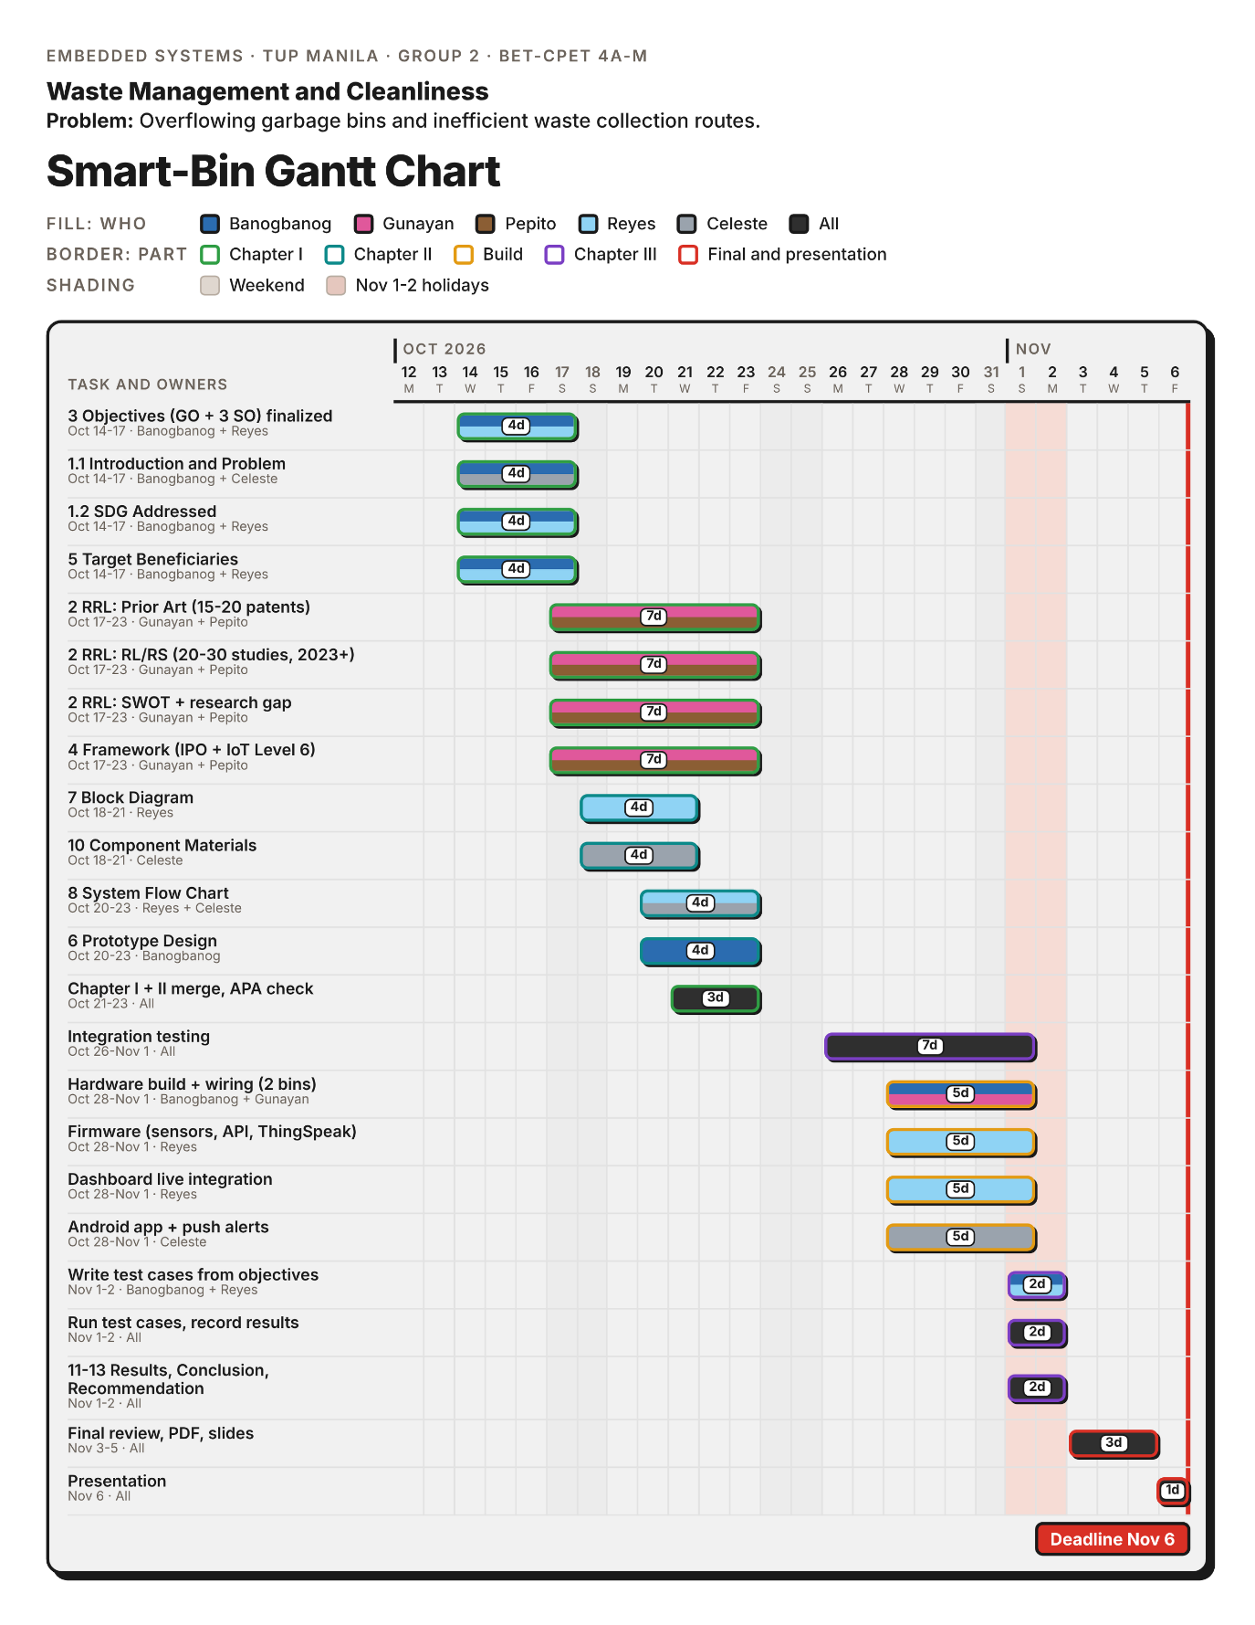

Appendix B
Bill of Materials of the Smart-Bin Prototype
Component | Quantity | Unit price | Amount
ESP32 DevKit V1 (38-pin, WROOM-32D) | 2 | ₱250.00 | ₱500.00
HC-SR04 ultrasonic sensor | 2 | ₱45.00 | ₱90.00
FC-51 IR obstacle avoidance sensor | 2 | ₱35.00 | ₱70.00
SG90 micro servo motor (180°) | 2 | ₱65.00 | ₱130.00
2.4-in. TFT touch display (ILI9341 + XPT2046) | 2 | ₱350.00 | ₱560.00
BMI160 six-axis inertial sensor module | 2 | ₱80.00 | ₱160.00
BME680 environmental sensor | 2 | ₱400.00 | ₱800.00
HX711 load cell amplifier board | 2 | ₱60.00 | ₱120.00
5kg straight bar load cell | 2 | ₱120.00 | ₱240.00
KY-016 RGB LED module (common cathode) | 2 | ₱8.00 | ₱16.00
MH-FMD passive buzzer module | 2 | ₱12.00 | ₱24.00
18650 battery shield, 4-cell (Bin A) | 1 | ₱310.00 | ₱310.00
18650 battery shield, 2-cell (Bin B) | 1 | ₱206.00 | ₱206.00
18650 Li-ion cell, 3.7V 2500mAh | 6 | ₱203.00 | ₱1,218.00
Ceramic capacitor 100nF (pack of 10) | 1 | ₱75.00 | ₱75.00
Electrolytic capacitor 10µF (pack of 10) | 1 | ₱39.00 | ₱39.00
Electrolytic capacitor 1000µF (pack of 10) | 1 | ₱165.00 | ₱165.00
Resistor 1kΩ (pack of 10) | 1 | ₱19.00 | ₱19.00
Resistor 2.2kΩ (pack of 10) | 1 | ₱19.00 | ₱19.00
Resistor 10kΩ (pack of 10) | 1 | ₱19.00 | ₱19.00
Smart-Bin building materials | 2 | ₱250 | ₱500
Universal PCB and materials | 2 | ₱300 | ₱600
Total |  |  | ₱5,955.00
Note. Quantities apply to both bins. The market prices as of the check in October 2026. ₱1,191.00 per person.

Appendix C
User Interface Screens
This appendix shows the two user interfaces of the Smart-Bin: the web dashboard served by the ESP32 and the Android app. The screens were captured from the actual software, the dashboard in a desktop browser and app version 2.2 on an Android emulator. Both ran on their built-in demo data, so the bin names and readings in the figures are sample values and not measurements. Figures C1 to C16 cover the web dashboard, from the start page and operator PIN through the Overview, Charts, Settings, Simulation and Alerts tabs. Figures C17 to C29 cover the same functions in the Android app, along with its app settings, connection and Bluetooth setup pages.
Figure C1
Start Page of the Web Dashboard
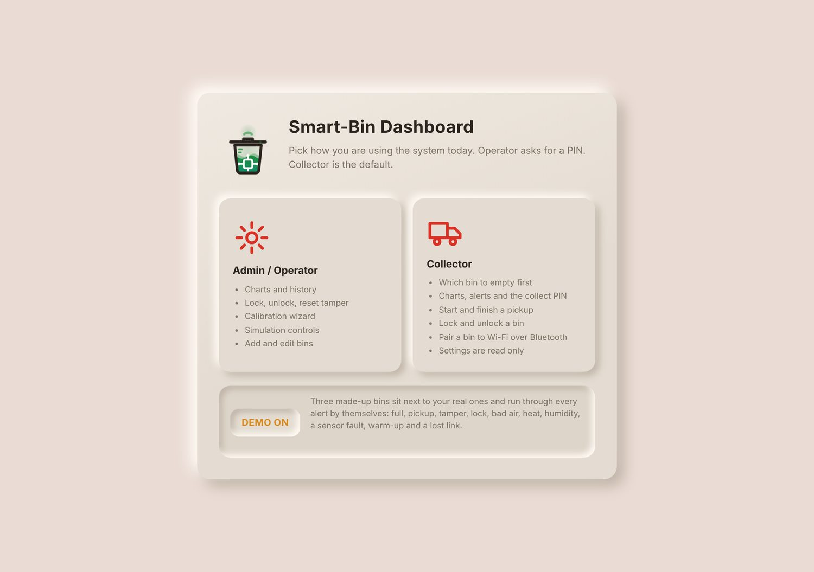
The dashboard opens on this page every time. The user picks a role first. Admin / Operator can change settings, calibrate, simulate and add bins, and it asks for a PIN. Collector is the default and can see everything but only acts on pickups, locks and Bluetooth setup. The DEMO key at the bottom adds three made-up bins that act out every alert by themselves, and it can only be switched on or off here.
Figure C2
Creating the Operator PIN
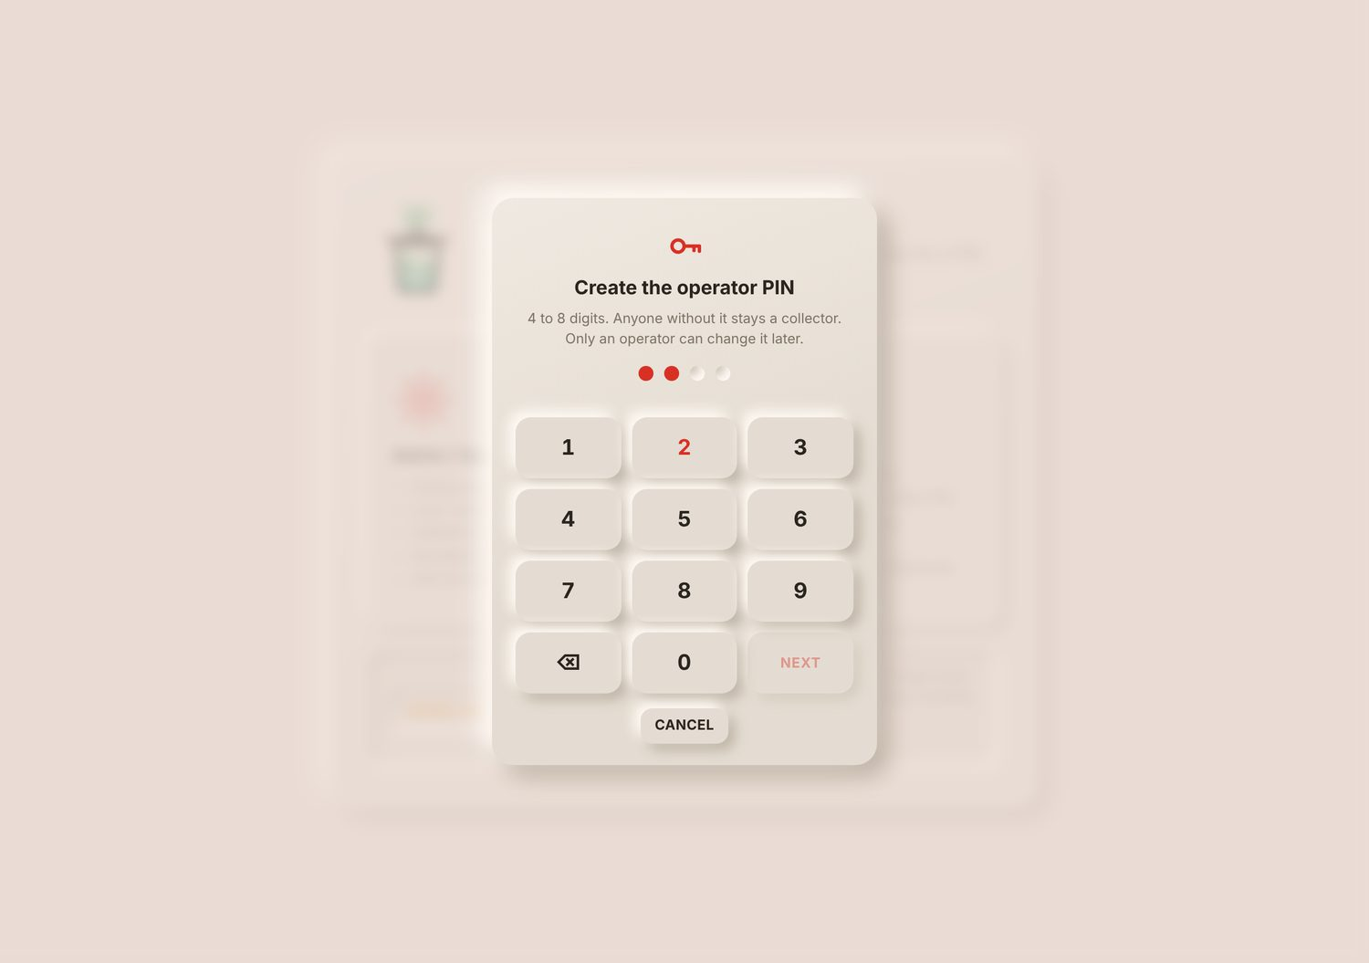
The first time Admin / Operator is picked, the dashboard asks for a new PIN of 4 to 8 digits, typed twice. Only a salted hash of the PIN is stored in the browser. After 5 wrong tries the keypad waits 30 s, and the wait doubles each time. The dashboard also drops back to collector after 2 min with the tab hidden.
Figure C3
Overview Tab with Bin Cards and Collection Priority
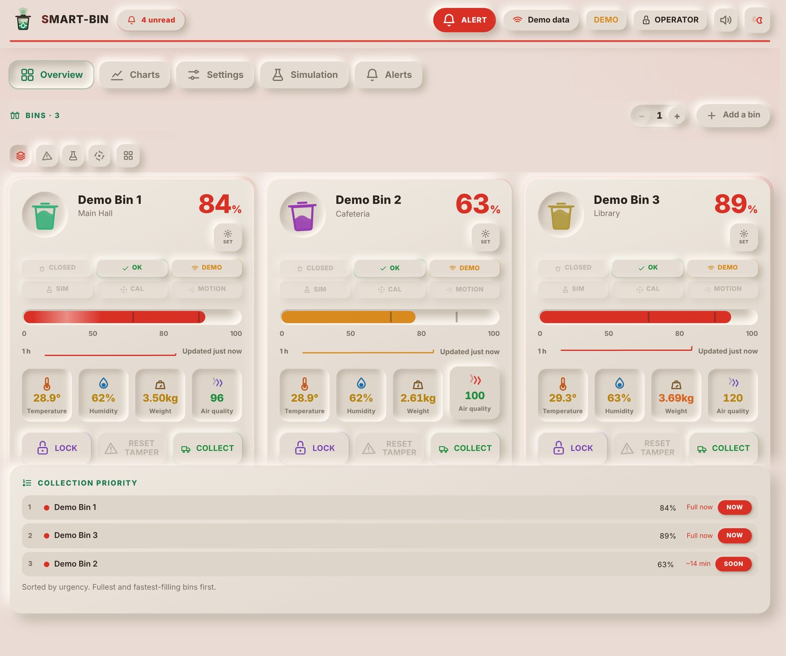
Each bin has one card. The large number is the fill level and the bar under it marks 50% and the alert limit (80% here). The chips show the lid, the bin status, the link in use, and whether simulation, calibration or motion is active. The four tiles show temperature, humidity, weight and the air quality index from the BME680, and a tile turns red when its reading passes its limit. The keys at the bottom send LOCK or UNLOCK, RESET TAMPER and COLLECT to the bin.
Collection Priority lists the bins in the order they should be emptied: full bins first, then the bins that will fill soonest, from the fill rate of the last 15 min. The tags NOW, SOON, TODAY, LATER and IDLE are the same in the phone app. The header shows the unread alerts, the system mode (ALERT here, because bins are full), the link (Demo data), the role, and the sound and theme keys.
Figure C4
Overview Tab in Grid View
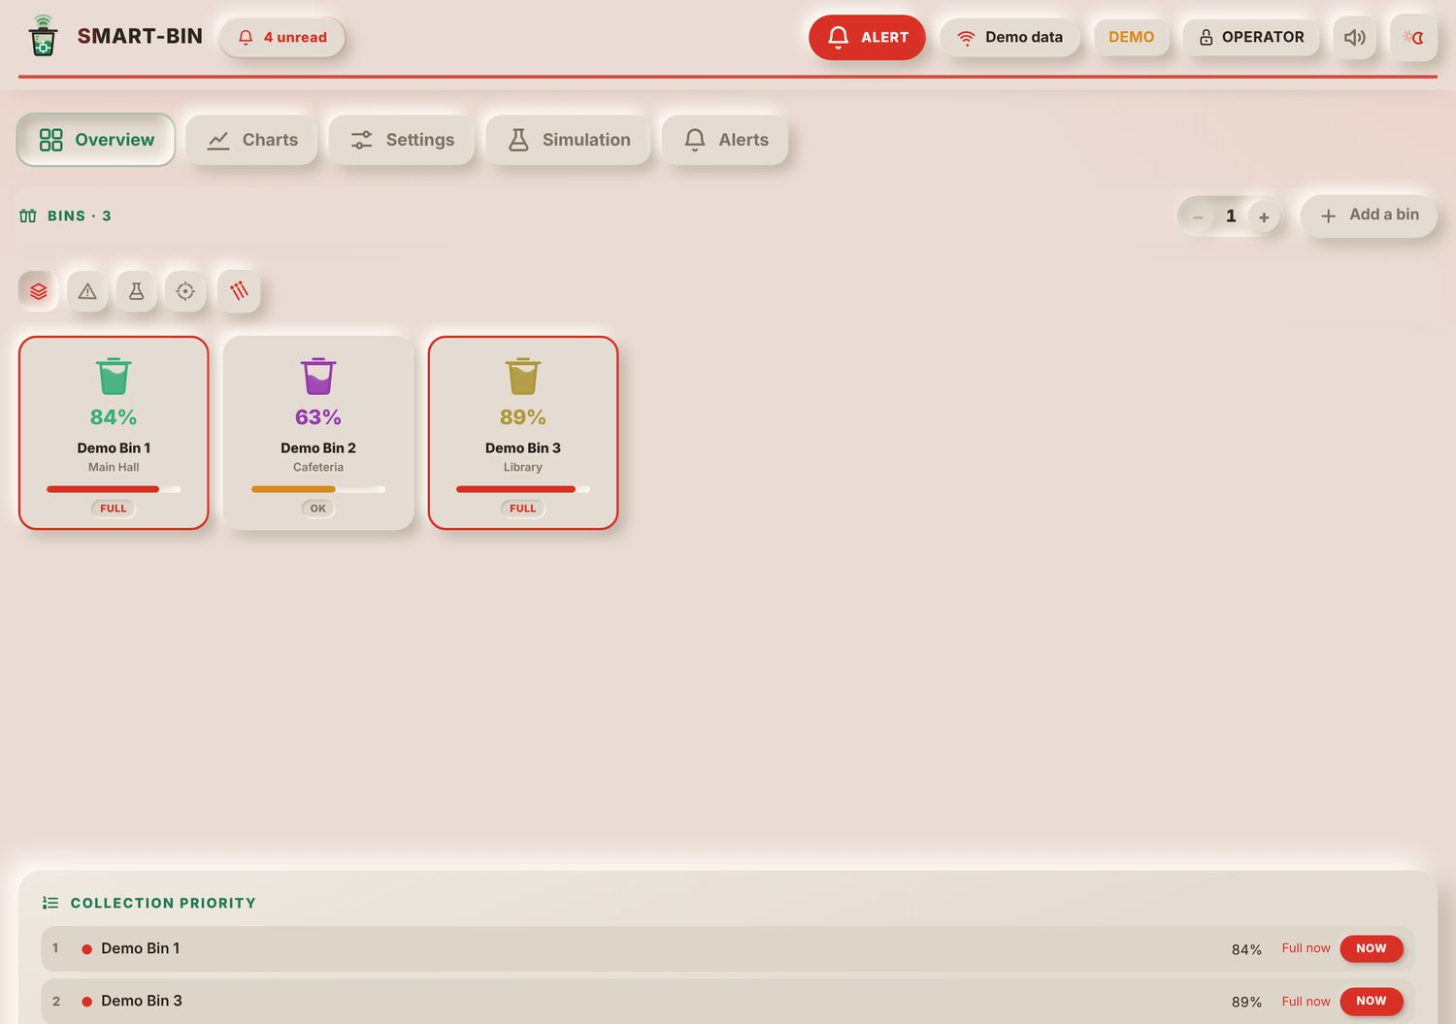
With 3 or more bins the cards can be switched to small tiles with the grid key, so many bins fit on one screen. Each tile shows the fill level, the name, the location and the status. The four filter keys above the bins show all bins, only the bins that need attention, bins in simulation, or bins being calibrated.
Figure C5
Bin Detail Opened from the Grid
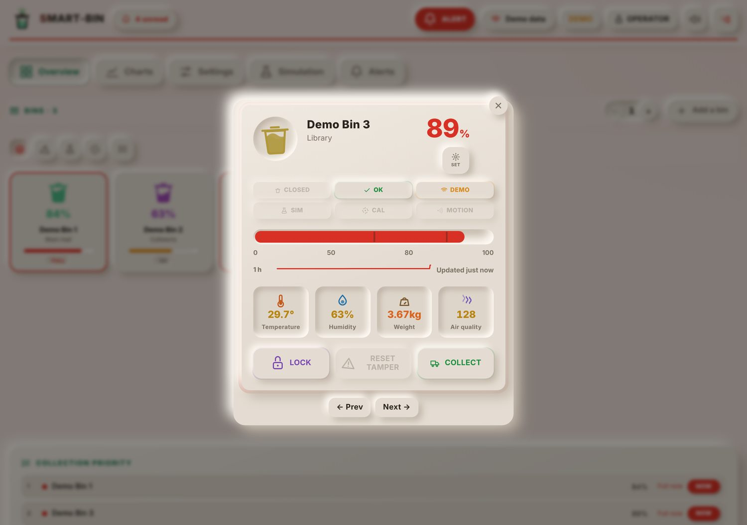
Clicking a tile opens the full card of that bin over the page, with the same readings and keys as the Overview card. Prev and Next step through the bins without closing it.
Figure C6
Charts Tab
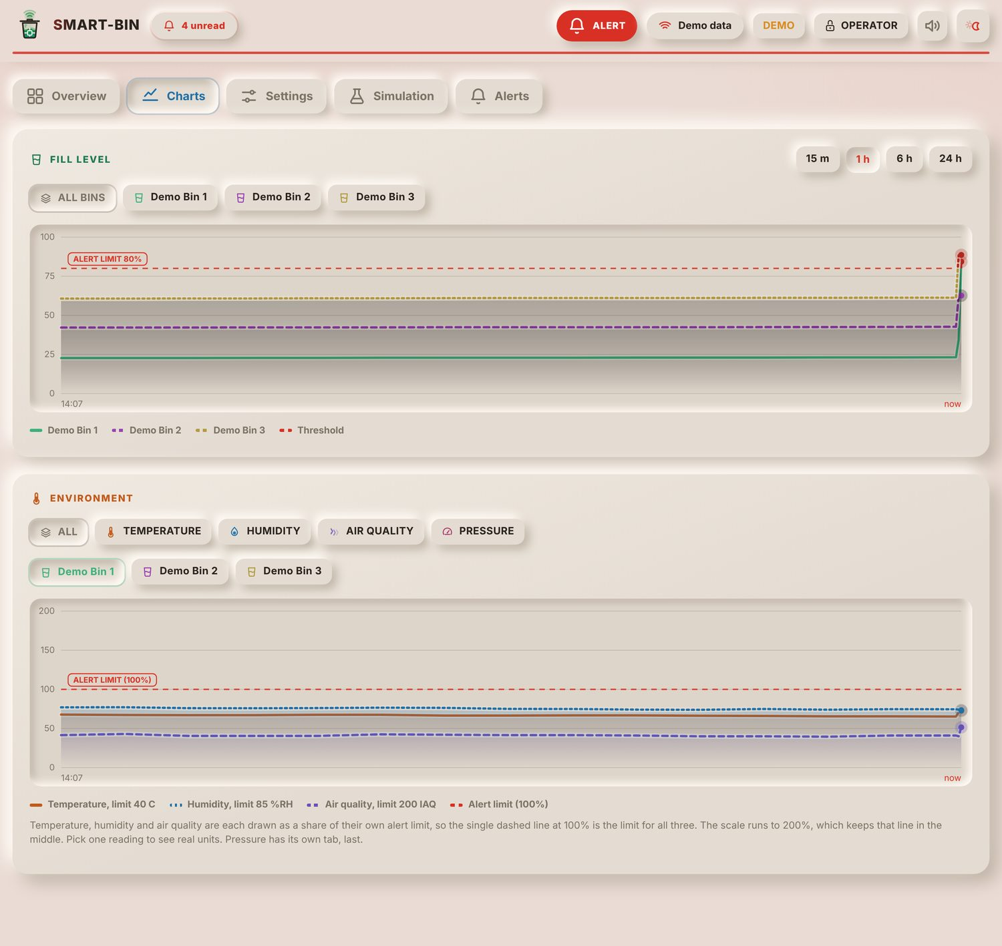
The Fill Level chart shows the fill of every bin over the last 15 min, 1 h, 6 h or 24 h, with the alert limit as a dashed red line. One bin or all bins can be picked. The Environment chart shows temperature, humidity and air quality of one bin. In the ALL view each reading is drawn as a share of its own alert limit, so the dashed line at 100% is the limit for all three. Picking one reading, or PRESSURE, draws it in its real unit instead.
Figure C7
Settings Tab in Calibration Mode: Fill Range, Alert Limits and Air Sensor
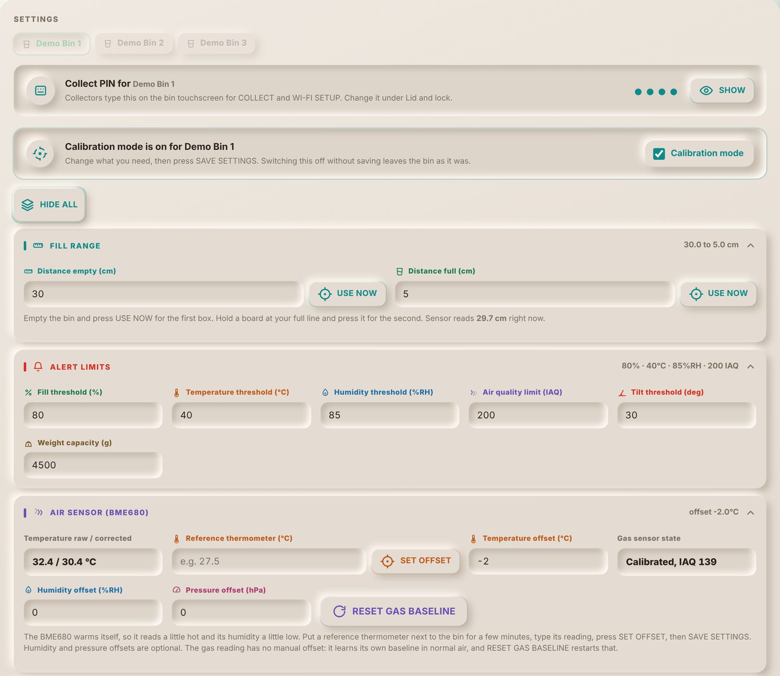
An operator switches on Calibration mode for one bin. The page and the bin's own screen turn teal, and the fields can then be edited. The first groups are Fill range (the distances for empty and full, with USE NOW to take the live sensor reading), Alert limits, and Air sensor (temperature offset against a reference thermometer and the gas baseline reset). A collector sees the same values but cannot change them.
Figure C8
Settings Tab in Calibration Mode: Tilt Sensor, Lid, Weight and Touchscreen
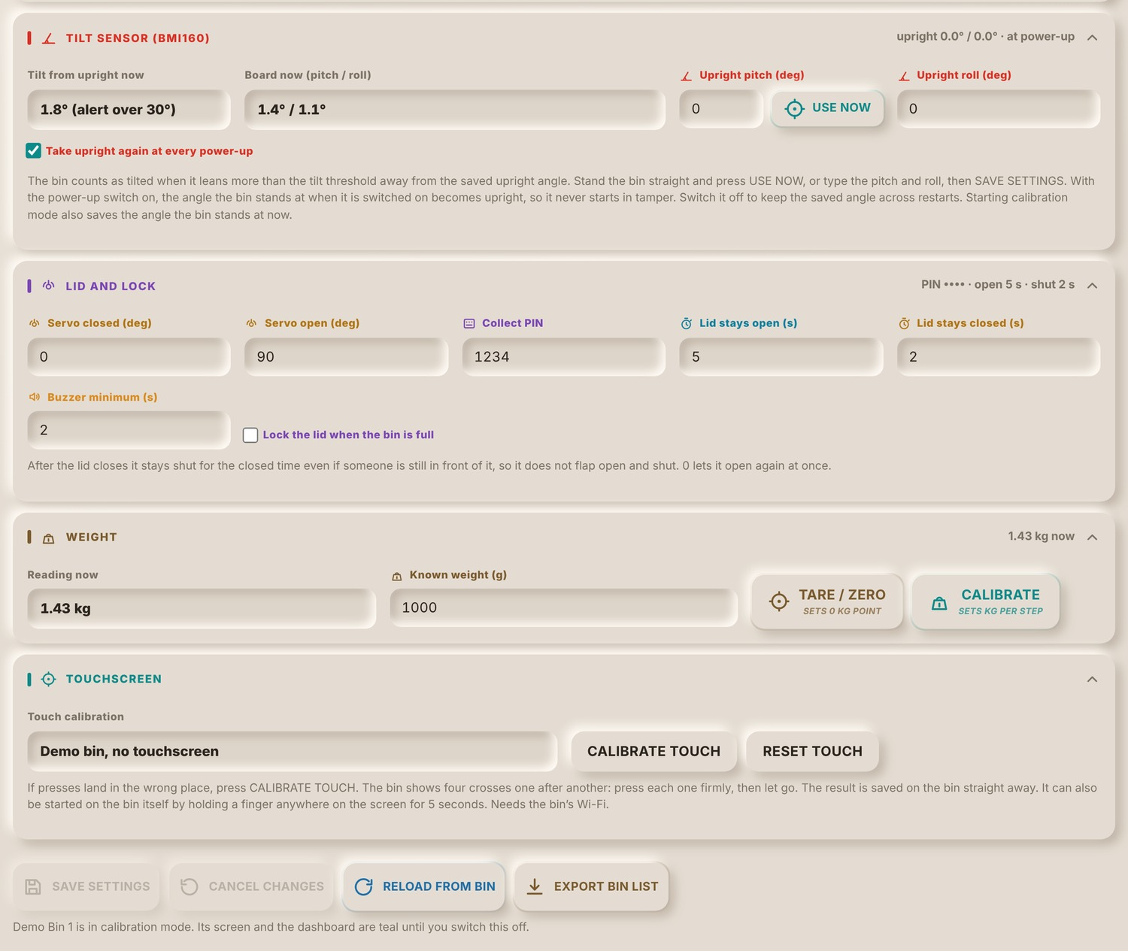
The rest of the calibration page holds Tilt sensor (the live tilt, the board’s pitch and roll, the saved upright angle with USE NOW, and the switch that takes the upright again at every power-up), Lid and lock (servo angles, Collect PIN, how long the lid stays open and how long it stays closed, buzzer time, auto-lock when full), Weight (tare and calibration with a known weight) and Touchscreen (touch calibration). SAVE SETTINGS sends the values to the bin, which keeps them after a restart.
Figure C9
Bluetooth Setup Panel
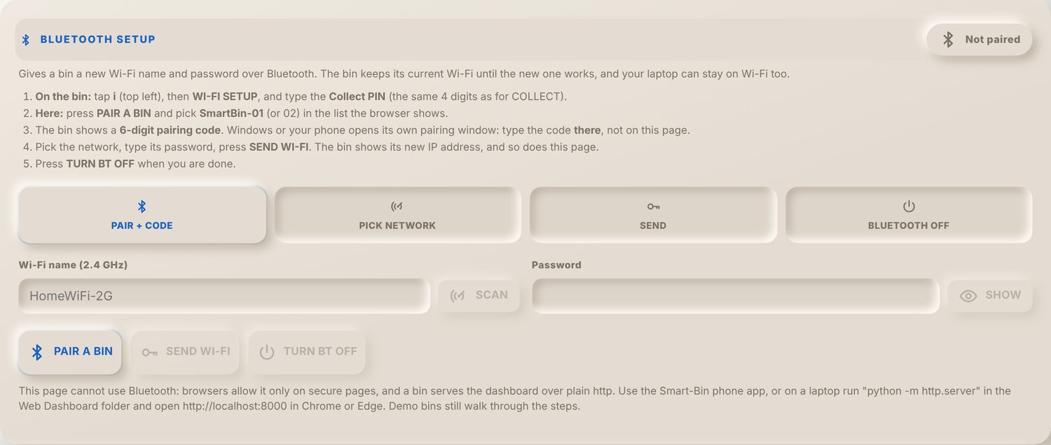
This panel gives a bin a new Wi-Fi network over Bluetooth LE. The steps are shown across the top: pair with the 6-digit code that the bin shows on its screen, pick a network from the bin's scan, send the name and password, then switch Bluetooth off. Browsers allow Bluetooth only on secure pages, so this works when the dashboard is opened from a laptop and not from the bin's own http page; the panel says so.
Figure C10
Cloud Backup Panel for Firebase and ThingSpeak
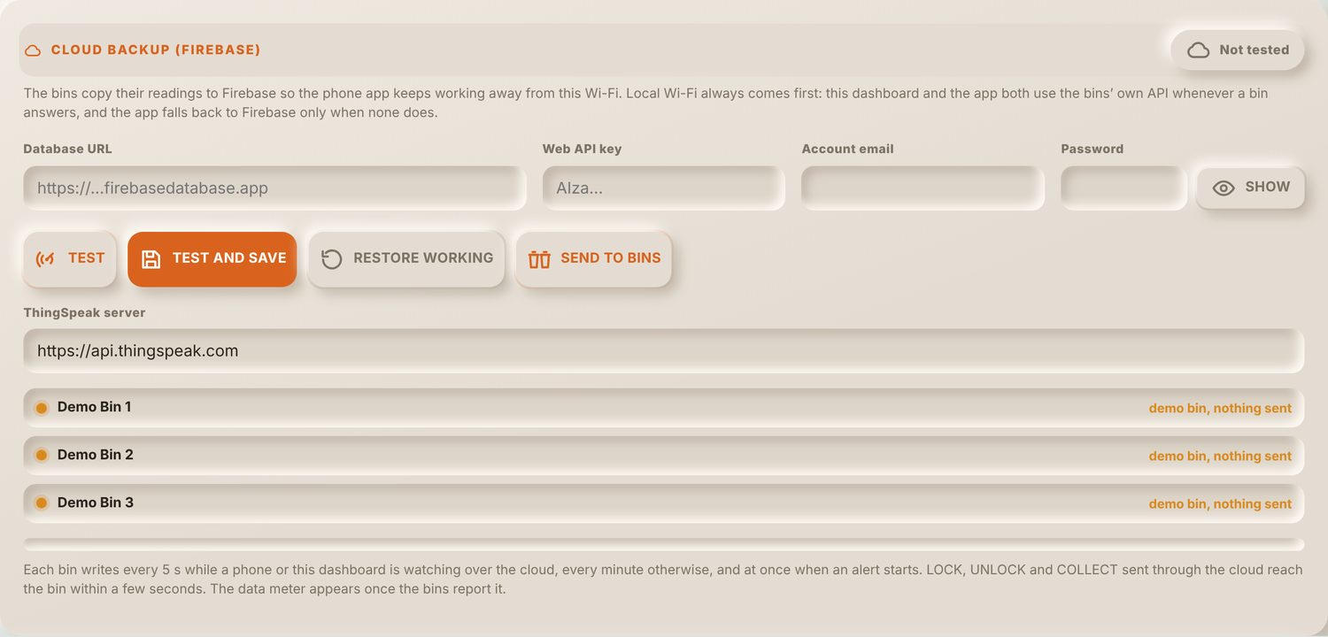
The Firebase account (database URL, Web API key, email and password) is entered here. TEST signs in and checks access, TEST AND SAVE keeps the account, and SEND TO BINS gives it to every bin on Wi-Fi so they all write to the same database. The rows below show what each bin last sent. Local Wi-Fi is always tried first; Firebase and then ThingSpeak are used only when a bin does not answer on Wi-Fi.
Figure C11
Operator Access Panel
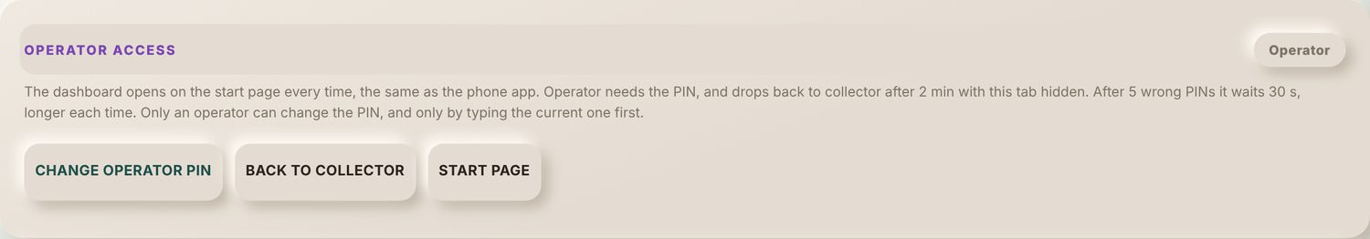
The operator can change the PIN, go back to collector, or return to the start page from here.
Figure C12
Demo Options Panel
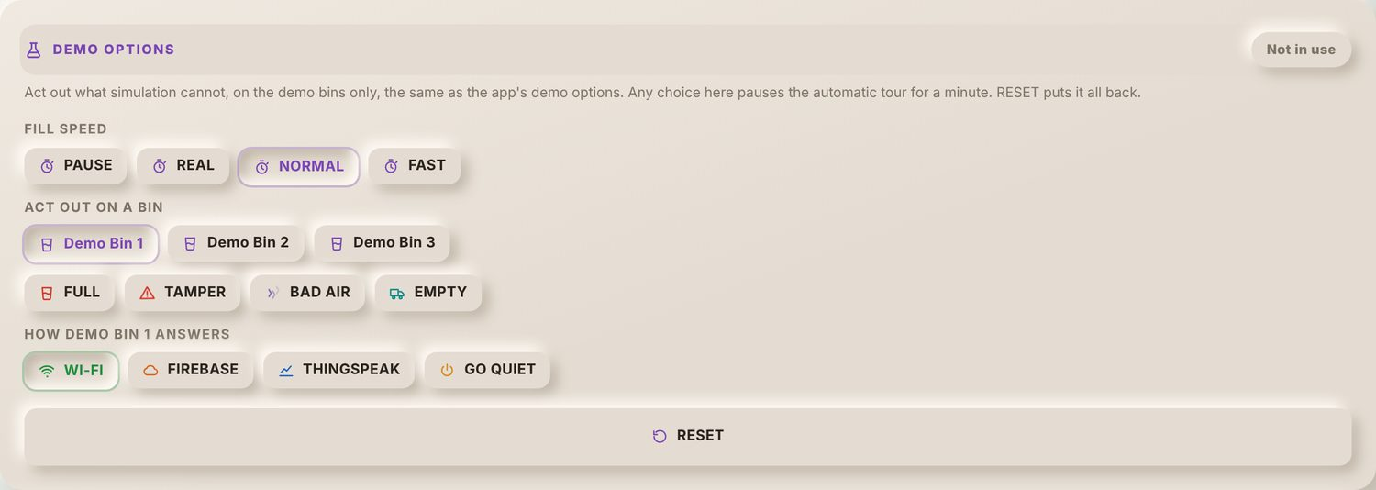
Shown only while DEMO is on. The demo bins can be paused or sped up, made to act out a full bin, a tamper, bad air or an emptied bin, and made to answer through Wi-Fi, Firebase, ThingSpeak or not at all. This shows every alert and link state in class without the hardware.
Figure C13
Sound Test Panel
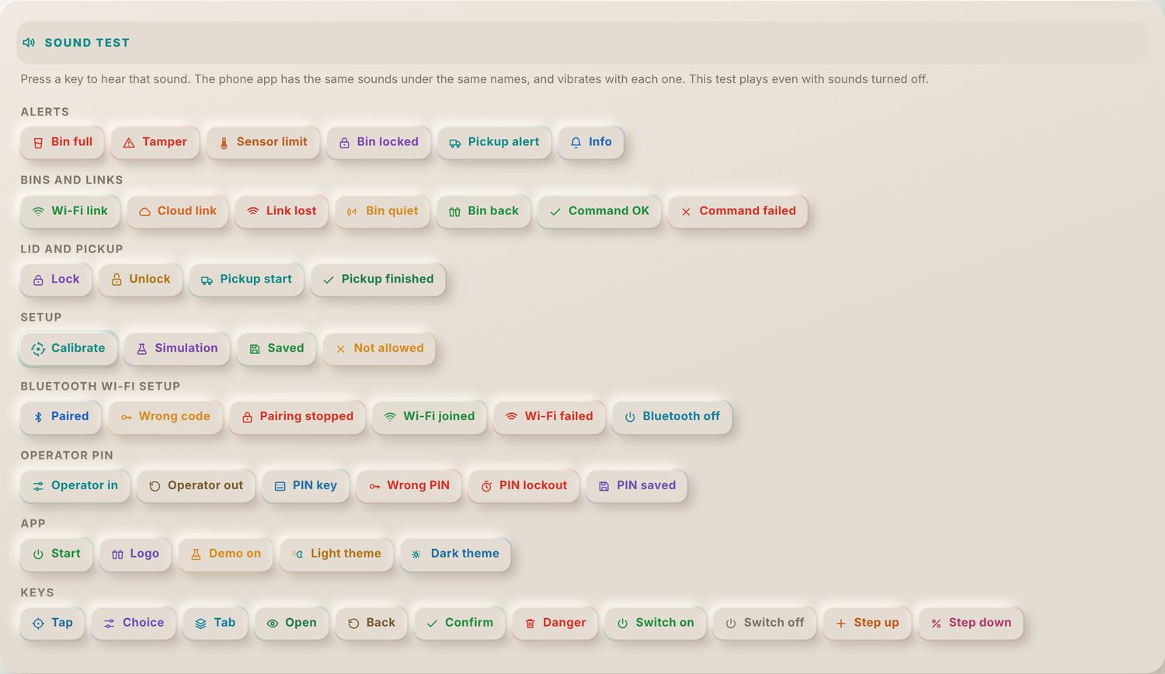
Every sound the dashboard plays is listed by group, from alerts to key clicks. Pressing a key plays it even with sounds switched off. The phone app has the same sounds under the same names.
Figure C14
Simulation Tab with One Sensor in Manual
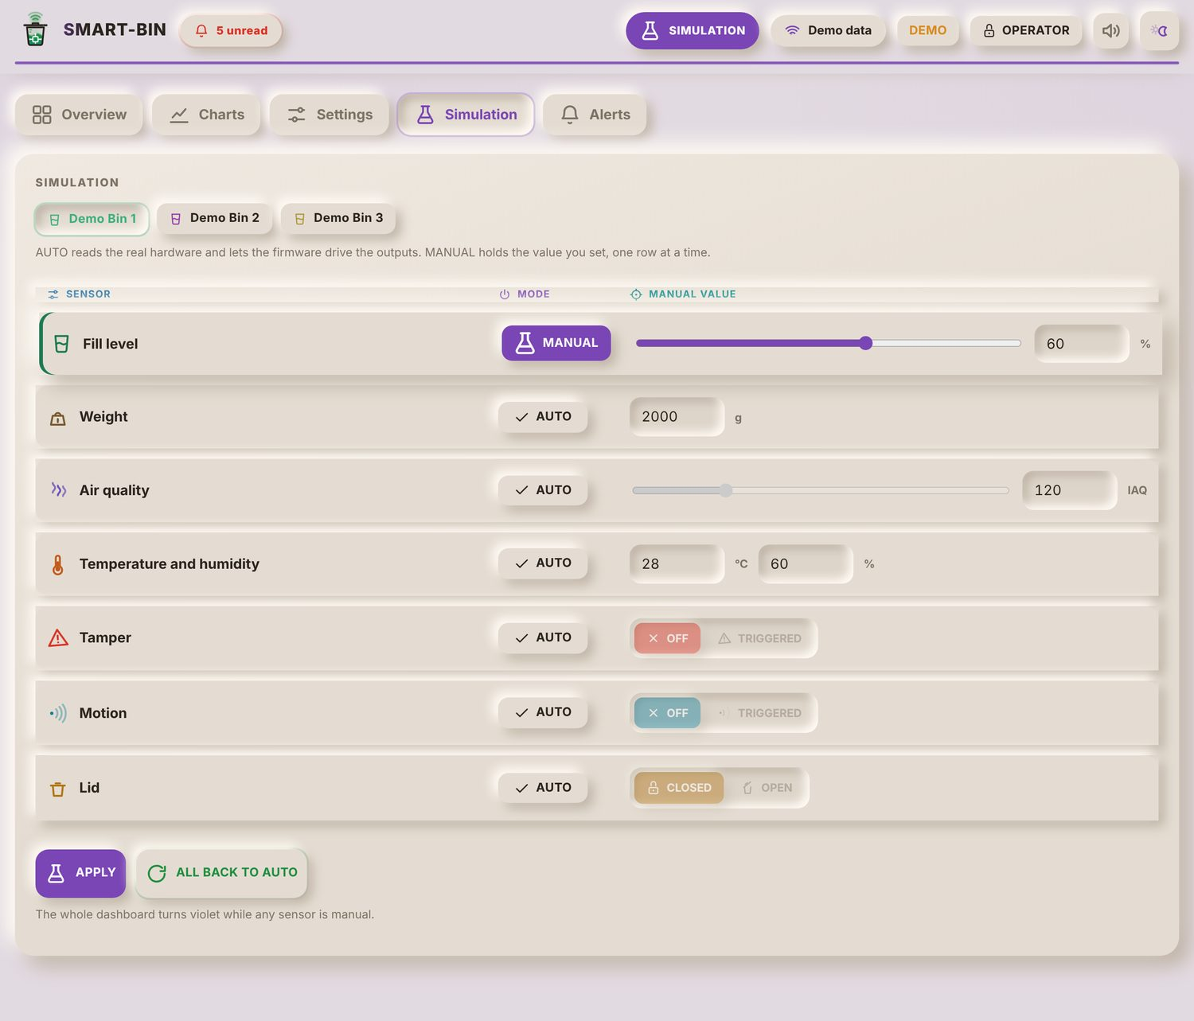
Each sensor row is AUTO, where the bin reads its real hardware, or MANUAL, where it holds the value typed here. In this figure the fill level is held at 60%. APPLY sends the rows to the bin over Wi-Fi, and ALL BACK TO AUTO ends the simulation. While any row is manual the whole dashboard turns violet and the mode chip says SIMULATION, so simulated readings are never mistaken for real ones.
Figure C15
Alerts Tab
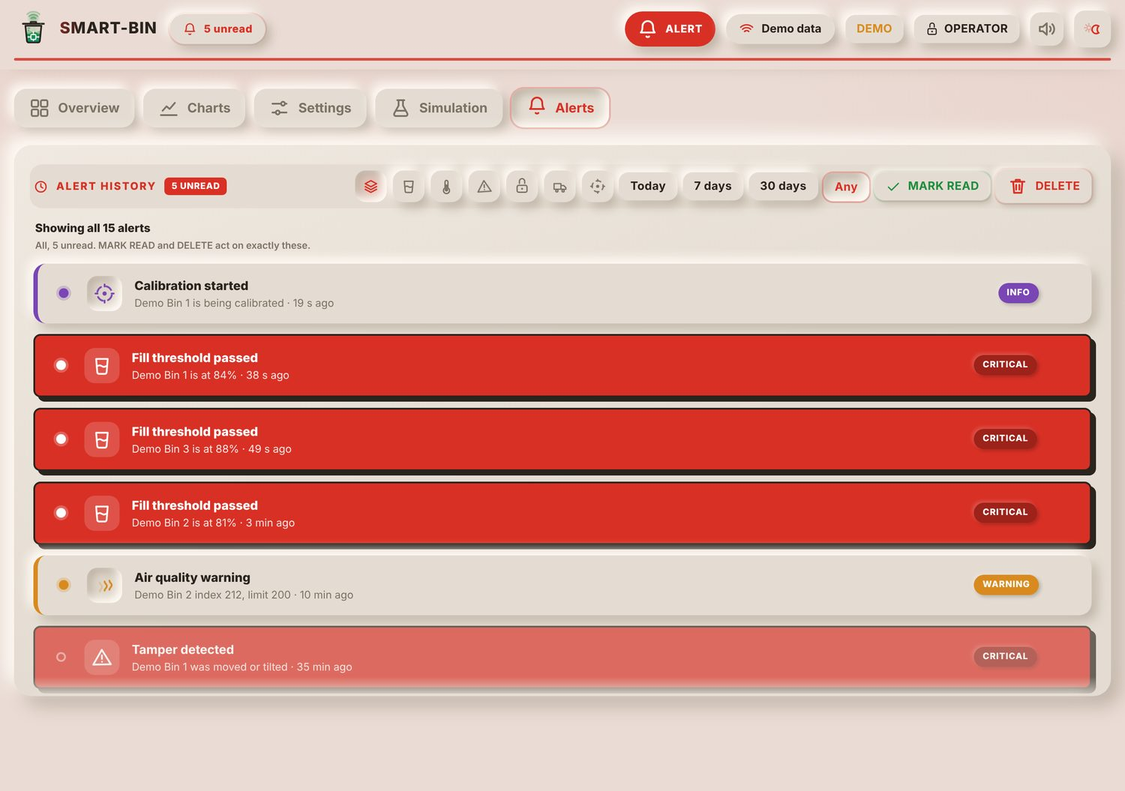
The alert history lists every alert with its bin, time and severity (CRITICAL, WARNING, INFO or RESOLVED). The symbols filter by kind (full bins, sensor limits, tamper, lock, pickups and calibration) and the keys beside them by date. MARK READ and DELETE act only on the alerts shown. A dot marks an unread alert.
Figure C16
Overview Tab in Dark Theme
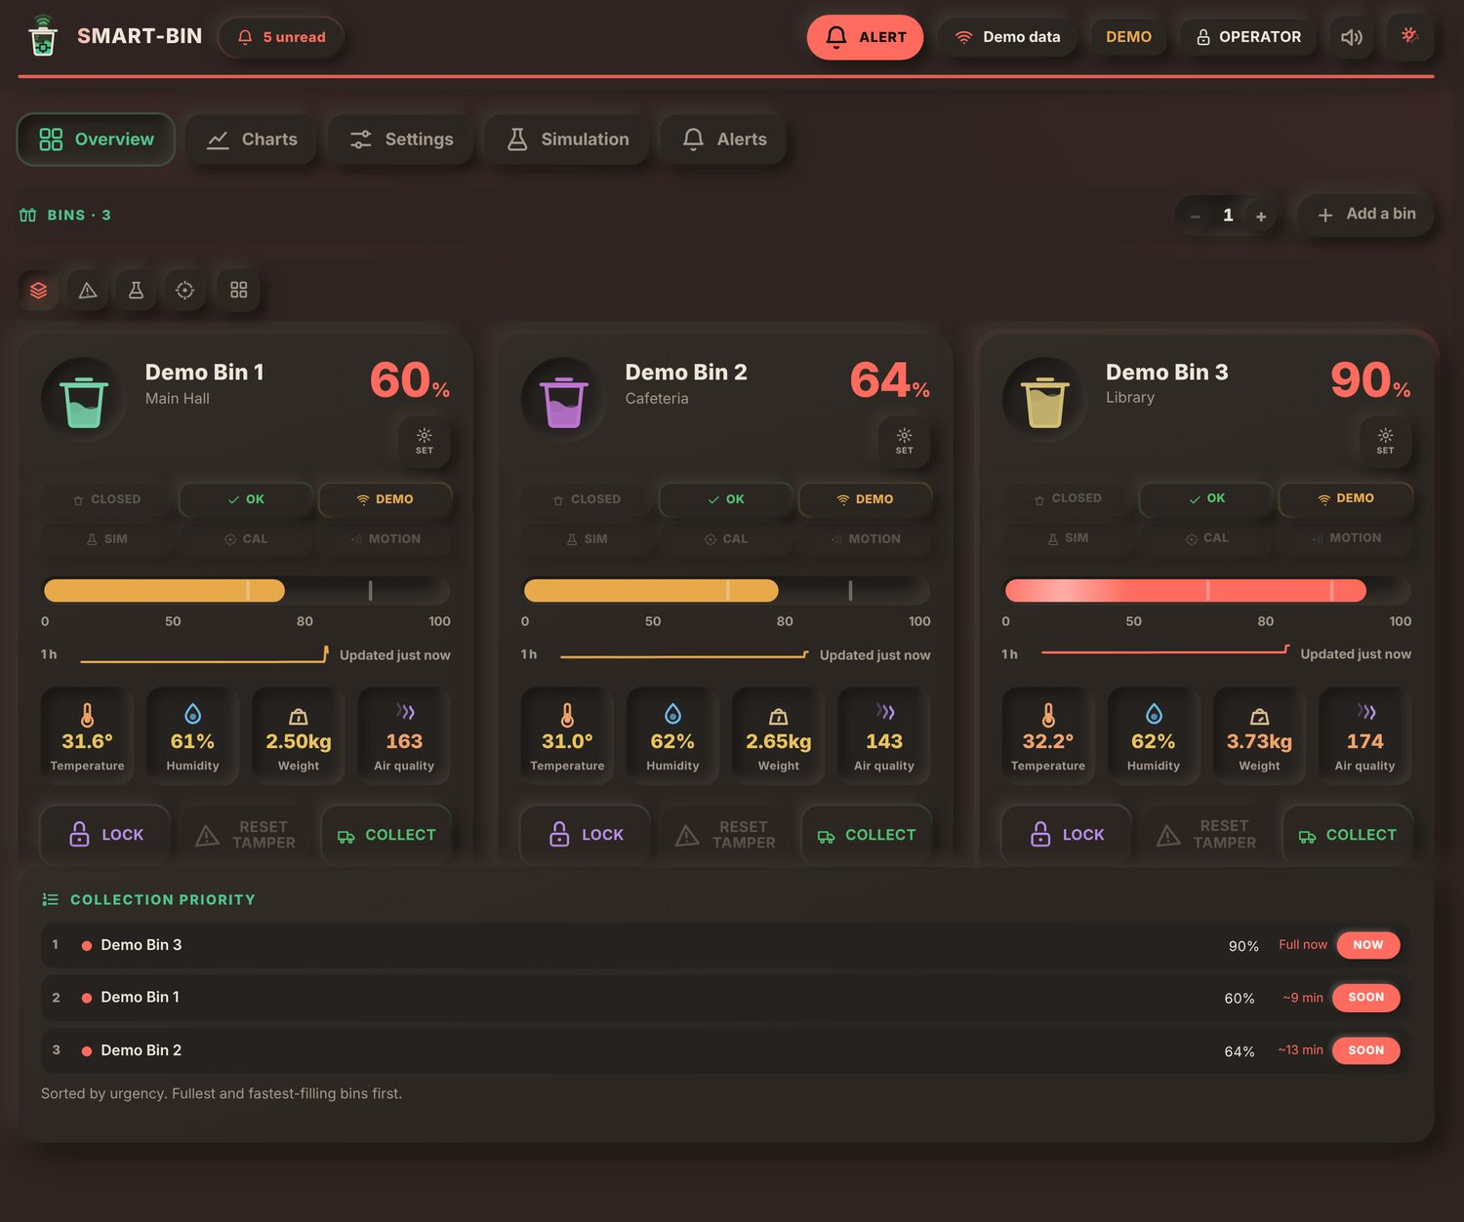
The theme key in the header switches between the light and dark themes. Both use the same layout and colors for each status.
Figure C17
Start Page and Operator PIN in the Android App
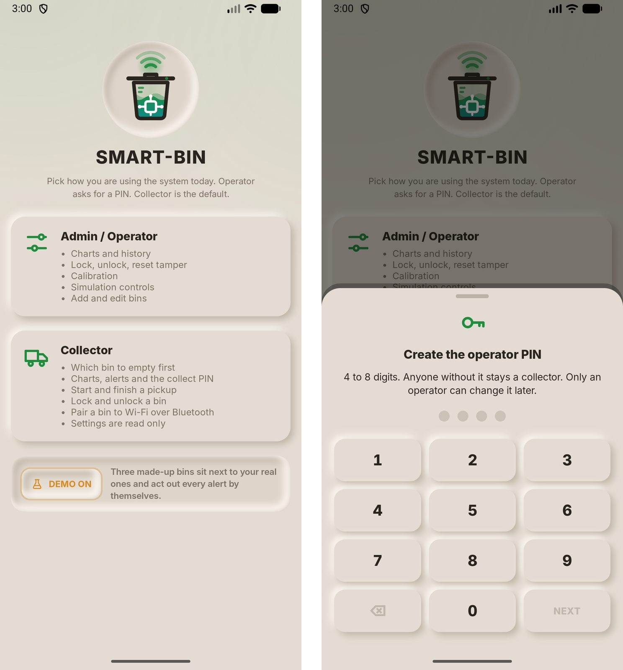
The app opens on the same start page as the dashboard, with the Admin / Operator and Collector roles and the DEMO key. The left screen has DEMO on. Picking Admin / Operator the first time opens the sheet on the right, where the operator PIN is typed once and then again to confirm it. The app keeps its own operator PIN, separate from the Collect PIN of the bins.
Figure C18
Overview Tab with Banners, Collection Priority and Bin Grid
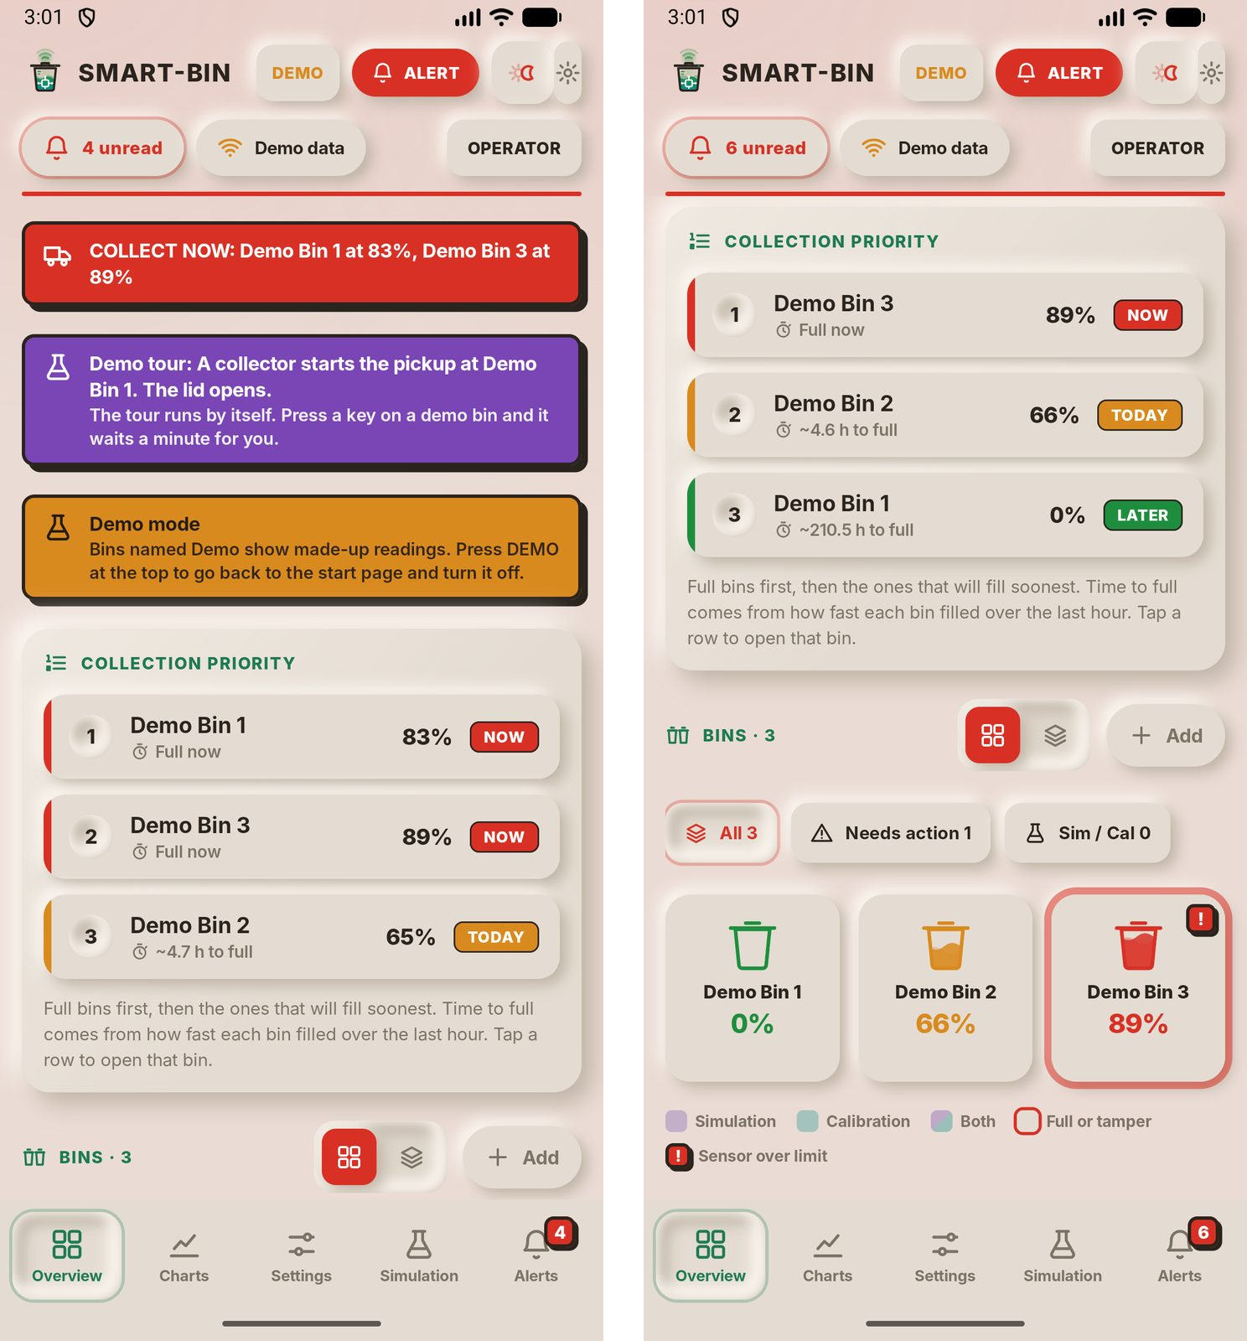
Banners at the top list what needs action now: here two bins are full (COLLECT NOW), the demo tour is running, and demo mode is on. Collection Priority orders the bins the same way as the dashboard, with the time to full and the NOW, TODAY and LATER tags. Below it the bins are shown as a grid; the filter keys show all bins, only the bins that need action, or bins in simulation or calibration, and the legend explains the tile colors. The badge on the Alerts tab counts unread alerts.
Figure C19
Starting and Finishing a Pickup from a Bin Card
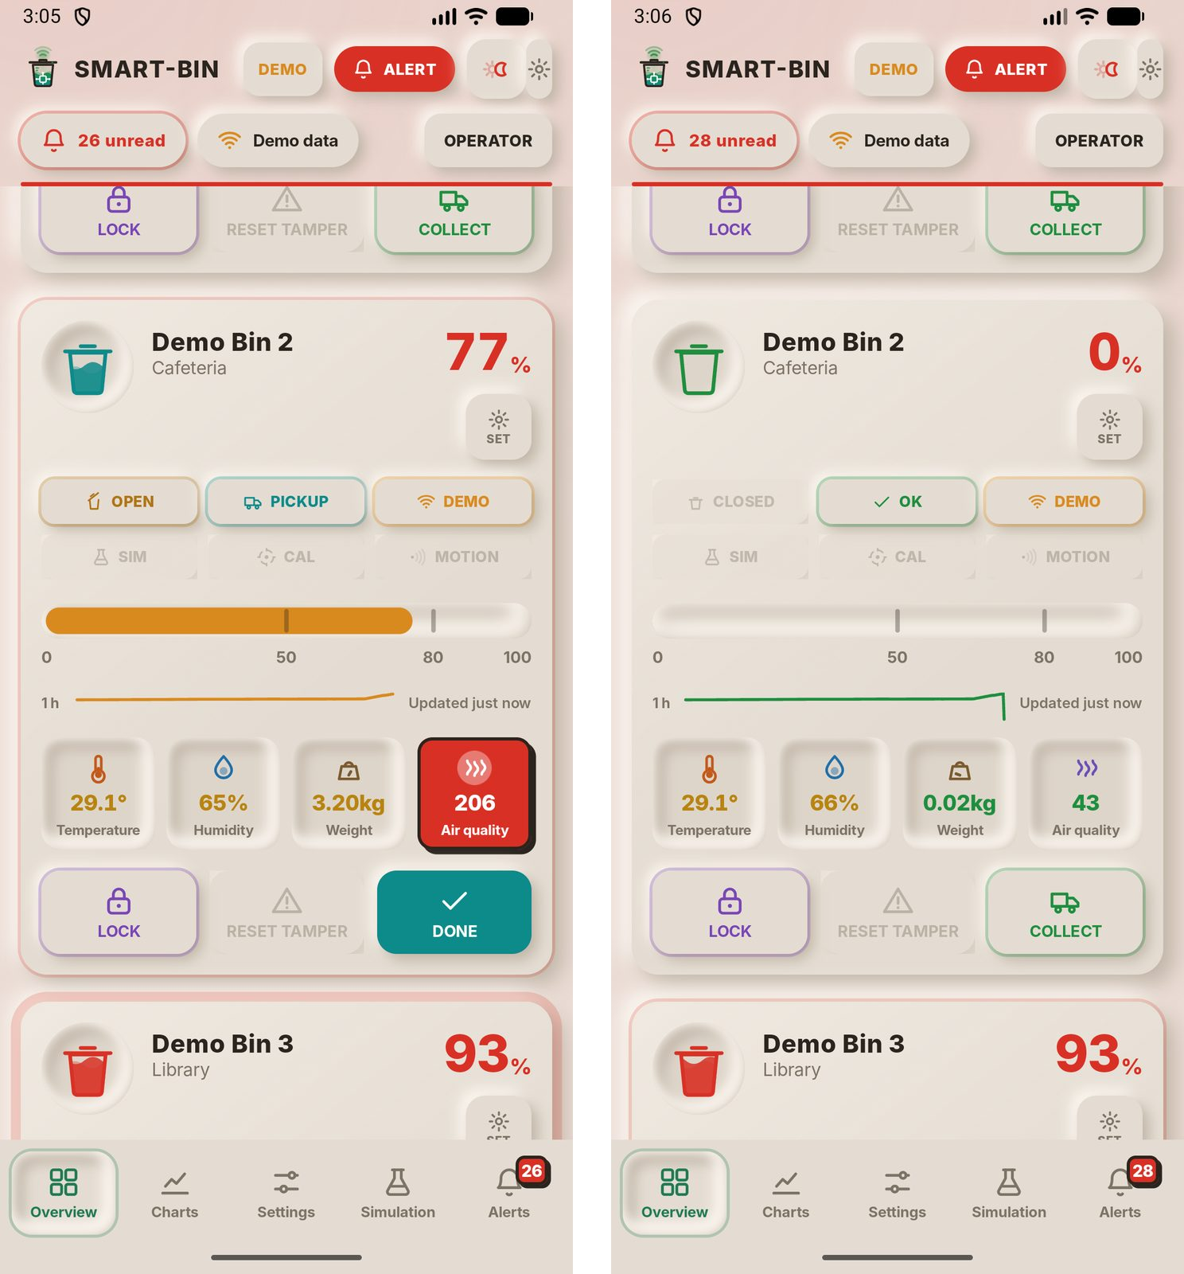
In list view each bin has a full card like the dashboard's. On the left, COLLECT was pressed on Demo Bin 2: the lid chip says OPEN, the status chip says PICKUP, and the COLLECT key turned into DONE. On the right, DONE was pressed: the lid is closed, the status is back to OK and the fill reads 0%. The air quality tile on the left is red because the index (206) is over its limit of 200.
Figure C20
Needs Attention Sheet and Alert History
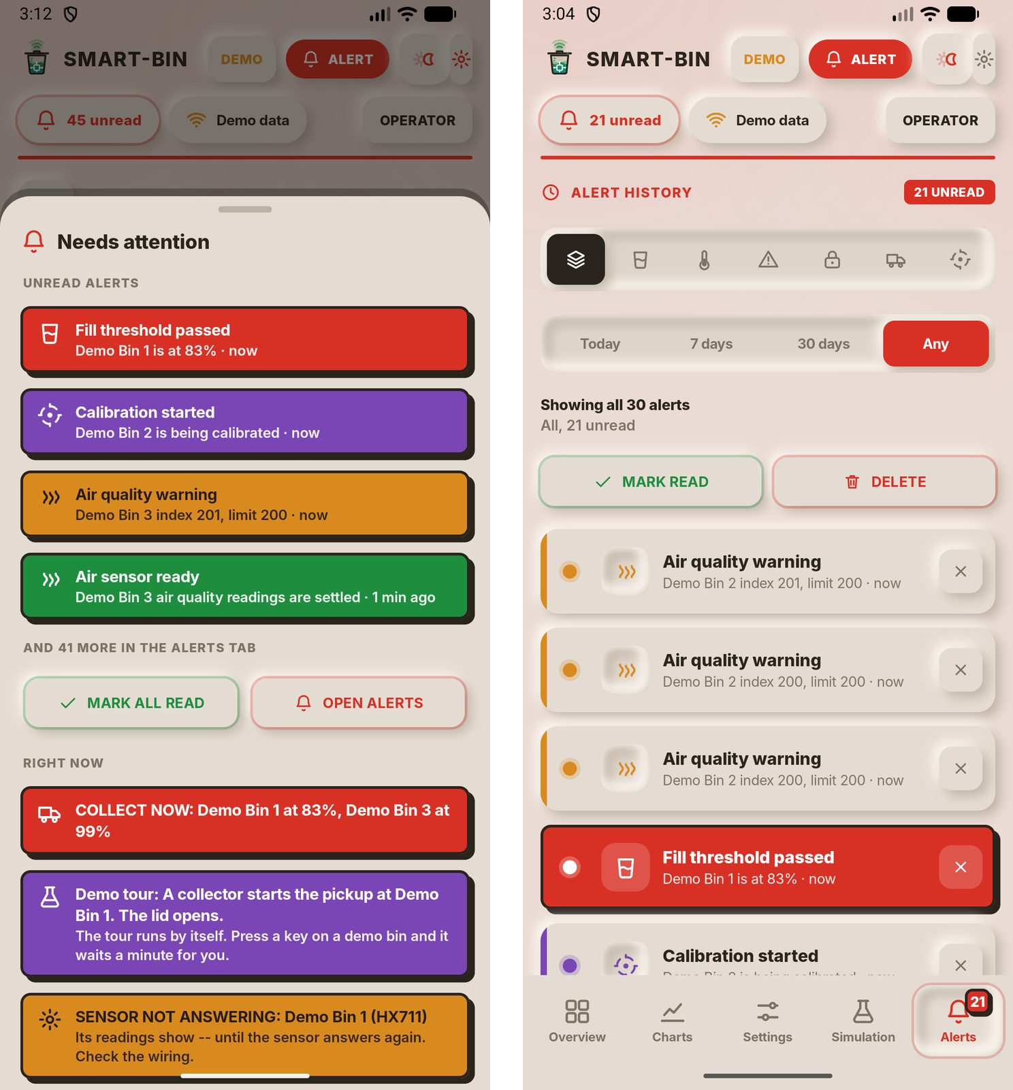
Tapping the unread pill in the header opens the Needs attention sheet on the left. It lists the unread alerts with their colors, then the conditions that are true right now, with MARK ALL READ and OPEN ALERTS. The Alerts tab on the right keeps the full history, filtered by kind and by date in the same way as the dashboard. MARK READ and DELETE act on the alerts shown, and the cross on a row removes that one alert.
Figure C21
Charts Tab in the Android App
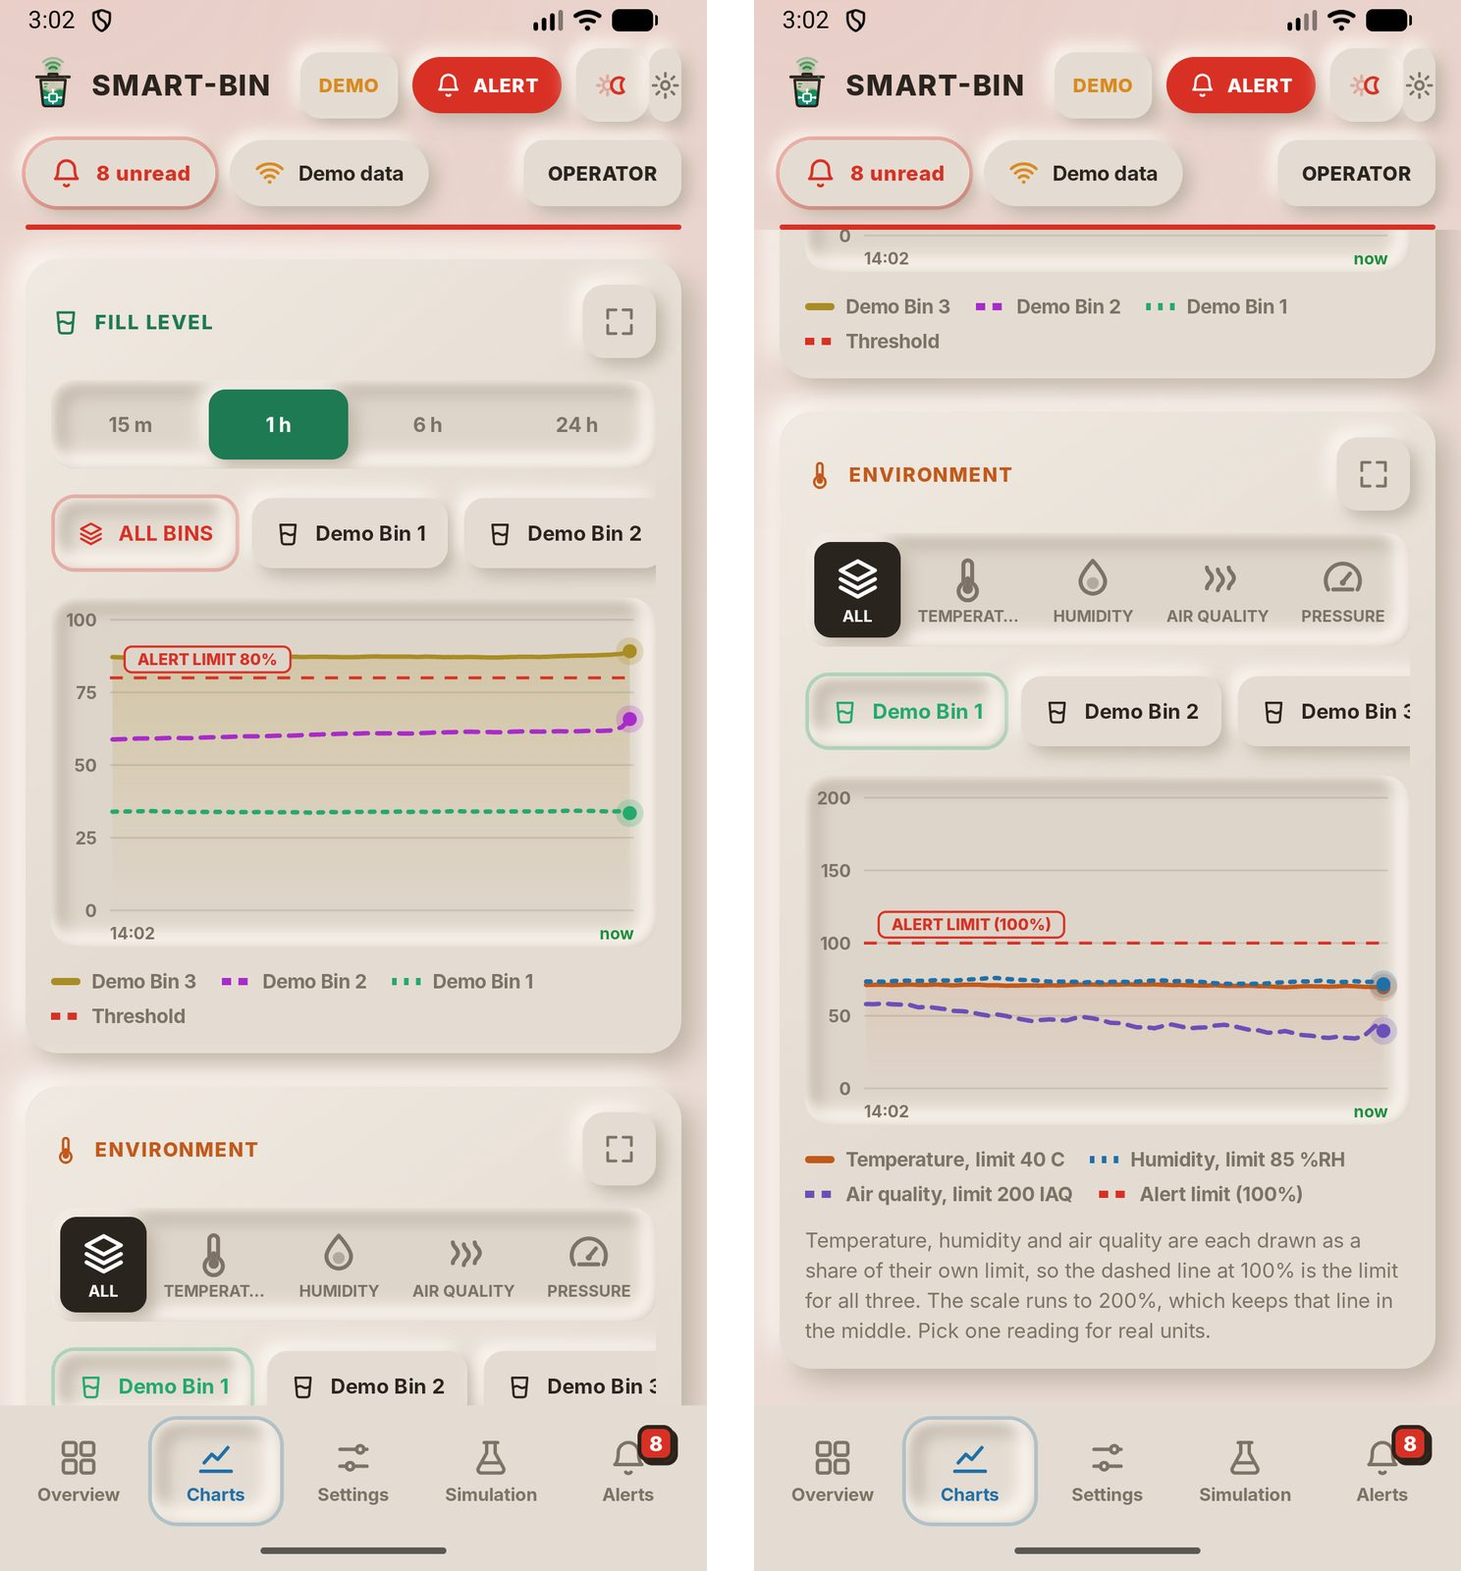
The Fill Level and Environment charts match the dashboard: a time range of 15 min to 24 h, one bin or all bins, and dashed lines for the alert limits. The key at the top right of each chart turns the phone sideways and shows the chart full screen.
Figure C22
Settings Tab with Calibration Mode Off and On
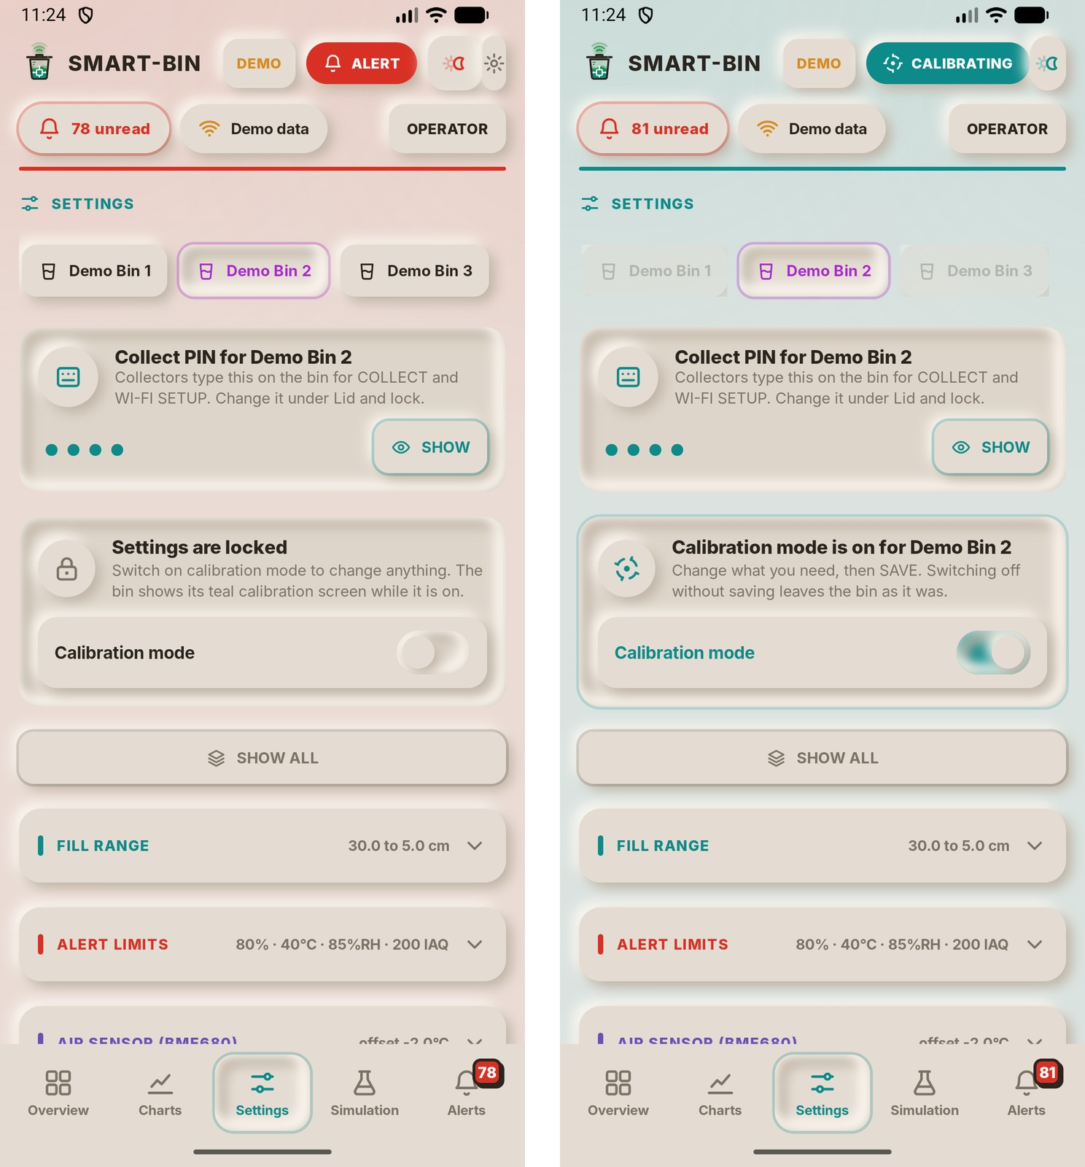
On the left the settings of Demo Bin 2 are locked; values can be read but not changed. The Collect PIN card at the top shows the PIN the collector types on the bin. On the right an operator has switched on Calibration mode, and the whole app turns teal with CALIBRATING in the header. The other bins are greyed out because only one bin is calibrated at a time. The app reads calibration mode back from the bin, so the dashboard and the bin’s screen turn teal at the same moment, whichever of the three started it.
Figure C23
Calibration Settings: Fill Range, Alert Limits and Air Sensor
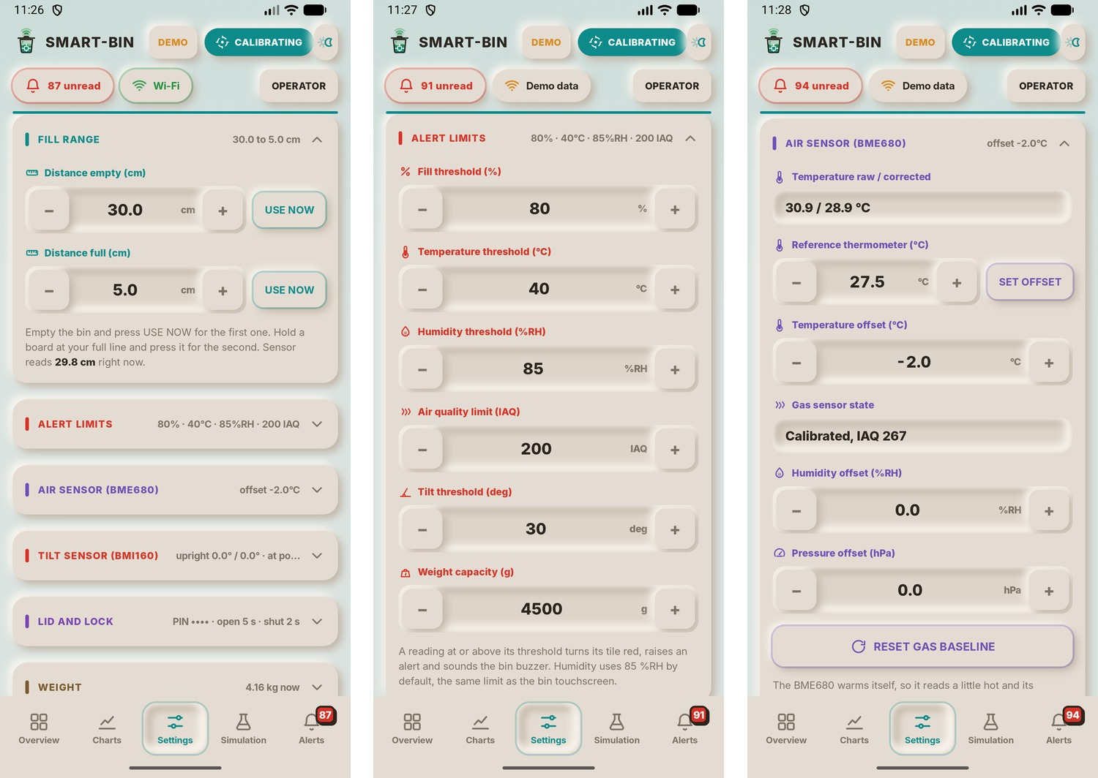
Each value has minus and plus keys. Fill range sets the distances from the ultrasonic sensor to the bottom of an empty bin and to the full line; USE NOW copies the live reading, which the hint shows (29.8cm here). Alert limits sets the fill, temperature, humidity, air quality and tilt limits and the weight capacity. The air sensor group corrects the BME680: a reference thermometer reading sets the temperature offset, humidity and pressure have their own offsets, and RESET GAS BASELINE restarts the gas sensor's clean-air learning.
Figure C24
Calibration Settings: Tilt Sensor, Lid, Weight and Touchscreen
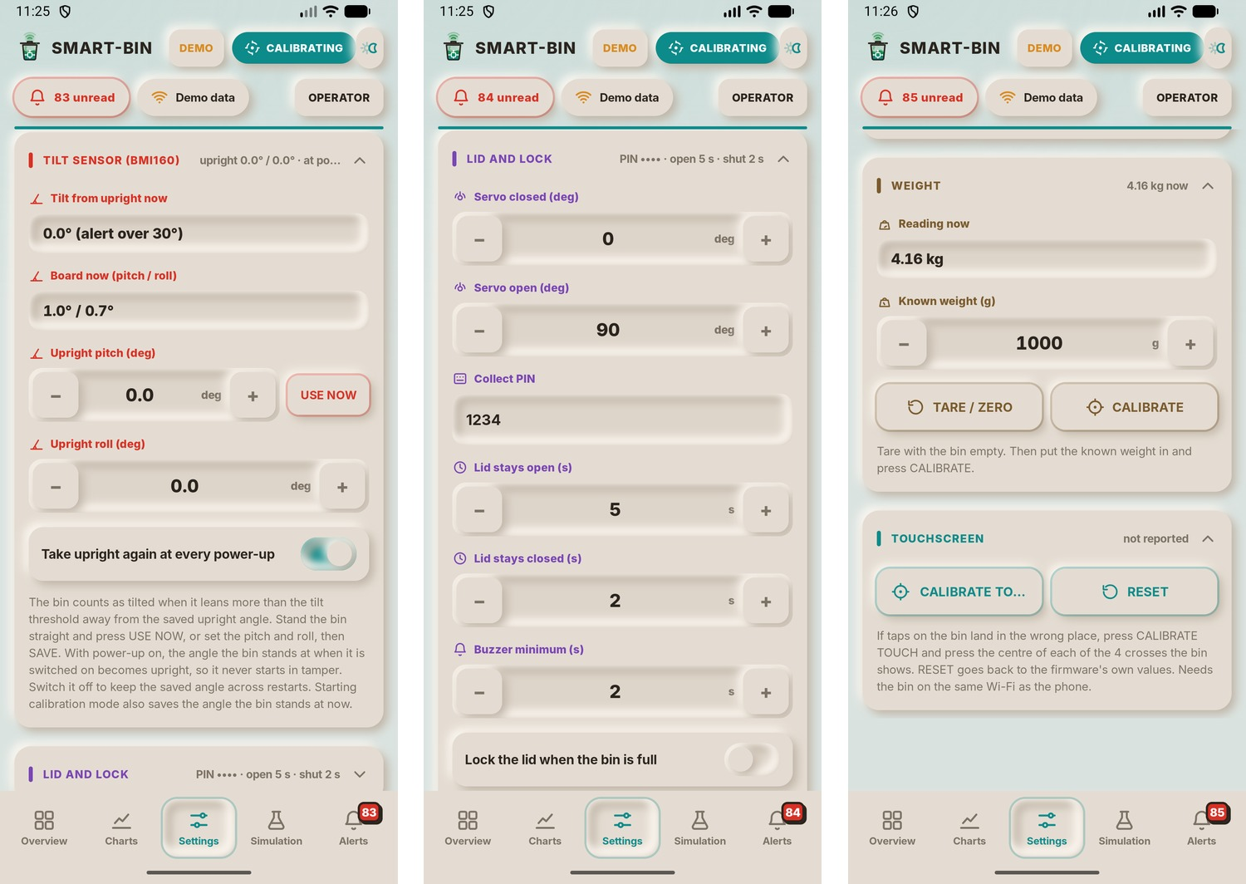
Tilt sensor (BMI160) shows how far the bin leans from upright and the board’s pitch and roll right now. The saved upright pitch and roll can be typed in or taken from the live reading with USE NOW, and the switch below takes the upright again every time the bin is powered up, which is on by default. Lid and lock holds the servo angles, the Collect PIN, how long the lid stays open after motion and how long it then stays closed (5s and 2s), the minimum buzzer time and the option to lock the lid when the bin is full. Weight calibration is done with TARE / ZERO on the empty bin, then CALIBRATE with a known weight inside (1000g here). Touchscreen starts the four-cross touch calibration on the bin or resets it.
Figure C25
Simulation Tab in the Android App
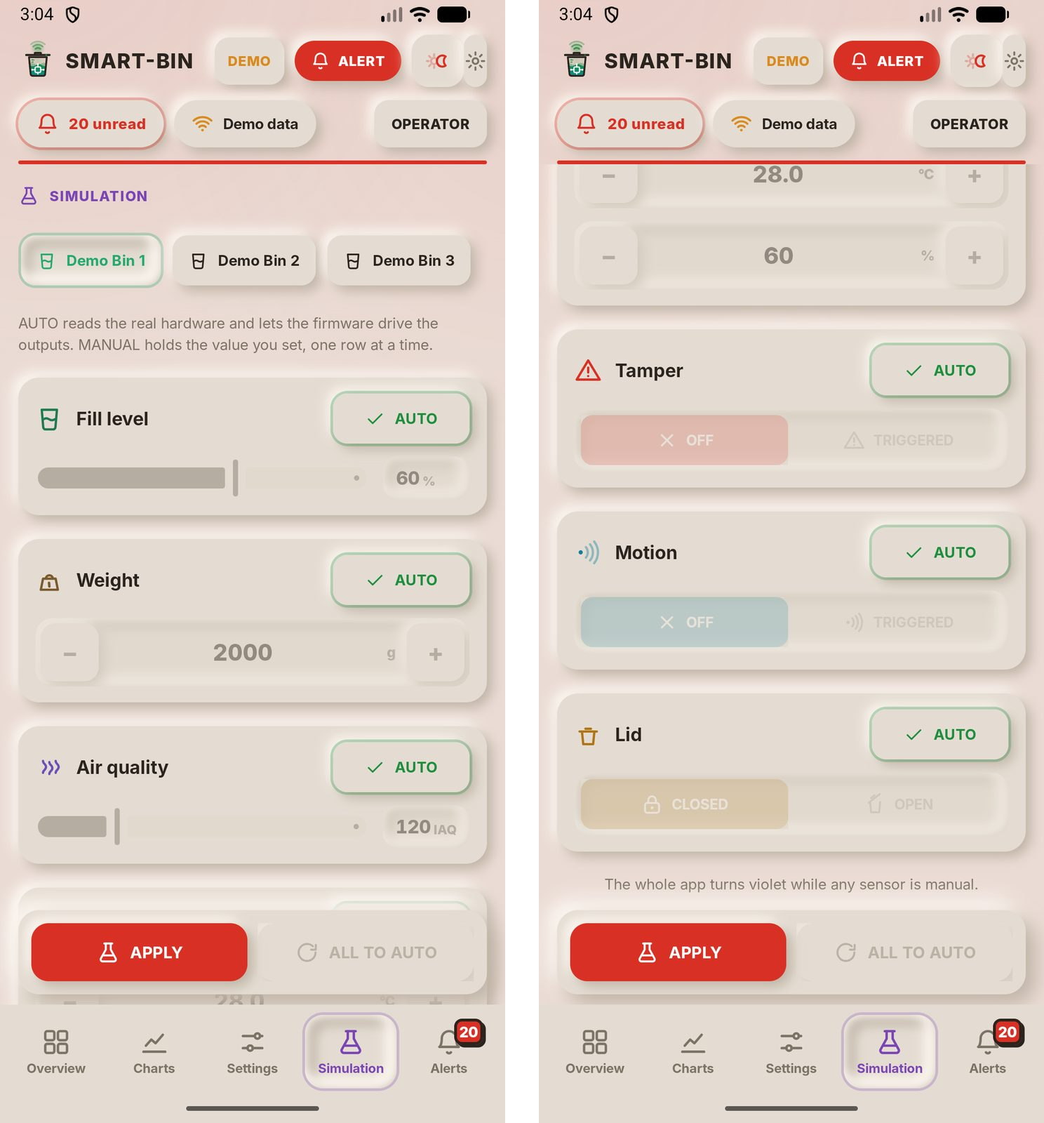
Each sensor of the selected bin can be set to MANUAL with its own value, as on the dashboard. APPLY sends the values to the bin over Wi-Fi and ALL TO AUTO ends the simulation. While any sensor is manual the whole app turns violet.
Figure C26
App Settings
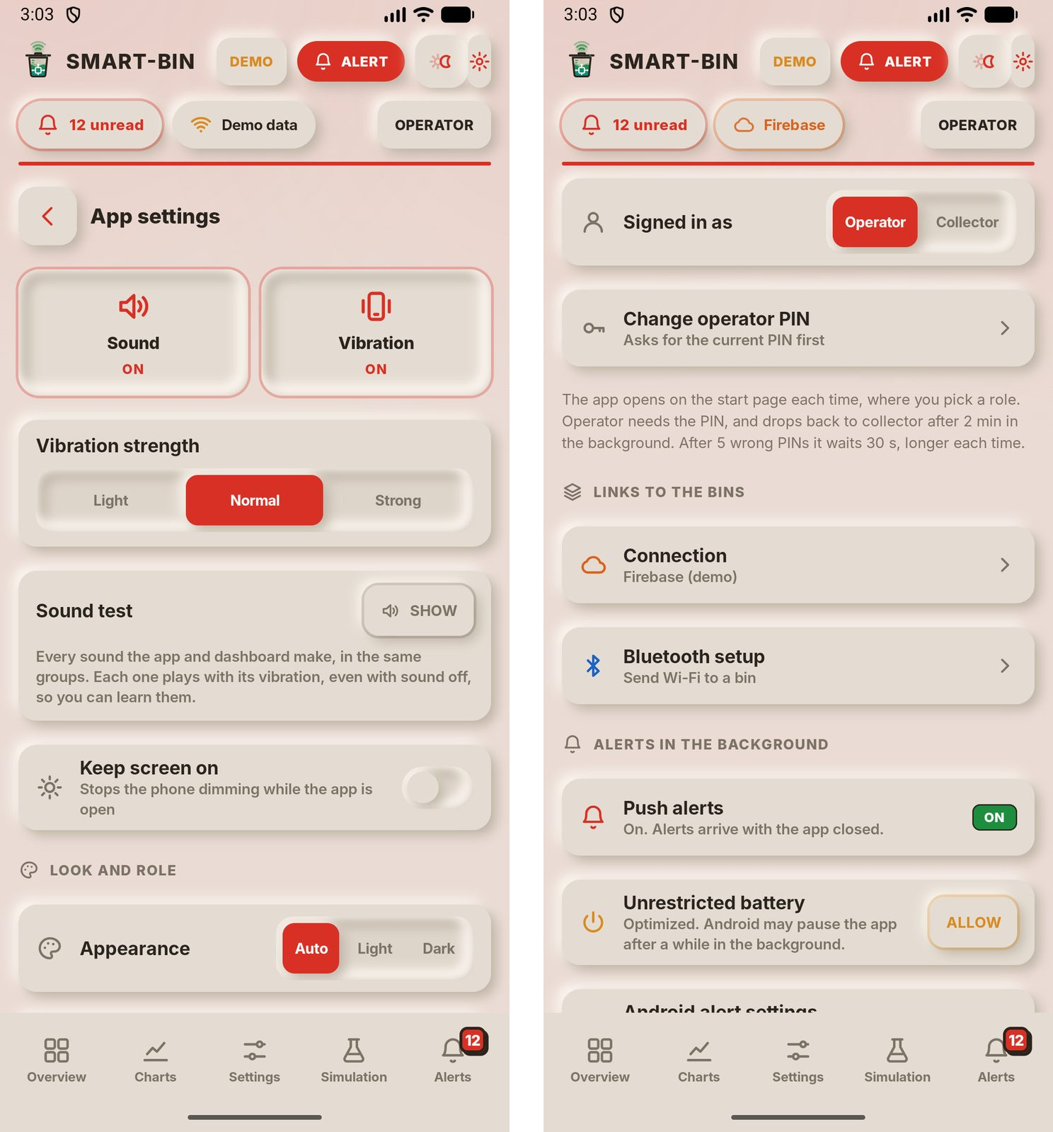
The gear key opens the settings of the phone app itself. Sound and Vibration turn the key sounds and haptics on or off, with three vibration strengths and a sound test. Appearance follows the phone (Auto) or forces light or dark. The second screen shows the signed-in role, the operator PIN, the Connection and Bluetooth setup pages, and the background options: push alerts while the app is closed, and unrestricted battery so Android does not pause the app.
Figure C27
Connection Page
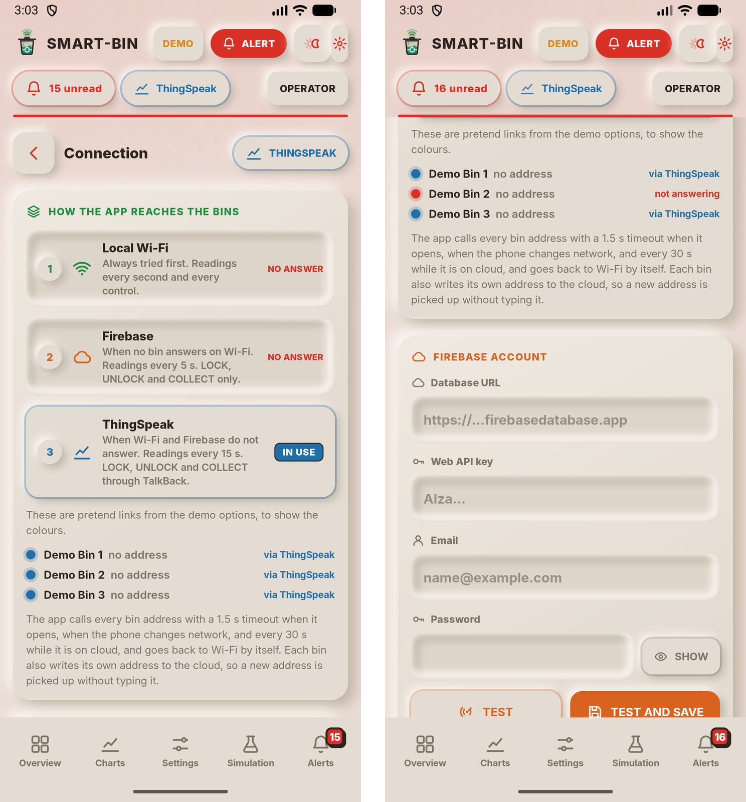
This page shows how the app reaches the bins, in order: local Wi-Fi is always tried first and read every second; Firebase is used when no bin answers on Wi-Fi and is read every 5 s; ThingSpeak is the last route, read every 15 s, with LOCK, UNLOCK and COLLECT sent through TalkBack. Over the clouds only those three commands are allowed. In this figure the demo options pretend that Wi-Fi and Firebase are down, so ThingSpeak is IN USE and the header chip turns blue. The second screen lists the route each bin is using and the Firebase account fields.
Figure C28
Bluetooth Setup Page and Bin Settings Sheet
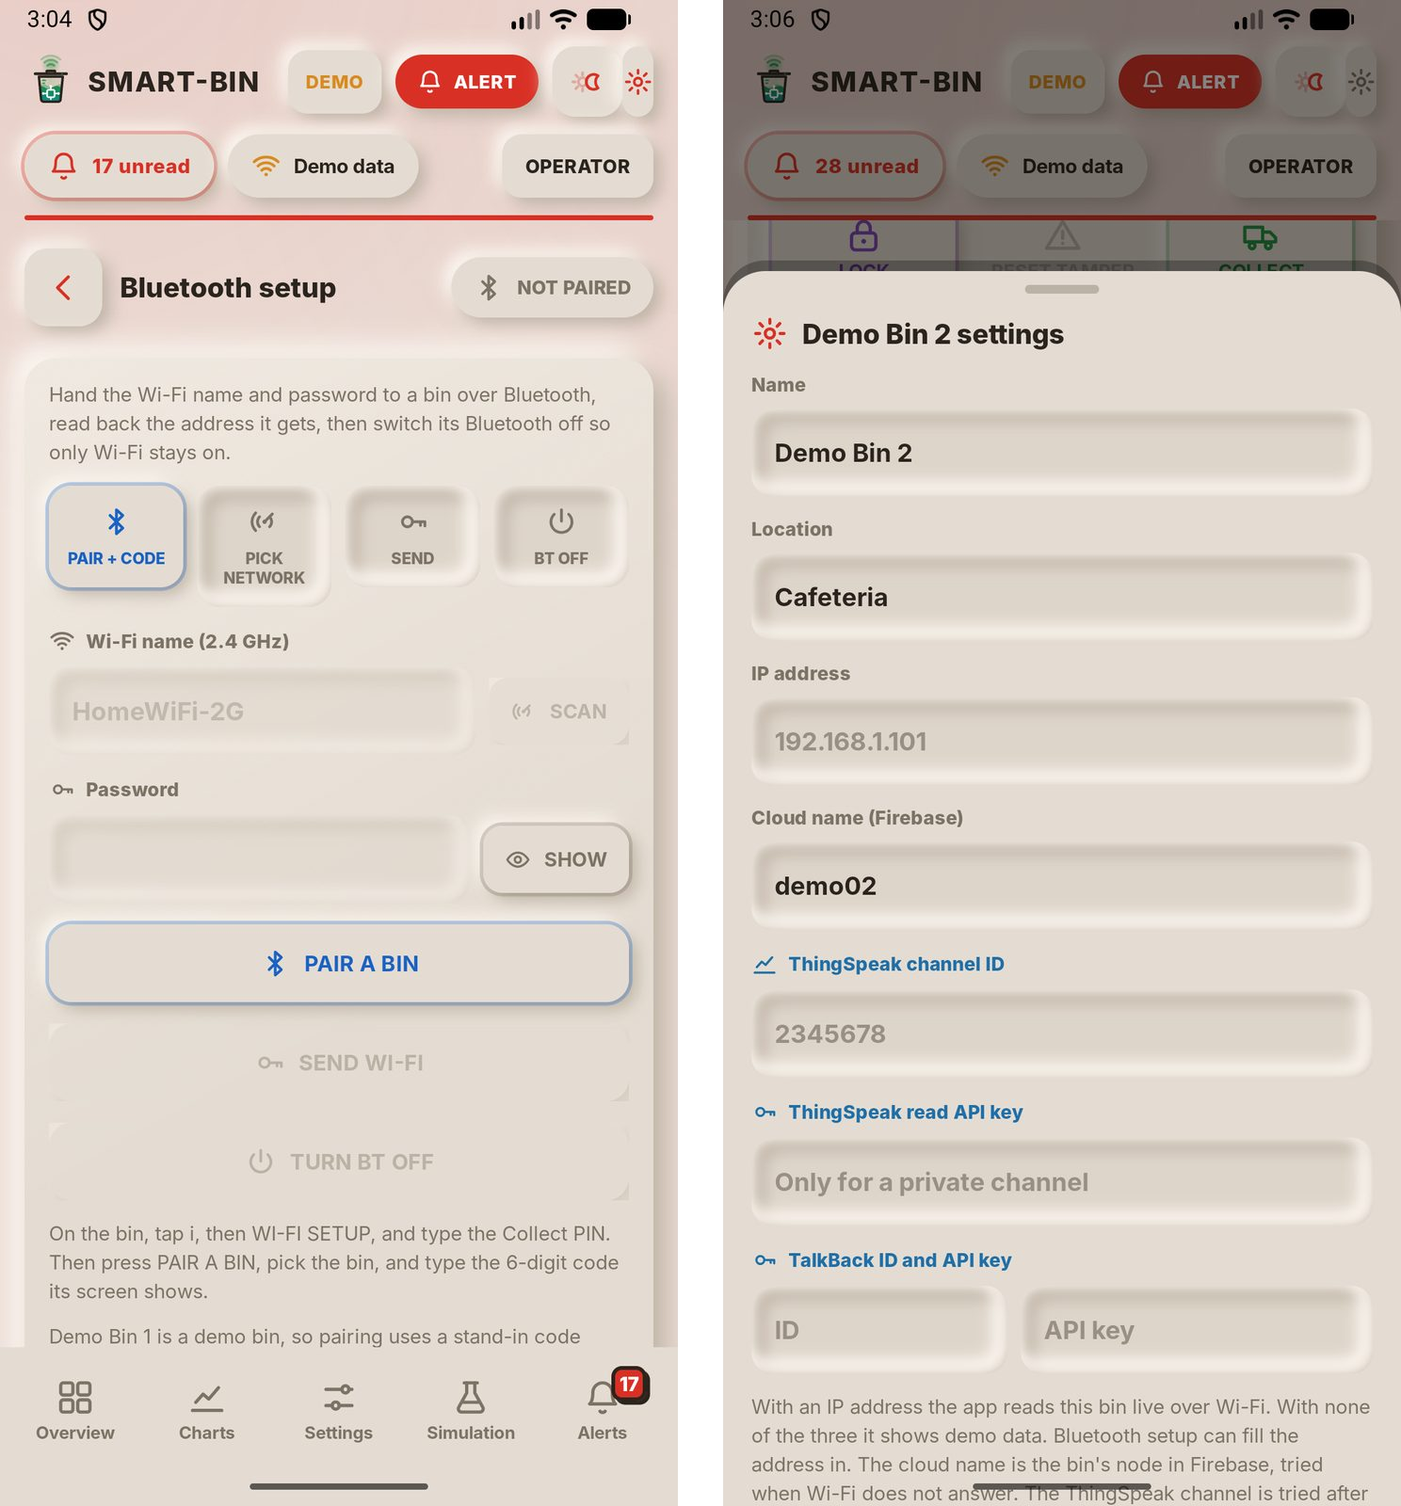
Bluetooth setup gives a bin a new Wi-Fi network: PAIR A BIN, type the 6-digit code shown on the bin's screen, pick the network, enter its password and SEND WI-FI, then turn the bin's Bluetooth off. With a demo bin the app shows a stand-in for the bin's screen. The sheet on the right opens from a bin's SET key and holds its name, location, IP address, Firebase cloud name and ThingSpeak keys. The values shown are the demo bin's placeholders, not real addresses or keys.
Figure C29
Overview in List View, Light and Dark Themes
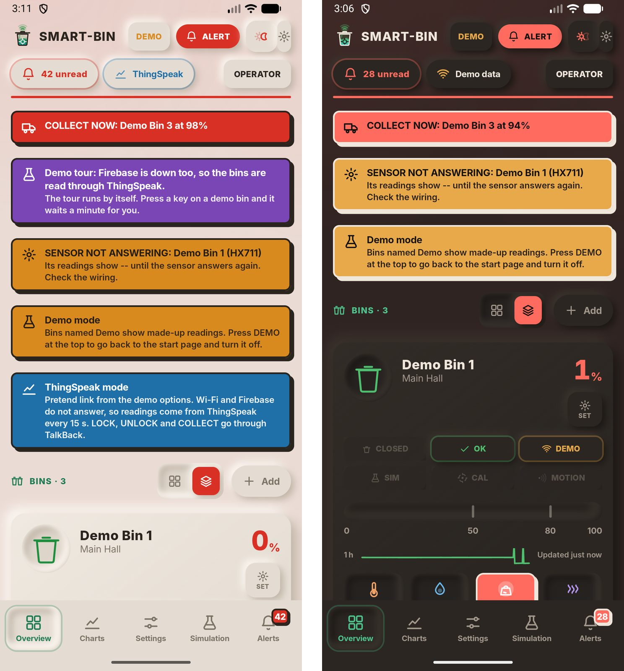
The same Overview in list view in the light theme (left) and the dark theme (right). Appearance in App settings picks the theme, or follows the phone. The banners, chips and tiles keep the same colors in both themes.

Appendix D
Build Documentation
This appendix follows the build of the two Smart-Bin units, from choosing the bin body to the last day of work on the prototype. The photos were taken by the group while they worked. The dates come from the Gantt chart in Appendix A and match the build notes in section 2.1: the bin body was picked after the prototype design was finished on October 23, and the build ran over four days, from October 27 to October 30, 2026.
Figure D1
Choosing the Bin Body, October 24, 2026
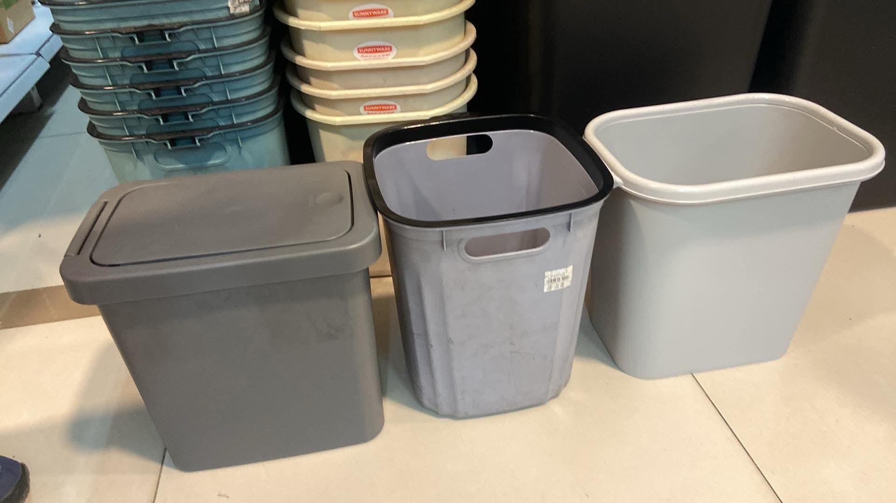
Before anything was built, the group compared bins in a store to find one that would fit the parts. The prototype design had been finished the day before, so the list of what had to go inside was already fixed: the servo and the HC-SR04 at the lid, the load cell under the trash, the touchscreen on the front wall, and a bay for the board and the four 18650 cells. The three bins in the photo were checked against that list for size, wall shape and lid, and the bin body was chosen from them.
Figure D2
Building the Board and Testing the Parts, October 27, 2026
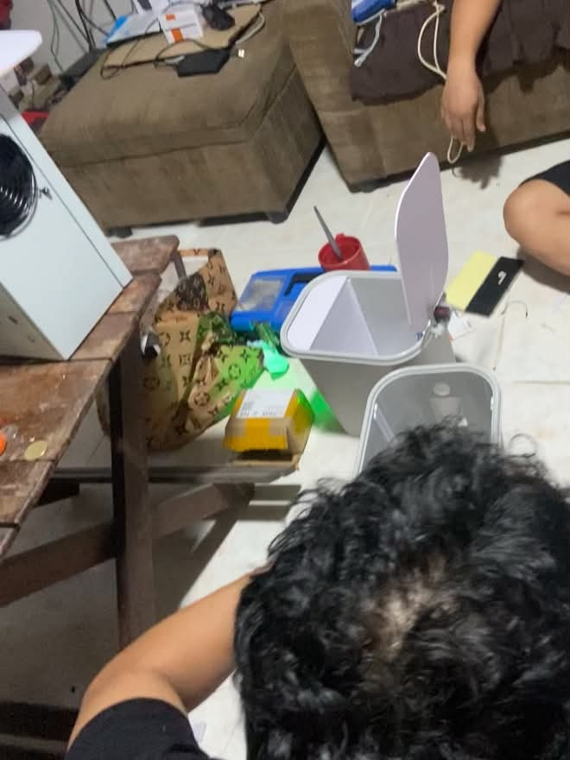  (a) | 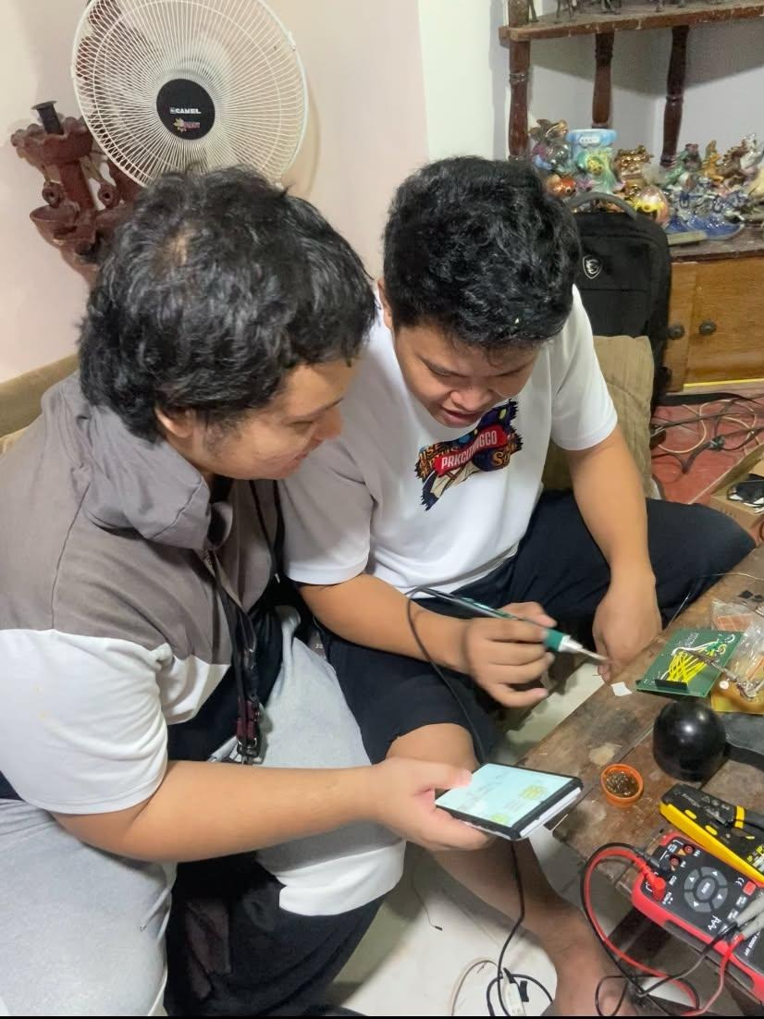  (b)
With the bin chosen, the group started on the circuit. The ESP32 and the sensor modules were soldered onto the perfboard, and each part was tested on its own before it went anywhere near the bin. Photo (a) shows the two bin bodies on the floor that day, one with its lid up and white cut panels fitted inside, with tools and parts around them. Photo (b) shows two members soldering and checking a reading on a phone with a multimeter at hand. The same day the group decided how the lid should open and where each part would sit inside the bin.
Figure D3
Fitting the Board Into the Bin, October 28, 2026
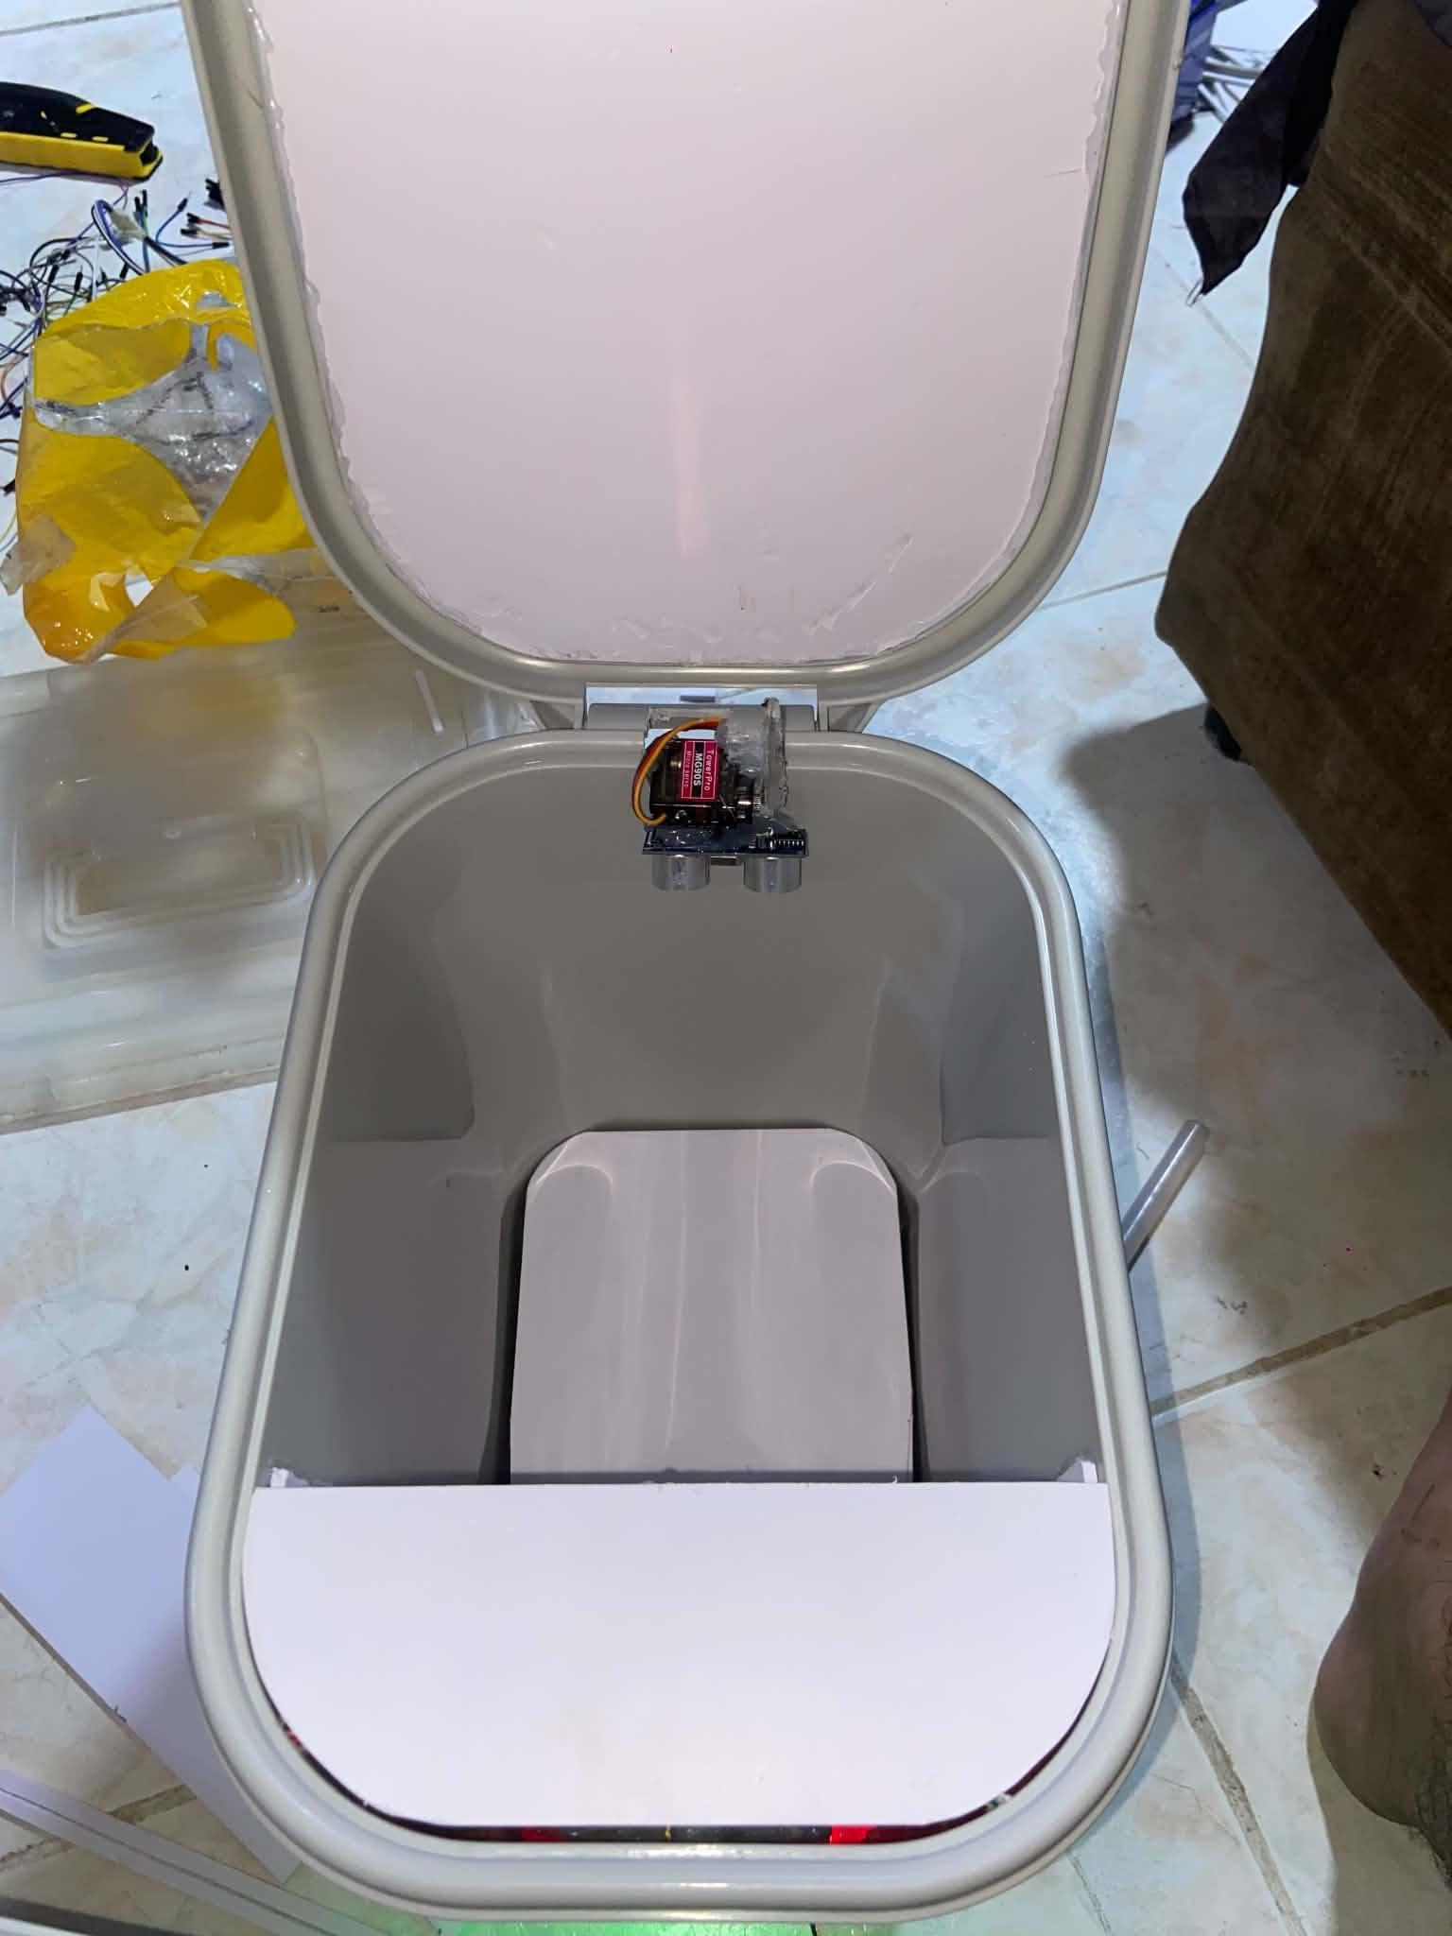  (a) | 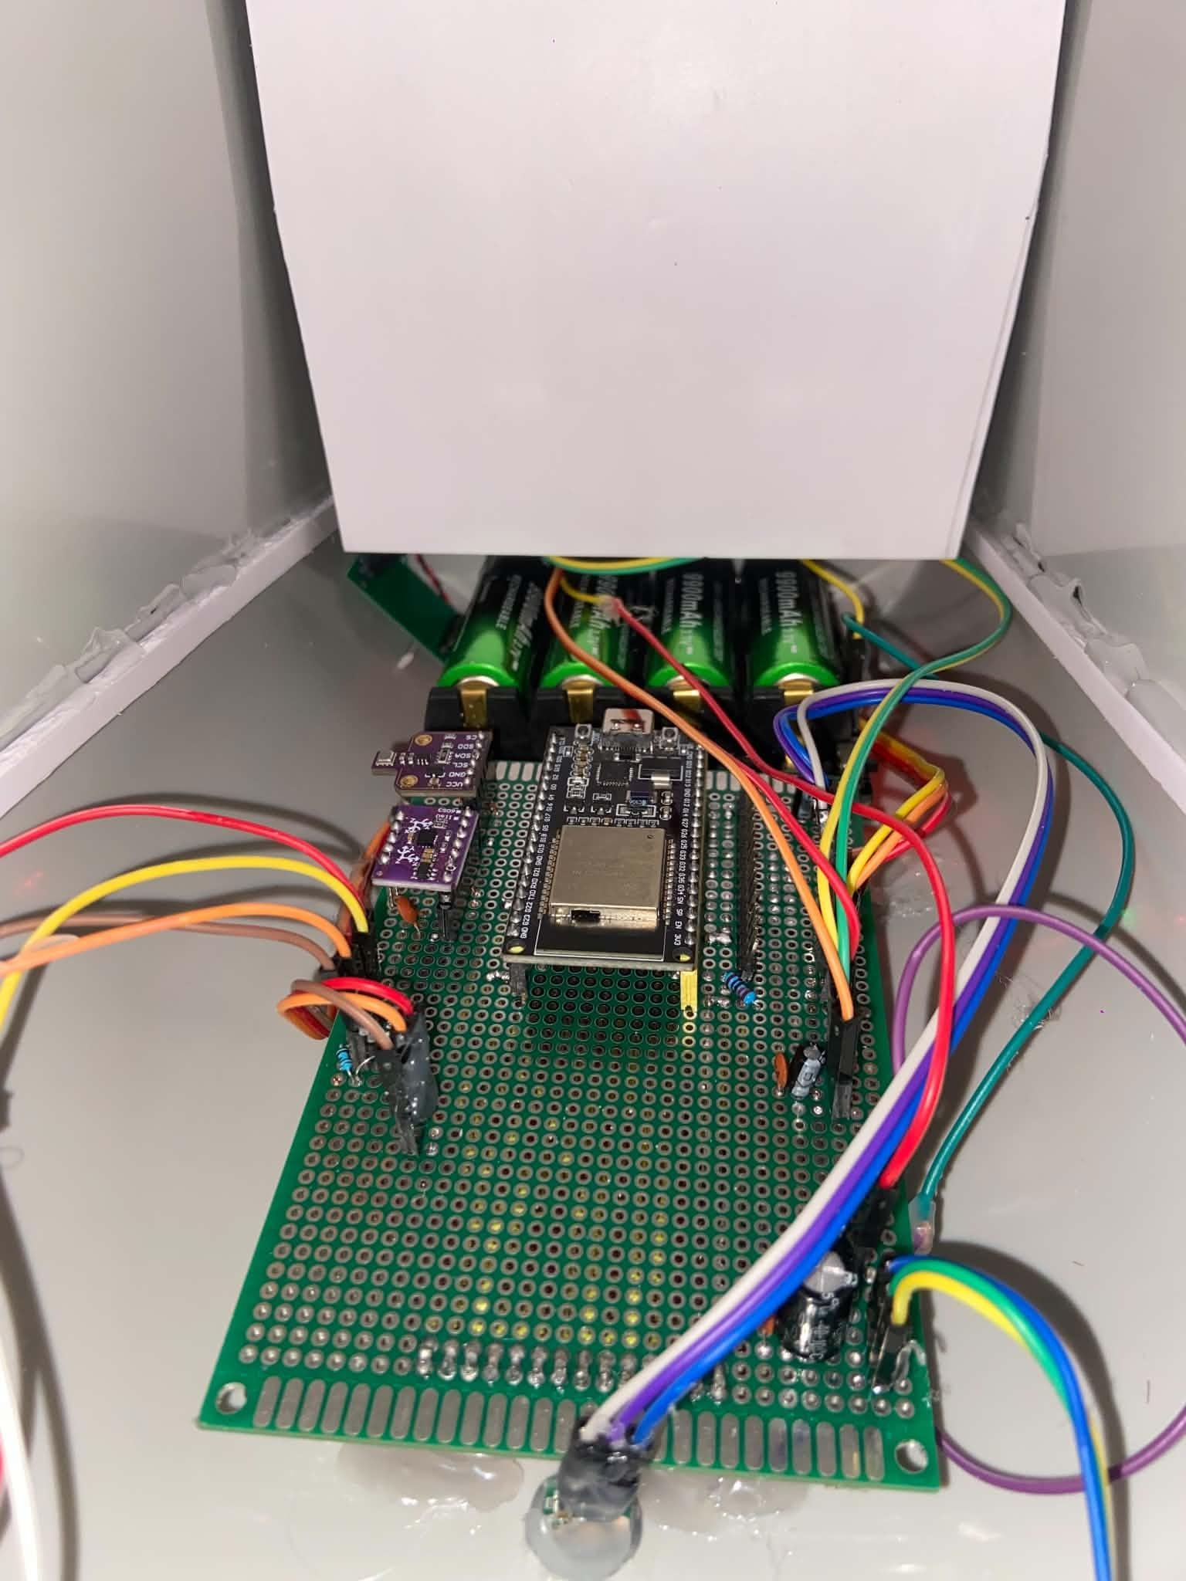  (b)
On the next day the board went into the bin. Photo (a) shows the servo and the HC-SR04 mounted together behind the lid hinge, looking down into the trash chamber. Photo (b) shows the perfboard with the ESP32, the BME680 and BMI160 modules, and the battery shield with its four 18650 cells in the electronics bay. Every part was moved and adjusted until it worked smoothly, and holes were cut in the bin for the buzzer, the status LED and the other parts that face out. This was the day the first bin was powered up and tested.
Figure D4
Moving Every Part Into the Bin and Changing the Lid, October 29, 2026
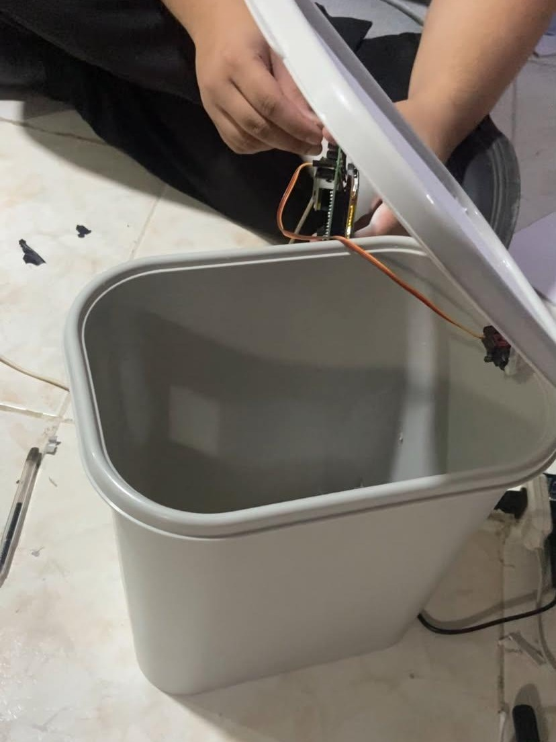  (a) | 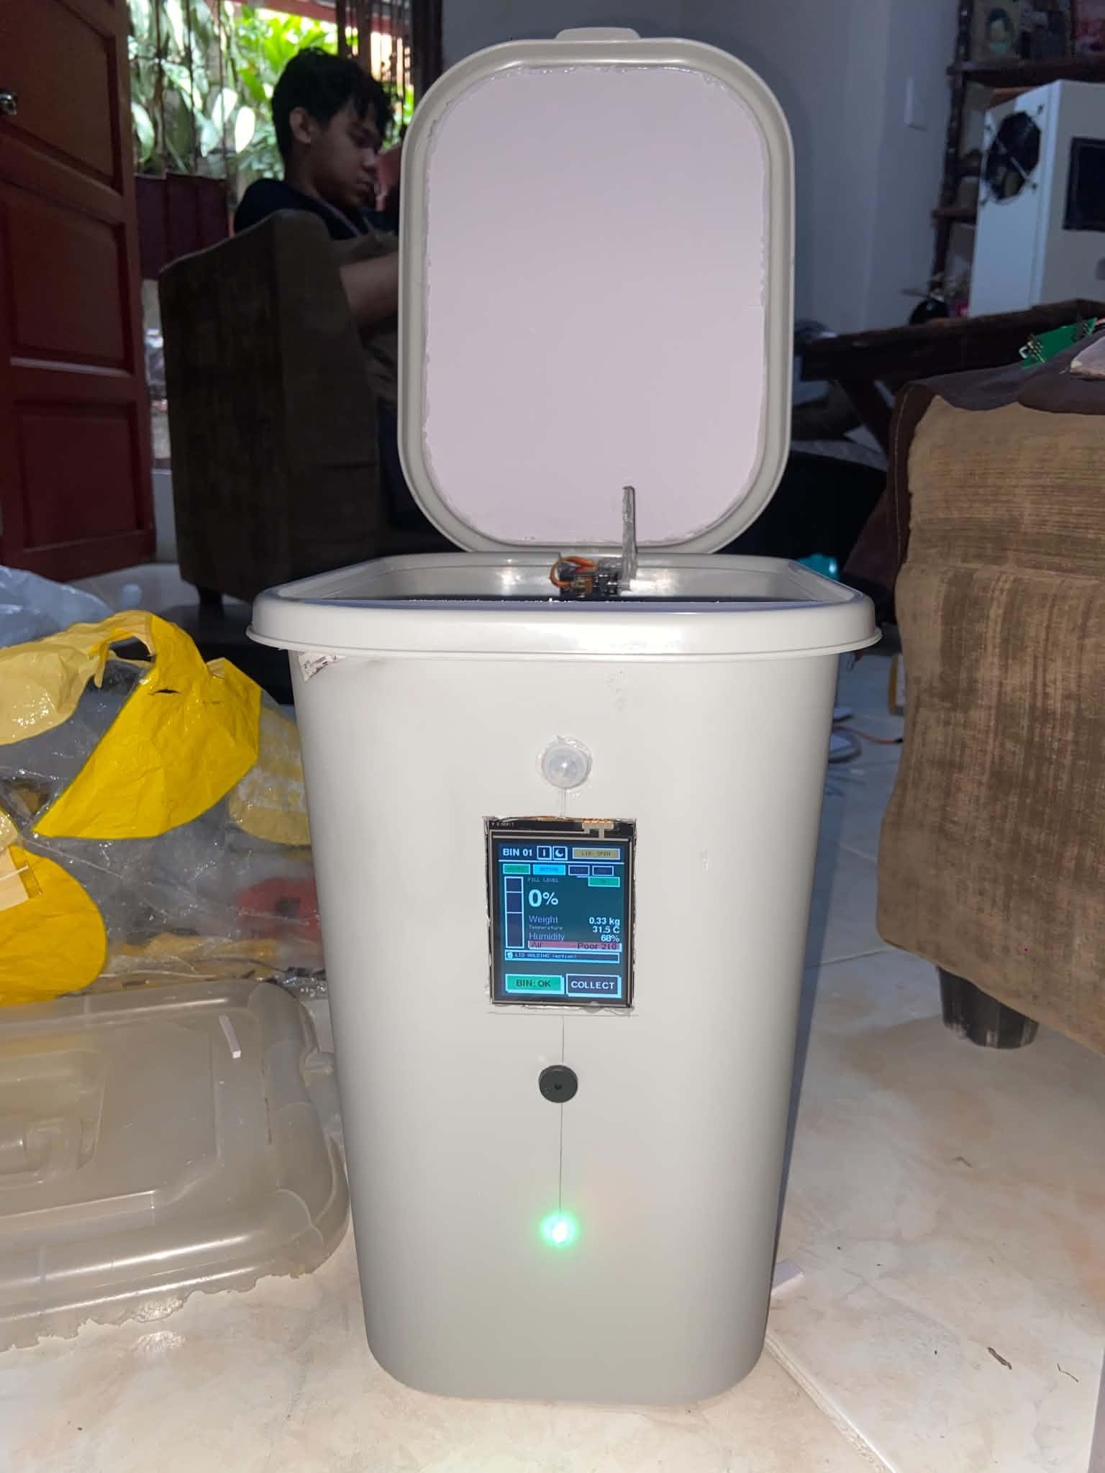  (b) | 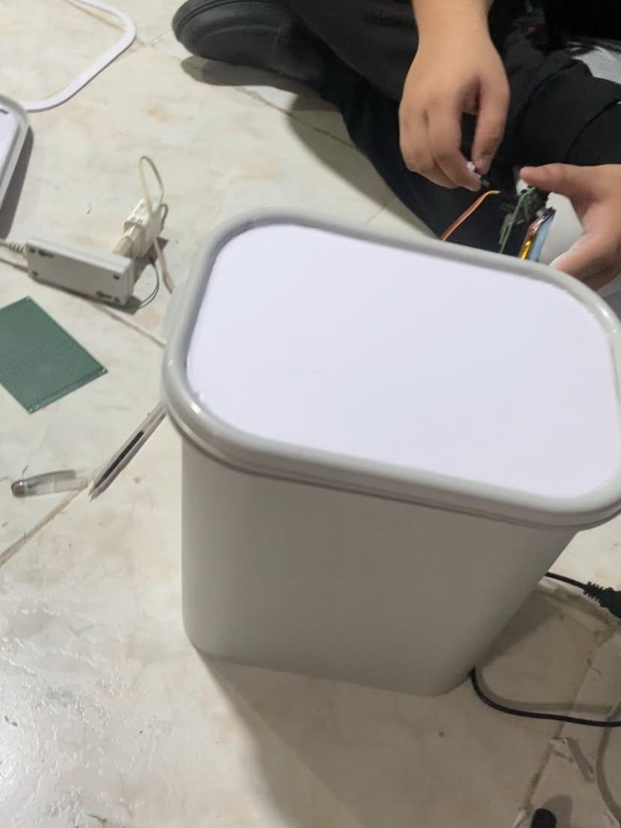  (c)
By the third day every component was inside the bin, and the whole system was tested as one. Photo (a) shows the servo and its wiring fixed to the original lid, and photo (b) shows the front of the bin with the touchscreen, the PIR motion sensor above it and the status LED below. The test showed a problem: when the motion sensor triggered the lid, the SG90 could not lift the original lid all the way. The group took that lid off and put a flat cardboard lid in its place (c), which is light enough for the servo to move.
Figure D5
Finishing the Build, October 30, 2026
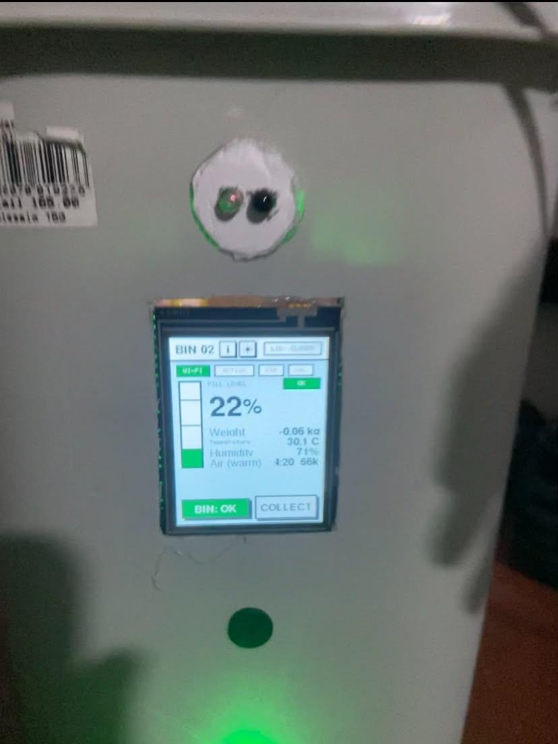  (a) | 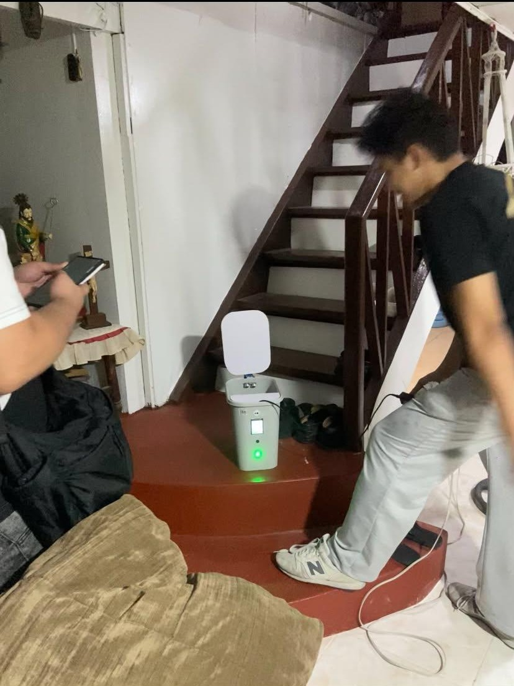  (b)
The last day finished the build. With the cardboard lid, the servo opened and closed the bin with no trouble. The remaining sensors were checked and adjusted until they met the requirements. Photo (a) shows the home screen of Bin 02 with its readings, the IR sensor that replaced the PIR sensor that day above the screen, and the green status LED below it. Photo (b) shows a lid test as a member walks up to the bin. After this the bins were to be cleaned and painted for the exhibit.

